Figure 2

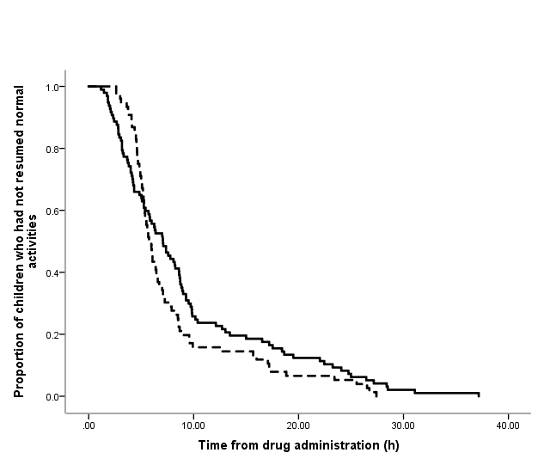

Figure 2 Time to resume normal activities after oral chloral hydrate () or intranasal dexmedetomidine ().

