Supplemental Figure 1: Comparison of expression levels of Crb1 in the retina of wildtype mice on different genetic backgrounds with a mouse line carrying the Crb1^{rd8/rd8} mutation.

Relative quantitative RT-PCR analysis of Crb1 RNA levels in retinas of C57BL/6, Balb/c, Sv129 and Crb1^{rd8/rd8}/J mice at 8 weeks of age (n = 4 each). As indicated by the significant reduction of Crb1 expression in Balb/c mice (0.47 ± 0.16 %) compared to C57BL/6 mice (1 ± 0.22) and by the intermediate expression level of Crb1 in retinas of Sv129 mice (0.71 ± 0.14 %), different genetic backgrounds can influence expression levels of Crb1 in the retina. However compared to the genetic background influence on Crb1 expression, the reduction in Crb1 expression due to the Crb1^{rd8/rd8} mutation is always more pronounced in Crb1^{rd8/rd8}/J mice compared to all three other wildtype strains. All samples were normalized to levels of β-actin and are presented relative to the average level of Crb1 in C57BL/6 retina. * (p<0.05), **, (p<0.01), *** (p<0.001) indicate significant differences base on Oneway ANOVA with Tukey’s multiple comparison analysis.

Supplemental Figure 2: Relative quantitative Real time PCR measurements of levels of chemokine RNA and microglia activation marker in retinae of wildtype and Crb1^{rd8/rd8} mice with different degree of degeneration. No significant alterations in RNA levels were observed neither for the chemokine ligand receptor pairs of Ccl2 (A) - Ccr2 (B) and Cx3cl1 (C) and Cx3cr1 (D) nor for the microglia activation marker iNOS (E), Arg1 (F) and TGFβ (G). All samples were normalized to levels of β actin and are presented relative to the average level of each transcript in wildtype retina.

Supplemental movies 1 & 2: 3D Imaris reconstruction of the retinal vasculature to illustrate remodelling of the retinal vascular beds and a single telangiectasia like lesion in a Crb1^{rd8/rd8}/J mouse at 12 months of age (supplemental movie 1) and a C57BL/6 mouse for comparison (supplemental movie 2). Endothelial cells are shown red, microglia in green and cell nuclei of only the ONL and the RPE in blue.

FIG S1

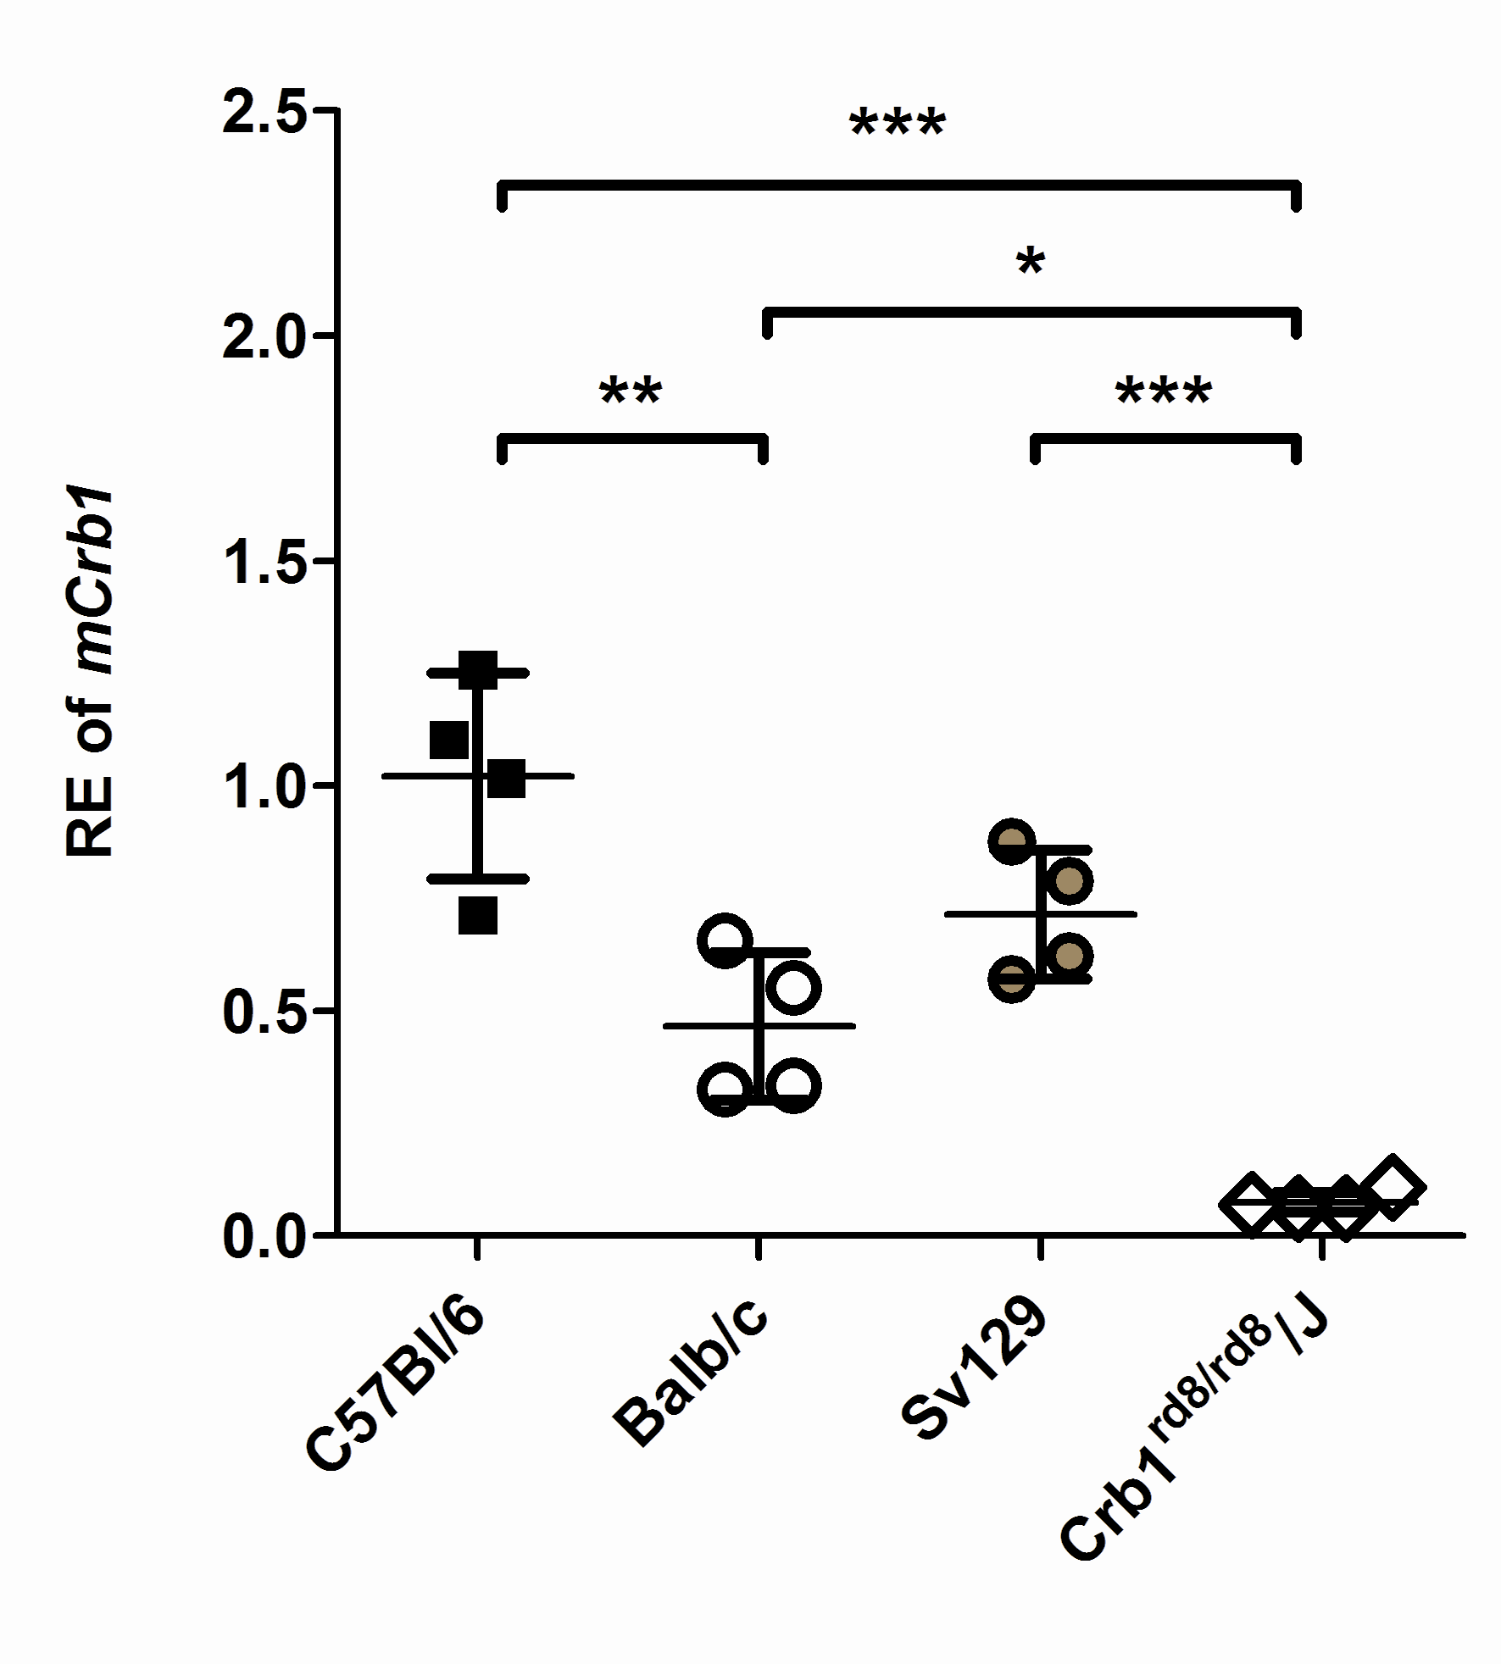

FIG S2

