Supplemental Materials for

**Electrographic Features of Catatonia with and without Comorbid Delirium**

James Luccarelli, MD, DPhila,b*, Joshua R. Smith, MDc,d, Niels Turley, BSe, Jonathan P. Rogers MBBChir, PhDf, Haoqi Sun, PhDa,e, Samuel I. Kohrman, MDa,b, Gregory Fricchione, MDa,b, M Brandon Westover, MD, PhDa,e

Author Affiliations:

aHarvard Medical School, Boston, MA, USA

bDepartment of Psychiatry, Massachusetts General Hospital, Boston, MA, USA

cDivision of Child and Adolescent Psychiatry, Department of Psychiatry and Behavioral Sciences; Vanderbilt University Medical Center at Village of Vanderbilt, 1500 21st Avenue South, Suite 2200, Nashville, Tennessee, 37212

dVanderbilt Kennedy Center, Vanderbilt University; 110 Magnolia Circle, Nashville, TN, 37203

eDepartment of Neurology, Beth Israel Deaconess Medical Center, Boston, MA, USA

fDivision of Psychiatry, University College London, London, UK

|  |  |  |  |  |  |
| --- | --- | --- | --- | --- | --- |
|  | Delirium without catatonia | | No delirium, no catatonia | | |
| N | 10 |  | 24 |  | |
| *Male Sex* | 4 | 40% | 15 | 63% | |
| Age (yrs; mean ± SD) | 47.3 ± 27.6 | | 41.3 ± 21.0 | | |
| *Race* |  |  |  |  | |
| *White* | 7 | 70% | 14 | 58% | |
| Black | 2 | 20% | 7 | 29% | |
| Asian | 0 | 0% | 1 | 4% | |
| Other | 1 | 10% | 2 | 8% | |
| Hispanic (yes) | 1 | 10% | 2 | 8% | |
| Study Site |  | |  |  | |
| *1* | 2 | 20% | 2 | 8% | |
| 2 | 8 | 80% | 22 | 92% | |
| Primary Diagnosis |  | |  |  | |
| *Psychiatric* | 3 | 30% | 15 | 63% | |
| Medical | 7 | 70% | 9 | 38% | |
| EEG Type |  |  |  |  | |
| *Spot* | 6 | 60% | 24 | 100% | |
| LTM | 4 | 40% | 0 | 0% | |
| Catatonic (yes) | 0 | 0% | 0 | 0% | |
| Delirious (yes) | 10 | 100% | 0 | 0% | |
| BFCSI Features (mean ± SD) | 2.7 ± 0.5 |  | 2.1 ± 0.9 |  | |
| *BFCRS Features (mean ± SD)* | 4.5 ± 1.2 |  | 3.7 ± 1.4 |  | |
| *Hospital Day of EEG (mean ± SD)* | 12.0 ± 9.0 |  | 4.5 ± 4.1 |  | |
| *Hospital Length of Stay (mean ± SD)* | 28.7 ± 19.5 |  | 12.9 ± 10.9 | |  |

Table S1: demographics of patients without catatonia, stratified by delirium status.

|  |  |  |  |
| --- | --- | --- | --- |
| Psychiatric | | Medical | |
| N | Diagnosis | N | Diagnosis |
| 40 | Catatonic Schizophrenia | 10 | Altered Mental Status |
| 12 | Bipolar Disorder | 7 | Infection |
| 10 | Catatonia (unspecified) | 6 | Encephalopathy/Delirium |
| 9 | Unspecified psychosis | 5 | Renal disorders |
| 6 | Major Depressive Disorder | 5 | Substance use/withdrawal |
| 3 | Autism Spectrum Disorder | 4 | NMDA Encephalitis |
| 2 | Schizoaffective Disorder | 4 | Epilepsy |
| 2 | Delusional Disorder | 3 | Brain injury |
| 1 | Unspecified Mood Disorder | 2 | Cancer |
|  |  | 2 | PE |
|  |  | 2 | Fracture |
|  |  | 2 | Endocrine disorders |
|  |  | 2 | Movement Disorders |
|  |  | 1 | Burn |
|  |  | 1 | Aspiration pneumonitis |
|  |  | 1 | Rhabdomyolysis |
|  |  | 1 | Neuroleptic Malignant Syndrome |
|  |  | 1 | Dementia |

Table S2: Primary discharge diagnoses for patients with catatonia with primary psychiatric and medical diagnoses.

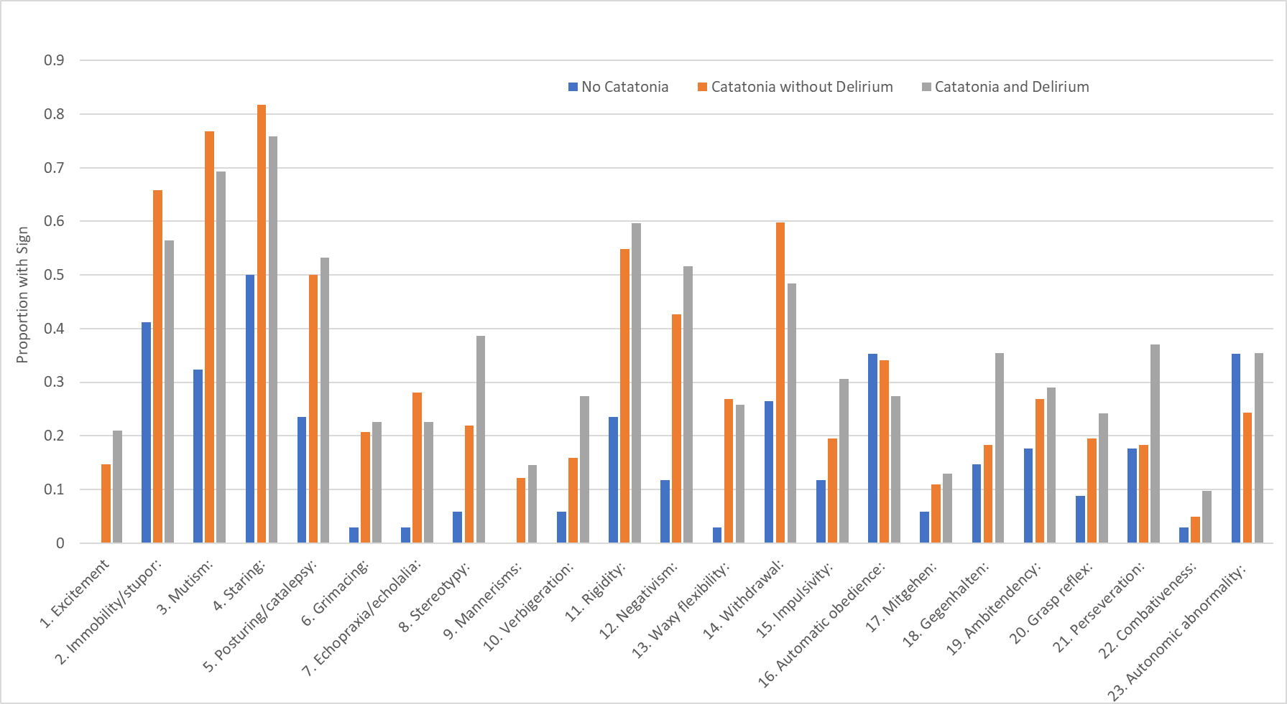

Figure S1: Proportion of patients without catatonia, with catatonia and no delirium, and catatonia with delirium exhibiting each catatonic sign on the BFCRS.