**Meta-analysis of mean transit time and pulmonary blood flow in the lung**

Marta Tibiletti1, Lucy Edwards1, Jo Naish1,2, Geoff JM Parker1,3, John C Waterton1,4

1: Bioxydyn Ltd, Manchester, UK

2: MCMR, Manchester University NHS Foundation Trust, Wythenshawe, Manchester, UK

3: Centre for Medical Image Computing, Department of Medical Physics and Biomedical Engineering, University College London, London, UK

4: Centre for Imaging Sciences, University of Manchester, Manchester, UK

[Max 1533 characters with spaces for abstract and title + 1 figure]

**Introduction:** CT and MRI can assess mean transit time (MTT) and pulmonary blood flow (PBF) in the lung. We aimed to determine whether MTT and PBF in the healthy lung are consistent across studies and differentiated from results in disease.

**Method:** A systematic literature search was conducted in PubMed to identify studies that quantified MTT and/or PBF in the lung. Inclusion criteria were limited to MRI or CT, English language, human subjects, injection of intravenous contrast agent, and quantitative values determined by indicator dilution theory. The weighted mean and standard deviation (SD) of MTT and PBF were estimated from the healthy volunteers’ (HV) values reported, weighted by number of subjects.

**Results:** We identified 34 studies for meta-analysis after exclusions, summarised in figure 1. In HV, weighted MTT was 5.91±1.84s (10 studies) and the weighted PBF 246±93 ml/100ml/min (14 studies).

**Conclusion:** MTT was consistent across studies in healthy volunteers and similarly in diseased subjects, with few values outside of the normal range. In comparison, PBF values were consistently markedly reduced in multiple diseases (figure 1).

# **Acknowledgements**

The research leading to these results received funding from the Innovative Medicines Initiatives 2 Joint Undertaking under grant agreement No 116106. This Joint Undertaking receives support from the European Union’s Horizon 2020 research and innovation programme and EFPIA.

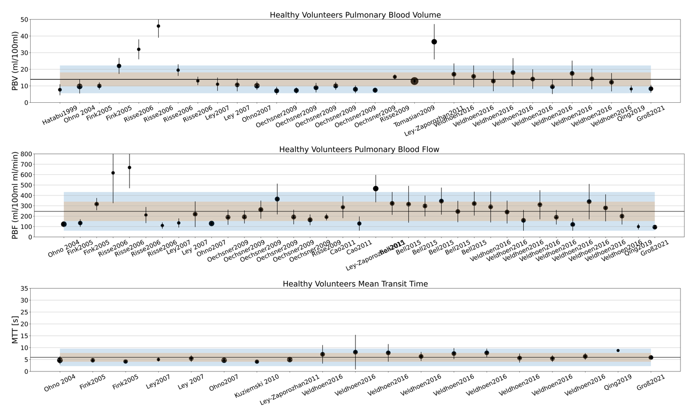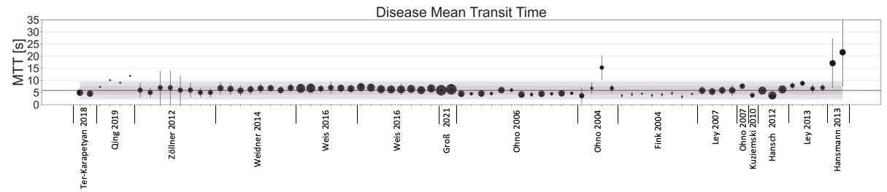

COPD

CDH

Cancer

Other

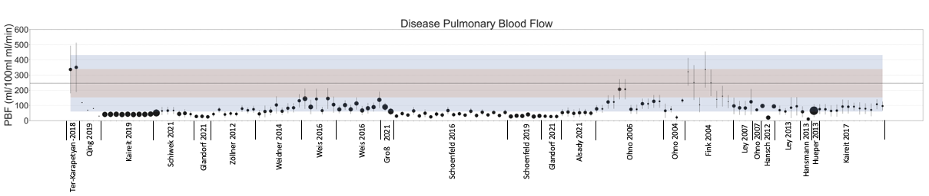

COPD

CDH

CTEPH

Other

Cancer

Figure 1. Mean PBF (ml/100ml/min) and MTT (s) in the lung from meta-analysis. A): PBF in HV; b): MTT in HV; c) PBF in disease, d), MTT in disease. Symbol size represents group size; symbol error bar represents intra-study SD; horizontal black line is the weighted mean for HV across all studies; shading represents ±1 and ±2 SD of the HV weighted mean. In case of disease groups, all values reported in the paper are shown.