**Figure 1: Presence of individual comorbidity at baseline for women compared to (A) MSM and (B) non-MSM, adjusted OR [95% CI].**

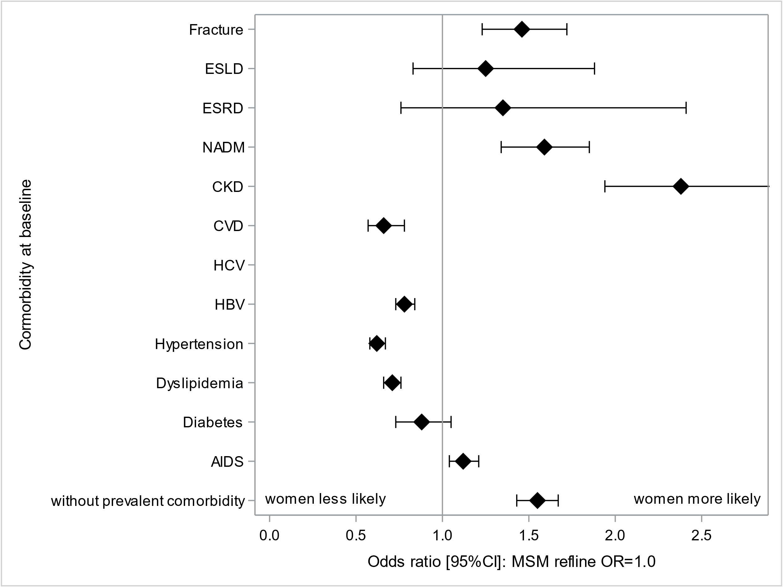

**A**

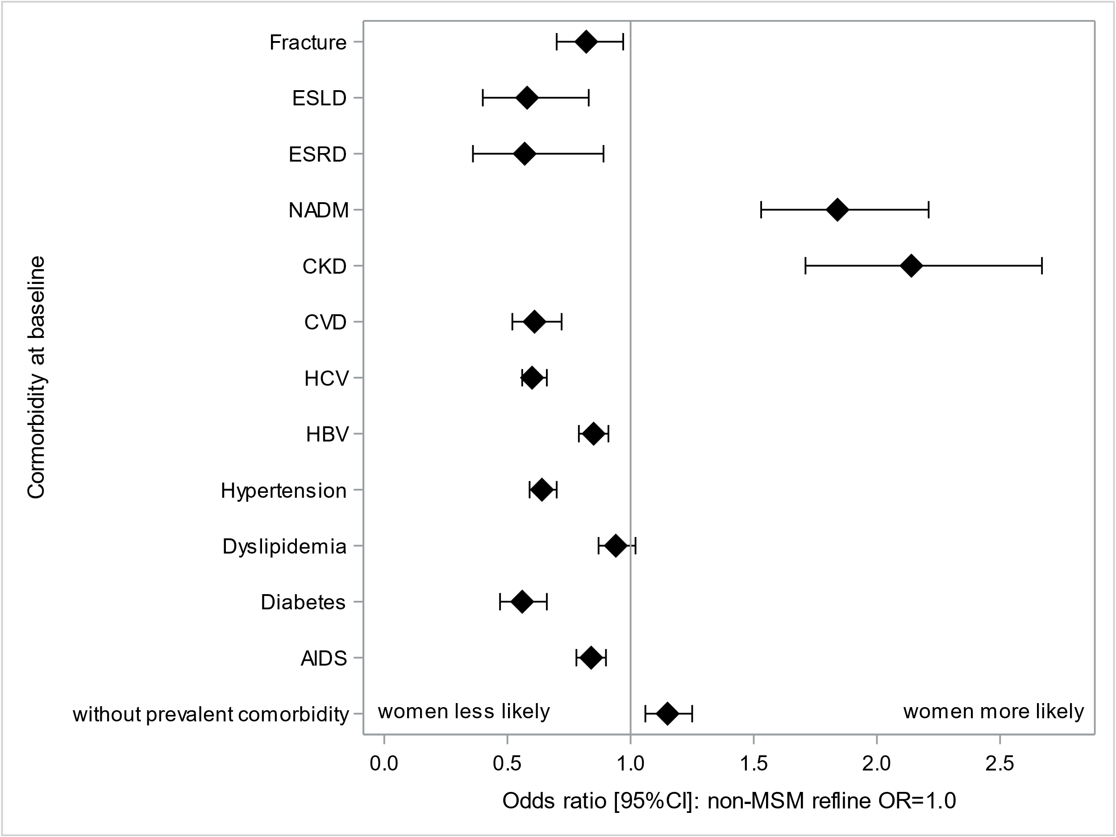

**B**