Supplementary Section
- b)
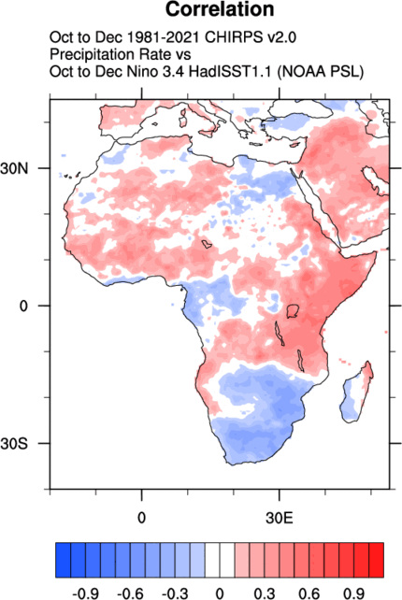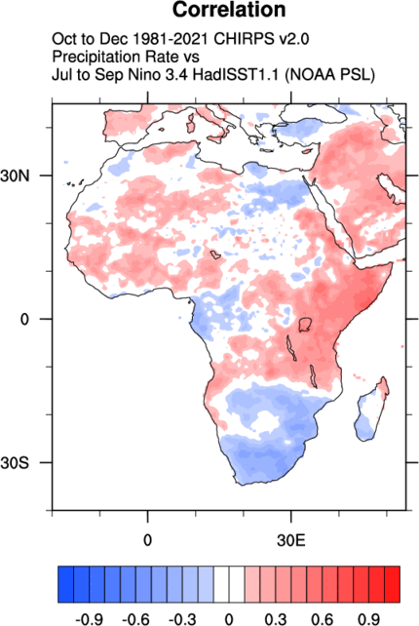
c) 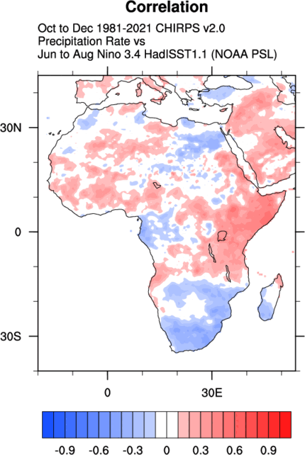
Fig. S1. Precipitation (OND) and Niño3.4 correlation. Same as Fig. 1 a, b and c respectively, but CHIRPS data is used instead of ERA5 and the period considered is ‘1981-2021’ instead of ‘1948-2021’.

- b)
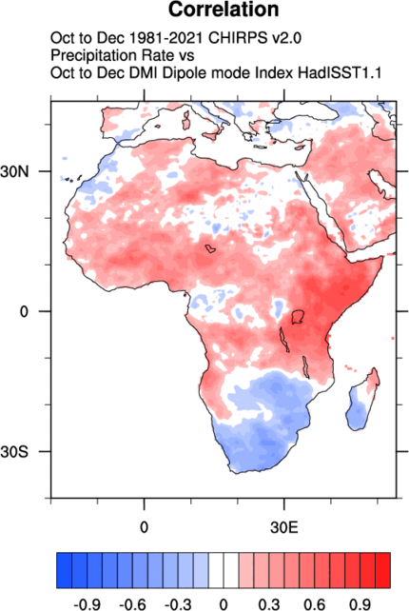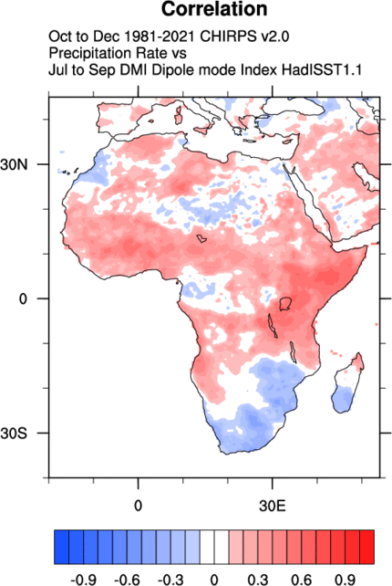
c) 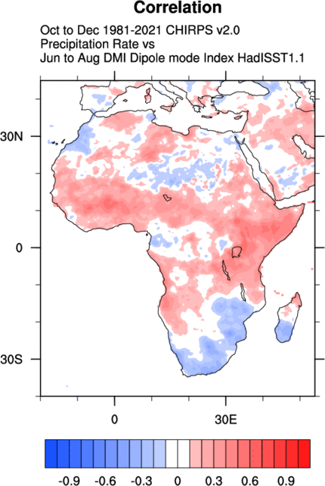
Fig. S2. Precipitation (OND) and IOD correlation. Same as Fig. 2 a, b and c respectively, but CHIRPS data is used instead of ERA5 and the period considered is ‘1981-2021’ instead of ‘1948-2021’.

