Non-vascular interventional radiology in the paediatric alimentary tract

Premal A. Patelª, Kishore Minhasª, Jestine Angª, Sam Stuartª, Paolo De Coppi^{b}, Ralph Gnannt^{c}

a. Interventional Radiology, Radiology Department, Great Ormond Street Hospital, Great Ormond Street, London, WC1N 3JH
b. Specialist Neonatal and Paediatric Surgery Department, Great Ormond Street Hospital, Great Ormond Street, London, WC1N 3JH
c. Bilddiagnostik, Bilddiagnostik, Paediatric Interventional Radiology, University Children’s Hospital, Steinwiesstrasse 75, CH-8032 Zürich.

Highlights
- Paediatric interventional radiology offer minimally invasive treatments.
- IR treatment in the GI tract is a safe and effective alternative to more invasive procedures.
- Sclerotherapy, stricture management, stenting, and enteral access are discussed.

Abstract
Paediatric interventional radiology is an evolving speciality which is able to offer numerous minimally invasive treatments for gastrointestinal tract pathologies. Here we describe interventions performed by paediatric interventional radiologists on the alimentary tract from the mouth to the rectum. The interventions include sclerotherapy, stricture management by dilation, stenting and adjunctive therapies such as Mitomycin C administration and enteral access for feeding, motility assessment and administration of enemas.

Abbreviations:
ACE (antegrade colonic enema), ADM (antroduodenal manometry), CM (colonic manometry), BTX-A (botulinum toxin A), GI (gastrointestinal), GJ tube (gastrojejunal tube), IR (interventional radiology), PTFE (polytetrafluoroethylene), STS (sodium tetradecyl sulphate), US (ultrasound)

Keywords:
Paediatric interventional radiology, Gastrointestinal, Gastrostomy, Gastrojejunal, Oesophageal dilation, Caecostomy, Antroduodenal manometry, Colonic manometry, Mitomycin C

1. Introduction
Minimally invasive surgery is becoming the gold standard for the treatment of many diseases in children. In parallel, the recent, fast development of paediatric interventional radiology (IR) offers the opportunity of minimise treatment for children who would normally undergo more extensive surgery. Paediatric IR procedures are performed throughout the body on a range of pathologies. Interventions on the gastrointestinal (GI) tract are often performed in children with complex multi-pathology conditions. To optimize patient preparation and longitudinal patient care, before undertaking interventions, specialists from relevant fields should to be consulted, either in joint clinics or in multi-disciplinary meetings [1, 2, 3]. Additionally, the approach to patient care in Paediatric IR should to be family-centred, as the family is integral to the paediatric patient's well-being and recovery [1].
We describe interventions performed by paediatric IR on the alimentary tract from the oropharynx to the rectum. The interventions include sclerotherapy, stricture management by dilation, stenting and adjunctive therapies such as Mitomycin C administration and enteral access for feeding, motility assessment and administration of enemas. Hepatobiliary interventions and endovascular treatment of gastro-intestinal haemorrhage are not discussed.

2. Salivary gland intervention
Drooling in neurologically impaired children is often due to impaired swallowing. This can be treated by ultrasound-guided (US-guided) injection of Botulinum Toxin A (BTX-A) into both submandibular glands (and in some institutions into both parotid glands also) usually under general anaesthesia. This is an off-label use. The glands are identified with US, and then injected with a fine needle. Dosage and frequency of injections are not established and a range of doses are reported [4, 5, 6, 7, 8]. The amount of toxin injected depends on the preparation. We use Dysport (Ipsen Biopharm, Wrexham, UK), and inject 3 U/kg, up to a maximum of 150 U, into each submandibular gland. Treatment has been reported effective in 68% of patients in a recent large series [6]. Children with severe neurological dysfunction, as measured by the Gross Motor Function Classification System score, have been found to respond to BTX-A injections as effectively as those with less severe neurological dysfunction. From this, it appears that the degree of response to treatment is not associated with the severity of neurological disability [7]. Treatment effect is most favourable between 1 and 6 months [4]. Children form antibodies to Botox more readily than adults, and this can affect efficacy [9]. Patients who undergo repeated injections do not have improved outcomes beyond that of the first procedure [6]. Repeat injection because of symptom recurrence results in symptom improvement; however, repeat injection because of failure is associated with a poor prognosis, frequently resulting in treatment failure [4]. In such cases, consideration can be given to injection of Botulinum Toxin B. Adverse effects are rare. In a series of 144 procedures, three complications occurred (<2%). [6]. The most significant reported adverse effects are over-drying of salivary secretions, dysphagia, requiring nasogastric feeding, and pneumonia.

3. Sclerotherapy in the mouth and oropharynx
Low flow vascular malformations are congenital vascular anomalies. They often affect the head and neck region and can be effectively treated by sclerotherapy. Venous malformations are a type of low flow vascular malformation involving veins. Venous malformations affecting the tongue, buccal and pharyngeal mucosa respond particularly well to sclerotherapy. Surgery for such lesions is often difficult when there is diffuse involvement of critical structures, and may be dangerous due to the risk of severe haemorrhage [10]. For intra-oral venous malformations, our sclerotherapy agent of choice is now Bleomycin as it causes minimal post-procedural swelling and risk of ulceration [11], when compared to Sodium Tetradecyl Sulphate (STS) or Ethanol. However, sclerotherapy agent choice remains an area of contention [12]. In a retrospective review on the use of 3% STS foam injection sclerotherapy to treat 12 children with venous malformations of the oral and pharyngeal region, the overall response rate was 83%. Complete resolution was achieved in 4 cases (33%), with a significant reduction in size in a further 6 cases (50%). There was an average of 3 treatments per patient, with 4 patients requiring only one treatment. Only one patient suffered minor bleeding following transcutaneous injection in this cohort [10].
To perform sclerotherapy, multiple needles are initially used to access the lesion usually under US-guidance either trans-orally or percutaneously. Under DSA, contrast injection is then performed through each needle to confirm their intra-lesion positions, as well as to assess the distribution of any subsequent sclerosant injection, venous outflow and reflux into arteries supplying the area. Following this, the sclerosant of choice is injected.
When performing sclerotherapy in the oropharynx, we routinely administer Dexamethasone and prophylactic antibiotics, to reduce swelling and minimise infection. The potential impact of post-procedural swelling on breathing and feeding must be considered prior to treatment. Sclerotherapy has also been shown to be effective for the treatment of lymphatic malformations in the oral cavity [13,14].
In addition to treating low flow vascular malformations, sclerotherapy can be successfully performed for plunging ranulas. Ranulas are acquired, minor, benign salivary gland retention cysts that occur at the floor of mouth. They elevate the mucosa, and often have a 'bluish' tinge. Surgery has traditionally been the treatment for ranulas; however, sclerotherapy has been recently advocated as a less invasive and extremely effective alternative. This has been performed successfully by injection of various agents, including OK-432 and ethanol, under US-guidance [15].

4. Management of oesophageal strictures

4.1. Oesophageal dilation
The most common paediatric IR procedure in the oesophagus is the dilation of oesophageal strictures. Oesophageal strictures in children may occur as a result of congenital anomalies, complications secondary to either caustic injury, gastro-oesophageal reflux or surgical correction of oesophageal atresia, or in patients with epidermolysis bullosa. Following oesophageal atresia repairs, 18–30% of oesophageal anastomoses develop strictures [16]. Those strictures usually respond well to multiple dilations, however in case of failure of multiple dilations alternative treatment such as steroids injections, mitomycin applications or stents leads to poor outcome [17]. In children with epidermolysis bullosa, a heterogeneous group of inherited congenital disorders characterised by blistering and scarring of skin and mucosa after minor trauma, GI involvement can represent a serious, difficult to manage, complication. Mouth blistering, fusion of the tongue to the floor of the mouth, oesophageal webs, strictures, and scarring can all occur, and they can cause severe dysphagia [18]. Oesophageal strictures occur most often (74%) in the upper third of the oesophagus [18]. Caustic injury to the oesophagus, which occurs when a strong alkali is ingested, is an injury to the mucosal surface that occurs within seconds and can result in severe and extensive stricture formation which can become evident only following weeks after the initial injury [19].
Oesophageal dilations are performed under general anaesthesia with endotracheal intubation. The oesophagus is initially visualised via fluoroscopy, with a water-soluble contrast medium injected through a curved-tip angiographic catheter. A flexible guidewire is then used to cross the oesophageal stricture, and an angioplasty balloon catheter is inserted into the oesophagus over the guidewire and placed across the stricture. Balloon inflation is performed under fluoroscopy to confirm successful abolishment of the “waist” (Fig. 1). Balloon size selection takes into account the size of the patient, size of the ‘normal’ non-strictured oesophagus and degree of stricture. Following balloon inflation, a repeat contrast injection into the oesophagus is performed to check whether perforation has occurred. Balloon dilation allows for the application of uniform axial forces for radial stricture dilation. This avoids the abrupt shearing forces that are inevitable with endoscopic bougienage [20], thereby decreasing the risk of oesophageal perforation. Following recovery from anaesthesia, there is gradual introduction of oral intake. Numerous dilations are often required to achieve a lasting benefit. There remains a role for combined endoscopic and IR dilations when further diagnostic investigations such as oesophageal biopsies are required. A systematic review of balloon dilation of anastomotic strictures secondary to surgical repair of oesophageal atresia including five studies and 139 children found that approximately three dilations were required per child [16]. In another single centre study, 103 consecutive patients underwent 378 oesophageal dilations, with clinical success in 90% of patients. 43% of successful cases were achieved with just one dilation [21]. The most important adverse event is oesophageal perforation. This occurs following oesophageal dilation of anastomotic strictures in 1.0–1.8% of cases [16,21].
4.2. Dilation in achalasia
Balloon dilation of the lower oesophageal sphincter can also be used safely and effectively to manage children with achalasia. However, since balloon dilation achieves short-term symptomatic improvement, there is a high requirement for subsequent interventions compared to Heller’s myotomy. In a study of 48 children, 85% of balloon dilation cases vs 46.4% of Heller’s myotomy required subsequent interventions [22]. A history of previous balloon dilation has been suggested to negatively affect the success of a future Heller’s myotomy. Some authors thus recommend that balloon dilation be used as a second-line intervention in symptomatic patients following Heller’s myotomy, to further widen the already divided oesophageal musculature, as well as to distract any fibrotic tissue or adhesions which may have formed post-surgery [22]. Balloon dilation can also be useful in cases where gastric fundoplication wraps which are symptomatic due to being too tight.

4.3. Mitomycin-C application
When oesophageal strictures are recalcitrant to repeated dilation, consideration can be given to application of mitomycin-C or stent placement. Mitomycin-C is an alkylating agent that inhibits DNA and protein synthesis. It inhibits fibroblast proliferation and collagen synthesis and is thought to prevent stricture recurrence by interfering with normal wound healing processes [23]. The evidence for Mitomycin-C is mixed; there are a number of studies which report its use at 0.1–1 mg/ml as an adjunct to dilation of benign oesophageal strictures. This resulted in improved outcomes in terms of resolution of symptoms and reduced number of dilations, without an increase in morbidity [24]. In contrast, there is at least one study which found no benefit in the resolution of the stricture when adding mitomycin-C treatment, compared with repeated oesophageal dilations alone [25]. Moreover, it has been recently shown that only 6 of 11 patients (55%) achieved a resolution of their strictures following a median number of 3 ± 2.5 dilations with Mitomycin C application per patient (range, 1–9). Five patients (45%) did not respond to Mitomycin C therapy, of which two needed esophageal redo-surgery [17]. Care must be taken to deliver mitomycin C to only the stricture mucosa, because mitomycin C interferes with collagen synthesis and may have local and/or systemic toxicities associated with inadvertent application to normal mucosa [23,26]. There are a number of mechanisms described for delivery whilst minimising non-target tissue contact. A large bore (12 F–16 F) vascular sheath placed into the oesophagus via existing gastrostomy with mitomycin-C–soaked pledgets delivered through the sheath [26] can be used. More recently a technique using a microporous polytetrafluoroethylene (PTFE) balloon (Clear-Way; Atrium Medical Corporation, Hudson, NH) has been described [23]. However, this device is no longer available.

4.4. Oesophageal stenting
Oesophageal stents are regularly used in adults for the palliative treatment of malignant dysphagia. Self-expanding metal stents, self-expanding plastic stents, and biodegradable stents are available (Fig. 1). Their use in children is not well-established, and an ideal stenting strategy has yet to be determined. In a systematic review of balloon dilation of anastomotic strictures secondary to the surgical repair of oesophageal atresia, two of the 139 patients received a stent [16]. In another large series of 103 patients receiving balloon dilation, stents were inserted in three patients [21]. Use of covered oesophageal stents as also been reported for the successful management of caustic strictures [27] and iatrogenic oesophageal perforation [28]. Stent placement in strictures unresponsive to serial dilation have been successful. Reported rates of stricture resolution following stenting ranges from 26 to 86% [29]. Oesophageal stents apply continuous radial pressure over a sustained period, thereby conferring luminal patency. This allows oral feeding, as well as simultaneously stretching of the stricture. The consequent remodelling of scar tissue also reduces risk of recurrent stricture formation [29]. Oesophageal stents should be placed only after discussion with a multidisciplinary team. Ideally the stent should extend beyond the stricture by 1–2 cm at both ends, should not cross the gastro-oesophageal junction, and should not be too close to the upper oesophageal sphincter [30]. However, this is not always possible in a paediatric population. The ideal duration of stenting is not established, although 4–6 weeks is a typical time-scale [29,30]. Although stent migration may be the most frequent complication, occurring in 5–29% of children [30], perforation haemorrhage and airway compression are also possible complications [29]. Patients may also not tolerate stents due to vomiting or discomfort which may necessitate early removal of the stent. In the future this problem may be addressed by development of 3D printed polymer stents which will have the ability to adapt to patients variability, and at the same time serve as a drug delivery systems [31].

5. Bowel dilation
In addition to oesophageal dilation, over-the-wire image-guided balloon dilation can be used for strictures elsewhere in the gastro-intestinal tract. In patients who have had a gastric pull-up, the pylorus may cause a functional obstruction. In such cases, dilation of the pylorus can help. Balloon dilation has also been used successfully in cases of caustic injury of the pylorus (Fig. 2) [32]. Successful dilation of the pylorus has also been used to avoid re-operation following post-surgical failure of pyloromyotomy secondary to recurrent pyloric stenosis [33]. Balloon dilation of congenital duodenal stenosis during the neonatal period, other small bowel strictures and colonic and rectal strictures secondary to necrotising enterocolitis, or previous surgery have all been reported to be safely performed [34,35]. In one series, 10 of 11 children younger than 2 years of age who underwent balloon dilation of small and large intestinal stenosis avoided surgery [35]. Balloon dilation is advantageous because, unlike stricture resection, it preserves bowel length [35]. Small and large bowel dilation is best performed over a stiff wire; this preserves access across the stricture and provides the necessary support to pass a balloon along what is often a tortuous approach.

6. Enteral access for nutrition
Enteral access procedures range from simple nasojejunal tube placements for temporary nutritional support, to gastrostomy formation and gastrojejunal (GJ) tube placements for long term nutritional support. Naso-jejunal tube placement will not discussed further here. The main indications for placement of a gastrostomy tube or a gastro-jejunal tube in a child are: gastric feeding, small bowel feeding, decompression of the GI tract, and diversion of intestinal contents to aid healing of intestinal fistulas [36,37].

6.1. Gastrostomy insertion and removal
A gastrostomy tube traverses the abdominal wall to reach the stomach. Traditionally gastrostomy tubes have been sited laparoscopically or endoscopically but placement by IR is increasing. Reported technical success rates for image-guided percutaneous gastrostomy range from 94.7 to 100% [36]. Superiority of radiologic gastrostomy over surgical and endoscopic approaches is established in adults. A large study of 5752 patients and meta-analysis of 5680 additional cases found radiologic gastrostomy insertion to be associated with a higher success rate than the endoscopic approach. There is also less morbidity than either the endoscopic or the surgical approach in adults [38]. In children, although retrospective studies have suggested that complications are more frequent following radiologically placed gastrostomy [39], a double-blind randomized clinical trial of percutaneous endoscopic gastrostomy versus radiologically inserted gastrostomy in 214 children found no significant difference in the number or severity of complications between percutaneous endoscopic and radiologically placed gastrostomies [40]. One of the advantages of insertion by IR is that the imaging allows the stomach to be accessed at an angle and position more favourable for subsequent conversion to GJ tube than the other methods. Additionally, the technique can be applied in children where there is no anatomical connection between the oral cavity and the stomach. There are two approaches to radiological placement of gastrostomies in children: the retrograde (push) and the antegrade (pull) approach (Fig. 3).

6.1.1. Small children
Some endoscopists and surgeons consider the lower limit of body weight for gastrostomy insertion to be 10 kg [41]. However, gastrostomies can be inserted safely into smaller children. The endoscopic antegrade technique has recently been reported to be safe and feasible in infants < 5kg recently [42,43]. Similar use of image-guided gastrostomy in low weight children has been investigated by Aziz et al. in a small cohort of 14 neonates with oesophageal atresia. The mean patient weight was 2.5 kg. The image-guided retrograde gastrostomy placement was found to be safe with no major complications encountered [44]. In our experience, antegrade gastrostomy insertion in infants less than 5 kg is technically feasible and safe, with comparable technical success and complication rates to radiological or endoscopic gastrostomy insertion in larger children [45].

6.1.2. Technique
Patients should receive prophylactic antibiotics prior to the procedure. To reduce the risk of trans-colonic passage of the needle and subsequently the gastrostomy, the transverse colon can be opacified, either by oral barium taken the evening prior to the procedure, or by performing a contrast enema at the time of gastrostomy insertion. However, radiological gastrostomy tube insertion without barium has recently been shown to significantly reduce patient radiation dose [46]. The stomach is inflated through a nasogastric tube. To identify the stomach, it can be helpful to observe the initial inflating of the stomach under US and fluoroscopy guidance. If escape of air in the duodenum is seen, intravenous glucagon (0.1–1 mg) can be administered to constrict the pylorus and prevent further loss of air [36]. If glucagon is given, blood glucose level should be monitored after tube insertion. An insertion site is chosen at least two finger breadths below costal margin. US is used to choose the optimal access site to the stomach. A tube position too close to ribs can lead to pain, tube kinking and tube malfunction in the future. A transmuscular approach through the rectus abdominis should be avoided as it increases discomfort and carries risk of injury of the superior epigastric artery. If there is uncertainty regarding the anatomy, a 27 G needle with a contrast syringe can be advanced into the stomach, and then slowly retracted during contrast injection to evaluate the planned puncture tract. For a retrograde approach a gastropexy should be performed. There are different systems available for gastropexy. An elegant option is to preload a 18 G one-part access needle with a pediatric retention suture. This needle is advanced, and the stomach is accessed pointing towards the pylorus and intragastric position of the needle confirmed with a small amount of contrast. A 0.035-inch guidewire is inserted through the needle deploying the retention suture at the same time. The wire should be observed carefully under fluoroscopy to prevent coiling of the wire in the intraperitoneal cavity between the stomach and the skin. The access is then dilated, and a gastrostomy tube is subsequently inserted and secured in place. Gentle tension on the retention suture during this whole process keeps the stomach close to the skin and prevents air leaking into the peritoneal cavity. The retention suture is secured in place on the skin and dressing applied. The gastrostomy and the nasogastric tube are open to drainage and venting at the end of the procedure.
For the antegrade technique a gooseneck or trefoil snare is inserted through the mouth and into the stomach (Fig. 3). The needle puncture site for accessing the stomach percutaneously is chosen in the same way as described above. A guide wire is then inserted through the needle and captured with the snare and pulled up through the mouth. The snare is passed over the wire in a retrograde fashion, a pull type gastrostomy tube is attached to the snare, and this tube is pulled into the stomach through the abdominal wall until it is met with resistance. At that point, the retention disc is up against the gastric wall. A friction lock is slid over the tube close to the skin to help pexy the stomach to the anterior abdominal wall.
The combination of US and fluoroscopy is the most frequently used imaging modality used to guide gastrostomy insertion. Use of reduced-dose C-arm CT to assist gastrostomy placement has also been reported in cases with challenging anatomy is challenging (for example superimposition of the transverse colon or situs inversus) [47]. A purely US-guided gastrostomy insertion technique has been reported in twelve patients with one complication [48]. Reported advantages include better visualization of other upper abdominal organs and radiation avoidance [48]. To aid visualisation by US, this technique involves gastric distension with warmed saline rather than air, which may increase aspiration risk [48].

6.1.3. Antegrade vs retrograde gastrostomy
An advantage of the retrograde approach is that it can be performed under local anaesthesia or light sedation. It can also be used to place a gastrostomy when access to the stomach is not possible via the oesophagus (such as in patients with long gap oesophageal atresia), in which case a small needle is used to puncture the stomach under US-guidance and the needle is used to inflate the stomach allowing for subsequent puncture with a larger gauge needle, placement of the gastropexy sutures and the gastrostomy tube. Another advantage is that with the retrograde approach, the gastrostomy tract is not exposed to oral flora [36]. The advantage of the antegrade approach is the that the disc retained devices are inherently more secure than the retrograde placed pigtail or balloon retained devices, and gastropexy sutures are not required.

6.1.4. Complications
Major complications of IR gastrostomy placement are reported to be between 0 and 5% [36]. Peritonitis following percutaneous gastrostomy in children has been reported to occur in up to 3% of cases [36,49]. This can usually be managed medically with a good outcome. However, patients who develop peritonitis generally have a delay in starting feeds and have a hospital stay that is an average of 5 days longer than those without [49]. Other infective complications include subcutaneous abscess (2%) and septicaemia (1%) [36]. Bowel transgression and extra-luminal tube placement are each reported to occur in 0.2% of cases [36]. GI bleeding and death are extremely rare [36,50]. If there is any discomfort of the child after tube insertion and signs of a peritonitis, the tube should be checked under fluoroscopy. A “buried bumper” is a rare complication of antegrade disc-retained gastrostomy. The internal disc becomes buried into the wall of the stomach which occurs in 1% of gastrostomies [51]. In one study, removal of gastrostomies with buried bumpers was attempted by IR in nine children. This was successful in only one case, demonstrating that endoscopy or laparoscopic surgery may be required [51].

6.2. Gastrostomy removal and exchange
In addition to insertion of gastrostomy tubes, IR can provide ongoing care for gastrostomy tubes by performing tube exchanges and gastrostomy removal. Removal of disc retained gastrostomy tubes is performed using a non-endoscopic fluoroscopically guided technique, either by pushing over a wire with a long dilator, or by pulling over a wire with an angioplasty balloon [52]. Some disc retained devices can be pulled antegrade through the tract in the abdominal wall. Balloon-retained devices are generally easy to replace, but caution should be exercised. If any difficulty is encountered, contrast injection to check device position is suggested, as misplaced tubes can result in peritoneal spill of feed with fatal consequences [53].

6.3. Gastrojejunal tube insertion and maintenance
When children cannot tolerate gastric feeds, such as those with severe gastro-oesophageal reflux or foregut dysmotility, there is a need to deliver feed to the small bowel. This can be performed either by a surgically created jejunostomy, or more commonly, using a GJ tube. There are multiple gastro-jejunal devices available, such as combination tubes with gastric and jejunal access ports which allow venting of the stomach, drug delivery to the stomach and feed delivery to the small bowel. There are also jejunal tubes designed to pass through existing gastrostomy tubes to provide access to the stomach and small bowel. Lastly, there are tubes which provide only access to the small bowel for feed and medication delivery [54]. The choice of device will depend on the requirements of the child, parents, requesting clinician and institutional preference.
Gastro-jejunal tubes can be placed de novo by IR, in much the same way as a gastrostomy insertion. An existing gastrostomy can also be converted to gastro-jejunal access. De novo antegrade low-profile GJ tube placement has been recently reported in a series of 34 children from 2 months – 11.8 years to be technically feasible and safe [55]. The exact steps required to place a gastro-jejunal tube depend on the type of device; in general, a wire and catheter are usually passed through a gastrostomy tract and manipulated through the pylorus and duodenum to just beyond the duodenal-jejunal flexure. The catheter is then removed and the device is advanced over the wire. Any wire and catheter combination can be used. We routinely use a combination of an 0.035-inch angled tip hydrophilic wire (Roadrunner® UniGlide® Hydrophilic Wire, Cook Medical LLC, Bloomington, IN) with a 5-French 45 cm biliary manipulation catheter (BMC). Sometimes an 0.035-inch floppy tipped coiled stainless-steel stiff guidewire (Amplatz Extra-Stiff Wire Guide, Cook Medical LLC, Bloomington, IN) will help provide a more stable wire for tube exchange over a wire. When performing the procedure de novo, passing a wire and catheter through the pylorus may be difficult if the patient is under general anaesthesia, or if an agent to inhibit gastric emptying has been administered to facilitate initial gastric puncture. In addition to the initial placement of GJ tubes, tube replacement is a frequent necessity.
Complications encountered with GJ tubes include breakage, jejunal limb dislodgement and device migration. Intestinal perforation and intussusception have also been reported in relation to GJ tubes [56]. Mechanical complications of jejunal tubes, such as tube blockage and tube migration, are regular occurrences [54]. Tube migration can result in the tip flipping into the stomach – this can present with vomiting, aspiration or feeding intolerance. Changing the tube is often required to resolve these problems; in fact, regular changes of the jejunal tube can help prevent these complications [54]. In many centres, the most common method for tube change is fluoroscopy-guided change over a guidewire by a radiologist. This usually needs no sedation. The main limitation is the ionizing radiation burden on the paediatric patient. As a result, one must optimise imaging while minimising this radiation burden. Good technique to minimise radiation exposure would include appropriate collimation and exposure parameter optimisation [36]. Other methods have further limitations, for instance, using a guidewire without imaging is often unsuccessful. Gastroduodenoscopic placement requires special equipment and requires sedation or anaesthesia [54]. Studies report replacement of GJ tubes replacement due to complications can occur as frequently as 1.7–3.6 times per year [56, 57, 58].
The occurrence of mechanical complications in tubes (blockage or tube coiling) has been associated with increased radiation exposure during exchange [59]. This strengthens the role of routine changes to prevent mechanical complications. Tube length has also been associated with increased mechanical complications [59].
Changing a tube may be extremely straightforward if a routine procedure by exchange of the device over a guidewire. Blocked or migrated tubes may be more challenging to replace. The preferred tip position may have been lost or may be impossible to obtain by advancing a guidewire through the existing device. As a result, the guidewire may need to be manipulated through the pylorus. Positioning the patient in a right-side-down lateral position may help facilitate gastric emptying and passage of guidewire into the duodenum. Providing patients and carers with a patient-specific plan to manage tube dysfunction has been shown to decrease the need for “out of hours” emergency procedures [60].

7. Enteral access for motility assessment
Children with suspected intestinal dysmotility chronic intestinal pseudo-obstruction undergo numerous investigations including antroduodenal manometry (ADM) and colonic manometry (CM). These manometry assessments are performed using specially designed catheters which are often placed by IR as alternative to endoscopic placement.
ADM is used in the diagnosis and classification of pseudo-obstruction, as well as the evaluation of patients with severe nausea and retching, inability to tolerate enteral feedings. It can also be used to distinguish between rumination and vomiting, and to determine gastric and small bowel responsiveness to medications [61]. ADM requires the placement of a special manometry catheter beyond the ligament of Treitz using either transnasal or through gastrostomy or jejunostomy stomas. There should be at least one recording port in the gastric antrum and three in small bowel for a successful study [61]. Placement of the ADM catheter by IR requires manipulation of a wire and catheter to the proximal jejunum, followed by the advancement of the ADM catheter over the wire. Navigation can be difficult due to a capacious stomach, or a dilated and tortuous duodenum (Fig. 4). The use of a long large (7-10-French) sheath passed trans-nasally to the gastric antrum can help prevent redundant loops forming in the stomach during catheter and wire advancement through the small bowel (Fig. 4). In a patient with a GJ feeding tube in place, the tube can simply be exchanged over wire for the ADM catheter. When placing an ADM catheter through a gastrostomy stoma, a small Foley catheter can be placed in the gastrostomy stoma alongside the ADM catheter. This allows for gastric venting, gastric drainage, medication administration and feed administration [61].
The CM catheter is used to assess colonic function in children. It helps to differentiate between functional constipation and intrinsic colonic dysmotility, helps plan surgical interventions such as placement of an appendicostomy or a cecostomy for the administration on of antegrade colonic enemas (ACE), or creation of a diverting ileostomy [62,63]. It has been shown to be helpful in predicting the outcome after caecostomy [64]. CM catheters are often placed under general anaesthesia during colonoscopy [62]. CM catheters can also be placed in IR using a retrograde approach through the anus or a antegrade approach through a caecostomy. As in the foregut, passage of the wire and catheter through dilated and tortuous colon can be difficult. Placement by IR avoids colonoscopy. There is no significant difference between colonoscopic and IR placement in the rate of successful placement of the CM catheter tip beyond the hepatic flexure [63]. In some circumstances, placement by IR may be safer than colonoscopic placement. For instance, colons that have been diverted are often inflamed. When colonoscopies are performed on such colons, there is a higher risk of bleeding and perforation [63]. Additionally, in children with a stoma, the ostomy may not accommodate the colonoscope, thus making IR placement favourable [63]. The disadvantage of IR placement is the lack of visual mucosal assessment.

8. Caecostomy formation
Faecal incontinence is an incapacitating condition, with significant psychosocial implications, for children and their families. The causes are numerous and include chronic constipation, spina bifida, imperforate anus, Klippel-Feil deformity, cerebral palsy, Hirschsprung disease and the sequela of previous surgery and trauma [65]. Historically, the most commonly used treatment strategy was the use of large volume enemas in an attempt to empty the colon but this is challenging and results in poor compliance. Antegrade colonic irrigation through a caecostomy tube is now considered the mainstay of management for this cohort of children.
Formation of a caecostomy involves bringing the caecum, the most proximal part of the large bowel, up to the abdominal wall and creating a stoma, or opening, so that the caecum can be irrigated, drained or decompressed. In the paediatric setting, the most common indication for creating a caecostomy is for the management of chronic constipation in which colonic lavage is necessary for children with overflow faecal incontinence. Once the stoma is created an appropriate agent can be injected through the caecostomy to encourage passage of faeces per rectum. In addition, a caecostomy can also be used to allow irrigation of the colon in an unprepared, obstructed colon prior to resection of an obstructing lesion, or to allow decompression of an obstructed colon, or for temporary protection of a downstream colonic or rectal anastomosis.
Traditionally the caecostomy has been created through an invasive surgical procedure but percutaneous caecostomy formation can now be performed by the Interventional Radiologist as a minimally invasive alternative.
In most circumstances, the paediatric patient would already have had contrast imaging of their colon, but if this has not been obtained and if the history or imaging performed before the procedure indicates variant or complex anatomy, a barium enema should be performed as part of the work up to delineate the position of the caecum [65].
Children undertake a pre-operative regimen of bowel preparation in an effort to evacuate the caecal contents. This typically consists of pre-admission for oral laxatives and a liquid diet for 48 h prior to the procedure. Immediately prior to the procedure, an abdominal radiograph can be performed to ensure adequate preparation of the large bowel and, if unsatisfactory, further oral laxatives can be given.
The procedure itself can be performed with local anaesthesia, conscious sedation or, more commonly in this age group, with general anaesthesia depending on what the individual child can tolerate. An intravenous dose of glucagon is administered to reduce bowel peristalsis, together with an intravenous dose of broad-spectrum antibiotics. Various regimens have been described. Some centres use a single dose of IV Cefoxitin (30 mg/kg) or triple antibiotics if the insertion is complicated has been suggested [66]. Other centres, in view of likely inevitable faecal contamination, continue antibiotics for 48 h [67].
The procedure is performed on a C-arm fluoroscopic table. Single-plane fluoroscopy is usually adequate to visualise the relevant anatomy, but in cases of difficult percutaneous access, such as redundant bowel loops of overlapping bowel or poor bowel preparation, C-arm computed tomography can be used to acquire real-time 3D images. For the latter, there are dose-reduction techniques which can be employed to limit the radiation dose to the patient whilst preserving image quality [47]. A focused US is performed to delineate the abdominal viscera and mark structures to be avoided such as the liver, gallbladder and urinary bladder.
A large bore Foley catheter is placed per rectum, the balloon is then inflated and the colon is insufflated with air under fluoroscopic guidance. After administering local anaesthetic to the skin and abdominal wall, while using a combination of US and fluoroscopic guidance, the air-filled caecum is punctured using an 18 G trocar needle pre-loaded with retention sutures. Injection of radio opaque contrast can be used to confirm correct endoluminal position. Each retention suture can then be deployed from the needle using an 0.035-inch guidewire to push the sutures out through the access needle. The needle can then be removed leaving the two retention sutures, anchored with an artery forceps, and the 0.035-inch guidewire in place. The tract is then dilated over the guidewire, with the confidence that the retention sutures are anchoring the caecum to the anterior abdominal wall, and an appropriately sized (e.g. 8.5 French) pigtail drain can be placed over the guidewire and the guidewire removed [67].
The retention sutures can be tied over a dental roll and cut at approximately day 14, by which time the tract has matured to some degree. The pigtail drain can also be secured externally with a non-absorbable suture to prevent accidental dislodgement. The drain can be attached to a drainage bag to allow the caecum to decompress and minimise the risk of faecal contents leaking around the caeceostomy tube. Post-operative analgesia is administered as required.
After approximately six to eight weeks, further maturation of the stoma tract would have occurred, and the pigtail drain can be exchanged for a Chait button (Chait Percutaneous Cecostomy Catheter, Cook Medical LLC, Bloomington, IN) over a guidewire [67]. A Chait button consists of an external access device and an internal coiled tube which sits in the lumen of the caecum. The external access device, which can be hidden discretely under the child’s clothing, can be easily accessed to attach an extension tube connected to an irrigation bag. After appropriate education, the patient and their family can perform colonic irrigation at home, by administering an enema through the Chait button.
Potential long-term complications include granulation tissue forming around the stoma and accidental dislodgement of the caecostomy tube. In cases of lost access, image guided re-establishment of access can be effectively performed without general anaesthesia, which can obviate the need for surgical re-establishment of the stoma tract [68].
Percutaneous placement of a caecostomy tube under image guidance by an Interventional Radiologist can be performed with a high success and low complication rates and patients have been shown to experience a significant decrease in the frequency of faecal incontinence [65, 66, 67]. There have also been cases where colonic irrigation performed through a percutaneous caecostomy has conferred functional improvement in large bowel motility to the extent that some children no longer require colonic irrigation [65].

9. Biopsy
US-guided biopsy is a widely-utilised procedure in diagnosing lesions occupying the abdominal and retroperitoneal space. It has high diagnostic accuracy, a low complication rate and a very low mortality rate [69]. For masses involving the bowel, percutaneous image-guided bowel mass biopsy has traditionally been avoided in favour of endoscopic or laparoscopic biopsy. The limitation of endoscopy is that the section of bowel between the duodenal-jejunal flexure and the terminal ilium is not easily accessible. Furthermore, masses which do not involve the mucosa may not be amenable to endoscopic biopsy. Performing the biopsy via the surgical approach is more invasive. An US-guided approach is an alternative method for obtaining samples of bowel wall lesions. Percutaneous bowel biopsy has been described in adults and demonstrated to be both safe and effective [69,70]. In our experience, masses stemming from the bowel wall and mesentery, which occur in conditions such as Burkitt’s lymphoma, have been easily and safely biopsied under US-guidance using percutaneous and transrectal approaches. Even when mucosa had been included in the histopathology sample, there has been no subsequent clinically significant symptomatic peritoneal spillage of bowel contents.

10. Drainage
Abscesses in the peritoneal space often occur secondary to gastro-intestinal pathology or after bowel surgery. Fluid collections associated with bowel inflammation or infection often need to be surgically or percutaneously drained. Clinical investigations and imaging studies can give hints as to whether a fluid collection is infected [71,72]. There is no absolute contraindication for fluid aspiration or drain placement. The vast majority of such procedures are performed by US, and fluoroscopy can be helpful during wire placement and catheter placement. Access is percutaneous or transrectal, and is dependent upon the collection’s location. Drain size is chosen based upon the quality of fluid during aspiration: for clear serous fluid collections, a 6 or 8.5 French drain is adequate. If the collection contains thicker fluid, a minimum of 10Fr drain should be placed.

11. Conclusion
We have described the successful application of various modalities of interventional procedures in the paediatric alimentary tract. The mainstay in children includes facilitating enteral feeding via gastrostomy and gastrojejunal tube insertion and dilation of alimentary strictures via balloon to alleviate symptoms while preserving bowel length. The review presented suggests that Interventional Radiology procedures on the alimentary tract in children can be considered a safe and effective alternative to more invasive treatment options. To be safely delivered to infants and small children, it requires careful case selection, MDT discussions and a dedicated paediatric IR team.

References
- Baskin, K.M., Hogan, M.J., Sidhu, M.K., Connolly, B.L., Towbin, R.B., Saad, W.E.A., Dubois, J., Heran, M.K.S., Marshalleck, F.E., Miller, D.L., Roebuck, D., Temple, M.J., Walker, T.G., Cardella, J.F. Developing a clinical pediatric interventional practice: a joint clinical practice guideline from the society of interventional radiology and the society for pediatric radiology. J. Vasc. Interv. Radiol. 2011;22:1647–1655
DOI: https://doi.org/10.1016/j.jvir.2011.07.010

- Connolly, B., Mahant, S. The pediatric hospitalist and interventional radiologist: a model for clinical care in pediatric interventional radiology. J. Vasc. Interv. Radiol. 2006;17:1733–1738
DOI: https://doi.org/10.1097/01.RVI.0000240728.63147.F0

- Rubenstein, J., Zettel, J.C., Lee, E., Cote, M., Aziza, A., Connolly, B.L. Pediatric interventional radiology clinic – how are we doing?. Pediatr. Radiol. 2016;46:1165–1172
DOI: https://doi.org/10.1007/s00247-016-3593-z

- Alvarenga, A., Campos, M., Dias, M., Melão, L., Estevão-Costa, J. BOTOX-A injection of salivary glands for drooling. J. Pediatr. Surg. 2017;52:1283–1286
DOI: https://doi.org/10.1016/j.jpedsurg.2016.09.074

- Formeister, E.J., Dahl, J.P., Rose, A.S. Surgical management of chronic sialorrhea in pediatric patients: 10-year experience from one tertiary care institution. Int. J. Pediatr. Otorhinolaryngol. 2014;78:1387–1392
DOI: https://doi.org/10.1016/j.ijporl.2014.06.005

- Lungren, M.P., Halula, S., Coyne, S., Sidell, D., Racadio, J.M., Patel, M.N. Ultrasound-guided botulinum toxin type a salivary gland injection in children for refractory sialorrhea: 10-year experience at a large tertiary children’s hospital. Pediatr. Neurol. 2016;54:70–75
DOI: https://doi.org/10.1016/j.pediatrneurol.2015.09.014

- Mahadevan, M., Gruber, M., Bilish, D., Edwards, K., Davies-Payne, D., van der Meer, G. Botulinum toxin injections for chronic sialorrhoea in children are effective regardless of the degree of neurological dysfunction: a single tertiary institution experience. Int. J. Pediatr. Otorhinolaryngol. 2016;88:142–145
DOI: https://doi.org/10.1016/j.ijporl.2016.06.031

- Roebuck, D.J., McLaren, C.A. Gastrointestinal intervention in children. Pediatr. Radiol. 2011;41:27–41
DOI: https://doi.org/10.1007/s00247-010-1699-2

- Herrmann, J., Geth, K., Mall, V., Bigalke, H., Schulte Mönting, J., Linder, M., Kirschner, J., Berweck, S., Korinthenberg, R., Heinen, F., Fietzek, U.M. Clinical impact of antibody formation to botulinum toxin A in children. Ann. Neurol. 2004;55:732–735
DOI: https://doi.org/10.1002/ana.20098

- Stimpson, P., Hewitt, R., Barnacle, A., Roebuck, D.J., Hartley, B. Sodium tetradecyl sulphate sclerotherapy for treating venous malformations of the oral and pharyngeal regions in children. Int. J. Pediatr. Otorhinolaryngol. 2012;76:569–573
DOI: https://doi.org/10.1016/j.ijporl.2012.01.019

- Ul Haq, F., Mitchell, S.E., Tekes, A., Weiss, C.R. Bleomycin foam treatment of venous malformations: a promising agent for effective treatment with minimal swelling. J. Vasc. Interv. Radiol. 2015;26:1484–1493
DOI: https://doi.org/10.1016/j.jvir.2015.05.007

- Yakes, W.F. Use of multiple sclerosant agents in vascular malformation management: a world in endovascular confusion and chaos. J. Vasc. Interv. Radiol. JVIR. 2015;26:1494–1496
DOI: https://doi.org/10.1016/j.jvir.2015.06.002

- Chakravarti, A., Bhargava, R. Lymphangioma circumscriptum of the tongue in children: successful treatment using intralesional bleomycin. Int. J. Pediatr. Otorhinolaryngol. 2013;77:1367–1369
DOI: https://doi.org/10.1016/j.ijporl.2013.05.009

- Lerat, J., Mounayer, C., Scomparin, A., Orsel, S., Bessede, J.-P., Aubry, K. Head and neck lymphatic malformation and treatment: clinical study of 23 cases. Eur. Ann. Otorhinolaryngol. Head Neck Dis. 2016;133:393–396
DOI: https://doi.org/10.1016/j.anorl.2016.07.004

- Nguyen, M.-L.T., Orloff, L.A. Successful ablation of plunging ranula by ultrasound-guided percutaneous ethanol injection. Laryngoscope. 2017;127:2239–2241
DOI: https://doi.org/10.1002/lary.26505

- Thyoka, M., Timmis, A., Mhango, T., Roebuck, D.J. Balloon dilatation of anastomotic strictures secondary to surgical repair of oesophageal atresia: a systematic review. Pediatr. Radiol. 2013;43:898–901
DOI: https://doi.org/10.1007/s00247-013-2693-2

- Madadi-Sanjani, O., Zimmer, J., Gosemann, J.-H., Ure, B.M., Lacher, M., Boehm, R. Topical mitomycin C application in pediatric patients with recurrent esophageal strictures-report on unfavorable results. Eur. J. Pediatr. Surg. 2018;28:539–546
DOI: https://doi.org/10.1055/s-0037-1615278

- Guerra-Leal, J.D., Meester, I., Cantu-Gonzalez, J.R., Ornelas-Cortinas, G., Montemayor-Martinez, A., Salas-Alanis, J.C. The importance of esophagography in patients with recessive dystrophic epidermolysis bullosa. AJR Am. J. Roentgenol. 2016;:1–4
DOI: https://doi.org/10.2214/AJR.16.16115

- Spitz, L. Esophageal replacement: overcoming the need. J. Pediatr. Surg. 2014;49:849–852
DOI: https://doi.org/10.1016/j.jpedsurg.2014.01.011

- Lang, T., Hümmer, H.-P., Behrens, R. Balloon dilation is preferable to bougienage in children with esophageal atresia. Endoscopy. 2001;33:329–335
DOI: https://doi.org/10.1055/s-2001-13691

- Thyoka, M., Barnacle, A., Chippington, S., Eaton, S., Drake, D.P., Cross, K.M.K., De Coppi, P., Kiely, E.M., Pierro, A., Curry, J.I., Roebuck, D.J. Fluoroscopic balloon dilation of esophageal atresia anastomotic strictures in children and young adults: single-center study of 103 consecutive patients from 1999 to 2011. Radiology. 2014;271:596–601
DOI: https://doi.org/10.1148/radiol.13122184

- Saliakellis, E., Thapar, N., Roebuck, D., Cristofori, F., Cross, K., Kiely, E., Curry, J., Lindley, K., Borrelli, O. Long-term outcomes of Heller’s myotomy and balloon dilatation in childhood achalasia. Eur. J. Pediatr. 2017;176:899–907
DOI: https://doi.org/10.1007/s00431-017-2924-x

- Heran, M.K.S., Pham, T.H., Butterworth, S., Robinson, A. Use of a microporous polytetrafluoroethylene catheter balloon to treat refractory esophageal stricture: a novel technique for delivery of mitomycin C. J. Pediatr. Surg. 2011;46:776–779
DOI: https://doi.org/10.1016/j.jpedsurg.2010.11.030

- Deng, H.-Y., Wang, W.-P., Lin, Y.-D., Chen, L.-Q. Can mitomycin facilitate endoscopic dilatation treatment of benign oesophageal stricture?. Interact. Cardiovasc. Thorac. Surg. 2017;24:112–114
DOI: https://doi.org/10.1093/icvts/ivw318

- Chapuy, L., Pomerleau, M., Faure, C. Topical mitomycin-C application in recurrent esophageal strictures after surgical repair of esophageal atresia. J. Pediatr. Gastroenterol. Nutr. 2014;59:608–611
DOI: https://doi.org/10.1097/MPG.0000000000000352

- Heran, M.K.S., Baird, R., Blair, G.K., Skarsgard, E.D. Topical mitomycin-C for recalcitrant esophageal strictures: a novel endoscopic/fluoroscopic technique for safe endoluminal delivery. J. Pediatr. Surg. 2008;43:815–818
DOI: https://doi.org/10.1016/j.jpedsurg.2007.12.017

- Alonso, V., Ojha, D., Nalluri, H., de Agustín, J.C. Use of self-expanding nitinol stents in the pediatric management of refractory esophageal caustic stenosis. Rev. Esp. Enferm. Dig. 2017;109:728–730
DOI: https://doi.org/10.17235/reed.2017.4959/2017

- Ahmad, A., Wong Kee Song, L.M., Absah, I. Esophageal stent placement as a therapeutic option for iatrogenic esophageal perforation in children. Avicenna J. Med. 2016;6:51–53
DOI: https://doi.org/10.4103/2231-0770.179552

- Tambucci, R., Angelino, G., De Angelis, P., Torroni, F., Caldaro, T., Balassone, V., Contini, A.C., Romeo, E., Rea, F., Faraci, S., Federici di Abriola, G., Dall’Oglio, L. Anastomotic strictures after esophageal atresia repair: incidence, investigations, and management, including treatment of refractory and recurrent strictures. Front. Pediatr. 2017;5
DOI: https://doi.org/10.3389/fped.2017.00120

- Lévesque, D., Baird, R., Laberge, J.-M. Refractory strictures post-esophageal atresia repair: what are the alternatives?. Dis. Esophagus. 2013;26:382–387
DOI: https://doi.org/10.1111/dote.12047

- Hoang, D., Perrault, D., Stevanovic, M., Ghiassi, A. Surgical applications of three-dimensional printing: a review of the current literature & how to get started. Ann. Transl. Med. 2016;4:456
DOI: https://doi.org/10.21037/atm.2016.12.18

- Temiz, A., Oguzkurt, P., Ezer, S.S., Ince, E., Gezer, H.O., Hicsonmez, A. Management of pyloric stricture in children: endoscopic balloon dilatation and surgery. Surg. Endosc. 2012;26:1903–1908
DOI: https://doi.org/10.1007/s00464-011-2124-0

- Nasr, A., Ein, S.H., Connolly, B. Recurrent pyloric stenosis: to dilate or operate? A preliminary report. J. Pediatr. Surg. 2008;43:e17–20
DOI: https://doi.org/10.1016/j.jpedsurg.2007.10.039

- van Rijn, R.R., van Lienden, K.P., Fortuna, T.L., D’Alessandro, L.C.A., Connolly, B., Chait, P.G. Membranous duodenal stenosis: initial experience with balloon dilatation in four children. Eur. J. Radiol. 2006;59:29–32
DOI: https://doi.org/10.1016/j.ejrad.2006.03.015

- Diamond, I.R., Hayes-Jordan, A., Chait, P., Temple, M., Kim, P.C.W. A novel treatment of congenital duodenal stenosis: image-guided treatment of congenital and acquired bowel strictures in children. J. Laparoendosc. Adv. Surg. Tech. A. 2006;16:317–320
DOI: https://doi.org/10.1089/lap.2006.16.317

- Crowley, J.J., Hogan, M.J., Towbin, R.B., Saad, W.E., Baskin, K.M., Marie Cahill, A., Caplin, D.M., Connolly, B.L., Kalva, S.P., Krishnamurthy, V., Marshalleck, F.E., Roebuck, D.J., Saad, N.E., Salazar, G.M., Stokes, L.S., Temple, M.J., Gregory Walker, T., Nikolic, B. Quality improvement guidelines for pediatric gastrostomy and gastrojejunostomy tube placement. J. Vasc. Interv. Radiol. 2014;25:1983–1991
DOI: https://doi.org/10.1016/j.jvir.2014.08.002

- Abdelhadi, R.A., Rahe, K., Lyman, B. Pediatric enteral access device management. Nutr. Clin. Pract. 2016;31:748–761
DOI: https://doi.org/10.1177/0884533616670640

- Wollman, B., D’Agostino, H.B., Walus-Wigle, J.R., Easter, D.W., Beale, A. Radiologic, endoscopic, and surgical gastrostomy: an institutional evaluation and meta-analysis of the literature. Radiology. 1995;197:699–704
DOI: https://doi.org/10.1148/radiology.197.3.7480742

- Nah, S.A., Narayanaswamy, B., Eaton, S., De Coppi, P., Kiely, E.M., Curry, J.I., Drake, D.P., Barnacle, A.M., Roebuck, D.J., Pierro, A. Gastrostomy insertion in children: percutaneous endoscopic or percutaneous image-guided?. J. Pediatr. Surg. 2010;45:1153–1158
DOI: https://doi.org/10.1016/j.jpedsurg.2010.02.081

- Singh, R.R., Nah, S.A., Roebuck, D.J., Eaton, S., Pierro, A., Curry, J.I. PEG-RIG trial collaborators, double-blind randomized clinical trial of percutaneous endoscopic gastrostomy versus radiologically inserted gastrostomy in children. Br. J. Surg. 2017;104:1620–1627
DOI: https://doi.org/10.1002/bjs.10687

- El-Matary, W. Percutaneous endoscopic gastrostomy in children. Can. J. Gastroenterol. 2008;22:993

- Macchini, F., Zanini, A., Farris, G., Morandi, A., Brisighelli, G., Gentilino, V., Fava, G., Leva, E. Infant percutaneous endoscopic gastrostomy: risks or benefits?. Clin. Endosc. 2018;51:260–265
DOI: https://doi.org/10.5946/ce.2017.137

- Fernandes, A.R., Elliott, T., McInnis, C., Easterbrook, B., Walton, J.M. Evaluating complication rates and outcomes among infants less than 5 kg undergoing traditional percutaneous endoscopic gastrostomy insertion: a retrospective chart review. J. Pediatr. Surg. 2018;53:933–936
DOI: https://doi.org/10.1016/j.jpedsurg.2018.02.017

- Aziz, D., Chait, P., Kreichman, F., Langer, J.C. Image-guided percutaneous gastrostomy in neonates with esophageal atresia. J. Pediatr. Surg. 2004;39:1648–1650

- Stuart, S., Patel, P.A., Chippington, S., Gibson, C., Barnacle, A., Roebuck, D. Antegrade gastrostomy insertion in very low weight infants – is it safe?. (FEATURED ABSTRACT)J. Vasc. Interv. Radiol. 2014;25:S131
DOI: https://doi.org/10.1016/j.jvir.2013.12.355

- Kelly, B., Mullen, E., Connolly, B. Radiologic retrograde gastrostomy tube insertions without the use of barium: implications for radiation dose in children. Am. J. Roentgenol. 2015;205:1135–1138
DOI: https://doi.org/10.2214/AJR.14.13859

- Acord, M., Shellikeri, S., Vatsky, S., Srinivasan, A., Krishnamurthy, G., Keller, M.S., Cahill, A.M. Reduced-dose C-arm computed tomography applications at a pediatric institution. Pediatr. Radiol. 2017;47:1817–1824
DOI: https://doi.org/10.1007/s00247-017-3964-0

- Church, J.T., Speck, K.E., Jarboe, M.D. Ultrasound-guided gastrostomy tube placement: a case series. J. Pediatr. Surg. 2017;52:1210–1214
DOI: https://doi.org/10.1016/j.jpedsurg.2017.03.061

- Dookhoo, L., Mahant, S., Parra, D.A., John, P.R., Amaral, J.G., Connolly, B.L. Peritonitis following percutaneous gastrostomy tube insertions in children. Pediatr. Radiol. 2016;46:1444–1450
DOI: https://doi.org/10.1007/s00247-016-3628-5

- Friedman, J.N., Ahmed, S., Connolly, B., Chait, P., Mahant, S. Complications associated with image-guided gastrostomy and gastrojejunostomy tubes in children. Pediatrics. 2004;114:458–461

- Singh, R.R., Eaton, S., Cross, K.M., Curry, J.I., De Coppi, P., Kiely, E.M., Roebuck, D.J., Pierro, A. Management of a complication of percutaneous gastrostomy in children. Eur. J. Pediatr. Surg. 2013;23:76–79
DOI: https://doi.org/10.1055/s-0032-1330844

- Cahill, A.M., Kaye, R.D., Fitz, C.R., Towbin, R.B. Non-endoscopic removal of radiologically placed percutaneous primary gastrostomy tubes: a new technique. Pediatr. Radiol. 2001;31:546–549

- Klein, W.M., der Putten, M.E.V., Kusters, B., Verhoeven, B.H. Fatal complications after pediatric surgical interventions: lessons learned. Eur. J. Pediatr. Surg. Rep. 2017;05:e12–e16
DOI: https://doi.org/10.1055/s-0037-1599795

- Shah, M., Klooster, M., Yanni, G., Shah, A. Frequency and methods of gastrojejunal tube replacement in children. Curr. Gastroenterol. Rep. 2010;12:223–227
DOI: https://doi.org/10.1007/s11894-010-0107-2

- Gill, A.E., Gallagher, N., McElhanon, B.O., Painter, A.R., Gold, B.D., Hawkins, C.M. Image-guided placement of percutaneous de novo low-profile gastrojejunostomy tubes in the pediatric population: a study of feasibility and efficacy. Pediatr. Radiol. 2018;48:882–888
DOI: https://doi.org/10.1007/s00247-018-4082-3

- Campwala, I., Perrone, E., Yanni, G., Shah, M., Gollin, G. Complications of gastrojejunal feeding tubes in children. J. Surg. Res. 2015;199:67–71
DOI: https://doi.org/10.1016/j.jss.2015.06.058

- Wales, P.W., Diamond, I.R., Dutta, S., Muraca, S., Chait, P., Connolly, B., Langer, J.C. Fundoplication and gastrostomy versus image-guided gastrojejunal tube for enteral feeding in neurologically impaired children with gastroesophageal reflux. J. Pediatr. Surg. 2002;37:407–412
DOI: https://doi.org/10.1053/jpsu.2002.30849

- King, M., Barnhart, D.C., O’Gorman, M., Downey, E.C., Jackson, D., Mundorff, M., Holubkov, R., Feola, P., Srivastava, R. Effect of gastrojejunal feedings on visits and costs in children with neurologic impairment. J. Pediatr. Gastroenterol. Nutr. 2014;58:518–524
DOI: https://doi.org/10.1097/MPG.0000000000000227

- Koo, K.S.H., Reis, J., Manchester, J., Chaudry, G., Dillon, B. Effects of mechanical complications on radiation exposure during fluoroscopically guided gastrojejunostomy exchange in the pediatric population. Dysphagia. 2017;:1–7
DOI: https://doi.org/10.1007/s00455-017-9854-7

- Sharafinski, M.E., Sehnert, E., Moe, D., Zhang, L., Simpson, P., Vo, N.J. Pediatric gastrojejunostomy tube replacement: effects of communication on the need for after-hours procedures. J. Pediatr. Gastroenterol. Nutr. 2016;63:e27–e30
DOI: https://doi.org/10.1097/MPG.0000000000001267

- Rosen, R., Garza, J.M., Tipnis, N., Nurko, S. An ANMS-NASPGHAN consensus document on esophageal and antroduodenal manometry in children. Neurogastroenterol. Motil. 2018;30
DOI: https://doi.org/10.1111/nmo.13239

- Rodriguez, L., Sood, M., Di Lorenzo, C., Saps, M. An ANMS-NASPGHAN consensus document on anorectal and colonic manometry in children. Neurogastroenterol. Motil. 2017;29
DOI: https://doi.org/10.1111/nmo.12944

- van den Berg, M.M., Hogan, M., Mousa, H.M., Di Lorenzo, C. Colonic manometry catheter placement with primary fluoroscopic guidance. Dig. Dis. Sci. 2007;52:2282–2286
DOI: https://doi.org/10.1007/s10620-007-9745-0

- van den Berg, M.M., Hogan, M., Caniano, D.A., Di Lorenzo, C., Benninga, M.A., Mousa, H.M. Colonic manometry as predictor of cecostomy success in children with defecation disorders. J. Pediatr. Surg. 2006;41:730–736
DOI: https://doi.org/10.1016/j.jpedsurg.2005.12.018

- Chait, P.G., Shlomovitz, E., Connolly, B.L., Temple, M.J., Restrepo, R., Amaral, J.G., Muraca, S., Richards, H.F., Ein, S.H. Percutaneous cecostomy: updates in technique and patient care. Radiology. 2003;227:246–250
DOI: https://doi.org/10.1148/radiol.2271020574

- Khan, W.U., Satkunasingham, J., Moineddin, R., Jamal, I., Afzal, S., Chait, P., Parra, D., Amaral, J.G., Temple, M.J., Connolly, B.L. The percutaneous cecostomy tube in the management of fecal incontinence in children. J. Vasc. Interv. Radiol. JVIR. 2015;26:189–195
DOI: https://doi.org/10.1016/j.jvir.2014.10.015

- Sierre, S., Lipsich, J., Questa, H., Bailez, M., Solana, J. Percutaneous cecostomy for management of fecal incontinence in pediatric patients. J. Vasc. Interv. Radiol. JVIR. 2007;18:982–985
DOI: https://doi.org/10.1016/j.jvir.2007.05.018

- Lockwood, G., Moe, D., Groth, T. The value of interventional radiology in re-establishment of lost access to catheterizable channels to the bladder and bowel. J. Pediatr. Urol. 2014;10:917–921
DOI: https://doi.org/10.1016/j.jpurol.2014.02.010

- de Sio, I., Funaro, A., Vitale, L.M., Niosi, M., Francica, G., Federico, A., Sgambato, D., Loguercio, C., Romano, M. Ultrasound-guided percutaneous biopsy for diagnosis of gastrointestinal lesions. Dig. Liver Dis. 2013;45:816–819
DOI: https://doi.org/10.1016/j.dld.2013.04.003

- Hasab Allah, M.S., El-Hindawy, A.A. Percutaneous ultrasound-guided bowel wall core biopsy: a nonconventional way of diagnosis of gastrointestinal lesions. Surg. Endosc. 2013;27:3187–3196
DOI: https://doi.org/10.1007/s00464-013-2888-5

- Gnannt, R., Fischer, M.A., Baechler, T., Clavien, P.-A., Karlo, C., Seifert, B., Lesurtel, M., Alkadhi, H. Distinguishing infected from noninfected abdominal fluid collections after surgery: an imaging, clinical, and laboratory-based scoring system. Invest. Radiol. 2015;50:17–23
DOI: https://doi.org/10.1097/RLI.0000000000000090

- Gale, H.I., Gee, M.S., Westra, S.J., Nimkin, K. Abdominal ultrasonography of the pediatric gastrointestinal tract. World J. Radiol. 2016;8:656–667
DOI: https://doi.org/10.4329/wjr.v8.i7.656

Figures

Fig. 1
Oesophageal dilation and stent insertion in a five-year-old with a history of repaired oesophageal atresia, gastroesophageal reflux and previous Nissen fundoplication. (a) Fluoroscopic image early in during inflation of a 14 mm × 60 mm balloon, showing a distal oesophageal stricture as a “waist” on the balloon (arrow), which reduces (arrow) as the balloon inflates (b). (c,d) Fluoroscopic imaging following deployment of a self-expanding 18 mm × 80 mm oesophageal stent (Niti-S™ Esophageal Stent, TaeWoong Medical Gyeonggi-do, South Korea) in the mid-distal oesophagus.
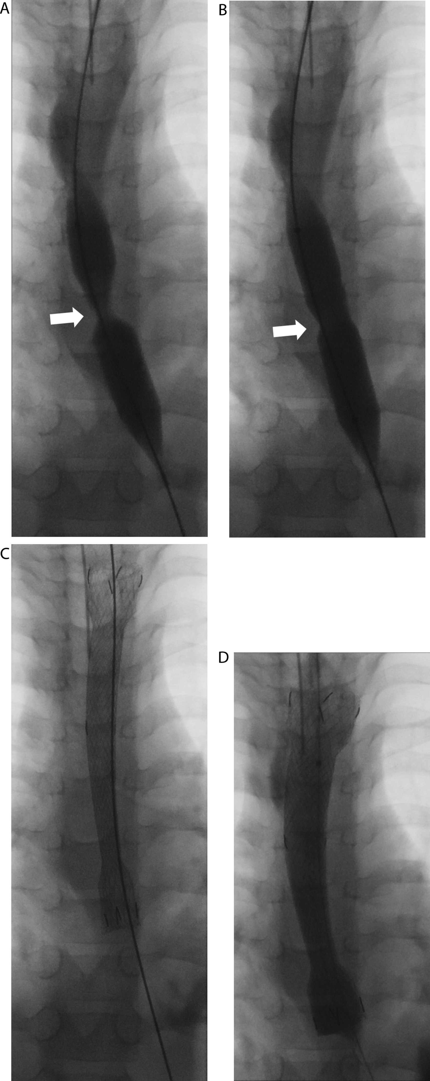

Fig. 2
Pyloric dilation in a two-year-old child who had suffered caustic injury to the pylorus. (a) Delayed image from an upper gastrointestinal series showing a dilated stomach with retained contrast consistent with gastric outlet obstruction. (b) Flouroscopic image showing balloon dilation of the pylorus. (c) Concurrent endoscopy shows balloon inflated across the pylorus, with pale scar tissue is seen at the pylorus (arrow).
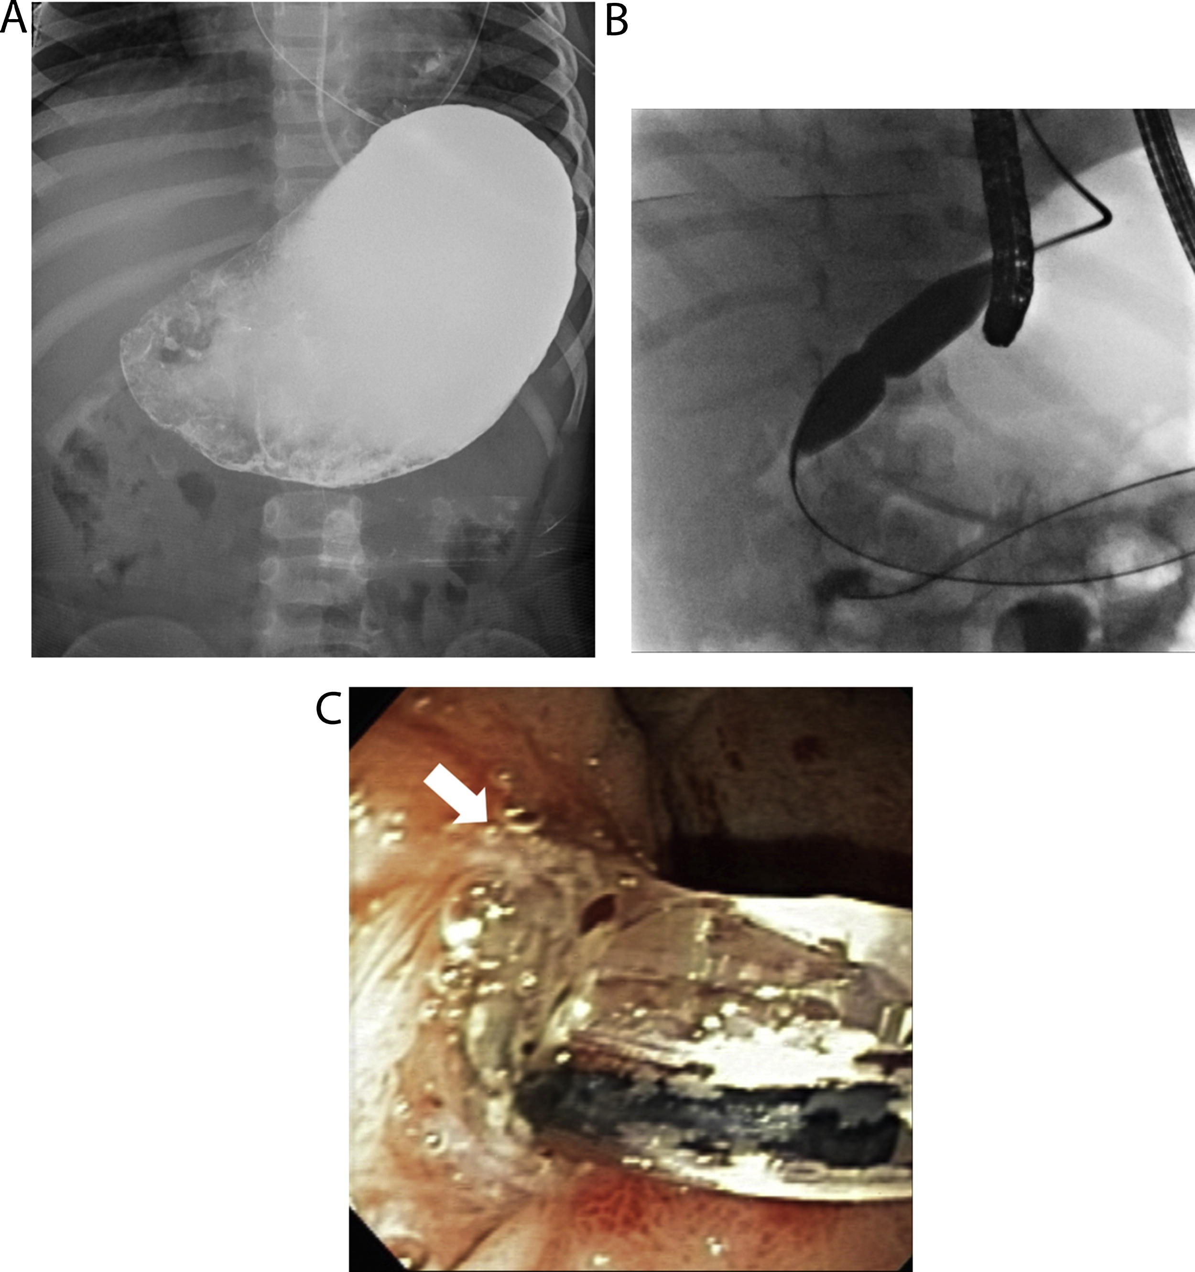

Fig. 3
Antegrade gastrostomy insertion in a ten-year-old boy prior to radiotherapy for an medulloblastoma. Series of frontal (a, c, e) and lateral (b, d, f) projection intra-procedural fluoroscopic images. (a,b) A trefoil snare has been inserted into the stomach (arrow) and the colon is well opacified by barium (curved arrow). (c) The stomach has been inflated with air using the in-situ nasogastric tube and a puncture site has been selected (d) Lateral projection showing needle puncture into the stomach (arrow) and into the snare. (e) ‘Through and through’ wire access has been obtained by snaring a wire. After pulling a 9 French gastrostomy (Freka-PEG-Gastric-Set-ENFit, Fresenius Kabi, Bad Homburg vor der Höhe, Germany) antegrade, a final lateral projection image (f) shows the gastrostomy flange holding the decompressed stomach against the anterior abdominal wall (arrow).
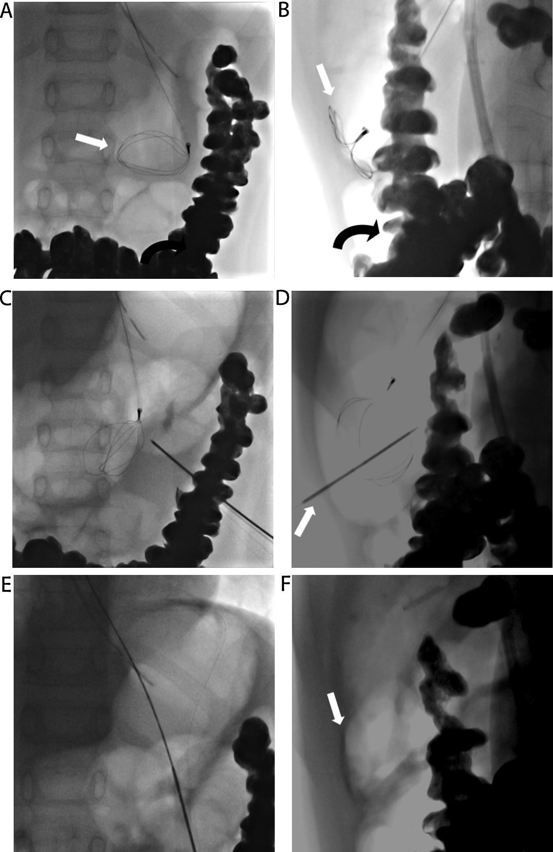

Fig. 4
(a) Intra-procedural image during ADM catheter insertion showing guide wire buckling in the stomach (arrow) as an attempt to advance the leading curve of the wire in the capacious duodenum. (b) A similar image from a procedure in another patient showing use of a 7 French sheath to prevent the wire buckling in very capacious stomach (arrow). The ADM catheter position with the tip at the duodeno-jejunal flexure shown in (c).
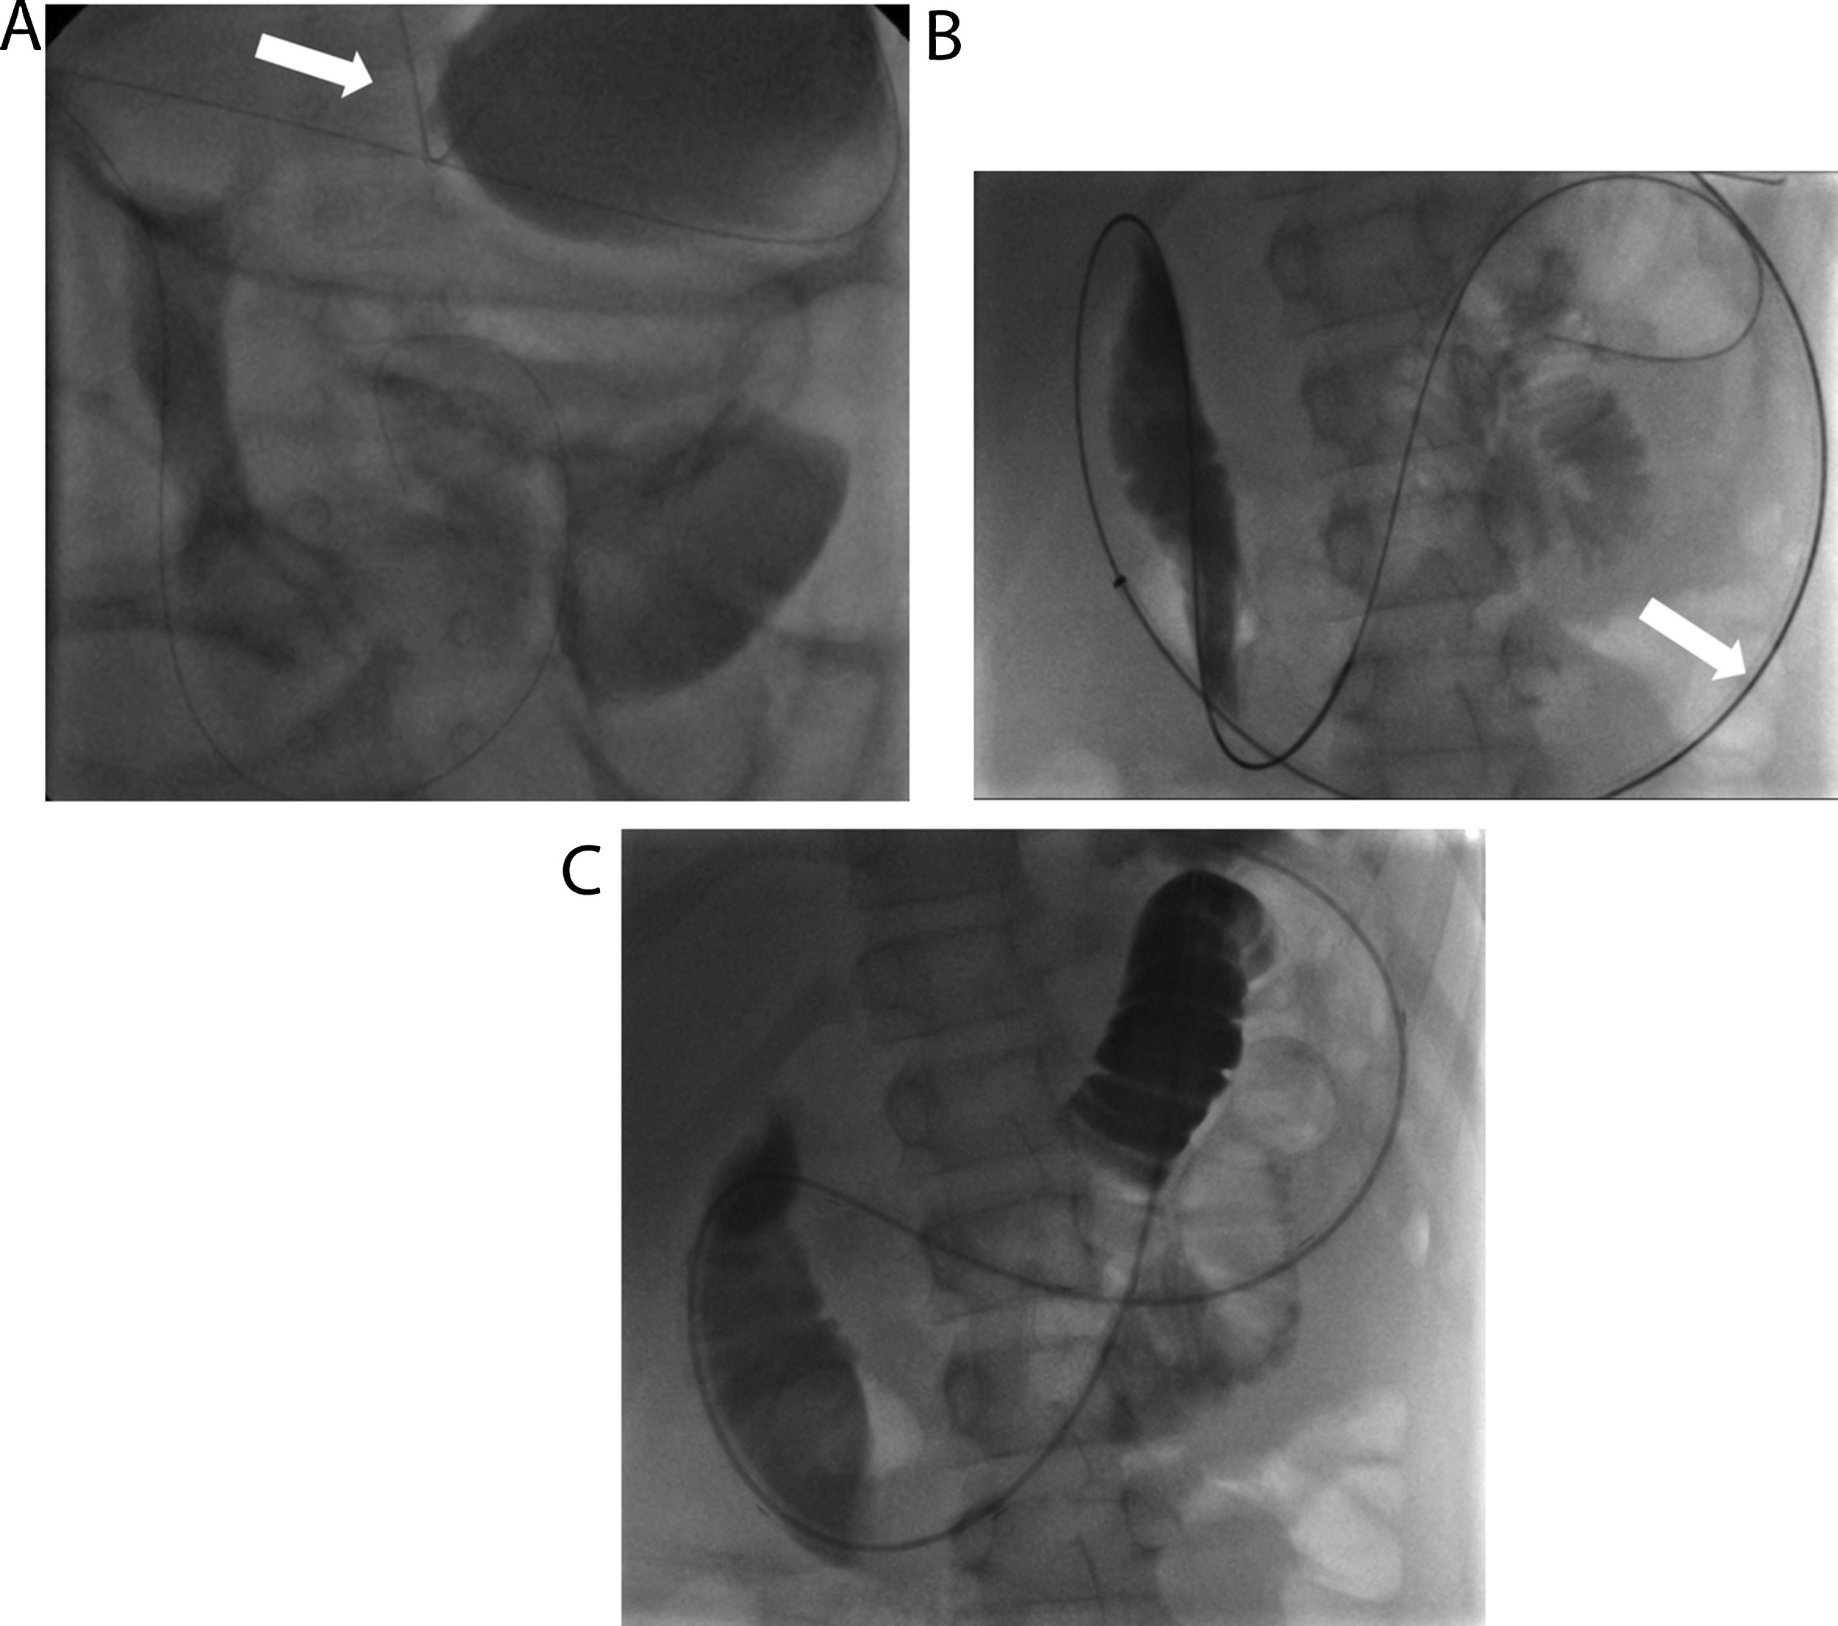

Funding
This research did not receive any specific grants from funding agencies in the public, commercial, or not-for-profit sectors.

