**Appendices A. Fishermen survey questionnaire (English version)**

DATE: LOCATION: INTERVIEWER:

**We undertaking an opinion survey related to fishers’ local ecological knowledge on cetacean species. The outcome of the survey will be published in a peer-reviewed journal but will remain anonymous. Would you consent to participate in this study and answer questions related to this subject?**

**Yes No**





**A: FISHERY AND CETACEANS**

1) How old are you? ________

Gender ________

Nationality ________

What is your education level?

University/College Senior mid school





Junior mid school Elementary school









Illiterate Other level (Please describe: ________)

2) You have engaged in fishing from ________ years old to ________ years old

3) Which months do you fish at sea each year? ________

4) How long is your vessel? ________

5) Which fishing gears have you used recently? ________

1. Drift gillnets 2. Fixed gillnets









3. Trawls 4. Purse nets

5. Light-trapping 6. Electric-fishing





7. Hooking 8. Long-line









9. Stow nets 10. Bomb-fishing



11. Other fishing gears or methods (Please describe: ________)

6) Please identify your target fish species (A-V) with the help of photographs of commercial fishes in the South China Sea; please list and describe if you mainly catch other species such as crustaceans or cephalopods.

A. *Engraulis* spp. (Anchoveta)



B. *Pampus* spp. (Butterfish)



C. *Pagrosomus* spp. (Sea bream)

D. *Pseudosciaena* spp. (Croaker)



E. *Trichiurus* spp. (Ribbonfish)



F. *Etrumeus* spp. (Herring)



G. *Muraenesox* spp. (Conger)



H. *Argyrosomus* spp. (White croaker)



I. *Nibea* ssp. (Yellow croaker)



J. *Nemipterus* spp. (Nemipterus)



K. *Decapterus* spp. (Scad)



L. *Scombermorus* spp. (Horse mackerel)



M. *Thunnus* spp. (Tuna)



N. *Trachurus* spp. (Mackerel)



O. Cynoglossidae spp. (Tonguefish)



P. *Collichthys* spp. (Croaker)



Q. *Branchiostegus* spp. (Tilefish)



R. *Sardinella* spp. (Sardine)



S. *Mugil* spp. (Mullet)



T. *Navodon* spp. (Filefish)



U. *Epinephelus* spp. (Grouper)



V. *Pneumatophorus* spp. (Chub mackerel)



Other species (Please describe and list: ________)



7) How many days do you devote to fishing on average every year?

________

8) Where do you typically engage in fishing?

________________(Please write down the grid numbers)

9) How have fishery resources changed during your fishing career?

a) Fishing catch

Increase Decrease Unchanged







b) Number of fishing vessels

Increase Decrease Unchanged







10) Recent incidental catch of cetaceans:

1. Which fishing gears or methods? ________
2. Which species? ________
3. How many? ________
4. Where? ________ (Write down the grid numbers)
5. When? ________

11) If you have incidentally caught a cetacean, please describe its status:

Dead Alive but injured Alive and not injured







Other status (Please describe: ________)



12) Have you ever seen or heard that cetaceans were hit by propellers of fishing vessels?

Ever seen Ever heard





Never seen Never heard





If you have you ever seen or heard:

1. When did it happen? ________
2. Which species? ________
3. Where? ________ (Please write down the grid numbers)

13) Relationship between fishing gears and cetaceans:

a) Which fishing gear is able to catch cetaceans most easily? ________

b) How many cetaceans do you know this gear has caught? ________

c) Which other gears can also catch cetaceans? ________

**B: DISTRIBUTION AND QUANTITY OF DOLPHINS**

**(Adult length <4m, typically without column of spray)**

14) Please identify and list all dolphin species you have seen

(Identify species with the help of the illustrated handbook, without any prompting or influence from colleagues present)

a) Which dolphin species have you seen most frequently? ________

b) Which dolphin species have you seen in the greatest numbers?

________

15) During which months is it easiest to see dolphins in your fishing area?

During which months is it more difficult to see dolphins in your fishing area?

16) Where do you see dolphins most frequently?

________________ (Please write down the grid numbers)

17) About the largest size of dolphin group you have ever seen.

1. When? ________
2. Where? ________ (Please write down the grid numbers)

18) How has the amount of dolphins changed during your fishing career?

Increase Decrease Unchanged Do not know









19) About your recent sighting(s) of stranded dolphin(s):

a) Which species? ________

b) How many? ________

c) When? ________

d) Where? ________ (Please write down the grid numbers)

20) Have you ever seen Indo-Pacific humpback dolphins?





Yes No

a) When? ________

b) Where? ________ (Please write down the grid numbers)

c) How many? ________

21) Have you ever seen finless porpoises?





Yes No

a) When? ________

b) Where? ________ (Please write down the grid numbers)

c) How many? ________

**C: DISTRIBUTION AND QUANTITY OF WHALES**

**(Adult length >4m, with recognizable spray column)**

22) Please identify and list all whale species you have seen

(Identify species with the help of the illustrated handbook, without any prompting or influence from colleagues present)

23) Which whale species have you seen most frequently? ________

24) Describe recent sightings of whales at sea (not including stranded cetaceans):

a) Which species? ________

b) When? ________

c) Where? ________ (Please write down the grid numbers)

25) About the largest group size of whales you have ever seen?

________

a) Which species? ________

b) How many? ________

c) When? ________

c) Where? ________ (Please write down the grid numbers)

26) Have you ever seen or heard of stranded whale(s): Yes No





a) Which species? ________

b) How many? ________

c) When? ________

d) Where? ________ (Please write down the grid numbers)

27) How has the number of whales changed during your fishing career?

Increase Decrease No change Not sure









**D: PERCEPTIONS OF CETACEANS AND FISHERY**

28) Average family income per month:







<2000 RMB 2000-4000 RMB 4000-6000 RMB

6000-8000 RMB 8000-10000 RMB >10000 RMB











29) Do you think fishing is a good profession? Yes No





Do you hope that your children work as fishers? Yes No

30) How often do you talk about cetaceans with other fishers?









Frequently Sometimes Occasionally Never

31) What topics do you discuss when you talk about cetaceans?

Sighting cetaceans at sea Cetaceans hurt by vessels or nets





Too many fish eaten by cetaceans Stranding events







Other topics (Describe: ________)

32) Have you ever eaten dolphin or whale meat? Yes No





When have you recently eaten it? ________





33) Have you ever sold cetaceans? Yes No

a) Dead Alive





b) How much? ________

c) When? ________

d) Purposes of the buyer: ________

34) Do you think cetaceans play an important role in the marine ecosystem?

Yes No Not sure







35) Do you think cetaceans should be protected?

Yes No Not sure







36) Will fishery resources increase cetaceans are removed?

Yes No Not sure







37) Why have marine fishery resources decreased in your opinion?

Increase of advanced fishing methods and gears



Increased number of marine fishers





Fishery resources consumed by cetaceans



Increasing water pollution

Other reasons (Please describe: ________)



38) Why have cetacean populations decreased?

Reduction of food resources due to overfishing



Increased collision risk from increasing vessel traffic





Increased water pollution



Other reasons (Please describe: ________)

39) How do you deal with stranded cetaceans?







Free Sell Eat





Inform local fisheries administration Ignore



Other choices (Please describe: ________)

40) How do you deal with entangled cetaceans?







Free alive Discard dead Sell





Inform local fisheries administration Eat



Other choices (Please describe: ________)

41) Do you think cetaceans are national protected animals in China?

Yes No Not sure







42) Do you think that hunting or selling cetaceans is illegal?

Yes No Not sure







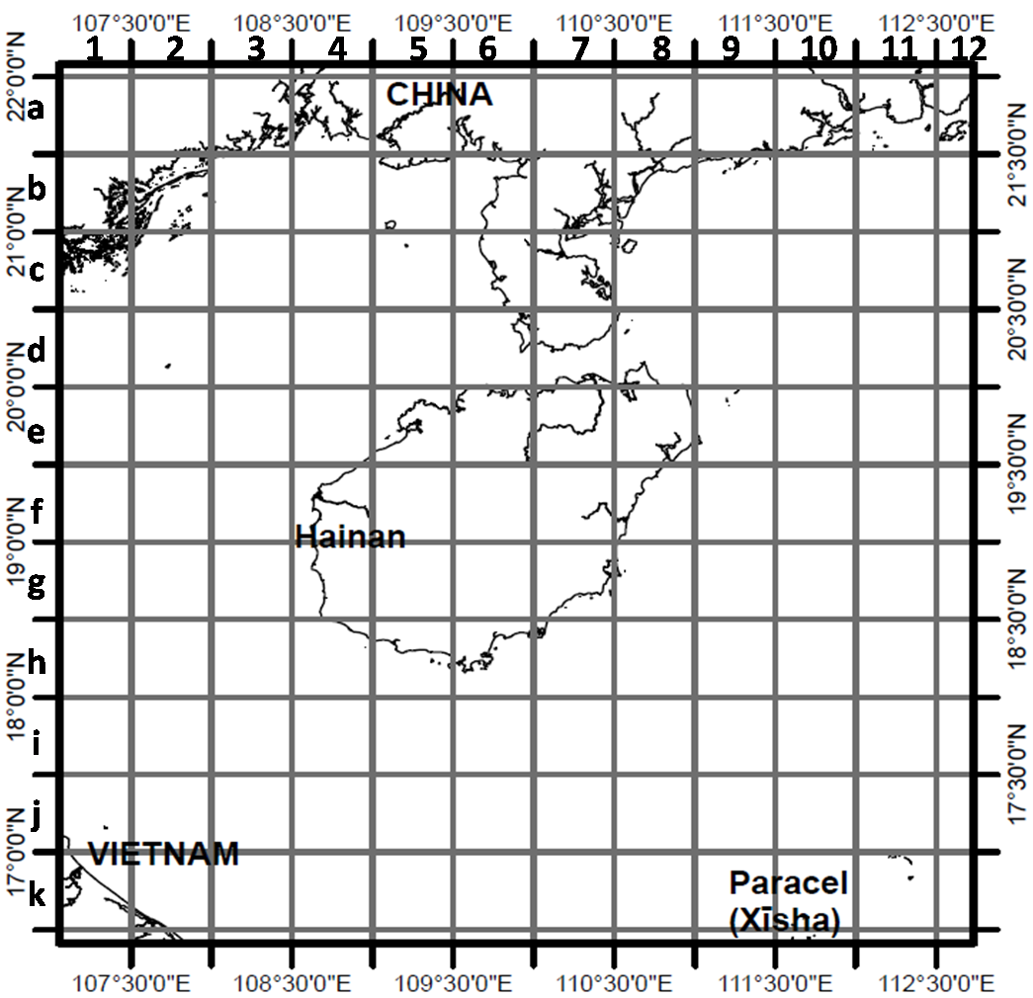

Figure S1 Grid map of Hainan and adjacent waters

**1). Please write down grid numbers according to the format “Letter + Number” (e.g., b4).**

**2). Please record names or geographic locations on the map of other areas in the South China Sea that you have mentioned (e.g., Nansha, Xisha).**

**SPACE FOR OTHER USEFUL OR ADDITIONAL INFORMATION:**