Evolving concepts in dilated cardiomyopathy
Merlo M¹, Cannatà A¹, Gobbo M¹, Stolfo D¹,
Elliott PM², Sinagra G¹

¹Cardiovascular Department “Ospedali Riuniti” and University of Trieste, Trieste, Italy
²Centre for Heart Muscle Disease, Institute of Cardiological Sciences, University College London and St. Bartholomew’s Hospital, London, United Kingdom

Conflicts of interest: None

Corresponding author:

Prof. Gianfranco Sinagra, MD

Cardiovascular Department, “Ospedali Riuniti” and University of Trieste, Trieste, Italy
Via P. Valdoni 7, 34100, Trieste, Italy,
Tel: +39 040 399 4865
Fax: +39 040 399 4878
E-mail: gianfranco.sinagra@asuits.sanita.fvg.it

Total Word Count: 3000
Abstract: 130
Abstract
Dilated cardiomyopathy (DCM) represents a particular etiology of systolic heart failure that frequently has a genetic background and usually affects young patients with few comorbidities. The prognosis of DCM has improved substantially during the last decades due to more accurate aetiological characterization, the red-flag integrated approach to the disease, early diagnosis through systematic familial screening, and the concept of DCM as a dynamic disease requiring constant optimization of medical and non-pharmacological evidence-based treatments. However, some important issues in clinical management remain unresolved, such as the role of cardiac magnetic resonance for diagnosis and risk categorization and the interaction between genotype and clinical phenotype, and arrhythmic risk stratification. This review provides a comprehensive survey of these and other emerging issues in the clinical management of DCM, providing where possible practical recommendations.

List of abbreviations

CMR | Cardiac magnetic resonance
CRT | Cardiac resynchronization therapy
DCM | Dilated cardiomyopathy
ICD | Implantable cardiac defibrillator
LBBB | Left bundle branch block
LGE | Late gadolinium enhancement
LV | Left ventricle
LVRR | Left ventricular reverse remodeling
RV | Right ventricle
SCD | Sudden cardiac death

Background
Dilated Cardiomyopathy (DCM) is a heart muscle disease characterized by left ventricular (LV) or biventricular dilation and systolic dysfunction in the absence of either pressure or volume overload or coronary artery disease sufficient to explain the dysfunction (1–3). Although previously considered as a rare and orphan disease, contemporary estimates for the prevalence of DCM range from 1/2500 up to 1/250 people (4).
Commonly, the onset of the disease occurs in the 3rd or 4th decade of life with a 3:1 male to female predominance. By time the patients are diagnosed, they often have severe contractile dysfunction and remodeling of the ventricles, reflecting a long period of asymptomatic silent disease progression. However, implementation of optimal pharmacological and non-pharmacological treatment has dramatically improved the prognosis of DCM (5) with an estimated survival free from death or heart transplantation up to 85% at 10 years (6, 7). Moreover, the lower prevalence of co-morbidities when compared to most patients with other forms of systolic LV dysfunction suggests that individuals with DCM tend to have fewer non-cardiovascular events (5). These improved outcomes are paralleled by a higher rate of LV reverse remodeling (LVRR) with optimal pharmacological and non-pharmacological treatments (5–7).
In spite of this therapeutic success, emerging evidence suggests that some patients remain vulnerable to sudden cardiac death (SCD) and refractory heart failure (HF) requiring heart transplant or mechanical circulatory support (7). This review highlights some important concepts in the clinical management of DCM patients such as the possible LVRR under therapy, the need of a continuous individualized long-term follow-up, the role of genetic testing. Some unresolved issues such as the arrhythmic stratification or the genotype-phenotype correlation are also discussed, highlighting potential strategies for diagnosing and treating high risk sub-sets of patients with DCM throughout the whole natural history of the disease.

1 - The cornerstones of clinical management of DCM at diagnosis: aetiological characterization and early diagnosis
1.1 Reversible causes of dilated cardiomyopathy
While there is a general appreciation that DCM can be caused by many different disease processes, in everyday clinical practice it is often considered under the catch-all heading of “non-ischaemic HF” with reduced ejection fraction. However, the concept that DCM represents a family of diseases characterized by complex interactions between environment and genetic predisposition is gaining prominence as the clinical impact of a precise diagnosis is better appreciated (8, 9).
The term idiopathic DCM is often used in clinical practice and in some series represents 20-30% of non-ischaemic HF. However, the approach to a patient with non-ischaemic DCM rarely seeks reversible factors other than hypertension, valve disease and congenital heart disease (Figure 1) Examples of commonly overlooked or underappreciated reversible triggers for left ventricular (LV) dysfunction include sustained supraventricular arrhythmias or very frequent ventricular ectopic beats which can lead to tachycardia-induced cardiomyopathy; substance abuse (e.g. alcohol, cocaine); acute emotional stress or chemotherapies that cause catecholamine or toxin-induced cardiomyopathies; and systemic autoimmune disorders (e.g. Churg-Strauss syndrome and sarcoidosis). The new-onset of HF with LV dysfunction occurring during pregnancy or during the post-partum period could identify a peripartum cardiomyopathy. Confirmation of an active myocarditis as the cause of recent onset severe HF (Figure 2) is particularly important as it may require investigations, such as endomyocardial biopsy, that are rarely performed in some health care settings (10).
Accordingly, a comprehensive integrated approach, including third level diagnostic tools, should be systematically implemented in clinical practice in order to remove every possible reversible cause through specific therapeutic intervention (Table 1). This issue appears essential to promote left ventricular reverse remodeling (LVRR) and subsequent outcome improvement.

1.2 Identification of genetic causes of DCM (Figure 3)
When obvious acquired factors have been excluded, a genetic basis for DCM becomes more likely, particularly when there is a family history of disease (2). Familial screening should be systematically performed to obtain an early diagnosis in relatives as this facilitates prompt prophylactic therapy in early or preclinical disease (11). Importantly, a negative family history does not rule out a genetic form of DCM as de novo mutations can be responsible for sporadic forms.
Genetic forms of DCM are also suggested by the presence of clinical traits, sometimes referred to as diagnostic red-flags (Table 2) (12). Rare, but important signs and symptoms that suggest specific forms of multisystem disease or specific genotypes are abnormal skin pigmentation, skeletal myopathy and neurosensory disorders (e.g. deafness, blindness) (12).
In most epidemiological studies, the proportion of patients with genetically determined DCM is substantially underestimated due to variable clinical presentation, incomplete disease penetrance and the lack of specific phenotypes. However, contemporary series using genetic screening suggest that up to 40% of DCM is genetically determined (4). Most patients with familial DCM have autosomal dominant inheritance, but X-linked, autosomal recessive and maternal transmission (as in mitochondrial disorders) are recognized in isolated cardiac disease and in the context of multiorgan syndromes. So far, more than 50 genes encoding for sarcomeric proteins, cytoskeleton, nuclear envelope, sarcolemma, ion channels and intercellular junctions have been implicated in DCM.
The most common is TTN (encoding for titin) which is estimated to cause or contribute to approximately 15-25% of familial DCM, according to different series (3, 13, 14). Another important cluster of genes involved in DCM pathogenesis includes cytoskeleton genes (DES, DMD, FLNC, NEXN, LDB3). Of note, the DMD gene (encoding for dystrophin) is involved in muscular dystrophy patients and X-linked familial DCM in the absence of overt skeletal muscle disease (4). Although ECG findings in DCM are generally non-specific, DMD-related DCM may represent an exception as it is frequently characterized by a posterolateral or inferolateral “pseudonecrosis” pattern. Echocardiographic and cardiac magnetic resonance (CMR) evaluations usually reveal posterolateral akinesia with late gadolinium enhanced (LGE)-based myocardial scar. Mutations in the DES gene (encoding for desmin) cause skeletal myopathy, cardiac disease with variable cardiomyopathy phenotypes including DCM and restrictive cardiomyopathy or a combination of the two (15,16).
Mutations in the LMNA gene (encoding Lamin A/C) are a cause of familial DCM characterized by cardiac conduction disturbances (atrioventricular block) with elevated serum creatine kinase levels and in some cases skeletal muscle involvement (limb-girdle or Emery-Dreifuss muscular dystrophy) (17). Lamin A/C mutations also convey an increased risk of life threatening ventricular arrhythmias irrespective of the severity of LV dysfunction and dilation (17).
Other forms of DCM increasingly grouped under the heading of arrrhythmogenic cardiomyopathies are also characterized by a propensity to ventricular arrhythmia. These include disease caused by mutations in genes encoding desmosomal proteins which are classically linked to arrhythmogenic right ventricular cardiomyopathy but have now emerged as a cause of isolated DCM (18–20). Mutations of FLNC (encoding for filamin C) gene are more recently described as also associated to arrhythmogenic phenotypes of DCMs (21).
Mutations in genes encoding for sarcomere (MYH7, ACTC1, TNNT2, MYH6 and MYBPC3) and sodium ion channels (RYR2 and SCN5A) may also be associated with DCM (22) with current widely unknown genotype-phenotype correlations.

1.3 Specific phenotypes of DCM
Recently, a position statement of the European Society of Cardiology (3) identified two specific phenotypes of preclinical or early stages of DCM: arrhythmic DCM and the hypokinetic non-dilated cardiomyopathy. The latter could often be the result of an early diagnosis of DCM and a timely management, which in turn can lead to favourable long-term outcome. Nonetheless, association with specific features such as familial history of SCD in arrhythmic DCM and severe diastolic dysfunction or non-sustained ventricular arrhythmias in hypokinetic non-dilated cardiomyopathy, can indicate distinct genotypes with a less favorable course that require focused follow-up and more aggressive therapeutic strategies such as ICD (19, 23).

2 - The cornerstones of clinical management of DCM during follow-up
2.1 – DCM as dynamic disease: left ventricular reverse remodeling and the importance of follow-up
DCM has long been considered to be an irreversible condition. However, in recent years several studies revealed that almost 40% of patients experience a significant LVRR when treated with evidence-based pharmacological and device treatments (6). LVRR is one of the main determinants of prognosis in DCM and should be considered a major goal in approaching newly diagnosed cases. In the absence of specific treatments, the medical management of DCM is based largely on conventional therapy with ACE-inhibitors/angiotensin receptors blockers, beta-blockers and mineralcorticoid receptors antagonists (24). In patients with LV dyssynchrony manifested by left bundle branch block (LBBB), cardiac resynchronization therapy (CRT) can induce LVRR, sometimes with normalization of LV size and systolic function (25, 26).
Even when there is improvement in LV dysfunction, the potential for later decline in systolic function remains, despite uninterrupted treatment (11). This issue emphasizes the pivotal role not only of an accurate and complete initial diagnostic evaluation but also of continuous therapy and individualized, long-term surveillance in order to recognize and treat the first signs of late disease progression (Table 3, Figure 4).
2.2 – Other markers of disease severity and progression
The process of LVRR may take up to two years following diagnosis (6). The following aspects have been demonstrated as influencing the course and the prognosis of the disease and the likelihood of LVRR in the early stages and should be hence systematically assessed:
- Right ventricular function at diagnosis, is an important prognostic feature in DCM (27). The recovery of right ventricular function under therapy is frequent and can already be observed at 6 months. It precedes LVRR, and is emerging as an early therapeutic target and an independent prognostic predictor (28). Improvement in right ventricular function is also described in CRT recipients as a secondary expression of haemodynamic improvement very early after resynchronization, with consequently favourable survival rates (29). In contrast, the development of right ventricular dysfunction during long term follow-up is an expression of structural progression of the disease and portends a negative outcome (28).
- Functional mitral regurgitation conveys important prognostic implications. Moderate to severe mitral regurgitation at diagnosis or persistent despite optimal medical treatment or CRT is associated with poorer outcomes (29, 30). Patients with DCM and haemodynamically important mitral regurgitation may require invasive therapeutic strategies such as percutaneous repair of the mitral valve, mechanical circulatory support or even heart transplantation.
- LBBB is a frequent ECG marker at diagnosis and is negatively associated with the likelihood of LVRR (6). Importantly the development of new LBBB during follow-up is a strong independent prognostic predictor of all-cause mortality (31). Importantly CRT has been reduced the risk induced by LBBB, specifically in DCM patients (25, 26) and should timely considered after LBBB development during follow-up.
- The onset of atrial fibrillation during the follow-up is a sign of structural progression of the disease and negatively impacts on the prognosis of these patients, despite effective treatments (32).
The implications of these observations are that a multiparametric approach to diagnosis and long-term follow-up, not limited to the left ventricular systolic function and size alone, appear essential in order to improve the quality of clinical management of DCM patients (Figure 5).

3 – Specific aspects in clinical management of DCM
3.1 - Re-classification of DCM during long-term follow-up
Modern management of HF has increased the survival rates of DCM and has resulted in long periods of clinical stability (5, 33). Consequently, affected patients followed for beyond 10-15 years are often encountered in clinical practice. Patients should be continuously re-assessed, particularly in the presence of cardiovascular risk factors. Indeed, abrupt worsening of LV function or an increased ventricular arrhythmic burden can be caused not only by the DCM progression but also by the development of new co-pathologies. Therefore, the possible presence of coronary artery disease, hypertensive heart disease, structured valve disease or an acute myocarditis should be systematically ruled out during the follow-up. (Table 1).

3.2 - Pediatric DCM
Although rare, DCM is the predominant cause of cardiomyopathy in children. The prevalence is approximately 1:170,000 in the United States (34) and the outcomes for children with DCM are poor, even in the presence of baseline characteristics of an early stage, as compared to adults. (35). The causes of this particular severe phenotype of the disease in paediatric age remain poorly characterised. The generally poorer prognosis in paediatric DCM means that more aggressive therapeutic interventions including implantable cardiac defibrillator (ICD) implantation and heart transplant list are more frequent in the young (35).

3.3 - The role of CMR

CMR is emerging as a fundamental tool for diagnosis purposes and for prognostic stratification in patients presenting with LV dysfunction of uncertain origin. CMR represents the gold-standard for the assessment of biventricular dimensions and function. Tissue characterization and the distribution of scar aid the identification of secondary causes of DCM such as coronary occlusion (36) and approximately one-third of DCM cases have a distinctive mid-wall distribution, more frequently within the septal wall (37). LGE presence, patterns and quantification may also help to assess the risk for malignant ventricular arrhythmias and the probability of LVRR (37–39). Future multicenter and prospective studies are required to confirm the role of CMR in the prognostic stratification of DCM, especially when defining the arrhythmic risk of those patients. Currently no guidelines mention CMR as a tool for arrhythmic prognostication in DCM patients.

3.4 - Endomyocardial biopsy
The role of endomyocardial biopsy in diagnosis of heart muscle disorders is controversial due to the invasiveness of the procedure and poor sensitivity in certain scenarios. Contemporary cardiovascular imaging is also promoted as an alternative to tissue biopsy in some circumstances. Although a broader use to improve the diagnosis of myocarditis and inflammatory cardiomyopathy has been recently proposed (40), many statements reserved the indications to endomyocardial biopsy for selected cases (10). In a patient with a newly diagnosed DCM endomyocardial biopsy is reasonable when there is a high probability of a specific diagnosis which can be confirmed only in myocardial samples and is amenable to therapy that has the potential to change the course of the disease (24, 41, 42). Examples of such scenarios include active myocarditis (see figure 2), the contemporary presence of hypertrophic and dilated LV (for example in end-stage hypertrophic cardiomyopathy), cardiac amyloidosis, sarcoidosis or hemochromatosis (10).

3.5 - Genetic testing in DCM
Various position statements recommend testing of a proband (the first or most clearly affected person in a family with a cardiomyopathy) when there is clear familial disease or in the presence of diagnostic red-flags suggestive of a genetic disorder. The rationale is to confirm the diagnosis, to identify individuals who are at high risk of arrhythmia and to facilitate cascade screening within families(43). However, restriction of genetic testing to familial cases has been recently questioned following studies showing that the yield of genetic testing is similar between familial and non-familial cases (44) and the presence of titin truncating mutations in 10-15% of sporadic DCM(45).
Genotype-phenotype interactions are still an unmet issue of translational research and the effects of mutations on the mechanisms of disease expression remain largely unknown. Extreme genetic heterogeneity and variable penetrance prohibited robust genotype-phenotype correlation studies and actually genotype information do not strongly impact on clinical management of DCM. Nevertheless, despite the complex genetic architecture of DCM, an increasing number of actionable prognostic genotype-phenotype associations are emerging. For carriers of LMNA mutations the presence of non-sustained ventricular tachycardia, left ventricular impairment, male gender, and non-missense mutations (nonsense, frameshift insertion-deletions or splicing) are reported to be independent risk factors for malignant ventricular arrhythmias. Consequently, primary preventive ICD implantation is recommended in patients with high risk features. An increased risk of SCD is also reported in individuals with DCM caused by mutations in DES, RBM20, PLN and filamin C truncating mutations (21). Multicenter studies are needed to fill the gap in knowledge of the multiple and heterogeneous genotype-phenotype correlations promoting the onset of DCM in carriers of disease-related gene mutations. Moreover it appears pivotal to clarify the influence of environmental factors (i.e. strenuous exercise) on still unknown predisposing gene variants, including the role of non-coding DNA regions and RNAs, in order to establish a complete expression of disease.

3.6 – Arrhythmic risk stratification
Primary prevention of SCD with ICD implantation significantly ameliorated overall mortality in patients with ischaemic heart failure (24) but in non-ischaemic DCM, randomized clinical trials such as SCD-HeFT, DEFINITE and the more recent DANISH trial have failed to demonstrate a clear survival benefit (46–48). Current indications for primary prevention with an ICD are based on a simplicistic assessment of LV function and HF symptoms (25, 46). However it is clear that the risk of ventricular arrhythmia varies according the etiology. For example, it has been reported that patients with dilated cardiomyopathy secondary to systemic hypertension (usually older and with more comorbidities) have lower arrhythmic event-rate during follow-up (49). Conversely younger patients with some of the more malignant genetic forms of DCM may have a greater survival benefit from ICD implantation (5, 47, 48).
In addition, only one third of DCM cases admitted with current criteria for ICD still fulfill indications for implantation 6 months after initiation of optimal medical treatment (7). Accordingly, a wait-and-see period of 3-to-9 months is currently recommended in order to increase the appropriateness of ICD therapy (25). However, in a large series of recently onset DCM, approximately 2% of patients died suddenly in the first 6 months after diagnosis (50). Patients presenting with severe LV dilatation, longer QRS and long duration of symptoms were at higher risk, while LV ejection fraction alone did not show any association with early events (50). It is clear that alternative and more reliable multiparametric models that incorporate aetiology, CMR biomarkers such as natriuretic peptides are required.

5 - Conclusions and future perspectives
In recent decades, long-term survival of DCM patients has markedly increased. Several strategies have contributed to this improvement, including early diagnosis through systematic familial screening, more refined phenotyping at the onset of disease, implementation of evidence-based medical and device treatments and a rigorous long-term individualized follow-up. However, DCM remains the most common cause of heart transplant and one of the leading causes of death in the Western world. Further progress in reducing morbidity and mortality requires systematic use of diagnostic tools including genetic testing, improved risk modelling and a deeper investigation of the basic mechanisms underlying the disease.

References
1. Elliott P, Andersson B, Arbustini E, et al. Classification of the cardiomyopathies: a position statement from the European Society Of Cardiology Working Group on Myocardial and Pericardial Diseases. Eur Hear. J 2008;29:270–276.
2. Mestroni L, Maisch B, McKenna WJ, et al. Guidelines for the study of familial dilated cardiomyopathies. Collaborative Research Group of the European Human and Capital Mobility Project on Familial Dilated Cardiomyopathy. Eur Hear. J 1999;20:93–102.
3. Pinto YM, Elliott PM, Arbustini E, et al. Proposal for a revised definition of dilated cardiomyopathy, hypokinetic non-dilated cardiomyopathy, and its implications for clinical practice: a position statement of the ESC working group on myocardial and pericardial diseases. Eur. Heart J. 2016;37:1850–1858.
4. Hershberger RE, Hedges DJ, Morales A. Dilated cardiomyopathy: the complexity of a diverse genetic architecture. Nat. Rev. Cardiol. 2013;10:531–547.
5. Merlo M, Pivetta A, Pinamonti B, et al. Long-term prognostic impact of therapeutic strategies in patients with idiopathic dilated cardiomyopathy: changing mortality over the last 30 years. Eur J Hear. Fail 2014;16:317–324.
6. Merlo M, Pyxaras SA, Pinamonti B, Barbati G, Di Lenarda A, Sinagra G. Prevalence and prognostic significance of left ventricular reverse remodeling in dilated cardiomyopathy receiving tailored medical treatment. J Am Coll Cardiol 2011;57:1468–1476.
7. Zecchin M, Merlo M, Pivetta A, et al. How can optimization of medical treatment avoid unnecessary implantable cardioverter-defibrillator implantations in patients with idiopathic dilated cardiomyopathy presenting with “SCD-HeFT criteria?”. Am. J. Cardiol. 2012;109:729–735.
8. Hazebroek MR, Moors S, Dennert R, et al. Prognostic Relevance of Gene-Environment Interactions in Patients With Dilated Cardiomyopathy: Applying the MOGE(S) Classification. J. Am. Coll. Cardiol. 2015;66:1313–1323.
9. Yokokawa T, Sugano Y, Nakayama T, et al. Significance of myocardial tenascin-C expression in left ventricular remodelling and long-term outcome in patients with dilated cardiomyopathy. Eur. J. Heart Fail. 2016;18:375–385.
10. Sinagra G, Anzini M, Pereira L N, et al. Myocarditis in clinical practice. A clinical approach to myocarditis. Mayo Clin. Proc 2016;[In Press].
11. Moretti M, Merlo M, Barbati G, et al. Prognostic impact of familial screening in dilated cardiomyopathy. Eur. J. Heart Fail. 2010;12:922–927.
12. Rapezzi C, Arbustini E, Caforio ALP, et al. Diagnostic work-up in cardiomyopathies: bridging the gap between clinical phenotypes and final diagnosis. A position statement from the ESC Working Group on Myocardial and Pericardial Diseases. Eur. Heart J. 2013;34:1448–1458.
13. Jansweijer JA, Nieuwhof K, Russo F, et al. Truncating titin mutations are associated with a mild and treatable form of dilated cardiomyopathy. Eur. J. Heart Fail. 2017;19:512–521.
14. Haas J, Frese KS, Peil B, et al. Atlas of the clinical genetics of human dilated cardiomyopathy. Eur. Heart J. 2015;36:1123–35a.
15. Taylor MRG, Slavov D, Ku L, et al. Prevalence of desmin mutations in dilated cardiomyopathy. Circulation 2007;115:1244–1251.
16. Arbustini E, Pasotti M, Pilotto A, et al. Desmin accumulation restrictive cardiomyopathy and atrioventricular block associated with desmin gene defects. Eur. J. Heart Fail. 2006;8:477–483.
17. van Rijsingen IAW, Arbustini E, Elliott PM, et al. Risk factors for malignant ventricular arrhythmias in lamin a/c mutation carriers a European cohort study. J. Am. Coll. Cardiol. 2012;59:493–500.
18. Elliott P, O’Mahony C, Syrris P, et al. Prevalence of desmosomal protein gene mutations in patients with dilated cardiomyopathy. Circ. Cardiovasc. Genet. 2010;3:314–322.
19. Spezzacatene A, Sinagra G, Merlo M, et al. Arrhythmogenic Phenotype in Dilated Cardiomyopathy: Natural History and Predictors of Life-Threatening Arrhythmias. J. Am. Heart Assoc. 2015;4:e002149.
20. Sen-Chowdhry S, Syrris P, Prasad SK, et al. Left-dominant arrhythmogenic cardiomyopathy: an under-recognized clinical entity. J Am Coll Cardiol 2008;52:2175–2187.
21. Ortiz-Genga MF, Cuenca S, Dal Ferro M, et al. Truncating FLNC Mutations Are Associated With High-Risk Dilated and Arrhythmogenic Cardiomyopathies. J. Am. Coll. Cardiol. 2016;68:2440–2451.
22. McNair WP, Sinagra G, Taylor MRG, et al. SCN5A mutations associate with arrhythmic dilated cardiomyopathy and commonly localize to the voltage-sensing mechanism. J. Am. Coll. Cardiol. 2011;57:2160–2168.
23. Gigli M, Stolfo D, Merlo M, et al. Insights into Mildly Dilated Cardiomyopathy: temporal evolution and long-term prognosis. Eur. J. Heart Fail. 2016;19:531–539.
24. Ponikowski P, Voors AA, Anker SD, et al. 2016 ESC Guidelines for the diagnosis and treatment of acute and chronic heart failure. Eur. Heart J. 2016;37:2129–2200.
25. Verhaert D, Grimm RA, Puntawangkoon C, et al. Long-term reverse remodeling with cardiac resynchronization therapy: results of extended echocardiographic follow-up. J. Am. Coll. Cardiol. 2010;55:1788–1795.
26. Zecchin M, Proclemer A, Magnani S, et al. Long-term outcome of “super-responder” patients to cardiac resynchronization therapy. Europace 2014;16:363–371.
27. Gulati A, Ismail TF, Jabbour A, et al. The prevalence and prognostic significance of right ventricular systolic dysfunction in nonischemic dilated cardiomyopathy. Circulation 2013;128:1623–1633.
28. Merlo M, Gobbo M, Stolfo D, et al. The Prognostic Impact of the Evolution of RV Function in Idiopathic DCM. JACC. Cardiovasc. Imaging 2016;9:1034–1042.
29. Stolfo D, Merlo M, Pinamonti B, et al. Early Improvement of Functional Mitral Regurgitation in Patients With Idiopathic Dilated Cardiomyopathy. Am. J. Cardiol. 2015;115:1137–1143.
30. Stolfo D, Tonet E, Barbati G, et al. Acute Hemodynamic Response to Cardiac Resynchronization in Dilated Cardiomyopathy: Effect on Late Mitral Regurgitation. Pacing Clin. Electrophysiol. 2015;38:1287–1296.
31. Aleksova A, Carriere C, Zecchin M, et al. New-onset left bundle branch block independently predicts long-term mortality in patients with idiopathic dilated cardiomyopathy: data from the Trieste Heart Muscle Disease Registry. Europace 2014;16:1450–1459.
32. Aleksova A, Merlo M, Zecchin M, et al. Impact of atrial fibrillation on outcome of patients with idiopathic dilated cardiomyopathy: data from the Heart Muscle Disease Registry of Trieste. Clin. Med. Res. 2010;8:142–149.
33. Japp AG, Gulati A, Cook SA, Cowie MR, Prasad SK. The Diagnosis and Evaluation of Dilated Cardiomyopathy. J. Am. Coll. Cardiol. 2016;67:2996–3010.
34. Lipshultz SE, Sleeper LA, Towbin JA, et al. The incidence of pediatric cardiomyopathy in two regions of the United States. N. Engl. J. Med. 2003;348:1647–1655.
35. Puggia I, Merlo M, Barbati G, et al. Natural History of Dilated Cardiomyopathy in Children. J. Am. Heart Assoc. 2016;5.
36. Friedrich MG, Sechtem U, Schulz-Menger J, et al. Cardiovascular magnetic resonance in myocarditis: A JACC White Paper. J. Am. Coll. Cardiol. 2009;53:1475–1487.
37. Gulati A, Jabbour A, Ismail TF, et al. Association of fibrosis with mortality and sudden cardiac death in patients with nonischemic dilated cardiomyopathy. JAMA 2013;309:896–908.
38. Masci PG, Schuurman R, Andrea B, et al. Myocardial fibrosis as a key determinant of left ventricular remodeling in idiopathic dilated cardiomyopathy: a contrast-enhanced cardiovascular magnetic study. Circ. Cardiovasc. Imaging 2013;6:790–799.
39. Di Marco A, Anguera I, Schmitt M, et al. Late Gadolinium Enhancement and the Risk for Ventricular Arrhythmias or Sudden Death in Dilated Cardiomyopathy. JACC Hear. Fail. 2017;5:28 LP-38.
40. Caforio ALP, Pankuweit S, Arbustini E, et al. Current state of knowledge on aetiology, diagnosis, management, and therapy of myocarditis: a position statement of the European Society of Cardiology Working Group on Myocardial and Pericardial Diseases. Eur. Heart J. 2013;34:2636–48, 2648a–2648d.
41. Besler C, Urban D, Watzka S, et al. Endomyocardial miR-133a levels correlate with myocardial inflammation, improved left ventricular function, and clinical outcome in patients with inflammatory cardiomyopathy. Eur. J. Heart Fail. 2016;18:1442–1451.
42. Chimenti C, Verardo R, Scopelliti F, et al. Myocardial expression of Toll-like receptor 4 predicts the response to immunosuppressive therapy in patients with virus-negative chronic inflammatory cardiomyopathy. Eur. J. Heart Fail. 2017;19:915–925.
43. Charron P, Arad M, Arbustini E, et al. Genetic counselling and testing in cardiomyopathies: a position statement of the European Society of Cardiology Working Group on Myocardial and Pericardial Diseases. Eur. Heart J. 2010;31:2715–2726.
44. Morales A, Hershberger RE. The Rationale and Timing of Molecular Genetic Testing for Dilated Cardiomyopathy. Can. J. Cardiol. 2015;31:1309–1312.
45. Pugh TJ, Kelly MA, Gowrisankar S, et al. The landscape of genetic variation in dilated cardiomyopathy as surveyed by clinical DNA sequencing. Genet. Med. 2014;16:601–608.
46. Kadish A, Dyer A, Daubert JP, et al. Prophylactic defibrillator implantation in patients with nonischemic dilated cardiomyopathy. N. Engl. J. Med. 2004;350:2151–2158.
47. Køber L, Thune JJ, Nielsen JC, et al. Defibrillator Implantation in Patients with Nonischemic Systolic Heart Failure. N. Engl. J. Med. 2016;375:1221–1230.
48. Bardy GH, Lee KL, Mark DB, et al. Amiodarone or an implantable cardioverter-defibrillator for congestive heart failure. N. Engl. J. Med. 2005;352:225–237.
49. Bobbo M, Pinamonti B, Merlo M, et al. Comparison of Patient Characteristics and Course of Hypertensive Hypokinetic Cardiomyopathy Versus Idiopathic Dilated Cardiomyopathy. Am. J. Cardiol. 2017;119:483–489.
50. Losurdo P, Stolfo D, Merlo M, et al. Early arrhythmic events in idiopathic dilated cardiomyopathy. JACC Clin. Electrophisiology 2016;5:535–543.

Figure Legend.
Figure 1. Etiologic characterization of DCM.
Legend: DCM: dilated cardiomyopathy; iDCM: idiopathic dilated cardiomyopathy
Figure 2. Characterization of DCM vs. active myocarditis at diagnosis. The role of ECG (panels A vs. B: note the left bundle branch block vs. low QRS voltages), echocardiography (panels C vs. D: note the huge vs. mild left ventricular/atrial dilation), cardiac magnetic resonance (panels D vs. E: note the midwall distribution pattern of late gadolinium enhancement vs. myocardial edema at T2-weighted imaging), endomyocardial biopsy (panels F vs G: note the cardiomyocyte damage and the myocardial fibrosis [in blue] vs. active lymphocytic inflammation).
Figure 3. Genotype-Phenotype correlations in DCM, the red-flags approach and overlap syndromes. Note on the left the main genes involved in DCM pathogenesis and, on the right their corresponding frequent phenotypic expression (red-flags approach and overlapping shown on the right).
* Desmosomal Genes (PKP2,DSC2,DSG2 DSP,JUP)
** Sarcomeric Genes (MYH6, MYH7, MYBPC3, TNNT2)

Figure 4. Scheme of current usual natural history of DCM and corresponding clinical management over time. Often occurs within 2 years, followed by a period of stability and then by the long-term progression of disease. Note cornerstones of clinical management right after diagnosis (in red) and during the follow-up (in orange). Finally, note remaining open issues (in grey) and the suggestion to continue therapy also in persistently apparently healed patients (in green).
Figure 5. The importance of a global evaluation of DCM different phenotypes (i.e. left ventricular dilation degree, right ventricular involvement, mitral regurgitation, diastolic dysfunction, syndromic phenotypes, arrhythmic expression, late gadolinium enhancement presence/pattern/quantification) and possible correlations with genotype.

Table 1. Diagnostic tools recommended at baseline and during follow-up
 | Baseline | Follow-up | Notes
Clinical History | Indicated  - Aetiological definition (identification of possible cause of DCM)  - Improvement of prognostic stratification (i.e presence of syncope; duration of symptoms) | Indicated  - Improvement of prognostic stratification (i.e presence of syncope);  - Useful in re-classification of the disease during the long-term | At every follow-up evaluation
Familial screening | Indicated  - Early diagnosis in family members  - Indication to genetic testing if presence of familial form  - Improvement of prognostic stratification in presence of family history for SCD | Indicated  - Indication to genetic testing if presence of familial form  - Improvement of prognostic stratification in presence of family history for SCD | Updates at every follow-up evaluation
Clinical evaluation | Indicated  - Aetiological definition (muscle disease)  - Improvement of prognostic stratification (severity of heart failure) | Indicated  - Improvement of prognostic stratification (severity of heart failure) | At every follow-up evaluation
E.C.G. | Indicated  - Aetiological definition (clues of genotype-phenotype correlation )  - Possible indication to genetic testing  - Improvement of prognostic stratification (atrial fibrillation; duration of disease; clues of amount of myocardial fibrosis/edema : left bundle branch clock, low QRS voltages) | Indicated  - Improvement of prognostic stratification (atrial fibrillation; duration of disease; clues of amount of myocardial fibrosis/edema : left bundle branch clock, low QRS voltages) | At every follow-up evaluation
Echo | Indicated  - Aetiological definition (differential diagnosis between acute myocarditis and DCM; clues of genotype-phenotype correlation)  - Possible indication to genetic testing  - Improvement of prognostic stratification (left/right ventricular involvement; left atrial enlargement; mitral regurgitation, diastolic dysfunction assessment) | Indicated  - Improvement of prognostic stratification (left/right ventricular reverse remodeling; mitral regurgitation improvement: left ventricular restrictive filling pattern improvement) | At every follow-up evaluation
LABs | Indicated  - Aetiological definition (CPK; TSH)  - Improvement of prognostic stratification (BNP/NTproBNP; Anemia; Chronic renal failure) | Indicated  - Improvement of prognostic stratification (BNP/NTproBNP; Anemia; Chronic renal failure) | Need of future research for the implementation of BNP/NTproBNP during follow-up.
STRESS TEST | No data supporting | No data supporting
CPET | Indicated after stabilization  - Prognostic stratification | Indicated in stable patients  - Prognostic stratification | Need of future research for the implementation of CPET during follow-up.  Not indicated at every follow-up evaluation  Useful in selection of heart transplanantion screening
HOLTER ECG 24 HOURS | Indicated  - Aetiological definition (tachy-induced cardiomyopathies)  - Possible indication to genetic testing  - Improvement of prognostic stratification (arrhytmogenic DCM) | Indicated  - Improvement of prognostic stratification (arrhytmogenic DCM) | Not always indicated in presence of CRTD/ICD implantation
SAECG | No data supporting | No data supporting
CMR | Indicated  - Aetiological definition (differential diagnosis: infiltrative cardiomyopathies; active myocarditis)  - Possible indication to genetic testing  - Improvement of prognostic stratification in particular for arrhythmic events (left/right ventricular morphology/involvement; late gadolinium enhancement ) | No data supporting | Need of future research for the implementation of CMR during follow-up.  Useful in re-classification of the disease in the long-term
Coronary angiography/CT | Indicated  - Aetiological definition (exclusion of ischemic heart disease) | No data supporting | Useful in re-classification of the disease in the long-term
Right catheterization | No data supporting | No data supporting | Useful in selection of heart transplanantion screeening
Endomyocardial biopsy | Indicated in suspect of active myocarditis | No data supporting | Useful in re-classification of the disease in the long-term
Legend: BNP: brain natriuretic peptide; CMR: cardiac magnetic resonance; CPET: cardiopulmonary exercise test; CPK: creatin-phospho-kinase; CRT-D: cardiac resynchronisation therapy-defibrillator; CT: computed tomography; DCM: dilated cardiomyopathy; ICD: implanted cardioverter defibrillator; SAECG: signal average electrocardiogram; SCD: sudden cardiac death

Table 2. Main red flags in the diagnosis of DCM
Red Flag | Finding | Suggested cause
Clinical History and Physical Examination | Mental ritardation | Dystrophinopathies  Mitochondrial disease
 | Neurosensory disorders | Mitochondrial disease
 | Skeletal muscle involvement | Dystrophinopathies  Desminopathies  Laminopathies
 | Carpal tunnel and macroglossia | Infiltrative DCM
 | Skin pigmentation | Hemocromatosis
 | History of severe hypertension | DCM secondary to hypertension
 | Pregnancy | Peripartum DCM
Biohumoral findings | Creatin kinase | Dystrophinopathie  Desminopathies  Myofibrillar miopathy  Laminopathies
 | Proteinuria | Infiltrative DCM
 | Hyperferritinaemia | Hemochromatosis
ECG | P wave alterations | Emerinopathies  Laminopathies
 | AV blocks | Laminopathies  Desminopathies  Post-inflammatory DCM  Sarcoidosis
 | Low voltages | Infiltrative DCM  Active myocarditis
 | Posterolateral pseudonecrosis | Dystrophinopathies
 | Intraventricular conduction delays | Laminopathies
Echocardiography | Cardiac hypertrophy | DCM secondary to hypertension  Infiltrative DCM
 | Posterolateral akinesia | Dystrophinopathies
CMR | Subendocardial/transmural LGE | Ischemic DCM
 | Subepicardial LGE | Post-inflammatory DCM
 | Septal LGE | Post-inflammatory DCM  Sarcoidosis
 | Midwall LGE | Arrhythmogenic phenotype
 | LV aneurysm | Sarcoidosis
Legend: AV: atrioventricular; CMR: cardiac magnetic resonance; DCM: dilated cardiomyopathy; LGE: late gadolinium enhancement; LV: left ventricle.

Table 3. Important time points in the natural history of DCM
Time | Evaluation
Baseline | - Complete evaluation (non-invasive and invasive, if necessary) in order to assess an etiological characterization, to decide timing of individualized follow-up and timing and type of therapeutic strategies  - Administration of optimal medical treatment
3 to 9 months | - “Hemodynamic” reverse remodeling (improvement of mitral regurgitation; normalization of right ventricular systolic function; improvement of diastolic dysfunction)  - Consider ICD/CRT-D implantation  - Attention to the onset of negative prognostic factors*
24 months | - Left ventricular reverse remodeling completed  - Attention to the onset of negative prognostic factors*
72-84 months | - Possible progression of the disease after stability induced by medical therapy  - Re-classification of the disease in presence of progression of the disease (attention to possible onset of possible causes of left ventricular dysfunction: hypertension; diabetes; ischemic heart disease; structural valve disease)  - Attention to the onset of negative prognostic factors*
After 120 months | - Need of continuing follow-up and therapy life-long in order to early detect signs of progression of the disease in the long-term  - Attention to the onset of negative prognostic factors*
* negative prognostic factors: atrial fibrillation; right ventricular dysfunction; left ventricular bundle branch block; functional mitral regurgitation
Legend: CRT-D: cardiac resynchronisation therapy-defibrillator; ICD: implanted cardioverter defibrillator

Figure 1

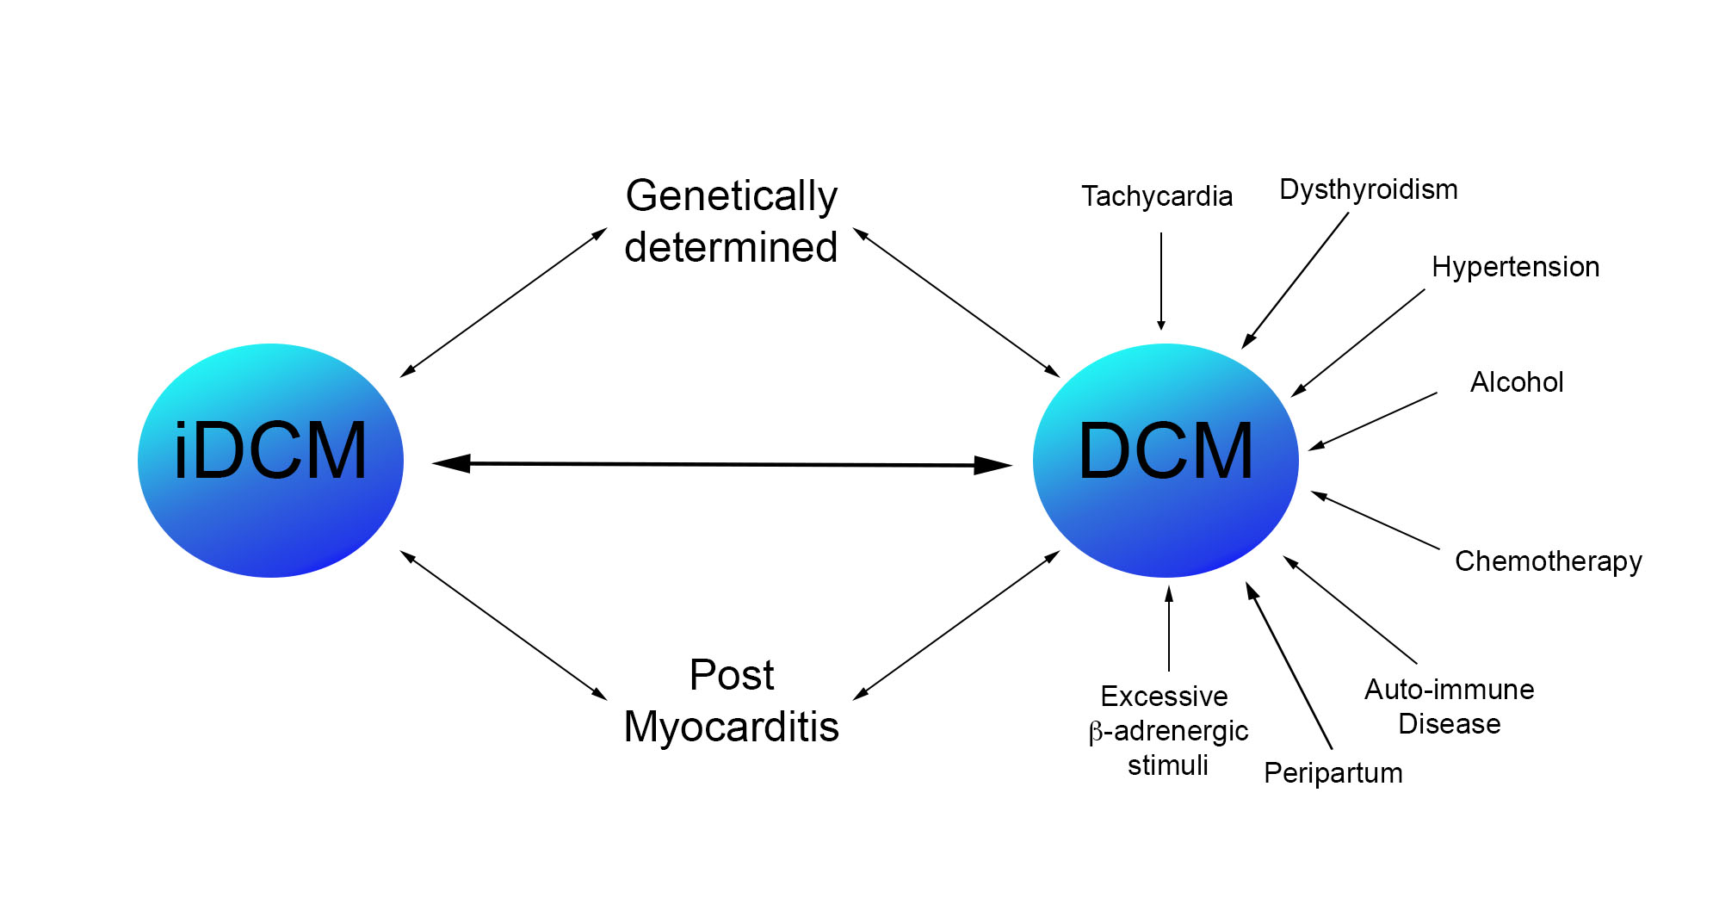
Figure 2
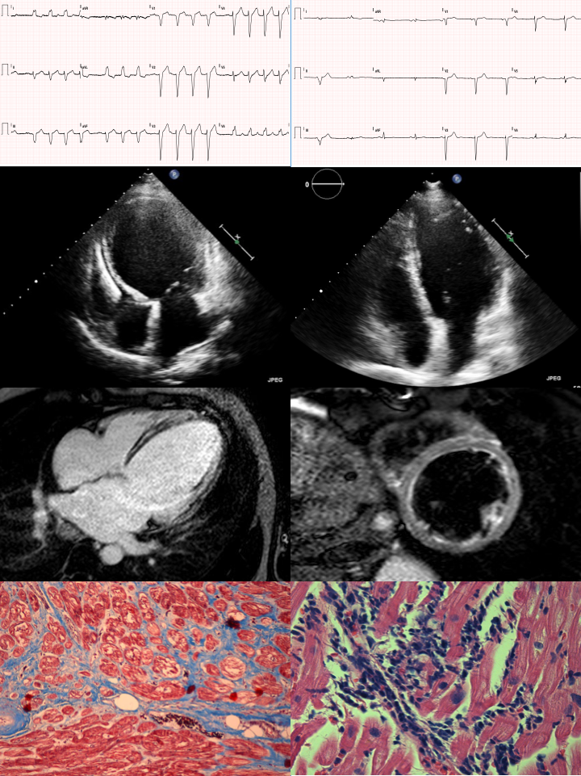

Figure 3

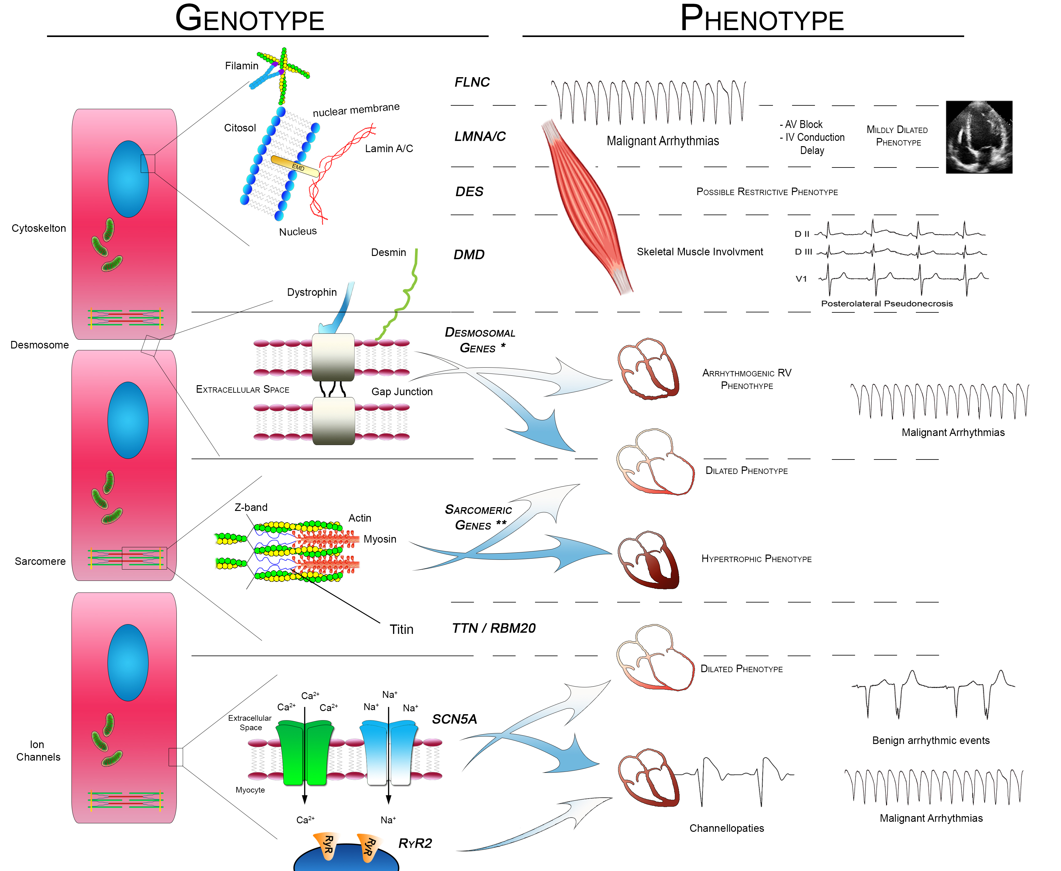
Figure 4

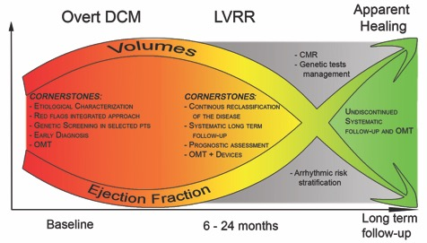

Figure 5.

