**Identification of capillary rarefaction using intracoronary wave intensity analysis with resultant prognostic implications for cardiac allograft patients**

Christopher J Broyd1,2, Francisco Hernández-Pérez3, Javier Sergovia3, Mauro Echavarría-Pinto1, Alicia Quirós-Carretero1, Clara Salas3, Nieves Gonzalo1, Pilar Jiménez-Quevedo1, Luis Nombela-Franco1, Pablo Salinas1, Ivan Núñez-Gil1, Maria Del Trigo1, Javier Goicolea3, Luis Alonso-Pulpón3, Antonio Fernández-Ortiz1, Kim Parker2, Alun Hughes4, Jamil Mayet2 Justin Davies2, Javier Escaned1*.

1 Department of Cardiology, Hospital Clinico San Carlos IDISSC and Universidad Complutense de Madrid, Prof Martin Lagos, 28040 Madrid, Spain;

2 National Heart and Lung Institute, Imperial College London, Hammersmith Hospital, Du Cane Road, London, W12 0HS, UK;

3 Department of Cardiology, Hospital Puerto de Hierro-Majadahonda, Calle Manuel de Falla, 1, 28222 Majadahonda, Madrid, Spain;

4 Population Science & Experimental Medicine, Institute of Cardiovascular Science, University College London, UK

* Corresponding author.

Tel: +34 91 330 34 38,

Fax: +34 91 330 31 82,

Email: escaned@secardiologia.es

**Abstract**

**Aims**

Techniques for identifying specific microcirculatory structural changes are desirable. As such, capillary rarefaction constitutes one of the earliest changes of cardiac allograft vasculopathy (CAV) in cardiac allograft recipients, but its identification with coronary flow reserve (CFR) or intracoronary resistance measurements is hampered because of non-selective interrogation of the capillary bed. We therefore investigated the potential of wave intensity analysis (WIA) to assess capillary rarefaction and thereby predict CAV.

**Methods and results**

Fifty-two allograft patients with unobstructed coronary arteries and normal left ventricular (LV) function were assessed. Adequate aortic pressure and left anterior descending artery flow measurements at rest and with intracoronary adenosine were obtained in 46 of which 2 were lost to follow-up. In a subgroup of 15 patients, simultaneous RV biopsies were obtained and analysed for capillary density. Patients were followed up with 1–3 yearly screening angiography. A significant relationship with capillary density was noted with CFR (*r* = 0.52, *P* = 0.048) and the backward decompression wave (BDW) (*r* = −0.65, *P* < 0.01). Over a mean follow-up of 9.3 ± 5.2 years patients with a smaller BDW had an increased risk of developing angiographic CAV (hazard ratio 2.89, 95% CI 1.12–7.39; *P* = 0.03). Additionally, the index BDW was lower in those who went on to have a clinical CAV-events (*P* = 0.04) as well as more severe disease (*P* = 0.01).

**Conclusions**

Within cardiac transplant patients, WIA is able to quantify the earliest histological changes of CAV and can predict clinical and angiographic outcomes. This proof-of-concept for WIA also lends weight to its use in the assessment of other disease processes in which capillary rarefaction is involved.

**Keywords**: Vasculopathy, Coronary artery, Physiology, Microcirculation, Cardiac transplant

**Introduction**

Structural remodelling of the coronary microcirculation occurs in a number of conditions resulting in microcirculatory dysfunction.1 A reduction in myocardial capillary density (rarefaction) constitutes a specific form of microcirculatory remodelling resulting in an impairment of coronary haemodynamics and influencing long-term outcome.2,3 Within cardiac allograft recipients, evidence suggests that the earliest changes of cardiac allograft vasculopathy (CAV) occur as capillary rarefaction4,5 before the process is clinically appreciable using angiography and IntraVascular Ultrasound (IVUS). However, a sound physiology-based methodology capable of quantifying early-CAV through capillary rarefaction is missing.

Since capillary density is a significant determinant of the capacity of the intramyocardial vasculature,6 a physiological technique capable of quantifying microcirculatory filling during early diastole might provide valuable clues on the magnitude of the subtended capillary density. The backward decompression wave (BDW), measurable through wave intensity analysis (WIA), originates from the microcirculation and is hypothesized to quantify the re-expansion of the intramyocardial network in early diastole.7 It may give a relatively-specific measure of capillary density and rarefaction uninfluenced by coexisting arteriolar obliteration whose influence on flow is noted during mid-to-late diastole.8 This is particularly important since such types of structural remodelling may also occur through disease processes with an independent effect on microcirculatory haemodynamics and outcome.8

To test this hypothesis, and to validate WIA as a diagnostic tool capable of measuring capillary rarefaction, we analysed coronary pressure and Doppler flow velocity measurements obtained in a cohort of consecutive of patients that had previously undergone cardiac transplantation without angiographic evidence of CAV. The study had two parts: firstly, a comparison of WIA and other physiological indices with capillary density estimated by histomorphometric-examination of simultaneously-obtained endomyocardial biopsies. Secondly, an assessment of the relationship between WIA and other physiological indices with long-term outcomes in patients with cardiac transplantation.

**Methods**

**Study population**

Patient flow through the protocol is demonstrated in *Figure 1*. Mean time from transplantation to assessment was 59.6 ± 55.0 months. Sixty-eight consecutive patients scheduled for routine follow-up cardiac catheterization ± endomyocardial biopsy were consented for enrolment. Fifty-two had angiographically normal coronary arteries and were included in the study. All patients were maintained on cyclosporine and steroid therapy. Forty one patients (93%) were taking a third immunosuppressive drug at the time of interrogation of which 36 were taking azathioprine and 5 mycophenolate mofetil (MMF). The study was approved by the centre’s ethics committee, and all participants provided written informed consent.

**Intracoronary physiological data**

A right femoral artery approach was used and 5000 IU of unfractionated heparin administered centrally. Aortic pressure was obtained from a 6 Fr guiding catheter without side holes. Coronary blood flow velocity measurements were performed in the mid-segment of the left anterior descending artery (LAD) with a 0.014 inch of intracoronary Doppler-tipped guidewire connected to the corresponding interface (FloWire and FlowMap, Cardiometric, Mountain View, CA, USA). Measurements were obtained after intracoronary nitrates, at baseline and then during maximal hyperaemia achieved using a 60-μg intracoronary adenosine bolus. Continuous simultaneous digital acquisition and storage of ECG, aortic pressure, and instantaneous intracoronary flow velocity were performed with a 12-bit-resolution analogue-to-digital converter (DI-200 PGL, DataQ Instruments, Akron, OH, USA) controlled by dedicated software (WinDaq200, DataQ Instruments).

The following indices were constructed: coronary flow reserve (CFR), basal microvascular resistance (BMR), hyperaemic microvascular resistance (HMR), instantaneous hyperaemic diastolic velocity pressure slope (IHDVPS), zero flow pressure (Pzf), and WIA. In addition to these physiological measurements, a subgroup of 15 patients underwent a right ventricular biopsy according to an established clinical protocol with care taken to sample the interventricular septum using multiple fluoroscopic views; 8 control patients were included for comparison. Haematoxylin staining and antibodies against endothelium were used to identify arterioles and capillaries respectively by a pathologist blinded to the physiological data.

**Follow-up**

The CAV endpoint was defined as a pre-determined composite of all CAV-related events incorporating CAV-related death, re-transplantation and re-vascularization. Patients underwent 1–3 yearly clinical and angiographic screening to identify evidence of CAV. Once identified, it was quantified according to standard International Society for Heart and Lung Transplantation (ISHLT) grading (Supplementary material online, *Table S2*).9 IntraVascular Ultrasound (IVUS) (Atlantis, Boston Scientific, Natick, MA, USA) was performed as standard and stratified according to the Stanford classification.10

**Statistics**

To ensure adequate power we estimated the minimum rate of development of angiographic CAV to be 50% over 5 years based on prior literature. We determined that 44 individuals were required with an expectation of 22 events to give a 90% power to reject a hazard ratio (HR) of at least 2.0 at the 0.05 significance (two-tail).

Continuous data is expressed as mean ± standard deviation. Significant differences between the study subgroups were determined by the Student’s *t*-test. ISHLT data were analysed using the Cuzick’s test for trend. Linear regression analysis was performed to assess univariate relationships between continuous variables. To determine the BDW value best predictive for the development of angiographic CAV, we generated a receiver-operator characteristic (ROC) curve from the ROCTAB function in STATA and the BDW closest to 100% sensitivity and specificity was identified. This value was used to categorize individuals into high- and low-risk groups, and survival free of angiographic CAV was then analysed using univariate Cox regression.

Data analyses were performed by STATA 13.1 for Windows (STATA software, College Station, TX, USA). A *P*-value of <0.05 was considered statistically significant.

**Results**

Adequate physiological data was obtained in 44 patients (Supplementary material online, Table S1); the 8 rejected patients were removed before any data processing because of poor quality flow-velocity signals. There were no procedural complications. All patients were in sinus rhythm, with a baseline heart rate of 84 ± 17 b.p.m. and normal left ventricular (LV) function. At recruitment, 52 (76%) reported no significant symptoms, 12 (18%) were breathless on moderate exertion, and 4 (6%) reported atypical chest pain.

Supplementary material online, Table S2 shows the mean values of the measured indices of microcirculatory function.

**Histological data**

An average of four biopsies were obtained per patient. Arteriolar density was similar in transplant biopsies (2.00 ± 1.22 arterioles per 1 mm2) and control subjects (2.50 ± 0.75 arterioles per 1 mm2, *P* = 0.5). Capillary density was significantly lower (623 ± 179 vs. 1101 ± 322 capillaries per 1 mm2, *P* < 0.01) in transplant biopsies than in control subjects (Supplementary material online, Figure S2).

Univariate regression analysis comparing the physiological indices with capillary density was performed. A correlation was noted between capillary density and both the BDW intensity (*r* = −0.65, *P* = 0.008) and CFR (*r* = 0.52, *P* = 0.048). There were weaker associations with IHDVPS (*r* = 0.51, *P* = 0.055), HMR (*r* = −0.47, *P* = 0.08), BMR (*r* = 0.36, *P* = 0.2), and Pzf (*r* = 0.13, *P* = 0.7) which did not reach significance (*Figure 2*).

Mean arteriolar obliteration index (AOI) was 77.1 ± 6.2%. A significant relationship was noted between AOI and IHDVPS (*r* = −0.59, *P* = 0.02), but not with the BDW (*r* = 0.25, *P* = 0.3) or any other indices of microvascular function.

**Follow-up**

Two patients were lost to follow-up. Of the remaining 42, mean follow-up was 9.3 ± 5.2 years. During this period there were 12 composite events (CAV-death 5, re-transplantation 4, re-vascularization 3). The BDW was significantly lower in patients suffering an event than those event-free (−4.5 ± 2.5 vs. −7.1 ± 3.9 × 103 W/m2/s, *P* = 0.04). A similar trend was noted with IHDVPS (1.2 ± 0.8 vs. 1.8 ± 1.2 cm/s/mmHg, *P* = 0.09). No relationship was noted with the other markers of microvascular function or other waves in the wave-intensity profile (CFR: 2.3 ± 0.6 vs. 2.3 ± 0.6, *P* = 0.9; HMR: 2.8 ± 1.2 vs. 2.8 ± 1.1, *P* = 1.0; Pzf: 47.5 ± 17.3 vs. 42.1 ± 34.3, *P* = 0.5) (*Figure 3*).

A smaller BDW (−4.8 ± 2.6 vs. −7.9 ± 4.1 × 103 W/m2/s, *P* = 0.01) and lower IHDVPS value (1.2 ± 0.8 vs. 2.1 ± 1.2 cm/s/mmHg, *P* = 0.01) were noted in the 21 patients who ultimately developed angiographic-CAV. Furthermore, the resultant ISHLT grade was higher in patients with a smaller index BDW (Grade 0: −7.6 ± 4.0 W/m2/s, Grade 1: −5.2 ± 2.9 W/m2/s, Grade 2: −5.6 ± 3.0 W/m2/s, Grade 3: −4.2 ± 2.3 × 103 W/m2/s, *P* = 0.01) and IHDVPS (Grade 0: 2.1 ± 1.2 cm/s/mmHg, Grade 1: 1.6 ± 1.0 cm/s/mmHg, Grade 2: 1.2 ± 0.2 cm/s/mmHg, Grade 3: 0.9 ± 0.4 cm/s/mmHg, *P* = 0.001) (*Figure 4*). Of those patients who went on to develop the severest disease according to IVUS classification (Stanford IV) a trend was noted towards a smaller BDW at enrolment than those with Stanford III or less (−5.6 ± 3.1 vs. −7.8 ± 4.5 × 103 W/m2/s, *P* = 0.07). No other relationship between the development of angiographic- or IVUS-CAV and markers of microcirculatory function were noted. Although a trend was noted with capillary density and these outcome measures, this did not reach significance (Supplementary material online).

By ROC analysis, a BDW of −44.4 × 102 W/m2/s was determined as the optimum cut-point for assessing the rate of angiographic CAV development (area under the ROC curve 0.76, sensitivity 0.62, specificity 0.91). Using this cut-off, it was possible to predict those at risk of developing angiographically evident disease (HR 2.89, 95% CI 1.12–7.39; *P* = 0.03, *Figure 5*). No other markers of microvascular function produced an equivalent trend. The influence of other clinical variables on CAV is highlighted in the Supplementary material online.

**Discussion**

The novel findings of this study are:

1. Coronary WIA findings correlate well with the capillary density of the subtended myocardium
2. In cardiac transplantation patients, wave-intensity analysis allows identification of myocardial capillary rarefaction.
3. Wave-intensity analysis predicts the development of angiographic CAV as well as its severity and the likelihood of a clinical CAV-event.

**Wave intensity analysis and capillary density**

Cardiac capillary rarefaction is an important pathogenic process in a number of cardiovascular and systemic diseases but obtaining this information *in vivo* remains difficult. We have shown that the BDW is a measure of capillary density and is able to identify capillary rarefaction. Although both CFR and IHDVPS are predictive of capillary density,2,8 in this small cohort the BDW gives the strongest correlation over other conventional pressure/flow-derived measures of microvascular function.

Coronary WIA was first performed 10 years ago in humans and since then has been used in a number of physiology studies to predict outcome11 or delineate mechanistic information.7,12,13 Six waves are identified within each cardiac cycle and each have been ascribed to particular temporal cardiac processes.7 Despite the wealth of clinical insight WIA has provided, until now this ascription has been based largely on theoretical concepts.

The most clinically relevant wave is the BDW. This wave is proposed to originate from the diastolic re-expansion of the intra-myocardial conduits that collapse under systolic compression, akin to a sponge immersed in water and being squeezed then released. As most of such microvascular collapsible conduits are capillaries due to their volume and compliance,6 the BDW constitutes a selective tool to interrogate the myocardial capillary domain. Previous studies7,12 have provided indirect evidence for the origin of this wave and its modification in conditions with increased extravascular compression of the microcirculation.

While ultimately the BDW will be influenced by both anatomical and physiological7,12,13 conditions, the relationship we have shown between the BDW and myocardial capillary density provides the first non-physiology-based direct evidence to support the theoretical concepts of the BDW.

**Wave intensity analysis to predict cardiac allograft vasculopathy**

Cardiac allograft vasculopathy continues to limit the long-term success of cardiac transplantation. Earlier manifestations of CAV take place in the microcirculation and ultimately progress to cause accelerated coronary artery disease with diffuse and circumferential intimal lesions that can ultimately impair coronary blood flow. Angiography is capable of detecting the very late states of the process in which obstructive disease of the epicardial vessels has already occurred. Given the asensory nature of transplanted-hearts, CAV currently necessitates frequent angiographic screening14 which incurs significant clinical risk as well as cost. However, its rate of development remains unpredictable. More accurate diagnosis of pre-clinical CAV would allow more accurate risk stratification, prognostication, appropriate targeting of aggressive therapy, and improved cost-effectiveness and as such is being sought through a number of modalities.

Although distinct from atherosclerotic heart-disease, CAV shares some pathological features including involvement of the microcirculation.15 Biopsy-based studies have identified structural changes that occur within the microcirculation within the first 1–3 months after transplantation reflecting the earliest stages of CAV4,16 of which capillary rarefaction5 (but not small artery involvement4) is a key process. Using histological analysis, we have confirmed here that capillary (but not arteriolar) density is reduced in cardiac transplant patients compared to controls supporting our hypothesis that our physiological marker of rarefaction can be used to predict the development, rate of progression, and outcome of CAV.

After a mean follow-up period of nearly 10 years, 50% of patients had developed angiographic evidence of CAV which is consistent with current contemporary practice.17 This feature could be predicted from both the BDW and IHDVPS but not through any other markers of microvascular function. Wave-intensity was also able to anticipate its rate of progression and severity. Therefore, it appears that the degree of microcirculatory involvement demonstrated by WIA reflects both the angiographic severity and rate of occurrence of CAV (*Figure 6*).

We defined a composite endpoint of adverse CAV-related events which included CAV-death, re-transplantation, and revascularization. Of our pre-defined markers of microvascular function, only the BDW was able to identify patients at risk of these events.

**Other markers of microvascular function**

Several other intracoronary physiology tools can be used *in vivo* to investigate the microcirculation including CFR, HMR, the index of Microcirculatory Resistance (iMR), IHDVPS, and zero-flow pressure (Pzf). Some of these markers have already been used to provide clinical and physiological insights into cardiac allograft patients.8,18,19 Our analysis incorporated all contemporary non-thermodilutional markers of microvascular function, but the strongest correlate remained with wave-intensity analysis for identifying histological and prognostic information in this group of patients.

IHDVPS is an alternative way to integrate pressure and flow responses and provides a measure of conductance. Previous work has shown that this marker correlates with capillary density8 and again we found a trend here which may have reached significance with a larger patient population. IHDVPS was also capable of providing some useful insights into prognosis particularly in delineating the resultant ISHLT-grade of disease severity. However, because of its dual influence from both the capillary and arteriolar domain it does not provide such a dedicated insight into capillary density as WIA. We speculate that mid-to-late diastole is governed by the combined resistance effect of the arterioles and capillaries which is therefore appreciable with IHDVPS. In early diastole the dominant influence is the capacitance of the re-expanding intramyocardial vessels, particularly that of the capillaries.6 Despite this, we are encouraged by the supportive information provided by IHDVPS in this cohort of patients reinforcing our earlier work in this field.8 We would highlight that rarely does a disease process solely affect one component of the microcirculation and alternate modalities (such as IHDVPS in this cohort) may provide important complimentary data. Furthermore, we note that there are other histological markers important to the pathogenesis of CAV, particularly that of fibrin deposition.16 This could well influence microvascular resistance, in part accounting for the relationships seen with IHDVPS.

Although Pzf is constructed from pressure-flow loops, it appears to provide differing clinical information. It is influenced markedly by LVEDP20 and following myocardial infarction provides significant prognostic information.21 However, unlike IHDVPS it does not provide information on microcirculatory histology or predictive data in this study. Interestingly, although the normal range for Pzf has not been established, values in this cohort appear relatively high; this may perhaps reflect some of the subtle abnormalities in LV relaxation following cardiac transplantation.22

Coronary flow reserve has been shown to convey prognostic information regarding LV systolic function in cardiac-transplant patients18 and is correlated with capillary density in patients with dilated cardiomyopathy.2 It is not therefore surprising that this index also provided some predictive information regarding capillary density in this cohort as well. However, CFR may be influenced by both macro- and micro-vascular disease23 as well as other haemodynamic parameters.24

To our knowledge there have been no studies linking whole-cycle derived measures of resistance (BMR or HMR) with outcome in cardiac transplant patients. In this study, we found no significant correlation with these measures. There was a trend towards a relationship between HMR and capillary density perhaps reflecting the decreased cross-sectional area of the capillary bed; in turn this may echo the previously documented relationship between iMR and outcome.25

**Future directions**

Capillary rarefaction is an important component in a number of disease processes and an indicator of prognosis. With this validatory work we have demonstrated the potential to assess capillary density using WIA which could therefore be applied to estimate prognosis in other conditions and potentially even in a non-invasive fashion.26 For example, the importance of microcirculatory function has been widely documented in acute myocardial infarction and an improvement in microcirculatory function noted with adjuvant therapy.27 Wave-intensity therefore has the potential to acutely investigate the state of the myocardium following infarction and potentially guide such therapies.

More specifically from this study, WIA may provide an option to risk stratify patients following transplantation thus offering a more individualized guide for therapy. Current guidelines recognise the importance of this subject28 and annual or even biannual angiography is suggested for cardiac transplant patients. This incurs a significant burden for both the patient and health service. We suggest that wave-intensity analysis (WIA) could be used to stratify patients and devise a more tailored investigative regimen, possibly further enhanced with the emergence of non-invasive methods for performing this assessment26 which ultimately may influence future guidelines.

We have also demonstrated the complementary nature of many emerging microcirculatory tools including IHDVPS, which provides a combined insight into the arteriolar and capillary domain. Thus we begin to delineate the ‘black box’ of the microcirculation with the aim of determining information specific to particular processes and anatomical regions within the microcirculation ultimately provide more specific information regarding health and disease in differing patient cohorts. Further work is clearly needed in this direction.

**Limitations and disadvantages**

Although this study produced a vast amount of sophisticated physiological data, the number of patients and events was relatively low. However, the data quality was high and the follow-up rigorous ensuring maximum reliability of these data. Despite this we acknowledge that larger studies are required before these findings can be extrapolated to the entire population.

Biopsies were obtained from the right ventricular approach but wave-intensity was performed in the LAD. However, we took great fluoroscopic care to ensure that our biopsies were taken from the interventricular septum. In each patient, multiple samples were taken from several separate approaches decreasing any potential error from an individual inadvertent non-septal sampling.

For ethical reasons, we only measured capillary density in the 15 patients in whom both angiography and biopsy was clinically justified. Given the rapidity with which capillary density can change we did not analyse biopsies unless WIA was performed simultaneously. Capillary density itself did not significantly predict CAV outcome most likely because this assessment only involved these 15 patients. However, this assumption needs to be acknowledged.

We were forced to exclude 8 (15%) patients originally enrolled in the study from our analysis due to poor quality pressure and/or flow signals. However, with more modern techniques and equipment, and increasing experience we envisage this percentage could be markedly reduced if used clinically. There was nothing to suggest those patients excluded were in any way different from our study cohort.

Our index data was gathered prior to the availability of the combined Doppler- and pressure-sensor tipped coronary wires that are used for conventional wave-intensity analysis. Therefore, the pressure signal was obtained from the tip of the catheter rather than at the same location as the flow-wire. However, we expect these waveforms to be identical in the absence of any epicardial disease—this remains the fundamental basis behind physiological coronary stenosis assessment in widespread clinical use.

**Conclusions**

Wave intensity analysis allows a reasonable estimation of capillary rarefaction, which may be one of the earliest changes of CAV, and provides a focused insight into the capillary domain of the microcirculation. The magnitude of the BDW is able to predict the development and severity of CAV as well as clinical CAV-endpoints. Wave-intensity analysis may have a clinical utility in the assessment of cardiac-allograft patients.

**Supplementary material**

Supplementary material is available at *European Heart Journal* online.

**Funding**

Fundación Interhospitalaria para la Investigación Cardiovascular (FIC) to C.J.B.; J.E. Davies (FS/05/006) is a BHF Fellow; NIHR Biomedical Research Centre.

**Conflict of interest:** none declared.

**References**

1 Pries AR, Badimon L, Bugiardini R, Camici PG, Dorobantu M, Duncker DJ, Escaned J, Koller A, Piek JJ, deWit C. Coronary vascular regulation, remodelling, and collateralization: mechanisms and clinical implications on behalf of the working group on coronary pathophysiology and microcirculation. Eur Heart J 2015; 36: 3134 –46.

2 Tsagalou EP, Anastasiou-Nana M, Agapitos E, Gika A, Drakos SG, Terrovitis JV, Ntalianis A, Nanas JN. Depressed coronary flow reserve is associated with decreased myocardial capillary density in patients with heart failure due to idiopathic dilated cardiomyopathy. J Am Coll Cardiol 2008; 52: 1391 –1398.

3 Kaul S, Jayaweera AR. Myocardial capillaries and coronary flow reserve. J Am Coll Cardiol USA 2008; 52: 1399 –1401.

4 Hiemann N, Meyer R, Wellnhofer E, Klimek W, Bocksch W, Hetzer R. Correlation of angiographic and immunohistochemical findings in graft vessel disease after heart transplantation. Transplant Proc 2001; 33: 1586 –1590.

5 Hiemann NE, Meyer R, Wellnhofer E. Letter by Hiemann regarding article, ‘Assessment of microcirculatory remodeling with intracoronary flow velocity and pressure measurements: validation with endomyocardial sampling in cardiac allografts’. Circulation 2010; 122: e404; author reply e405.

6 Spaan JA. Coronary diastolic pressure-flow relation and zero flow pressure explained on the basis of intramyocardial compliance. Circ Res 1985; 56: 293. http://dx.doi.org/10.1161/01.RES.56.3.293

7 Davies JE, Whinnett ZI, Francis DP, Manisty CH, Aguado SJ, Willson K, Foale RA, Malik IS, Hughes AD, Parker KH, Mayet J. Evidence of a dominant backward-propagating ‘suction’ wave responsible for diastolic coronary filling in humans, attenuated in left ventricular hypertrophy. Circulation 2006; 113: 1768 –1778.

8 Escaned J, Flores A, García-Pavía P, Segovia J, Jimenez J, Aragoncillo P, Salas C, Alfonso F, Hernández R, Angiolillo DJ, Jiménez-Quevedo P, Bañuelos C, Alonso-Pulpón L, Macaya C. Assessment of microcirculatory remodeling with intracoronary flow velocity and pressure measurements: validation with endomyocardial sampling in cardiac allografts. Circulation 2009; 120: 1561 –1568.

9 Mehra MR, Crespo-Leiro MG, Dipchand A, Ensminger SM, Hiemann NE, Kobashigawa JA, Madsen J, Parameshwar J, Starling RC, Uber PA. International Society for Heart and Lung Transplantation working formulation of a standardized nomenclature for cardiac allograft vasculopathy-2010. J Heart Lung Transplant Elsevier 2010; 29: 717 –727.

10 St Goar FG, Pinto FJ, Alderman EL, Valantine HA, Schroeder JS, Gao SZ, Stinson EB, Popp RL. Intracoronary ultrasound in cardiac transplant recipients. In vivo evidence of ‘angiographically silent’ intimal thickening. Circulation 1992; 85: 979 –987.

11 Silva KD, Guilcher A, Lockie T, Marber M, Redwood S, Plein S, Perera D. Coronary wave intensity: a novel invasive tool for predicting myocardial viability following acute coronary syndromes. J Am Coll Cardiol 2012; 59: E421 –E421.

12 Davies JE, Sen S, Broyd C, Hadjiloizou N, Baksi J, Francis DP, Foale RA, Parker KH, Hughes AD, Chukwuemeka A, Casula R, Malik IS, Mikhail GW, Mayet J. Arterial pulse wave dynamics after percutaneous aortic valve replacement: fall in coronary diastolic suction with increasing heart rate as a basis for angina symptoms in aortic stenosis. Circulation 2011; 124: 1565 –1572.

13 Lockie TP, Rolandi MC, Guilcher A, Perera D, Silva KD, Williams R, Asrress KN, Patel K, Plein S, Chowienczyk P, Siebes M, Redwood SR, Marber MS. Synergistic adaptations to exercise in the systemic and coronary circulations that underlie the warm-up angina phenomenon. Circulation 2012; 126: 2565 –2574.

14 Costanzo MR, Dipchand A, Starling R, Anderson A, Chan M, Desai S, Fedson S, Fisher P, Gonzales-Stawinski G, Martinelli L, McGiffin D, Smith J, Taylor D, Meiser B, Webber S, Baran D, Carboni M, Dengler T, Feldman D, Frigerio M, Kfoury A, Kim D, Kobashigawa J, Shullo M, Stehlik J, Teuteberg J, Uber P, Zuckermann A, Hunt S, Burch M, Bhat G, Canter C, Chinnock R, Crespo-Leiro M, Delgado R, Dobbels F, Grady K, Kao W, Lamour J, Parry G, Patel J, Pini D, Towbin J, Wolfel G, Delgado D, Eisen H, Goldberg L, Hosenpud J, Johnson M, Keogh A, Lewis C, O'connell J, Rogers J, Ross H, Russell S, Vanhaecke J. The International Society of Heart and Lung Transplantation Guidelines for the care of heart transplant recipients. J Hear Lung Transpl 2010; 29: 914 –956.

15 Kofoed KF, Czernin J, Johnson J, Kobashigawa J, Phelps ME, Laks H, Schelbert HR. Effects of cardiac allograft vasculopathy on myocardial blood flow, vasodilatory capacity, and coronary vasomotion. Circulation 1997; 95: 600 –606.

16 Labarrere CA, Nelson DR, Faulk WP. Myocardial fibrin deposits in the first month after transplantation predict subsequent coronary artery disease and graft failure in cardiac allograft recipients. Am J Med 1998; 105: 207 –213.http://dx.doi.org/10.1016/S0002-9343(98)00246-0

17 Stehlik J, Edwards LB, Kucheryavaya AY, Aurora P, Christie JD, Kirk R, Dobbels F, Rahmel AO, Hertz MI. The Registry of the International Society for Heart and Lung Transplantation: twenty-seventh official adult heart transplant report—2010. J Hear Lung Transpl 2010; 29: 1089 –1103.

18 Weis M, Hartmann A, Olbrich HG, Hor G, Zeiher AM. Prognostic significance of coronary flow reserve on left ventricular ejection fraction in cardiac transplant recipients. Transplantation 1998; 65: 103 –108.http://dx.doi.org/10.1097/00007890-199801150-00020

19 Fearon WF, Hirohata A, Nakamura M, Luikart H, Lee DP, Vagelos RH, Hunt SA, Valantine HA, Fitzgerald PJ, Yock PG, Yeung AC. Discordant changes in epicardial and microvascular coronary physiology after cardiac transplantation: Physiologic Investigation for Transplant Arteriopathy II (PITA II) study. J Heart Lung Transpl 2006; 25: 765 –771.

20 Herck PLV, Carlier SG, Claeys MJ, Haine SE, Gorissen P, Miljoen H, Bosmans JM, Vrints CJ. Coronary microvascular dysfunction after myocardial infarction: increased coronary zero flow pressure both in the infarcted and in the remote myocardium is mainly related to left ventricular filling pressure. Heart 2007; 93: 1231 –1237.

21 Teunissen PFA, Waard GA. D, Hollander MR, Robbers LFHJ, Danad I, Biesbroek PS, Amier RP, Echavarría-Pinto M, Quirós A, Broyd C, Heymans MW, Nijveldt R, Lammertsma AA, Raijmakers PG, Allaart CP, Lemkes JS, Appelman YE, Marques KM, Bronzwaer JGF, Horrevoets AJG, Rossum AC. V, Escaned J, Beek AM, Knaapen P, Royen N. V. Doppler-derived intracoronary physiology indices predict the occurrence of microvascular injury and microvascular perfusion deficits after angiographically successful primary percutaneous coronary intervention. Circ Cardiovasc Interv 2015; 8: e001786.

22 Paulus WJ, Bronzwaer JG, Felice H, Kishan N, Wellens F. Deficient acceleration of left ventricular relaxation during exercise after heart transplantation. Circulation 1992; 86: 1175.

23 Gould KL, Lipscomb K, Hamilton GW. Physiologic basis for assessing critical coronary stenosis: Instantaneous flow response and regional distribution during coronary hyperemia as measures of coronary flow reserve. Am J Cardiol 1974; 33: 87 –94.http://dx.doi.org/10.1016/0002-9149(74)90743-7

24 Bruyne B. D, Bartunek J, Sys SU, Pijls NHJ, Heyndrickx GR, Wijns W. Simultaneous coronary pressure and flow velocity measurements in humans: feasibility, reproducibility, and hemodynamic dependence of coronary flow velocity reserve, hyperemic flow versus pressure slope index, and fractional flow reserve. Circulation 1996; 94: 1842 –1849.

25 Yang H-M, Khush K, Luikart H, Okada K, Lim H-S, Kobayashi Y, Honda Y, Yeung AC, Valantine H, Fearon WF. Invasive assessment of coronary physiology predicts late mortality after heart transplantation. Circulation 2016;

26 Broyd CJ, Nijjer S, Sen S, Petraco R, Jones S, Al-Lamee R, Foin N, Al_Bustami M, Sethi A, Kaprielian R, Ramrakha P, Khan M, Malik I, Francis D, Parker KH, Hughes AD, Mikhail G, Mayet J, Davies JE. Estimation of coronary wave intensity analysis using non-invasive techniques and its application to exercise physiology. Am J Physiol Heart Circ Physiol 2016; 310: H619 –H627.

27 Sezer M, Oflaz H, Gören T, Okçular I, Umman B, Nişanci Y, Bilge AK, Sanli Y, Meriç M, Umman S. Intracoronary streptokinase after primary percutaneous coronary intervention. N Engl J Med 2007; 356: 1823 –1834.

28 Ponikowski P, Voors AA, Anker SD, Bueno H, Cleland JGF, Coats AJS, Falk V, González-Juanatey JR, Harjola V-P, Jankowska EA, Jessup M, Linde C, Nihoyannopoulos P, Parissis JT, Pieske B, Riley JP, Rosano GMC, Ruilope LM, Ruschitzka F, Rutten FH, van der Meer P. ESC Guidelines for the diagnosis and treatment of acute and chronic heart failure. Eur Heart J 2016; 37: 2129 –2200. 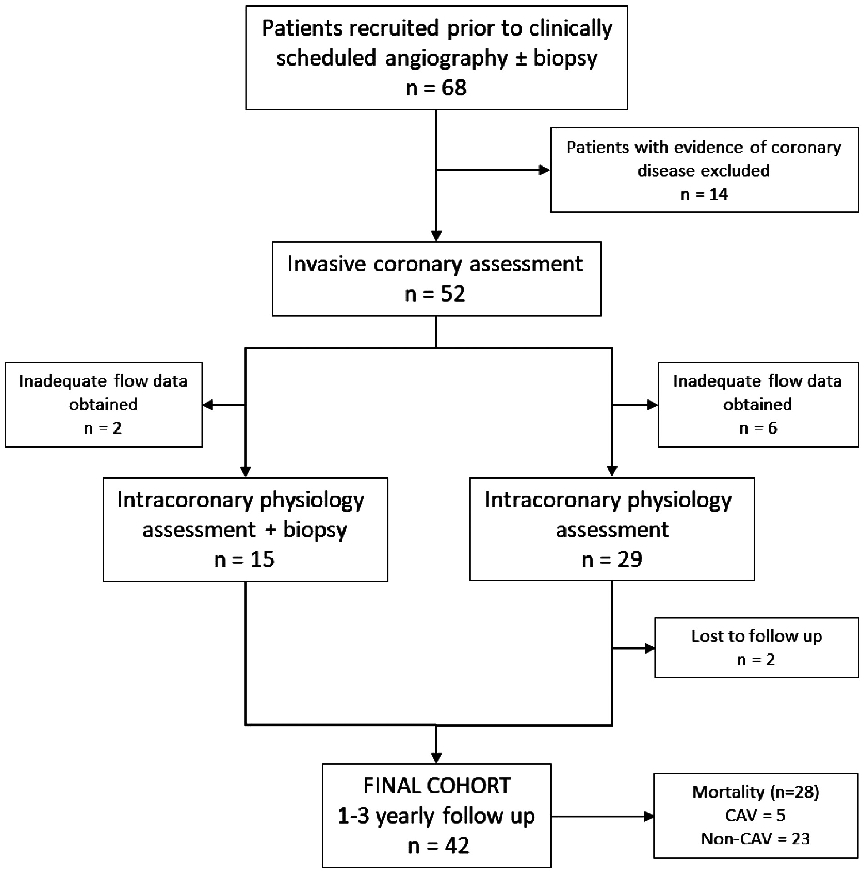 Figure 1. Diagram of patient flow through the study protocol. Mortality data is displayed in the Supplementary material online, *Appendix*. 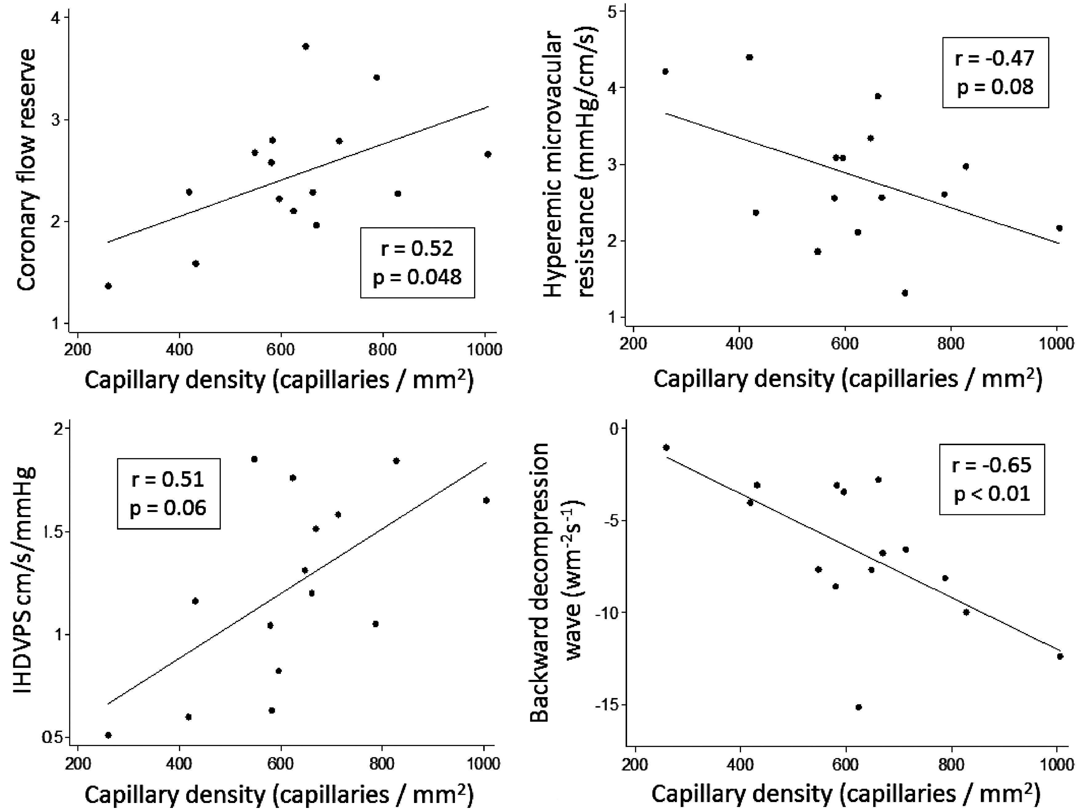 Figure 2. Correlation of four indices of microcirculatory function and capillary density. A trend towards significance was noted with hyperaemic microvascular resistance and instantaneous hyperaemic diastolic velocity pressure slope (IHDVPS) and a significant relationship observed with coronary flow reserve and the backward decompression wave. 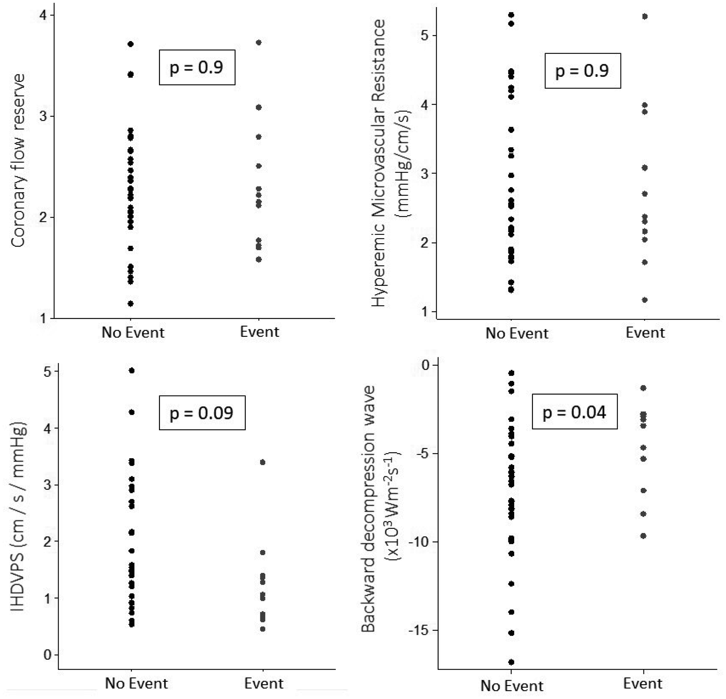 Figure 3. Dot-plot demonstrating four indices of microcirculatory function in patients with and without cardiac-allograft vasculopathy driven events during follow-up. Cardiac allograft vasculopathy-related events (composite of cardiac allograft vasculopathy-related death, re-transplantation, and re-vascularization) were most accurately predicted by the backward decompression wave. 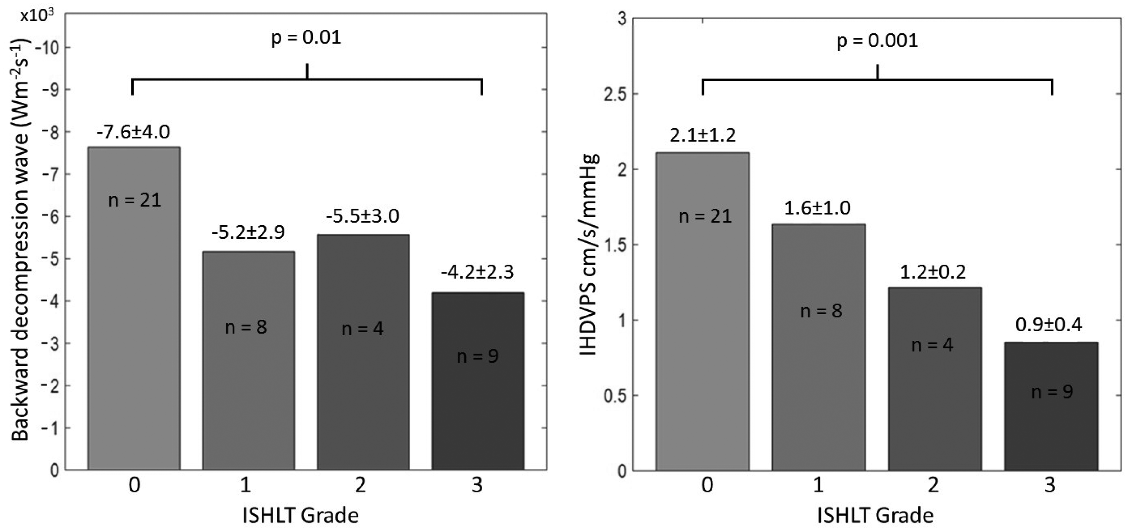 Figure 4. Backward decompression wave and IHDVPS at the time of assessment and the resultant severity of cardiac allograft vasculopathy. Both the index backward decompression wave and IHDVPS carried prognostic information regarding the ultimate severity of cardiac allograft vasculopathy according standardized guidelines. Data displayed with mean ± standard deviation and P-values according to the Cuzick’s test for trend. 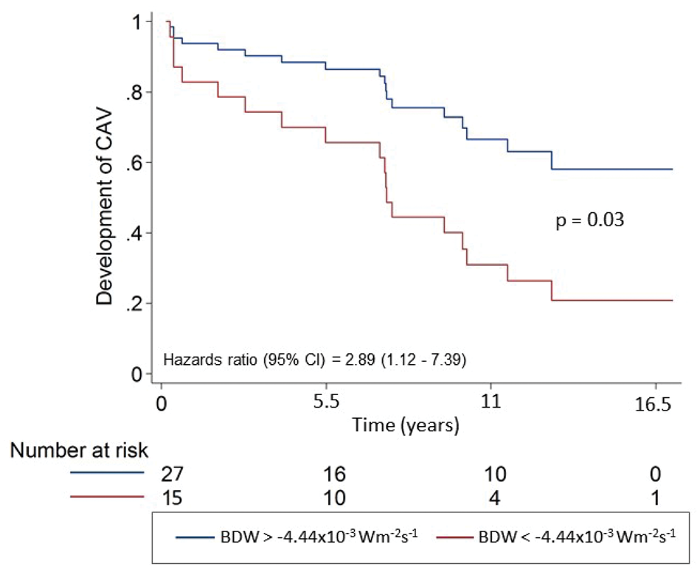 Figure 5. Cox proportional hazards ratio regression demonstrating survival free from angiographic cardiac allograft vasculopathy according to the backward decompression wave (BDW). The most appropriate BDW cut-off value (−4.44 × 10−3 W/m2/ s) was determined by receiver-operator characteristic-curve analysis. Angiographic cardiac allograft vasculopathy was ISHLT Grade 1 or above. 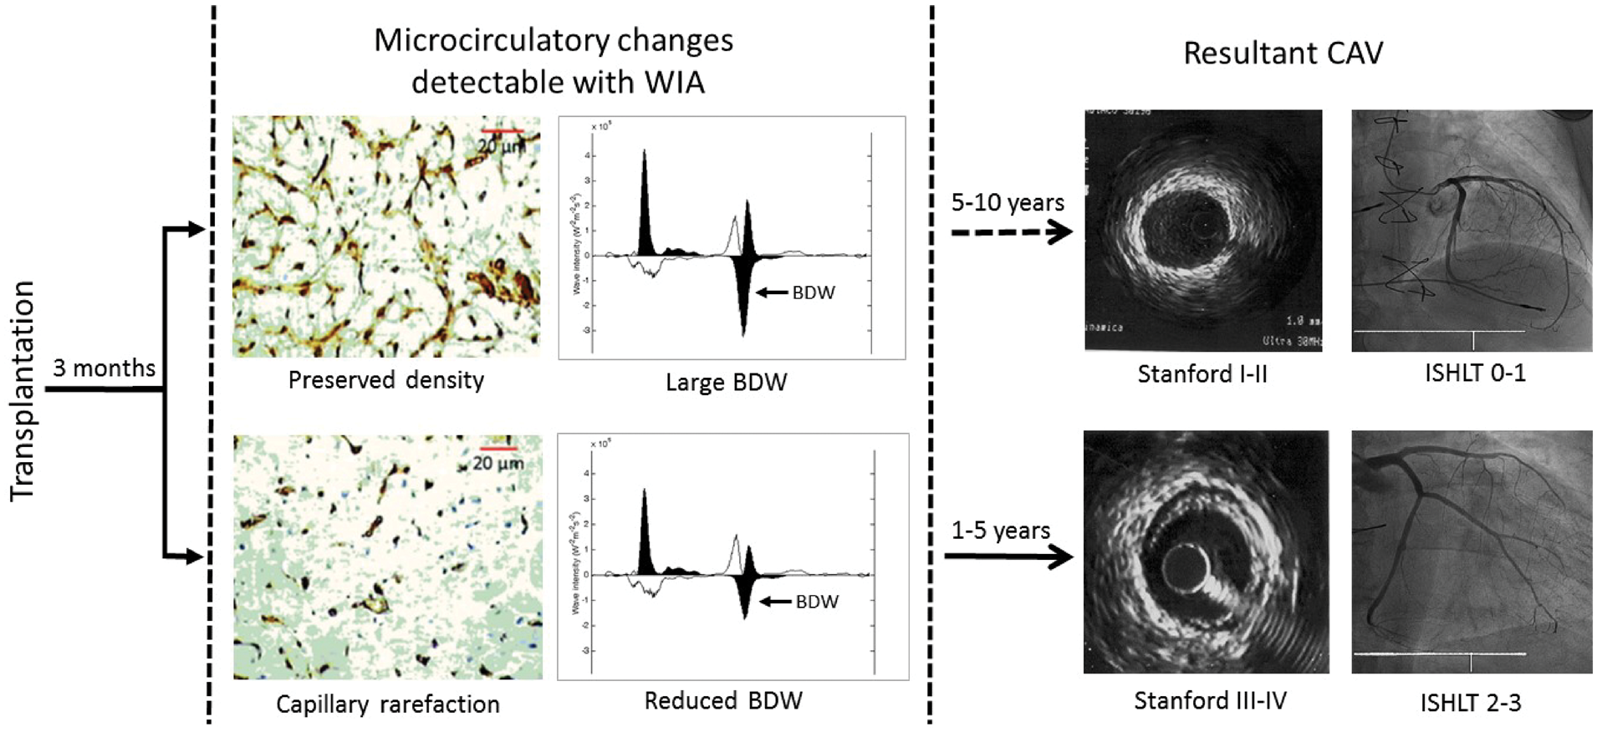 Figure 6. Schematic representations of the process of cardiac allograft vasculopathy and the ability of coronary wave intensity analysis to predict rate and severity of angiographic and clinical outcomes. In the first few months following transplantation, more severe capillary rarefaction occurs in those patients who ultimately go on to develop angiographically and clinical severe allograft vasculopathy. This change is quantifiable using wave intensity analysis where the size of the backward decompression wave identifies capillary rarefaction, and therefore predicts the rate and severity of angiographic and clinical disease and could guide screening rates.