Surfactants Adsorption on Crossing Stripes and Steps
Manaswee Suttipong,ª Brian P. Grady,^{b} and Alberto Striolo*ª
ªDepartment of Chemical Engineering, University College London, London WC1E 7JE, United Kingdom
^{b}School of Chemical, Biological and Materials Engineering, University of Oklahoma, Norman, Oklahoma 73069, United States
*Author to whom correspondence should be addressed: a.striolo@ucl.ac.uk

ABSTRACT
Using coarse-grained dissipative particle dynamics (DPD) simulations, we systematically study the effect of surface heterogeneity on surfactant adsorption. Here we investigate the adsorption and aggregation of surfactants on hydrophobic stripes crossing each other perpendicularly (i.e., crossing stripes) and on hydrophobic steps. The results are compared with those obtained for isolated stripes. We find that on crossing stripes of moderate stripe widths (e.g., L = 0.61L_{S}, 1.22L_{S} and 1.83L_{S}, where L_{S} is the length of one surfactant molecule) the crossing region hinders the formation of defect-free adsorbed surfactant structures. By increasing the stripe width and/or by increasing the length of one of the two perpendicularly crossing stripes (i.e., lowering the surface density of defects/intersections), the crossing region is found to have a weaker effect on the features of the adsorbed structures. Regarding surfactant adsorption on steps, our simulation results show that the self-assembled aggregates can be stretched along the step corner, and the resultant elastic deformation can hinder adsorption. This qualitative observation can facilitate a description of surfactant adsorption that takes into consideration also the deformation of the self-assembled film. As suggested by such a general model, increasing the convex angle of the step, increasing the size of the surfactant head groups, and changing other physical parameters can reduce the elastic energy penalty, and therefore result in larger amounts of surfactants adsorbed. The results presented could assist in understanding and sometimes predicting surfactant adsorption on heterogeneous surfaces, suggest methods to formulate surfactant mixtures to control surface coverage on heterogeneous surfaces, and perhaps facilitate new methods for the fabrication of nano-structured surfaces.

1. INTRODUCTION
Adsorption of surfactants on solid surfaces has received considerable attention due to its importance in a wide variety of applications. For example, in surface modification with admicellar polymerization, the adsorbing surfactants are used to localise monomers on the surface, for subsequent polymerization.¹⁻³ During surfactant flooding process for enhanced oil recovery, one of the retention mechanisms invoked is the adsorption of surfactants on the mineral surfaces.⁴ Also, via the adsorption of surfactants and their self-assemblies it is possible to improve the graphene dispersibility in polymer matrixes⁵ as well as stabilise carbon nanotubes in water.^{6, 7}
Researchers have investigated the adsorption and aggregation of surfactants on various substrates and environments. Adsorption depends on surface hydrophobicity,⁸⁻¹¹ radius of curvature of the surfaces,¹²⁻¹⁵ surface features,¹⁶⁻²⁰ surfactant molecular structure,²¹⁻²³ presence and nature of counter-ions²⁴⁻²⁶ and electrolytes,²⁷⁻²⁹ surfactant concentration,³⁰⁻³² and system conditions such as temperature²² and pH.^{33, 34} Many studies were focused on smooth and uniform surfaces despite the fact that natural solid surfaces exhibit physical and/or chemical heterogeneities. On heterogeneous surfaces the adsorption characteristics of surfactants differ significantly from those obtained on the homogeneous ones in terms of adsorption capacity,^{17, 20} morphology of adsorbed aggregates,^{18, 19} and even shape of the adsorption isotherms.^{16, 20} For example, using the atomic force microscope (AFM), Schulz and Warr provided evidence of hemi-spherical surfactant structures on quartz; these structures formed because of the rough surface on which adsorption took place.³⁵ Schniepp et al.^{18, 19} documented experimentally the influence of Au surface roughness on sodium dodecyl sulphate (SDS) aggregation. Wu et al.²⁰ and Gutig et al.³⁶ measured adsorption isotherm using the quartz crystal microbalance with dissipation (QCM-D); they reported that the amount of adsorbed cetyltrimetylammonium bromide (CTAB) surfactant was influenced by surface roughness. Using small-angle neutron scattering (SANS), Müter et al.³⁷ found that curvature of cylindrical silica nanopores affects the aggregate morphology of ethylene glycol (C₁₂E₅) surfactants. This brief overview highlights that the properties of self-assembled surfactant aggregates on heterogeneous surfaces strongly differ compared to those observed on atomically flat and homogeneous substrates. To understand the driving forces for these differences a systematic study in which the surface properties are changed from atomically flat and homogeneous to rough and heterogeneous would be required. Unfortunately, this is not easily achieved in experiments due to difficulties in controlling surface properties.
In support of experiments, computational studies can assist in better understanding how surfactants adsorb on heterogeneous substrates. Both atomistic and coarse-grained studies have indeed been initiated for these purposes. For example, Sammalkorpi and co-workers³⁸ examined the surfactant aggregates formation on imperfect graphite using molecular dynamics (MD) simulations, and demonstrated that point (i.e., vacancies) and line (i.e., surface steps) defects affected the stability and orientation of SDS aggregates. Tummala et al.³⁹ performed MD simulations to investigate SDS adsorption on graphene nano-sheets and nano-ribbons; they reported pronounced effects due to the edges of the nano-materials. Recently, by employing dissipative particle dynamics (DPD) simulations, our group found that the morphology of adsorbed surfactant aggregates depends strongly on surface morphological and chemical heterogeneities.^{40, 41} To consider the effect of chemical heterogeneity on an otherwise atomically flat substrate, we previously considered surfactants adsorption on individual hydrophobic stripes surrounded by regions that effectively repelled the surfactants; we documented the effect of stripe width, and the synergistic effects observed when two narrow stripes are found near each other. To start investigating the effect of surface roughness, we investigated the adsorption of surfactants within fully and partially hydrophobic trenches. Those prior works paved the road for continuing our systematic study on the effect of surface heterogeneity on the properties of self-assembled surfactant aggregates. In the present work we expand and complement our previous observations. We investigate the surfactants adsorption on surfaces containing two perpendicularly intersecting stripes and steps. We systematically change the width of the intersecting stripes, as well as some of the geometrical features of the steps. We compare the results to those obtained on individual stripes. All results are obtained by conducting simulations at ambient conditions within the equilibrium DPD formalism.
The remainder of this paper is organised as follows. The models and the simulation methods are presented in section 2; the results are discussed in section 3, where we present a simple model that is able to describe, qualitatively, the amount of surfactants adsorbed on a step by taking into consideration, among other factors, also the contribution of the elastic deformation of the self-assembled film due to the stretching induced by the step. We conclude with a brief summary of the main conclusions.

2. SIMULATION MODELS AND METHODS
Building on our prior studies,^{40, 41} we implemented coarse-grained DPD simulations^{42, 43} to study the adsorption of aqueous surfactants on the chosen heterogeneous surfaces. In Fig. 1 we show a schematic illustration of the heterogeneous surfaces considered, including the hydrophobic perpendicular crossing of stripes and the hydrophobic step. For comparison, we also considered the isolated hydrophobic stripe, which was considered extensively elsewhere.⁴⁰ The hydrophobic patterns are surrounded in all cases by surfaces that repel the surfactants. The stripe width L (for crossing stripes and isolated stripes), the width of step terrace L_{T} and the height of step wall L_{W} (for steps) are the parameters changed systematically in our study. L, L_{T}, and L_{W} are expressed in units of one surfactant length, L_{S}, which is ~ 20.8 Å for sodium dodecyl sulphate (SDS).⁴⁴

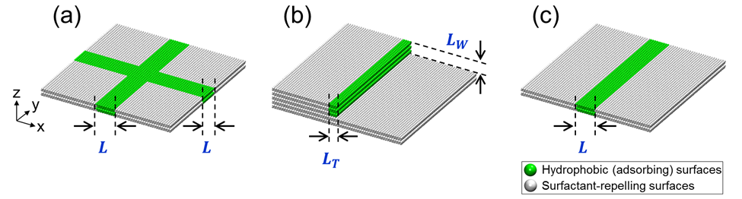
Fig. 1 Schematic illustration of (a) the hydrophobic perpendicular crossing of stripes, (b) the hydrophobic step, and (c) the isolated hydrophobic stripe. ‘L’ is the stripe width of the crossing stripes and the isolated stripe. ‘L_{T}’ and ‘L_{W}’ are the width of step terrace and the height of step wall, respectively. Hydrophobic (adsorbing) and surfactant-repelling surfaces are shown as green and grey, respectively.

The simulated system contains five types of DPD beads: water, surfactant tail, surfactant head, hydrophobic (adsorbing) surface site, and surfactant-repelling surface site. In our model, one water bead of volume 150 Å³ represents five water molecules. The reduced density of one DPD bead was set to ρ = 5. The DPD cut-off length was r_{c} = 9.0856 Å. As all beads were set to the same volume, the surfactant was chosen as a chain of one hydrophilic head and two hydrophobic tail beads, connected by a harmonic spring. The spring constant was k_{s} = 100 k_{B}T/r_{c}²,⁴⁰ and the equilibrium bond length was r₀ = 10.4 Å.⁴⁴ In Table 1 we summarise the DPD interaction parameters implemented in this study. Note that head-head interactions are less repulsive than head-tail ones. The surfactant-repelling surface is designed to prevent the adsorption of the surfactants; a complete description of the simulation setup and the chosen parameters can be found elsewhere.⁴⁰
All the DPD simulations were conducted within the NVT ensemble (constant number of particles, volume, and temperature) using the package LAMMPS,⁴⁵ version 10Feb15. Based on the fluctuation-dissipation theorem, the friction coefficient and the strength of the random force were linked by the relation σ² = 2γk_{B}T, and were taken as γ = 4.5 and σ = 3, respectively.⁴³ The reduced temperature was kept at k_{B}T = 1 (representative of ambient conditions). The time step was ∆t = 0.156 ps. Each system was equilibrated for 1.248 µs with the last 0.156 µs used for data analysis. We carried out three parallel runs for each system.
In most cases the simulations were performed within a rectangular simulation box of size 21×21×42 r_{c}³ (L_{x}×L_{y}×L_{z}). In some cases the simulations were conducted in boxes of dimension 31.5×21×42 r_{c}³ (rectangular surface) to investigate size-dependent effects on the results. Periodic boundary conditions were applied along x and y directions. The bulk surfactant concentration of all simulated systems was maintained at ~ 20–23 mM (≈ 3 CMC).

Table 1 DPD repulsion parameters a_{ij} for water (w), surfactant head (h), surfactant tail (t), surfactant-repelling surface site (rs), and hydrophobic (adsorbing) surface site (as). All values are expressed in k_{B}T/r_{c} units
a_{ij} | w | h | t | rs | as
w | 15 | 0 | 81 | 15 | 81
h |  | 15 | 69 | 15 | 69
t |  |  | 15 | 81 | 15
rs |  |  |  | 15 | 81
as |  |  |  |  | 15

3. RESULTS AND DISCUSSION

3.1 Adsorption on crossing stripes

Morphology of self-assembled aggregates
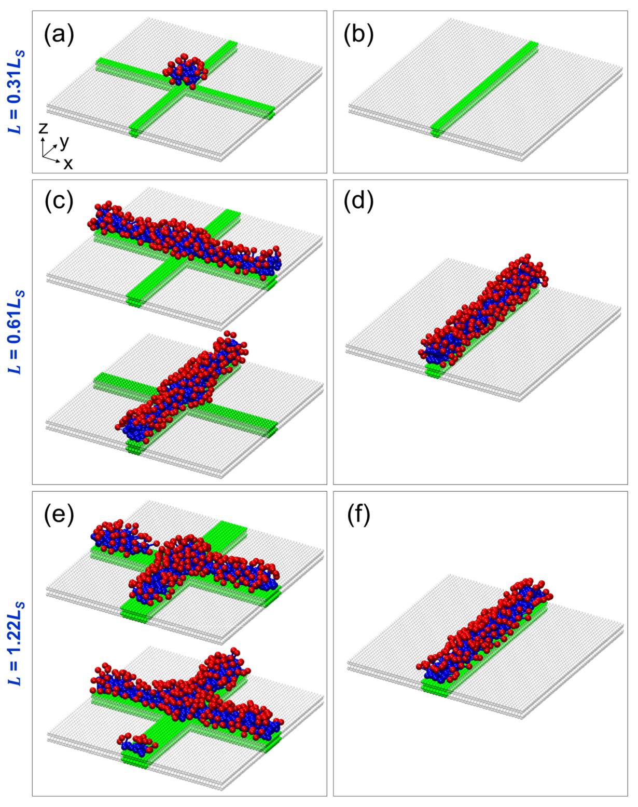
Fig. 2 Representative simulation snapshots of surfactant aggregates adsorbed on perpendicularly crossing stripes (left) and isolated stripes (right) of increasing stripe width L = (a, b) 0.31L_{S}, (c, d) 0.61L_{S}, and (e, f) 1.22L_{S}. Water beads are not shown for clarity. Surfactant head beads, surfactant tail beads, hydrophobic surfaces, and surfactant-repelling surfaces are shown as red, blue, green, and grey, respectively.

Representative simulation snapshots of model surfactants adsorbed on hydrophobic perpendicularly crossing stripes and isolated hydrophobic stripes are shown in Fig. 2, left and right panels, respectively. From top to bottom, the results are obtained on crossing stripes and on isolated stripes, in both cases with stripe width L = 0.31L_{S}, 0.61L_{S}, and 1.22L_{S}. On the narrowest stripe width considered, L = 0.31L_{S}, we find a small surfactant hemi-sphere anchored to the crossing region (Fig. 2a). The tail groups form the core of this hemi-sphere, and they are at contact with the hydrophobic surface; the head groups face the water, as expected. In contrast, on the isolated stripe of the same L, our results show no permanent adsorption of surfactants (Fig. 2b). In fact, as it was discussed previously, our simulations show that occasionally small amounts of surfactants adsorb on the isolated stripe of width L = 0.31L_{S}. However, this adsorbed ‘aggregate’ is unstable, and easily desorbs from the stripe. The main reason for the lack of permanent adsorption is that on such a narrow stripe the gain in entropy caused by removing the water-hydrophobic tail interaction in solution is not large enough to overcome the loss in entropy of restricting the surfactant to the surface. However, as the results in Fig. 2 suggest, it seems to be energetically more favourable for a few surfactants to agglomerate at the crossing region rather than adsorbing on the rest of the patterned surface (i.e., on the arms of the crossing stripes). The adsorption behaviour observed from our simulations agrees, qualitatively, with the results of Angelikopoulos and Bock,⁴⁶ who studied self-assembled surfactants on intersecting carbon nanotubes. They found that the aggregation was promoted near the region where the nanotubes intersected.
A structure similar to the one just described was observed when the crossing stripes were of width L = 0.46L_{S} (results not shown for brevity). While the hemi-sphere is firmly located at the crossing region, similarly to the one shown in Fig. 2a, on the isolated stripe the adsorbed aggregate is free to move along the stripe, and we found that it is smaller in size compared to the one self-assembled on the crossing stripes.
When L = 0.61L_{S}, surprisingly, we found that the hydrophobic surfaces of the crossing stripes are not fully covered by self-assembled surfactant aggregates, despite the fact that the stripe width is large enough to allow for the full surface coverage (see right panel in Fig. 2, and discussion in Ref. [40]). Visual inspection shows that the surfactant aggregate self-assembled on the patterned surface yields an individual hemi-cylinder along either one of the two perpendicularly crossing stripes, but not on both simultaneously (Fig. 2c). The aggregate structure matches almost perfectly what was observed on the isolated stripe at similar L (Fig. 2d). Within the hemi-cylinder, the surfactant molecules mainly align perpendicular to the long axis of the stripe, allowing numerous tail-tail and tail-hydrophobic surface interactions, as discussed in our previous investigations.⁴⁰ However, it appears that the formation of the hemi-cylinder on one of the arms of the crossing stripes prevents further adsorption of surfactants on the other arm. Although we do not have sufficient statistical data, it appears that which one of the two arms to be covered by the self-assembled surfactant aggregate is determined randomly, but once one of the crossing stripes is covered, the other one remains uncovered. Perhaps it could be possible to drive the preferential adsorption on one of the two crossing stripes by adding preferential adsorption sites, but this was not investigated here.
Increasing the stripe width further to L = 1.22L_{S} (and also L = 1.83L_{S}, results not shown) yields discontinuous hemi-cylinders on the crossing stripes (Fig. 2e). This result was also unexpected because, since L is now commensurate with the length of one surfactant molecule, the surfactants could cover the entire hydrophobic surface of the crossing stripes,⁴⁰ similarly to what observed for the isolated stripe (Fig. 2f). Even increasing the surfactant concentration in solution up to twice the one used for obtaining the results discussed in Fig. 2 does not yield the expected complete coverage of the crossing stripes by two self-assembled adsorbed surfactant hemi-cylinders linked at the crossing region. In the following, we refer to the adsorbed aggregate shown in either Fig. 2d or f as a hemi-cylindrical structure. The structure obtained for the crossing stripes of L = 0.61L_{S} and 1.22L_{S} is therefore referred to as a distorted structure.
The qualitative analysis of snapshots obtained for the crossing stripes can be complemented by in-plane density distributions computed for the adsorbed surfactant aggregates within planes parallel to the surface. The results are presented in Fig. 3. The left panels show the results obtained for the tail groups, and the right panels those for the head groups. On the crossing stripes of L = 0.31L_{S}, the tail density profiles display high densities at the crossing region, corresponding to the formation of the hemi-sphere (Fig. 3a). When L = 0.61L_{S,} as the surfactants self-assemble into one hemi-cylinder, the results show that the tail groups adsorb on one of the two crossing stripes (Fig. 3b). The density profiles show evidence of the non-uniform distribution of the tail densities on the crossing stripes of L = 1.22L_{S}, which is consistent with the distorted hemi-cylindrical aggregates (Fig. 3c). In all cases the head density profiles are found near the locations where the tail groups accumulate (Fig. 3d to f). It should be pointed out that on the crossing stripes of L = 0.61L_{S}, the density profiles of the head groups displays high densities at the boundary between hydrophobic and surfactant-repelling surfaces (Fig. 3e). This is a consequence of the formation of hemi-cylindrical structures, whose curvature decreases with increasing stripe width, as the hemi-cylinders become flat monolayers.⁴⁰ We point out that the curvature of the self-assembled surfactant hemi-cylinders can also be controlled by the surface geometry¹⁴ and by the addition of electrolytes.⁴⁷
Overall, the results discussed so far suggest that the adsorption of surfactants on patterned surfaces is dependent on details such as the size of the hydrophobic features on the surface and whether or not such features intersect. We conclude that the differences discussed among the aggregates formed on isolated vs. perpendicularly intersecting stripes are due to the presence of the crossing region. At the crossing region, presumably, there is an energy penalty to be paid by packing the hydrophobic tails against the hydrophilic head groups of the neighbouring surfactants on or near the solid surface. To minimise this penalty, on the crossing stripes of L = 0.61L_{S}, 1.22L_{S}, and 1.83L_{S} only distorted hemi-cylinders formed, rather than two hemi-cylinders coalesced at the crossing region. This suggests that the penalty encountered by completing the two intersecting hemi-cylinders is larger than that caused by leaving part of the hydrophobic surface exposed to water. We speculate that the entire crossing stripes could be covered by surfactant molecules if either (1) the free-energy penalty due to intersecting hemi-cylinders was reduced, and/or (2) the free-energy advantage of covering the entire hydrophobic surface was increased by, e.g., making the surface more hydrophobic, rendering tail-hydrophobic surface interactions more attractive, and perhaps even increasing the attractions between surfactant tails. We examine these possibilities hereafter.

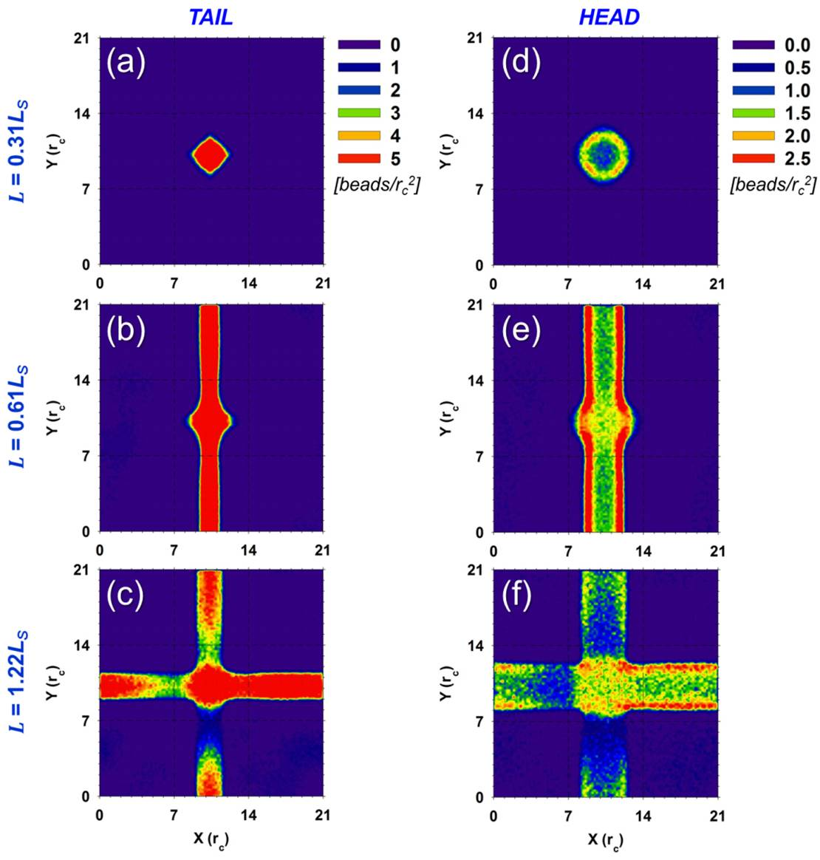
Fig. 3 In-plane density profiles of surfactant tails (left) and heads (right) adsorbed on perpendicularly crossing stripes of stripe width L = (a, d) 0.31L_{S}, (b, e) 0.61L_{S}, and (c, f) 1.22L_{S}. The results are obtained along planes parallel to the surface. Surface densities are expressed as number of beads per r_{c}².

Crossing stripes completely covered by adsorbed surfactant aggregates
We performed simulations in which the absorbing surface sites at the crossing region effectively repel the surfactant molecules, rather than being hydrophobic. Crossing stripes of L = 0.61L_{S}, 1.22L_{S}, and 1.83L_{S} were considered for these simulations. The results (not shown for brevity) reveal that the surfactants self-assembled into one hemi-cylinder on each hydrophobic arm. The hemi-cylindrical aggregate structure is comparable with that illustrated in Fig. 2d and f. We conclude that the adsorption of surfactants on crossing stripes such as those considered in Fig. 2 is indeed affected by the crossing region, as discussed above.

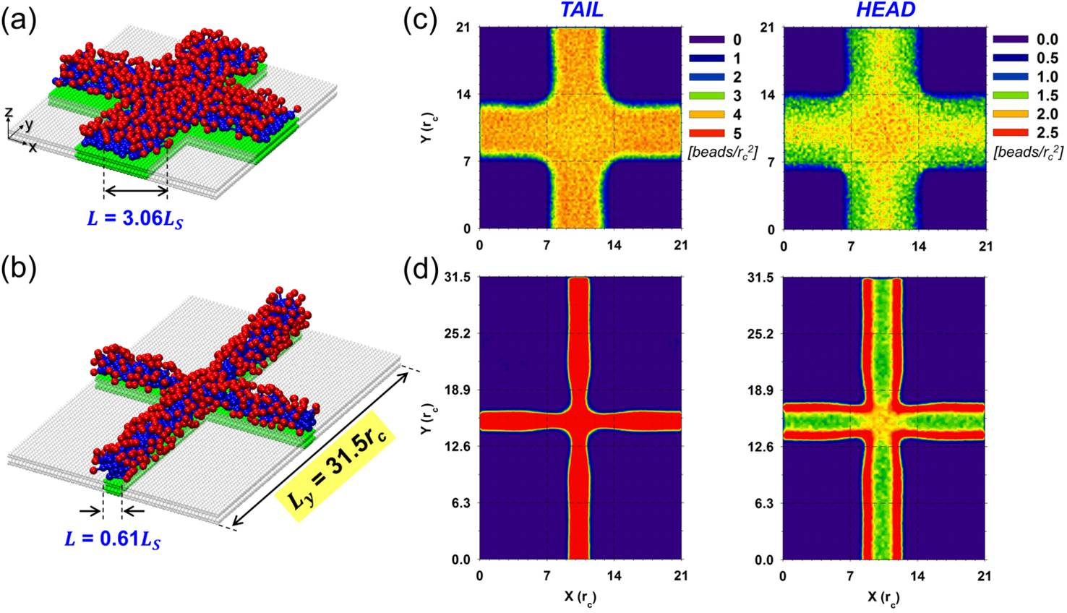
Fig. 4 Representative simulation snapshots of surfactant aggregates adsorbed on (a) the crossing stripes of L = 3.06L_{S} and (b) the crossing stripes within the rectangular surface cell (L_{x}×L_{y} = 31.5×21 r_{c}²) of L = 0.61L_{S}. Water beads are not shown for clarity. The colour code is the same as that used in Fig. 2. (c, d) In-plane density profiles of surfactant tails (left) and heads (right) obtained for panels (a) and (b), respectively. The results are obtained along planes parallel to the surface. Surface densities are expressed as number of beads per r_{c}².

We simulated systems in which the geometry of the crossing stripes was such that a larger number of tail-hydrophobic surface and tail-tail contacts were possible. We considered the crossing stripes formed by very wide stripes, L = 3.06L_{S}. To increase the penalty of not covering the hydrophobic surface with surfactants we decreased the surface density of crossing stripes by changing the size of the simulation box and generating a rectangular surface cell (L_{x}×L_{y} = 31.5×21 r_{c}²) for a system in which the stripes have width L = 0.61L_{S}. In Fig. 4, we provide simulation snapshots and in-plane density profiles of adsorbed aggregates obtained for the two systems. On the crossing stripes of L = 3.06L_{S}, visual inspection confirms that the surfactants cover the entire hydrophobic surface, yielding a thin monolayer of adsorbed surfactants (Fig. 4a). This aggregate morphology is somewhat different to that obtained on an isolated stripe of the same L on which the surfactants form a dense monolayer (results not shown). In particular, the density of the adsorbed surfactants is lower when the stripes cross than when they are isolated, as discussed later, further confirming that the crossing region introduces defects to the adsorbed aggregate. For the crossing stripes of L = 0.61L_{S}, on the rectangular surface, we also find that the surfactants cover the entire hydrophobic surface, yielding two hemi-cylinders linked at the crossing region (Fig. 4b).
In-plane density profile results, shown in Fig. 4c and d, confirm that the surfaces of the two crossing stripes are fully surrounded by the surfactant molecules.
While it is not surprising that the increase in the stripe width, which results in numerous tail-hydrophobic surface and tail-tail interactions that compensate for the energy penalty due to unfavourable surfactant packing at the crossing region, yields complete coverage of the hydrophobic surface, our results suggest that increasing the length of one of the arms of the crossing stripes has the same effect. The width of the stripes considered for these simulations is such that, based on the results shown in Fig. 2, one of the arms should be fully covered by the surfactant aggregate, but not the other. Instead, our results showed that both arms were covered by surfactants at the end of our simulations even when we first covered the long arm with surfactants. In this latter case, after 1.62 million time steps, the surfactant aggregates covered both arms. This suggests, perhaps, that fluctuations in density and aggregate shape are responsible for the results, suggesting that the simulation results are strongly dependent on the system size considered. To confirm this, we conducted additional simulations for a system of crossing stripes of width L = 0.61L_{S} within a square surface of side length 1/3 that considered in the simulations of Fig. 2. Even in this case surfactants only adsorbed on one arm of the crossing stripes. It is possible that the energy penalty due to the presence of the crossing region is (a) large enough to prevent surfactant adsorption on both arms of the crossing stripes when the distance between next-neighbouring crossing regions across the periodic replicas of the simulated system is small; (b) small enough to allow complete surfactant adsorption when the distance between crossing regions is large; and (c) sufficient to induce kinetic barriers to surfactant adsorption when the distance between crossing regions is somewhat in between. A full characterisation of free energy profiles as a function of pattern features and surfactant properties is required to completely quantify these scenarios, which is beyond the scopes of this manuscript. Our results suggest that the crossing region behaves as a defect preventing the surfactants from covering the entire hydrophobic surface available. The results clearly show a strong dependence on the simulation box size when the stripe width is ~ comparable to the length of one surfactant molecule. At such conditions the density of the defects on the surface (which decreases as the simulation box size increases) is an important parameter in determining surfactant adsorption. At high density of surface defects it is likely that significant portions of a surface will not be covered by surfactants. This observation is consistent with experimental data, which show that as the roughness increases the amount of surfactant adsorbed per unit surface area decreases.²⁰

Amount of surfactants adsorbed
We further quantified the amount of surfactant adsorbed on the various surfaces, and compared it to that observed on the correspondent isolated stripes. To rationalise the results we computed the surface density of the adsorbed surfactants, which was estimated by dividing the time-average number of surfactant molecules adsorbed on the various surfaces by the hydrophobic surface area. In Fig. 5 we plot the surface density as a function of stripe width L for the various cases considered. In this case we only consider simulations conducted for systems in which the length of the two crossing stripes was the same. The surface density is expressed in units of molecules per r_{c}². The results show that, below L = 0.61L_{S} (e.g., narrow stripe widths), the amount of surfactants adsorbed increases as L increases both for the isolated stripes and for the crossing stripes. Because the surfactants cannot adsorb when the stripes are too narrow, they start adsorbing forming hemi-spheres on narrow stripes, and as L increases they yield hemi-cylinders. Note that when L is small, the amount adsorbed on the crossing stripes can be larger than on the isolated stripes, as discussed qualitatively in Fig. 2a.
When L = 0.61L_{S}, however, the amount adsorbed on the crossing stripes is significantly less than that of the correspondent isolated stripe, because of the difficulties encountered by the surfactants to form a complete coverage on the patterned surface, as discussed above. As L increases further beyond L = 0.61L_{S}, the density of surfactants adsorbed on both surfaces decreases, as the self-assembled aggregates morph from hemi-cylinders (on isolated stripes) and distorted hemi-cylinders (on crossing stripes) into monolayers. When L = 3.06L_{S} and L= 3.67L_{S}, the adsorbed density reaches a constant plateau on the isolated stripes, which corresponds, approximately, to the surface density achieved on a homogeneous hydrophobic surface (≅ 2.50 molecule/r_{c}²). For the crossing stripes of L = 3.06L_{S} and L= 3.67L_{S}, however, the density of surfactants adsorbed is lower than that on the isolated stripes. To better understand this difference we computed the surface density at the crossing of the two perpendicular stripes and on their arms. For the crossing stripes of L = 3.06L_{S}, for example, we obtain that the surface density of adsorbed surfactants is of 1.68±0.01 and 1.57±0.01 molecules/r_{c}² (crossing and arms, respectively). This indicates that the surfactant molecules tend to accumulate on the crossing region rather than on the arms, suggesting that the crossing region not only influences the amount adsorbed, but also leads to a non-uniform distribution of surfactants on patterned surfaces. As discussed above, our simulations suggest that the surface density would be the same as that on the homogeneous hydrophobic surface if the crossing stripes were formed by much wider stripes, in which case the crossing region would not perturb the adsorbed aggregate.

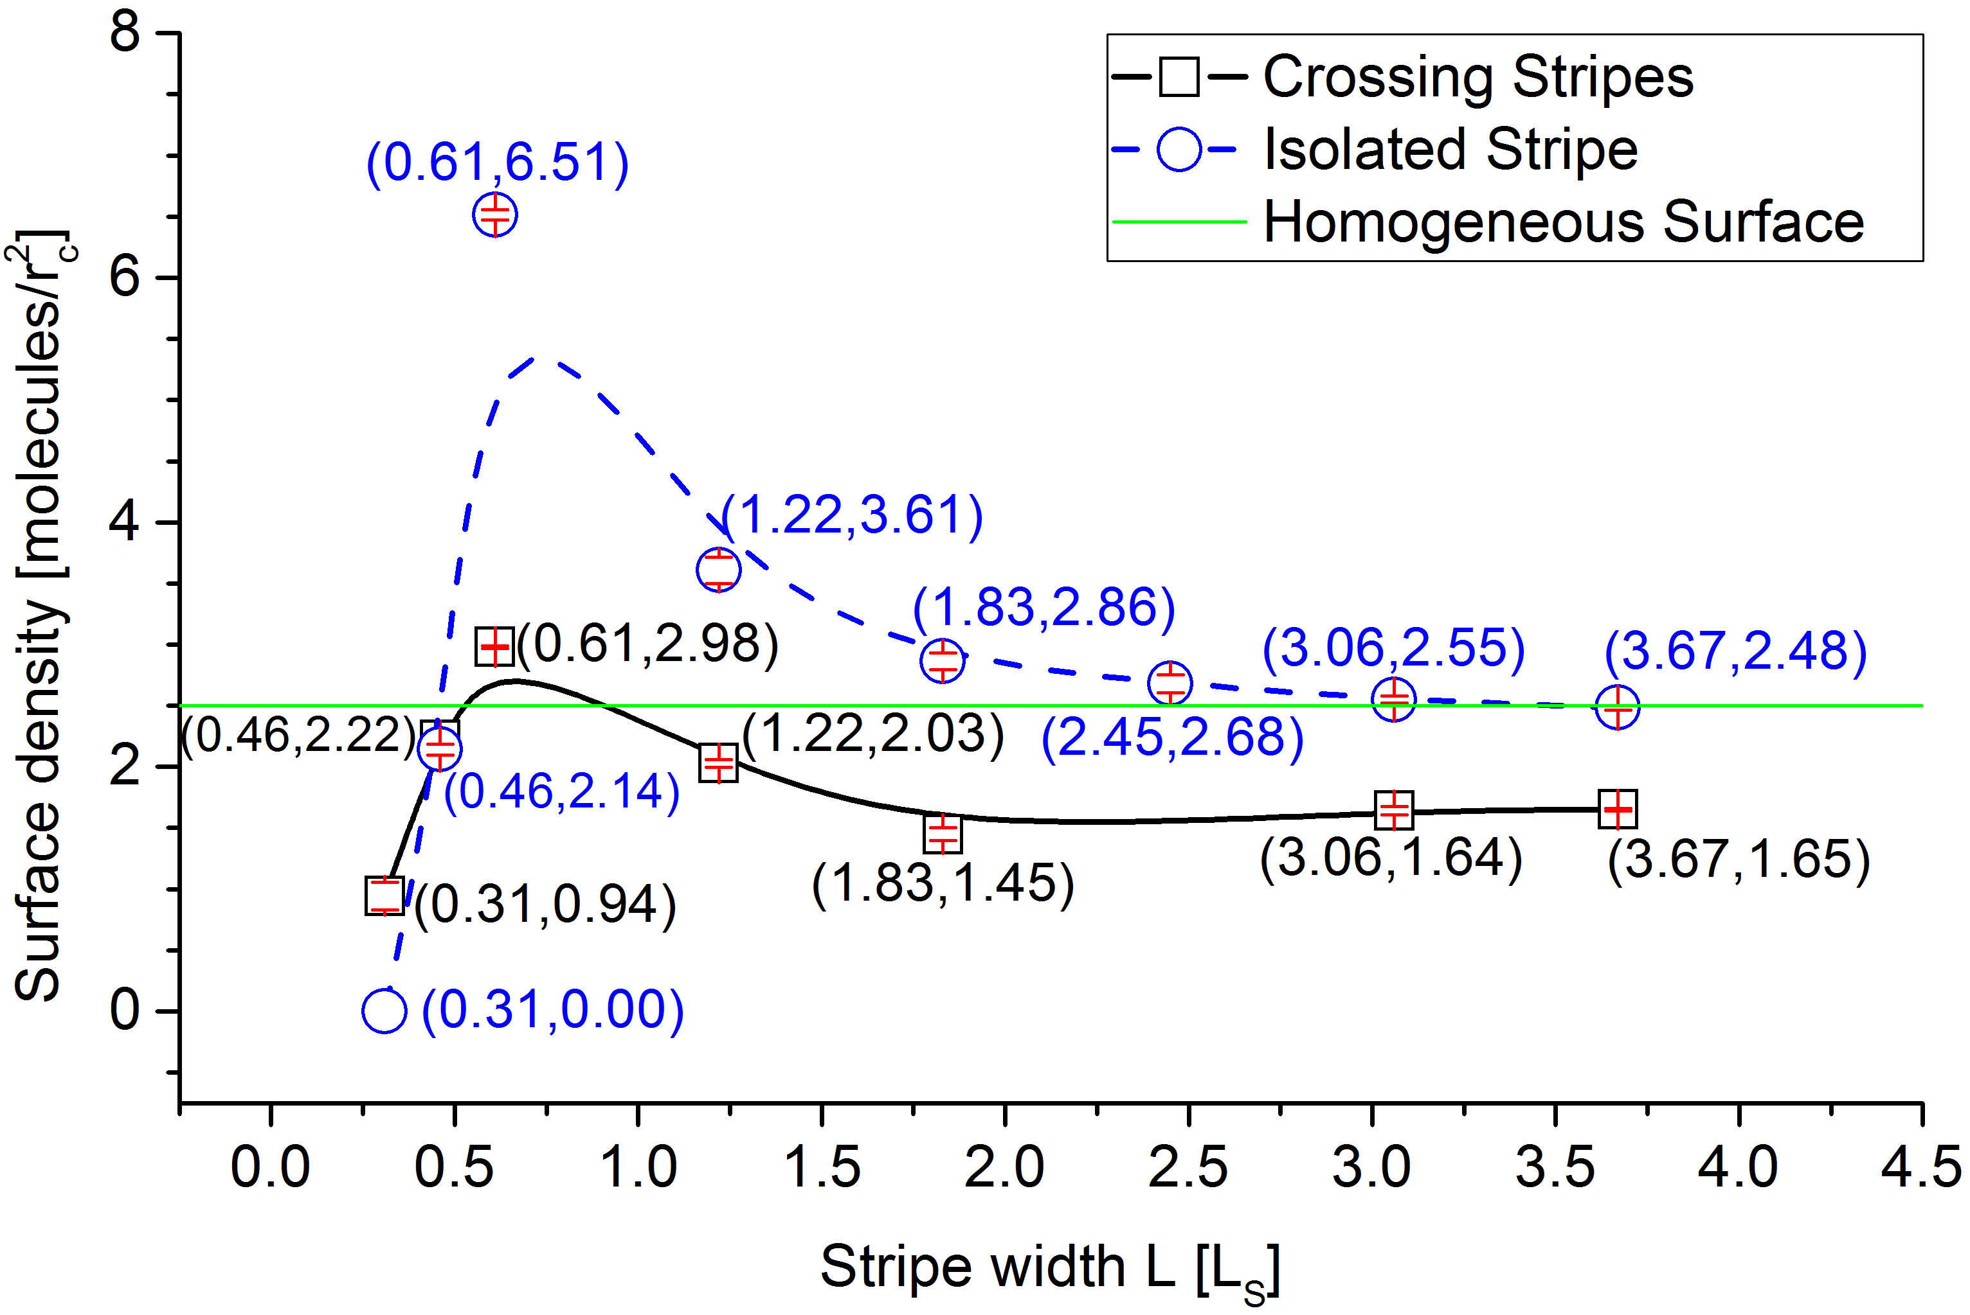
Fig. 5 Surface density as a function of stripe width L for surfactant aggregates adsorbed on perpendicularly crossing stripes (squares) and isolated stripes (circles). Surface density and L are expressed in units of molecules per r_{c}² and L_{S}, respectively. The standard errors are slightly smaller than size of the symbols. The green solid line indicates the adsorbed surfactants density on a homogeneous hydrophobic surface fully covered by surfactants (2.50 molecules/r_{c}²).

3.2 Adsorption on steps

Morphology of self-assembled aggregates
In Fig. 6 we show representative simulation snapshots of surfactants adsorbed on hydrophobic steps (left panels) and isolated hydrophobic stripes (right panels). In each panel of Fig. 6, we provide a close-up view perpendicular to the axis of the surface plane and a side view. From top to bottom, the results are obtained on steps whose net hydrophobic length, L_{Net}, equals 0.61L_{S}, 1.22L_{S}, 1.83L_{S}, 2.45L_{S}, and 3.06L_{S}, respectively. L_{Net} is defined as the sum of the width of the step terrace, L_{T}, and the height of the step wall, L_{W}. For all steps in Fig. 6a–e, L_{T} is 0.46L_{S} and the depth of step wall is L_{W} = 0.15L_{S}, 0.76L_{S}, 1.37L_{S}, 1.99L_{S}, and 2.60L_{S}, respectively. We compare the results to those obtained on isolated stripes of width L equal to L_{Net} (L_{Net} = L_{T} + L_{W} = L).
When L_{Net} is less than approximately twice the length of one surfactant molecule (e.g., L_{Net} = 0.61L_{S}, 1.22L_{S}, and 1.83L_{S}), a common feature shared by the adsorbed aggregates on the steps (Fig. 6a–c) and the isolated stripes (Fig. 6f–h) is that the surfactants self-assemble yielding a hemi-cylinder. The tail groups adsorb close to the surfaces, while the head groups extend to the aqueous phase. The curvature within the adsorbed aggregates decreases with increasing L_{Net}, as expected. We highlight that the curvature of the hemi-cylinders obtained on the steps is more pronounced than that of those formed on the correspondent isolated stripes. In particular, on the steps characterized by L_{Net} = 1.22L_{S} (L_{W} = 0.76L_{S}) and 1.83L_{S} (L_{W} = 1.37L_{S}) the surfactant aggregates have a tendency to be deformed and thinned over the step edge (see Fig. 6b and c). Analysis of the density profiles (Fig. 7a) suggests that these structures are also stretched, in the sense that the surfactant density is lower compared to the correspondent structures obtained on the isolated stripes. This observations is qualitatively consistent with experimental studies by Schniepp and co-workers,¹⁹ who found elongated structures of SDS micelles on topographic steps obtained on gold surfaces. The results are also in qualitative agreement with previous MD simulation results by Sammalkorpi et al.,³⁸ who provided evidence of the preferential orientation of SDS surfactant and dodecane along the rising steps on graphite.
On the other hand, on steps characterized by L_{Net} = 2.45L_{S} (L_{W} = 1.99L_{S}) and 3.06L_{S} (L_{W} = 2.60L_{S}), visual inspection reveals that the surfactants do not adsorb on the step terraces, self-assembling into a thin film adsorbed on the step wall (Fig. 6d and e). On the corresponding isolated stripes the surfactants cover the entire hydrophobic surfaces, yielding monolayer structures (Fig. 6i and j). We speculate that the surfactants do not cover the entire hydrophobic surface exposed to water on the steps considered in Fig. 6d and e because to do so the resultant aggregate would be extended over the step edge. The resultant penalty in the form of elastic energy that would distort the aggregate adsorbed on both the step wall and terrace would be larger than the energy penalty correspondent to exposing the step terrace to water.
We calculated in-plane density profiles for the surfactant tail and head groups within planes perpendicular to the surface. The results are shown in Fig. 7 for steps and isolated stripes with L_{Net} = 1.22L_{S} (L_{W} = 0.76L_{S}) and 3.06L_{S} (L_{W} = 2.60L_{S}). When L_{Net} = 1.22L_{S}, the density profiles show that the tail groups predominantly adsorb on hydrophobic surfaces (top panels of Fig. 7a). The head groups are exposed to the outside of the hemi-cylinders (bottom panels of Fig. 7a). The head density profiles display low densities on the step, compared with those of the isolated stripe. When L_{Net} = 3.06L_{S}, the density profiles confirm that the adsorbed aggregates have the morphology of monolayers on the step and on the isolated stripe (Fig. 7b). The results show no evidence of either surfactant tails or heads adsorbing on the step terrace, as expected (left panels of Fig. 7b).

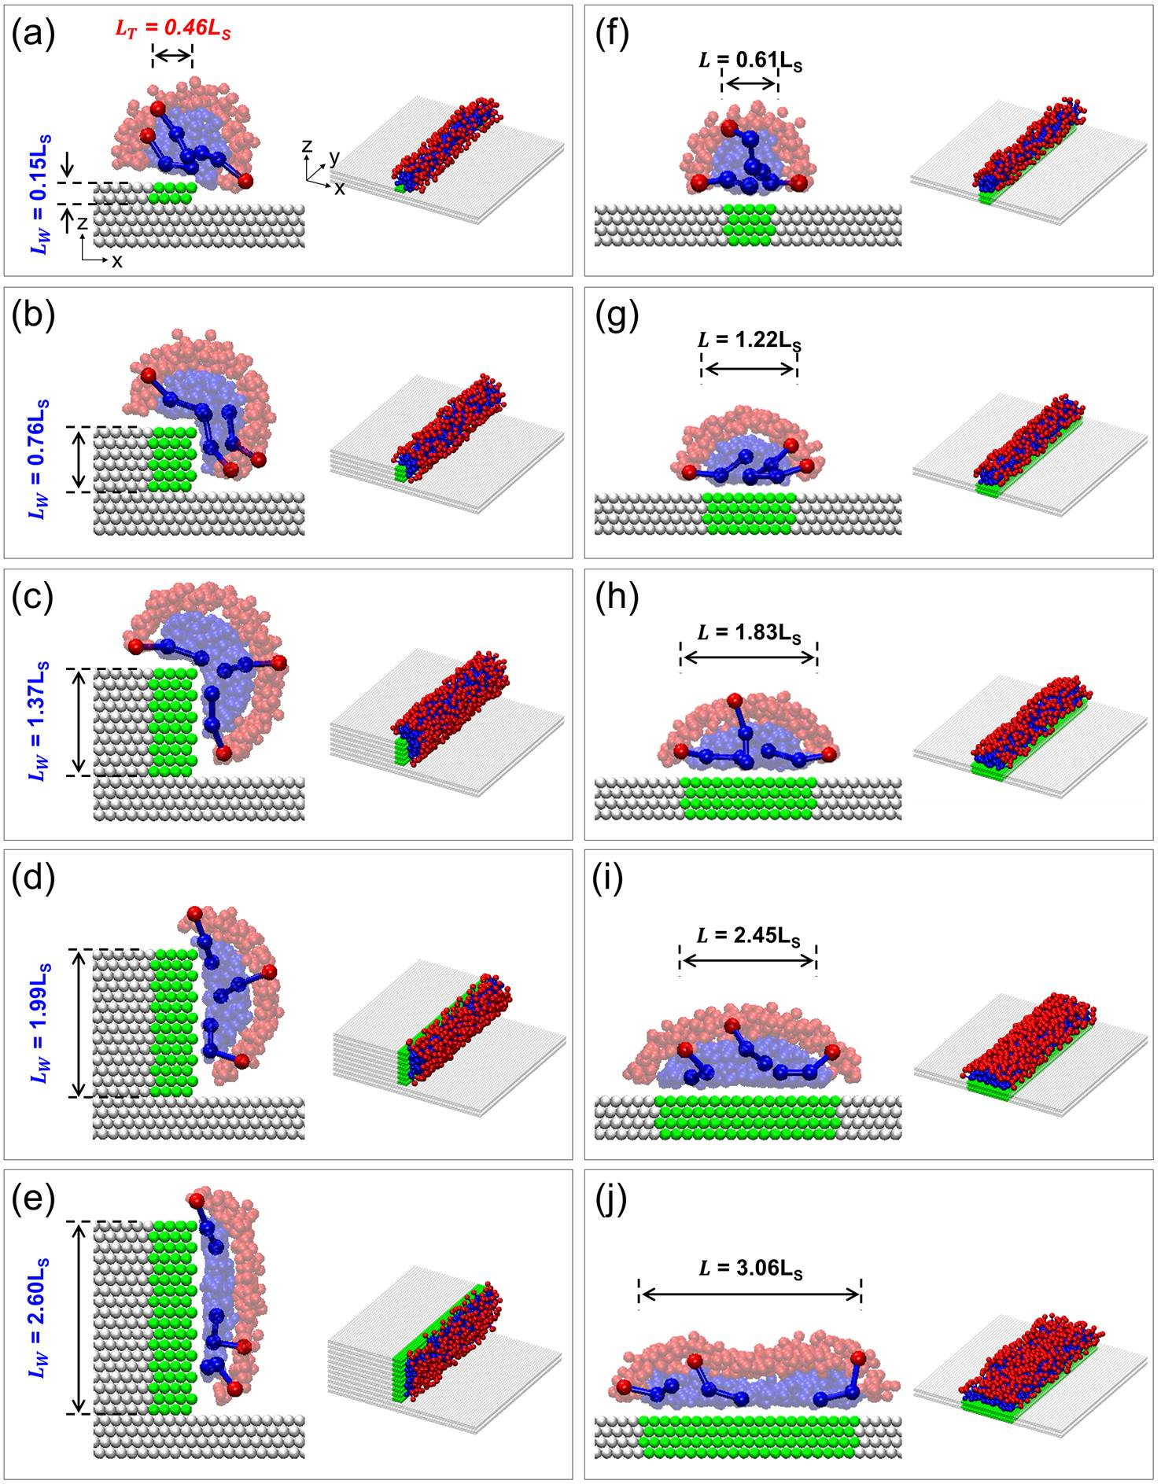
Fig. 6 Representative simulation snapshots of surfactant aggregates adsorbed on steps (left) and isolated stripes (right) of L_{Net} = (a, f) 0.61L_{S}, (b, g) 1.22L_{S}, (c, h) 1.83L_{S}, (d, i) 2.45L_{S}, and (e, j) 3.06L_{S}. Note that L_{Net} is defined as sum of the width of step terrace L_{T} and the height of step wall L_{W}, and is identical to the width of isolated stripe L (L_{Net} = L_{T} + L_{W} = L). Water beads are not shown for clarity. The colour code is the same as that used in Fig. 2.

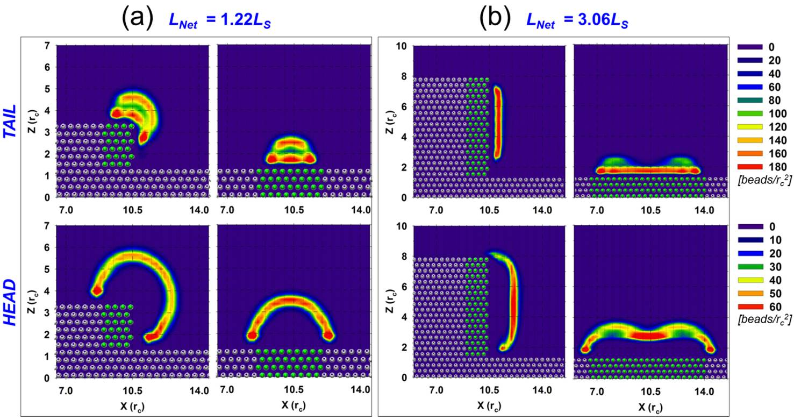
Fig. 7 In-plane density profiles for surfactant tails (top) and heads (bottom) adsorbed on steps and isolated stripes of L_{Net} = (a) 1.22L_{S} and (b) 3.06L_{S}. The results are obtained along planes perpendicular to the surface. Surface densities are expressed as number of beads per r_{c}².

Amount of surfactants adsorbed
In Fig. 8 we show the surface density against net hydrophobic length L_{Net} for the surfactant adsorption on steps and isolated stripes. The surface density was quantified by dividing the time-average number of surfactant molecules adsorbed on the various surfaces by the hydrophobic surface area. In general, and on both substrates, as L_{Net} increases the density of surfactants adsorbed decreases, because of the morphological transition from hemi-cylinders to monolayers discussed above. Surprisingly, for L_{Net} between 0.61L_{S} and 1.83L_{S}, the amount adsorbed on the steps is greater than that adsorbed on the isolated stripes. Evidently, the increased curvature of the self-assembled aggregate promoted by the corner allows for a larger number of surfactants adsorbed compared to the aggregate formed on an isolated stripe for this range of lengths. No significant thinning of the adsorbed aggregate occurs, in fact the opposite takes place since the density of adsorbed surfactant molecules increases. The trend changes when L_{Net} ranges between 2.45L_{S} and 3.67L_{S}. In this regime our results show that the density of surfactants adsorbed on the steps is significantly less compared to that on the isolated stripes, as well as on the homogeneous hydrophobic surface. Visual inspection of the snapshots of Fig. 6 demonstrates that the lower density of adsorbed surfactants is due to the fact that the terraces of the steps are not covered by adsorbed surfactants. By mapping the conditions at which the amount adsorbed on the steps is comparable to that adsorbed on the isolated stripes (L_{Net} = ~ 2.2L_{S}, in correspondence to which ~ 2.7 surfactant molecules adsorb per r_{c}²) we identify the system geometry for which the elastic deformation of the surfactant self-assembled aggregate becomes an important parameter to predict surfactant behaviour. These conditions, within the geometry considered in our calculations, correspond to the step with L_{T} = 0.46L_{S} and L_{W} = 1.74L_{S}.

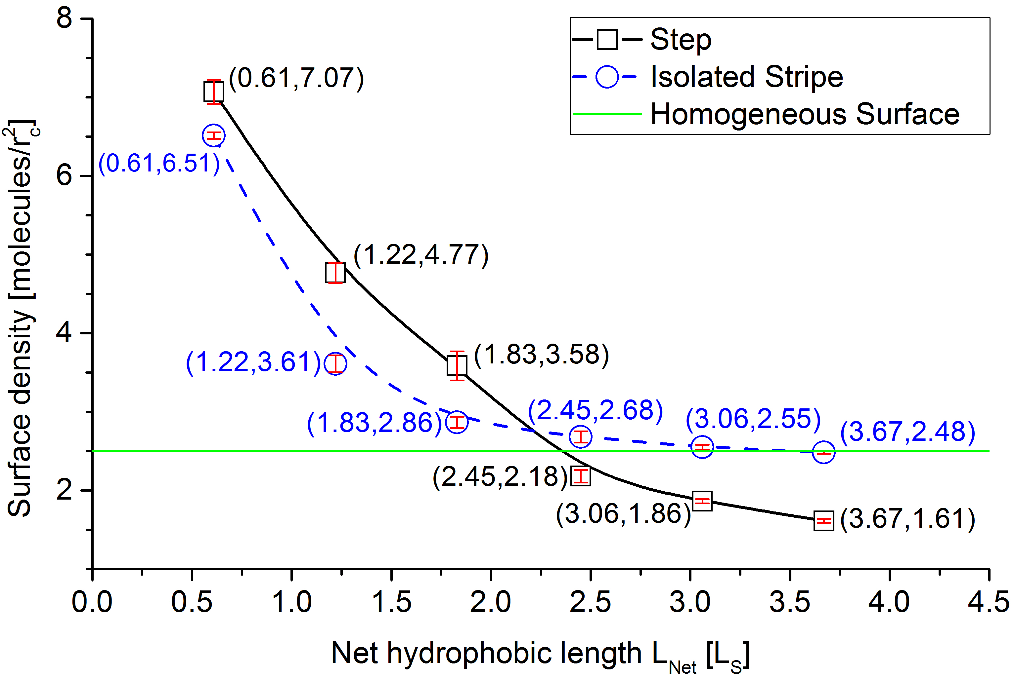
Fig. 8 Surface density as a function of L_{Net} for surfactant aggregates adsorbed on steps (squares) and isolated stripes (circles). Surface density and L_{Net} are expressed in units of molecules per r_{c}² and L_{S}, respectively. The standard errors are slightly smaller than size of the symbols. The green solid line indicates the adsorbed surfactants density on a homogeneous hydrophobic surface fully covered by surfactants (2.50 molecules/r_{c}²).

Modelling surfactant adsorption on step edges via a simple free energy approach
A simple free energy model can perhaps explain, qualitatively, the adsorption results discussed above. Before the surfactants adsorb on the hydrophobic step edges, the free energy of the ‘exposed surface’ can be expressed as:
U_{Exposed Surface} = (A_{T} + A_{W}) γ_{H} (1)
In eqn (1) A_{T} and A_{W} are surface area of the step terrace and the step wall, respectively, while γ_{H} is the interfacial tension of the interface between water and the hydrophobic surface.
When the hydrophobic surface is completely covered by surfactants, the free energy of the ‘covered surface’ can be expressed as:
U_{Covered Surface} = (A_{T} + A_{W}) γ_{H−S} + E_{Stretching} (2)
In eqn (2) γ_{H‒S} is the interfacial tension of the interface between the hydrophobic surface and the surfactants. In this approximation, this term includes the interfacial tension between the surfactant head groups and the surrounding water, as well as that between the surfactant tail groups and the underlying surface. The term E_{Stretching} represents a penalty due to the elastic deformation of the surfactant self-assembled film due to the curvature imposed by the step edge, i.e., the fact that the density of adsorbed surfactant molecules becomes less. Our results, discussed in Fig. 8, suggest that when L_{Net} is less than ~ 2.2 L_{S}, E_{Stretching} is not a penalty, as the number of favourable contacts between tail groups increases; on the other hand, E_{Stretching} is a penalty for larger L_{Net} because the surfactant film at the edge becomes less packed, with a consequent decrease in the contacts between tail groups. We expect that the absolute value of E_{Stretching} for the system simulated here will depend on the geometry of the step edge.
We tested this expectation by conducting simulations of steps (1) with different convex angles, and (2) for systems containing only surfactants with larger head groups (i.e., two beads per head group). The results were compared once equilibrium was reached and the bulk surfactant concentration was always of ~ 3 CMC. We also simulated surfactant adsorption on edges for surfactant mixtures containing both one- and two-bead head groups. In these simulations we did not attempt to quantify the CMC, but we started the simulations from systems composed of equimolar composition of the two surfactants considered. As surfactants adsorbed, we added additional surfactants to the bulk. While the surfactants adsorbed varied in the various cases discussed below, we maintained approximately 200 surfactants in the bulk by adding surfactants in an equimolar ratio. These surfactants were sufficient to yield 3–5 micellar aggregates in the bulk.

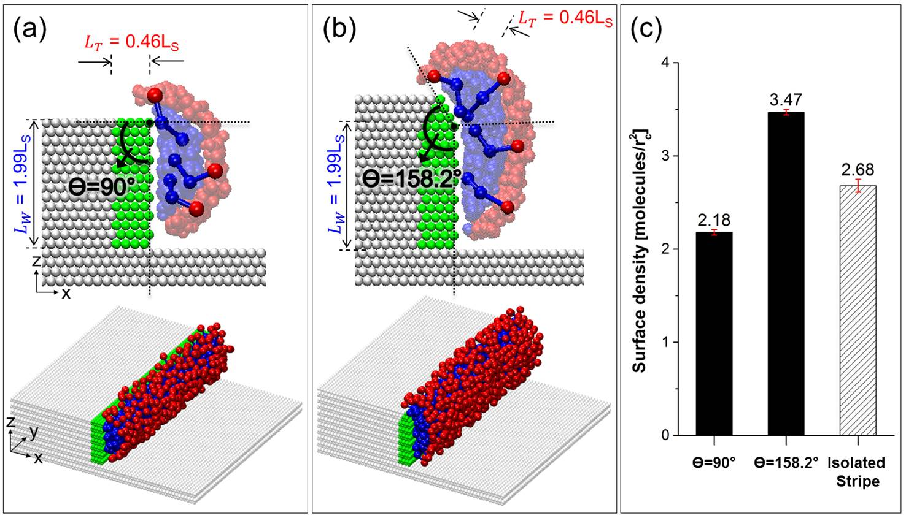
Fig. 9 Representative simulation snapshots for adsorbed surfactant films on steps of convex angle θ = (a) 90° and (b) 158.2°. The results are obtained for the step of L_{Net} = 2.45L_{S} (L_{T} = 0.46L_{S} and L_{W} = 1.99L_{S}). The colour code is the same as that used in Fig. 2. (c) Amount adsorbed in units of molecules/r_{c}² at constant bulk conditions obtained for panels (a) and (b) and the isolated stripe at similar L_{Net} (L = 2.45L_{S}).

In Fig. 9a and b we compare simulation snapshots for the surfactant aggregates adsorbed on steps with convex angle θ = 90° and 158.2°, respectively. These simulations were conducted for steps characterized by L_{Net} = 2.45L_{S} (L_{T} = 0.46L_{S} and L_{W} = 1.99L_{S}). The results demonstrate that when the convex angle increases, surfactant molecules cover the entire hydrophobic surface. This is clearly a consequence of the decreased elastic penalty, due to the reduced imposed curvature on the adsorbed surfactant film. In addition, and perhaps surprisingly, we found that the density of surfactants adsorbed on the step with convex angle θ = 158.2° is larger than those observed on either the step with convex angle θ = 90° or the isolated stripe (Fig. 9c). The latter result is consistent with the observation, discussed in Fig. 7, that increasing the curvature of the self-assembled film leads to larger available space for the surfactant molecules to pack. The present analysis further suggests that this occurs, provided the deformation is not so large to induce elastic penalties.
Representative simulation snapshots obtained for systems containing surfactants with different head groups compared to those discussed so far are shown in Fig. 10. For clarity, we refer to the surfactants with head groups composed by one bead as H1, whereas we refer to those with two beads per head group as H2. In Fig. 10a and Fig. 10b we compare the results obtained for H1 and H2 surfactants, respectively, on the same step edge. While H1 surfactants are not able to cover the entire step edge, as discussed above, because of an elastic energy penalty, we observe that the H2 surfactants cover the entire step edge. The larger head groups allow the H2 surfactants to form aggregates with smaller curvature with lower, if any, elastic energy penalty. This behaviour seems consistent with the self-assembly of surfactants in bulk solutions, in which case surfactant molecules with large head groups with respect to the tail groups, and therefore small packing parameters, usually form spherical micelles.^{48, 49}
In Fig. 10c we present the results obtained when a mixture containing both H1 and H2 surfactants was simulated in the presence of the step edge considered in the rest of Fig. 10. We find that the surfactant mixture yields an aggregate that covers the entire surface of the step. In Fig. 10d we quantify the amount of surfactants adsorbed on the step edges in the various cases considered. The results show that the amount of mixed surfactants adsorbed is significantly greater than that of either pure H1 or pure H2 surfactants, indicating a synergistic effect due to the simultaneous presence of both large and small head groups, possibly due to the entropy of mixing. It is possible that this synergistic effect lowers the elastic energy penalty, although it is also possible that the mixed surfactant system takes advantage of complex steric effects to maximise adsorption. We note however that H1 adsorption on the isolated stripe has higher density than the mixed surfactant system on the step: clearly, steric effects due to the larger head group of H2 are responsible for this observation. The results for the adsorption from mixed surfactant system, shown in Fig. 10d, show that the amount adsorbed on the isolated stripe is similar to that adsorbed on the step, confirming that for the mixed surfactant aggregate the energy penalty due to aggregate stretching is minimal. In fact, the results suggest that the entropic advantage of adsorbing a mixed surfactant system is much larger than the energetic penalty due to the step. We compared the composition of the aggregates adsorbed on the step vs. that adsorbed on the isolated stripe, finding that while adsorption on the isolated stripe is equimolar, that on the step is slightly enriched in H2 (H1:H2 = 46:54).

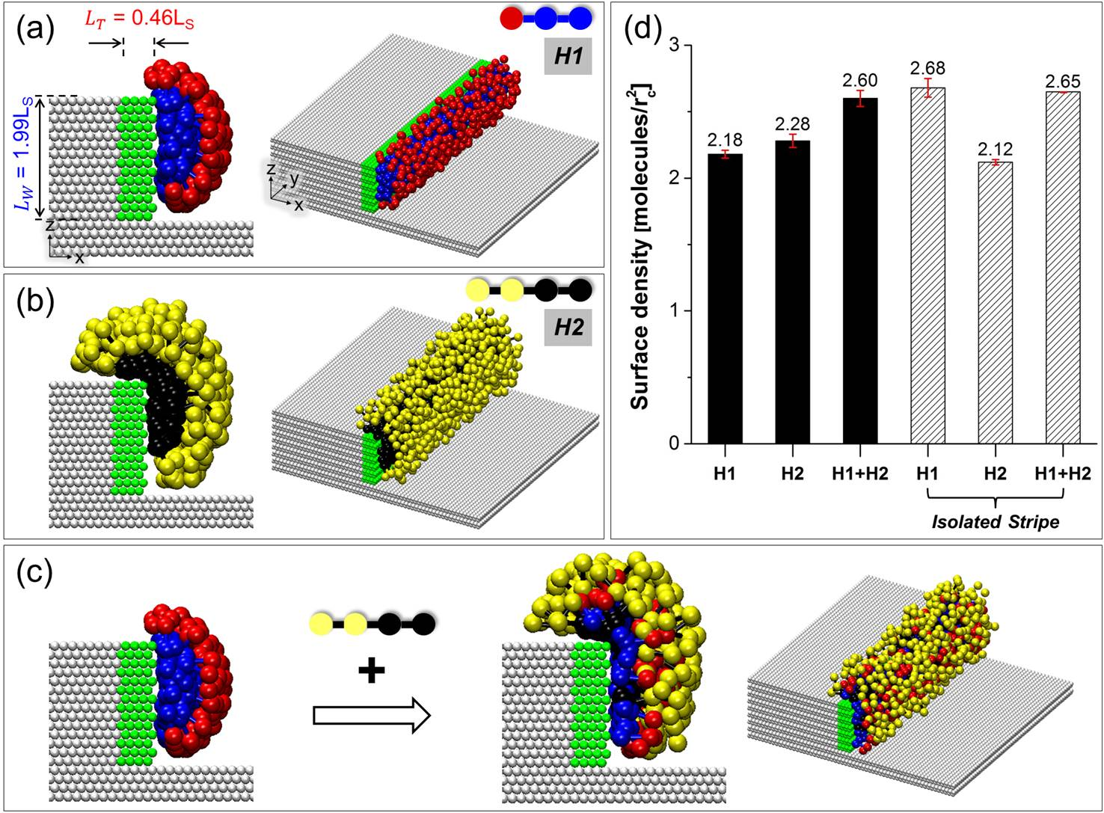
Fig. 10 Representative simulation snapshots for adsorbed surfactant films on steps within the systems of (a) one-head surfactant H1, (b) two-head surfactant H2, and (c) equimolar mixture of H1 and H2. The results are obtained for the step of L_{Net} = 2.45L_{S} (L_{T} = 0.46L_{S} and L_{W} = 1.99L_{S}). The colour code is the same as that used in Fig. 2. In the case of H2, head beads and tail beads are shown as yellow and black, respectively. (d) Amount adsorbed in units of molecules/r_{c}² at constant bulk conditions obtained for panels (a)–(c) and for the isolated stripe of the same L_{Net} (L = 2.45L_{S}) in the presence of pure H1 and pure H2.

Returning to eqn (1) and (2), when surfactant adsorption is partial and the terrace of the edge is depleted of surfactants, the free energy of the partially covered edges can be written as:
U_{Partially Covered} = A_{T} γ_{H} + A_{W} γ_{H−S} + E_{Stretching} (3)
In this case, E_{Stretching} is 0, because the surfactant aggregate is not stretched across the step edge. However, our results show that the surfactant adsorption depends strongly on the length L_{W} (see Fig. 6d and e). Note that because the step is infinite in one direction, the surface areas A_{T} and A_{W} are proportional to L_{T} and L_{W}, respectively. It is possible that as the relative length of L_{T} and L_{W} change, adsorption can be modulated. In other words, if L_{T} increases, then the penalty due of not covering the terrace of the step could be larger than the penalty due to the elastic deformation of the film needed to cover both sides of the step. It would also be possible, under appropriate conditions, that the surfactant aggregates form on both sides of the step, but leave the edge uncovered not to experience the elastic deformation.
To test our expectations, we conducted a systematic investigation in which we changed L_{T} and L_{W} for a step with convex angle 90° and we exposed this step to a system containing only the H1 surfactants. The results are summarised in the diagram shown in Fig. 11. In Fig. 12 we provide selected simulation snapshots to illustrate the various systems observed. The aggregate structures on the steps can be divided into: hemi-spheres or hemi-cylinders (i.e., L_{Net} is too small to allow complete adsorption), surfactant films covering the whole hydrophobic surface of the step, surfactant films only on the step wall, and complete adsorbed surfactant layer on the step wall with partial adsorption on the step terrace. The L_{T}/L_{W} ratio seems an important parameter in controlling the resultant morphology of the self-assembled aggregate. For instance, if a ratio of L_{T}/L_{W} is increased from 0.14 (L_{T} = 0.46L_{S} and L_{W} = 3.21L_{S}), at which conditions the surfactant film only covers the wall of the step, to either 0.33 (by increasing L_{T}) or 0.34 (by decreasing L_{W}), it is possible to obtain a surfactant film on the whole hydrophobic surface of the step. In our systems we never observed cases in which both terrace and wall were covered, but the edge was not covered. In some cases it can be seen from Fig. 11 that for a fixed height of the step wall, a non-monotonic change in the structure of the surfactant aggregate occurs as the width of the step terrace increases. For example, when L_{W} = 2.60L_{S} the adsorbed surfactant films adsorb on the step wall only at L_{T} = 0.15L_{S}, yield a partial adsorption on the terrace at L_{T} = 0.31L_{S}, adsorb only on the step wall at L_{T} = 0.46L_{S}, yield a partial adsorption on the terrace at L_{T} = 0.61L_{S}, and then adsorb on the entire surface at L_{T} = 0.76L_{S}. The aggregates that partially cover the terrace cannot be explained with the simple model derived above, as they show a local deformation of the aggregate. It is possible that these structures are evidence of long-lived metastable states. It is also possible that such aggregates are stable, and are representative of conditions at which the elastic penalty due to the partial distortion of surfactant aggregate is compensated by the reduction in interfacial energy due to the surfactants covering part of the terrace surface. Because the aggregate structure changes with stripe width, as we discussed in our prior contributions, the elastic penalty due to aggregate distortion is in fact expected to depend, perhaps weakly, on the height of the step wall. Discriminating among these two possibilities is beyond the scopes of the present manuscript.

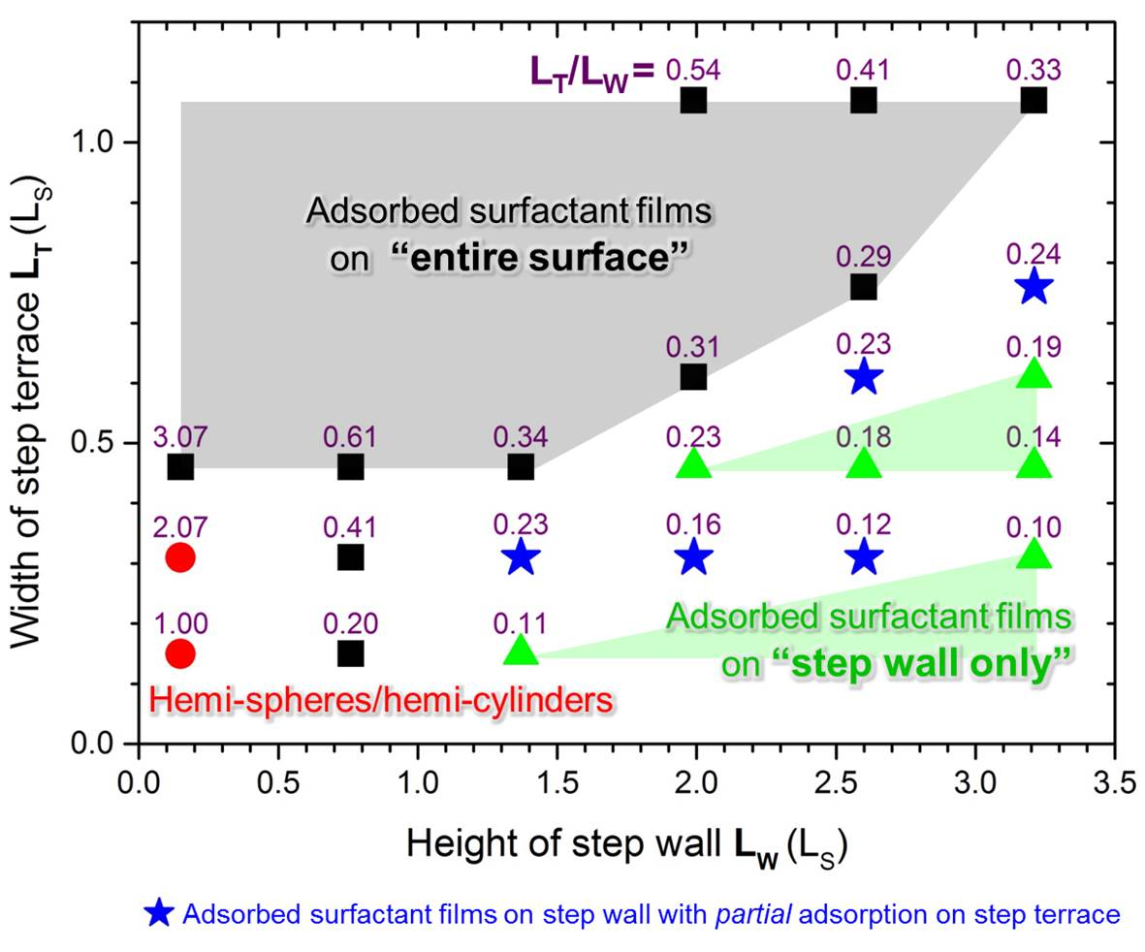
Fig. 11 Adsorbed surfactant film morphology on steps as a function of width of step terrace L_{T} and depth of step wall L_{W}; namely, adsorbed surfactant films on entire surface (black squares), adsorbed surfactant films on step wall with partial adsorption on step terrace (blue stars), adsorbed surfactant films on step wall only (green triangles), and hemi-spheres/hemi-cylinders (red circles). Colours of symbols correspond to coloured text explanations.

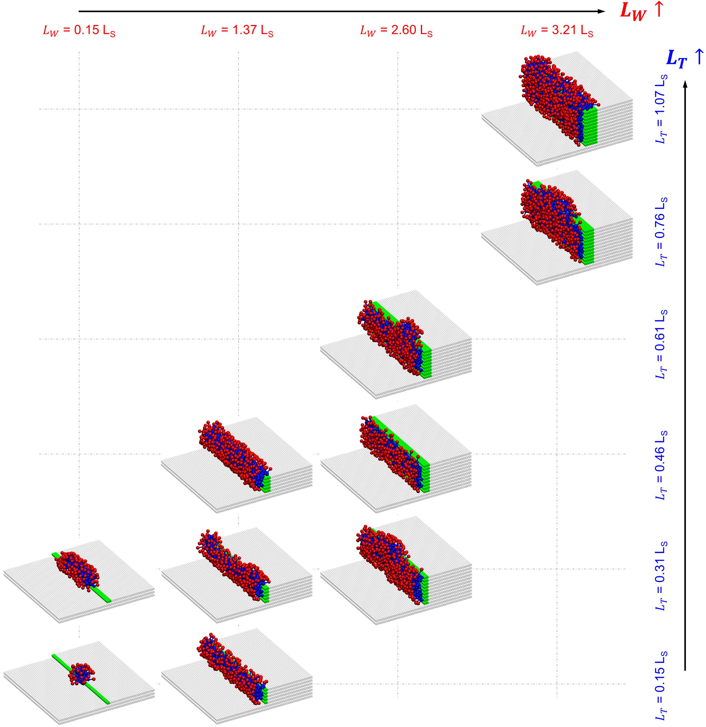
Fig. 12 Representative simulation snapshots for adsorbed surfactant films on steps of selected systems. The colour code is the same as that used in Fig. 2.

4. CONCLUSIONS
We employed coarse-grained dissipative particle dynamics (DPD) simulations to study the adsorption and aggregation of surfactants on heterogeneous patterned surfaces. The patterns considered were perpendicularly crossing stripes and steps formed by hydrophobic surfaces surrounded by model surfaces on which the surfactants could not adsorb. All simulations were conducted at constant bulk concentration of the surfactant (~ 3 CMC). The results were compared to those obtained for surfactant adsorption on isolated stripes. On both patterns we found evidence for defects introducing significant penalties on adsorption. The defects are represented by either the crossing region, where two perpendicular stripes intersect, or by the edge of the step, which is accentuated by the convex angle. In the case of adsorption on perpendicularly crossing stripes it was found that when the surfactants cover the complete available hydrophobic surface an energetic penalty is induced where the stripes intersect. This penalty is relatively stronger for stripes of width comparable to the length of a surfactant, in which case complete surface coverage can be difficult to achieve for sufficiently high surface densities of intersection points within a surface. In the case of adsorption on the steps, we used a simple free energy model to illustrate the effect of geometric parameters on both the amount of surfactants adsorbed and on the morphology of the surfactant aggregates self-assembled on the surfaces. The model, albeit simple, suggests that energetic penalties due to changes in the geometry of the self-assembled surfactant aggregates could prevent the surfactants to completely cover hydrophobic regions available on a surface. Based on this observation, adding surfactants whose molecular structure can reduce the elastic penalty is found to enhance surface coverage. We generated a generalised diagram that could be useful for translating our simulations to the general case of surfactants adsorption on heterogeneous surfaces. Overall, the results presented suggest that surface heterogeneity can significantly reduce the amount of surfactants adsorbed on a surface, with the important consequence that portions of the hydrophobic surface may remain exposed even when the surfactant concentration is much larger than the critical micelle concentration. The results also suggest possible strategies for enhancing surface coverage, for example using mixtures of surfactants appropriate for the morphology of the substrate of interest. The resultant insights could be useful for developing advanced applications such as manufacturing of new coatings and materials and nanofabrication, as well as for traditional, yet highly important ones such as mineral flotation.

ACKNOWLEDGEMENTS
The authors acknowledge financial support from the Department of Chemical Engineering at the University College London and from the US National Science Foundation (NSF) under Grant No. CMMI–1068705. Allocations of computing time were provided by Legion Supercomputer at the University College London, the National Energy Research Scientific Computing Centre (NERSC) at Lawrence Berkeley National Laboratory, Berkeley, CA, and from the Oklahoma Supercomputer Centre for Education and Research (OSCER), in Norman, OK. The authors also acknowledge the support of the Institute for Applied Surfactant Research with member companies CESI Chemical, Church & Dwight, Clorox, ConocoPhillips, Ecolab, Halliburton Services, Huntsman, Ingevity, Novus, Procter and Gamble, Sasol, SC Johnson and Shell Chemical

REFERENCES
1. M. Marquez, K. Patel, A. D. W. Carswell, D. W. Schmidtke and B. P. Grady, Langmuir, 2006, 22, 8010-8016.
2. M. Marquez, S. Kim, J. Jung, N. Truong, D. Teeters and B. P. Grady, Langmuir, 2007, 23, 10008-10019.
3. S. Hanumansetty and E. O’Rear, Langmuir, 2014, 30, 3665-3672.
4. S. Iglauer, Y. Wu, P. Shuler, Y. Tang and W. A. Goddard Iii, J. Pet. Sci. Eng., 2010, 71, 23-29.
5. A. Mohamed, T. Ardyani, S. A. Bakar, P. Brown, M. Hollamby, M. Sagisaka and J. Eastoe, J. Adv. Colloid Interface Sci., 2016, 230, 54-69.
6. H. Kato, A. Nakamura and M. Horie, RSC Adv., 2014, 4, 2129-2136.
7. M. Suttipong and A. Striolo, RSC Adv., 2015, 5, 90049-90060.
8. F. Tiberg, J. Brinck and L. Grant, Curr. Opin. Colloid Interface Sci., 1999, 4, 411-419.
9. M. Soria-Sánchez, A. Maroto-Valiente, A. Guerrero-Ruiz and D. M. Nevskaia, J. Colloid Interface Sci., 2010, 343, 194-199.
10. S. Manne and H. E. Gaub, Science, 1995, 270, 1480-1482.
11. S. Manne, J. P. Cleveland, H. E. Gaub, G. D. Stucky and P. K. Hansma, Langmuir, 1994, 10, 4409-4413.
12. P. C. Ke, Phys. Chem. Chem. Phys., 2007, 9, 439-447.
13. N. Mackiewicz, G. Surendran, H. Remita, B. Keita, G. Zhang, L. Nadjo, A. Hagege, E. Doris and C. Mioskowski, J. Am. Chem. Soc., 2008, 130, 8110-8111.
14. M. R. Farrow, P. J. Camp, P. J. Dowding and K. Lewtas, Phys. Chem. Chem. Phys., 2013, 15, 11653-11660.
15. N. R. Tummala and A. Striolo, Phys. Rev. E, 2009, 80, 021408.
16. J. M. Cases and F. Villieras, Langmuir, 1992, 8, 1251-1264.
17. L. Macakova, E. Blomberg and P. M. Claesson, Langmuir, 2007, 23, 12436-12444.
18. H. C. Schniepp, H. C. Shum, D. A. Saville and I. A. Aksay, J. Phys. Chem. B, 2007, 111, 8708-8712.
19. H. C. Schniepp, H. C. Shum, D. A. Saville and I. A. Aksay, J. Phys. Chem. C, 2008, 112, 14902-14906.
20. S. Q. Wu, L. Shi, L. B. Garfield, R. F. Tabor, A. Striolo and B. P. Grady, Langmuir, 2011, 27, 6091-6098.
21. N. Kumar, S. Garoff and R. D. Tilton, Langmuir, 2004, 20, 4446-4451.
22. S. Paria and K. C. Khilar, Adv. Colloid Interface Sci., 2004, 110, 75-95.
23. L. Mivehi, R. Bordes and K. Holmberg, Langmuir, 2011, 27, 7549-7557.
24. S. B. Velegol, B. D. Fleming, S. Biggs, E. J. Wanless and R. D. Tilton, Langmuir, 2000, 16, 2548-2556.
25. M. Suttipong, N. R. Tummala, A. Striolo, C. S. Batista and J. Fagan, Soft Matter, 2013, 9, 3712-3719.
26. N. R. Tummala and A. Striolo, J. Phys. Chem. B, 2008, 112, 1987-2000.
27. R. E. Lamont and W. A. Ducker, J. Am. Chem. Soc., 1998, 120, 7602-7607.
28. R. Atkin, V. S. J. Craig and S. Biggs, Langmuir, 2000, 16, 9374-9380.
29. H. Domínguez, Langmuir, 2009, 25, 9006-9011.
30. Z. Kiraly, G. H. Findenegg, E. Klumpp, H. Schlimper and D. I, Langmuir, 2001, 17, 2420-2425.
31. H. Domínguez, J. Phys. Chem. B, 2007, 111, 4054-4059.
32. A. G. Hsieh, C. Punckt, S. Korkut and I. A. Aksay, J. Phys. Chem. B, 2013, 117, 7950-7958.
33. P. C. Pavan, E. L. Crepaldi, A. de and J. B. Valim, Colloids Surf., A, 1999, 154, 399-410.
34. J. Radulovic, K. Sefiane and M. E. R. Shanahan, J. Colloid Interface Sci., 2009, 332, 497-504.
35. J. C. Schulz and G. G. Warr, Langmuir, 2002, 18, 3191-3197.
36. C. Gutig, B. P. Grady and A. Striolo, Langmuir, 2008, 24, 4806-4816.
37. D. Müter, T. Shin, B. Demé, P. Fratzl, O. Paris and G. H. Findenegg, J. Phys. Chem. Lett., 2010, 1, 1442-1446.
38. M. Sammalkorpi, A. Z. Panagiotopoulos and M. Haataja, J. Phys. Chem. B, 2008, 112, 12954-12961.
39. N. R. Tummala, B. P. Grady and A. Striolo, Phys. Chem. Chem. Phys., 2010, 12, 13137-13143.
40. M. Suttipong, B. P. Grady and A. Striolo, Phys. Chem. Chem. Phys., 2014, 16, 16388-16398.
41. M. Suttipong, B. P. Grady and A. Striolo, J. Phys. Chem. B, 2015, 119, 5467-5474.
42. P. J. Hoogerbrugge and J. Koelman, Europhys. Lett., 1992, 19, 155-160.
43. R. D. Groot and P. B. Warren, J. Chem. Phys., 1997, 107, 4423-4435.
44. H. T. Zhao and K. L. Nagy, J. Colloid Interface Sci., 2004, 274, 613-624.
45. S. Plimpton, Journal of Computational Physics, 1995, 117, 1-19.
46. P. Angelikopoulos and H. Bock, J. Phys. Chem. B, 2008, 112, 13793-13801.
47. E. J. Wanless, T. W. Davey and W. A. Ducker, Langmuir, 1997, 13, 4223-4228.
48. J. Eastoe, in Colloid Science, Blackwell Publishing Ltd., 2009, pp. 50-76.
49. D. Myers, in Surfactant Science and Technology, John Wiley & Sons, Inc., 2005, pp. 107-159.

