Unusually Large Band Gap Changes in Breathing Metal-Organic Framework Materials

Sanliang Lingª and Ben Slaterª
ª Department of Chemistry, University College London, 20 Gordon Street, London, WC1H 0AJ, United Kingdom
E-mails: s.ling@ucl.ac.uk; b.slater@ucl.ac.uk

Abstract: Many of the potential applications for metal organic frameworks (MOFs) focus on exploiting their porosity for molecular storage, release and separation where the functional behaviour is controlled by a subtle balance of host-guest interactions. Typically the host structure is relatively unperturbed by the presence of guests, however, a subset of metal organic frameworks exhibit dramatic phase change behaviour triggered by the adsorption of guests or other stimuli, for which the MIL-53 material is an archetype. In this work, we use density functional approaches to examine the electronic structure changes associated with changes of phase and density and find the associated change in band gaps can be larger than 1 eV for known MIL-53 type materials and hypothecated structures. Moreover, we show that internal pressure (via guest molecules) and external pressure can exert a major influence on the band gap size and gap states. The large response in electronic properties to breathing transitions in MOFs could be exploitable in future applications in resistive switching, phase change memory, piezoresistor, gas sensor, and thermochromic materials.
Keywords: MIL-53, metal organic frameworks, density functional theory, band gap, breathing
1. Introduction
Over the last ~15 years, there has been an explosion of successful reports of experimental synthesis of metal-organic frameworks (MOFs) with different compositions and porosities and potential applications. MOFs have proven to be valuable platforms for designing new solids with potential for solar energy harvesting and photocatalysis,¹⁻² optoelectronic devices³ and piezoresistors,⁴ where an informed design strategy requires insight into and control of electronic structure. As an exemplar application, MOF-based light-responsive photocatalysts and optoelectronic devices are rapidly developing areas and excellent recent reviews are available.⁵⁻⁷ In contrast to traditional inorganic photocatalysts, the electronic structure of MOFs may be tuned through the modification of the organic linker as well as the metal centre, opening up the possibility for the control of the electronic structure through linker functionalization, which greatly expands the palette of extrinsic defects that can be incorporated into the structure and with this, the scope of functionality. Although there is an increasing number of studies that demonstrate how MOF electronic properties have been tuned, to the best of our knowledge, all of these studies have been conducted on relatively rigid MOFs. In this work, we show that the well-studied material MIL-53 has a hitherto unreported property: an unusually broad range of possible band gap states that can be dialled up through temperature, external pressure, internal pressure and host functionalization.
MOFs have been and frequently still are referred to as semiconductors,⁸⁻⁹ with assumed or implied similarities with purely inorganic semiconductors for example. In the latter, semiconductivity results from delocalized valence and conduction bands through which charge transport occurs. Gradually, it is becoming more generally accepted that MOFs are often different from classical inorganic semiconductors and should be considered as periodic arrays of self-assembled molecules that retain their individual, characteristic, discrete molecular absorption modes. There is now a general consensus that the highest occupied molecular orbital - lowest unoccupied molecular orbital (HOMO-LUMO) or the highest occupied crystal orbital - lowest unoccupied crystal orbital (HOCO-LUCO) terminology is more appropriate to describe the electronic structure of non-conducting MOFs, although the more widespread parlance of band gap terminology is still de facto and we will refer to both band gaps and HOMO-LUMO nomenclature in this work.
The MOF literature is dominated by synthesis and characterisation reports of new materials and input from theory typically focuses on rationalising observation through classical simulations of host-guest interactions. Nevertheless, there are an increasing number of electronic studies of MOFs which date back more than decade: early work of Dovesi reported a high-level ab initio study of the electronic properties of MOF-5,¹⁰ through tight-binding calculations, Kuc et al. found the band gaps of a series of Zn-based isoreticular MOFs (IRMOFs) are determined by the carbon sp² states of the organic linkers and longer linkers yield smaller band gaps.⁹ In a recent density functional theory (DFT) study by Pham et al., halogen functionalization of the organic linkers of IRMOFs was found to modify the band gaps and also affect the absolute positions of the valence band maxima.¹¹ The nature of the metal centres also affects electronic properties; using DFT, Fuentes-Cabrera et al. studied IRMOF1 with different metal centres, including Be, Mg, Ca, Zn and Cd, and found all these materials possess similar band gaps but distinct conduction band splitting, and that the metallicity can be influenced by selective metal doping.¹² Tunable electronic properties of IRMOFs have been verified in different experiments. For example, in a recent UV/Vis spectroscopy experiment by Gascon et al., it was reported the band gaps of IRMOFs are conditioned by the organic linkers of IRMOFs, and that 1,4- or 2,6-naphthalenedicarboxylic acid organic linkers yielded the smallest band gaps (~ 3.3 eV) .¹³ In another experiment by Lin et al., it was shown that the band gaps of Zn-based MOFs can be tuned by changing the cluster sizes of the secondary building unit or the conjugation of the organic linker.¹⁴ An indirect example of the influence upon electronic properties is that of Brozek et al. who, by post-synthetic ion metathesis, have incorporated Ti³⁺, V²⁺, Cr²⁺, Cr³⁺, Mn²⁺, and Fe²⁺ into MOF-5, and it was demonstrated some of these materials show improved catalytic activities over other MOFs.¹⁵ Studies by Chizallet et al. have also shown catalytic activity for transesterification processes on ZIF-8,¹⁶⁻¹⁷ where surface species on this material has been suggested to be the active centres, indicating opportunities for tuning bulk and surface electronic structures for particular applications.
In the quest for the development of MOFs for electronic applications and devices, much effort has been focussed upon making conductive MOFs,¹⁸⁻²³ either intrinsic conductors,²²⁻²³ or through adsorption of small molecules inside pores that leads to conductive channels within the structure.¹⁸⁻²¹ Recently Kobayashi et al. reported a p-type semiconducting Cu[Ni(pdt)₂] featuring one-dimensional channels that showed, a 10⁴ increase in conductivity to 1x10⁻⁴ S/cm, upon exposure to I₂ vapor.¹⁸ In another important study, Talin et al. found that by infiltrating HKUST-1 with TCNQ molecules, the electrical conductivity of the material was increased by six orders of magnitude to 7x10⁻² S/cm.¹⁹ In addition to molecular loading, other methods have also been developed to increase the electrical conductivity of MOFs, e.g. Fernandez et al. reported the switchable Cu(TCNQ) MOF, which can be reversibly transformed between a high-resistance state and a conducting state by the application of an external potential.²⁴ These works have demonstrated the potential of MOFs for incorporation into future electronic devices. MOFs could provide superior functionalities to devices based on traditional inorganic materials, due to their extraordinarily tuneable and adaptable chemical structures and porosities, which provides a vast design palette for the tuning of MOF electronic properties.
Here we report on a special class of MOFs that show breathing behaviour (substantial change in density from a small pore material to a large pore material) under an external stimulus such as temperature, pressure and/or loading with guest molecules.²⁵⁻²⁷ A range of MOFs showing breathing behaviours have been reported, including MIL-53,²⁸ MIL-88,²⁹ MIL-89,²⁹ DMOF-1,³⁰ and CAU-13³¹ and there are several reviews cataloguing the detailed behaviours of the archetypal material MIL-53.^{25, 32} The structures of these MOFs can be tuned either through external forces (temperature, pressure, and adsorption of guest molecules^{25, 33}) or through internal forces, including substitution of the framework metal cations,³⁴ the inorganic linkers,³⁵ and the organic linkers.³⁶ Most of the reported discussion of breathing behaviour in the literature focuses on structural changes, but to the best of our knowledge, there have been no comprehensive studies of how electronic properties and specifically band gaps, are affected by breathing and the presence of guest molecules. Taking MIL-53 as an archetypal example, we show that the band gaps can be tuned over a wide range through external or internal forces. Combining the tunability of the breathing behaviours with the large changes in band gaps, these MOFs could find applications in resistive switching,³⁷ phase change memory,³⁸ piezoresistor,⁴ gas sensor,³⁹⁻⁴⁰ and thermochromic materials.⁴¹
We now start with a brief introduction and justification of the theoretical methodologies that were used in this work. Next, we discuss the effect of internal forces on the electronic properties and band gaps of MIL-53 type materials, including narrow pore (np) and large pore (lp) forms, see Figures 1a and 1b, respectively. The np structure is typically seen at low temperature and/or low loading of guest molecules whereas the lp form is seen at higher temperature and/or high loading of guest molecules. We focus on MIL-53 type materials with different M³⁺ metal cations, connected by the same organic linker, i.e. BDC²⁻ (benzene dicarboxylate), see Figure 1c. The metal cations considered include three 3p metal cations, i.e. Al³⁺, Ga³⁺ and In³⁺, and five transition metal cations, i.e. Sc³⁺, Ti³⁺, V³⁺, Cr³⁺ and Fe³⁺. We note different MIL-53 type materials based on most of these metal cations, with the exception of Ti³⁺, have been successfully synthesized, and several of them have been observed to exhibit breathing behaviours under different stimuli.^{25, 42} A more detailed summary on the availability, i.e. np/lp forms, with/without guest molecules, of these MIL-53 type materials have been included in the Supporting Information. Note that MIL-53 features hydroxide (OH⁻) in the inorganic chain of M³⁺ metal cations (see Figure 1d), whilst the isostructural analogue MIL-47 features oxy groups (O²⁻) instead of OH⁻ bridging the inorganic chains that contain M⁴⁺ metal cations (unless otherwise indicated, M³⁺ metal cations relate to MIL-53, and M⁴⁺ metal cations relate to MIL-47). MIL-47-V was previously considered as rigid, non-breathing⁴³ but recently, it was discovered that MIL-47-V can be transformed from the open lp form into the closed np form upon mechanical pressure,⁴⁴ hence we consider both np and lp forms of MIL-47 in our study as a comparator to MIL-53, the primary focus of this study. MIL-47-V has been well studied for several years,⁴⁵ whilst the experimental synthesis of MIL-53-Ti has not been reported so far, however, several other MOFs with titanium nodes exist, e.g. MIL-125⁴⁶⁻⁴⁷ and NTU-9.⁴⁸ Ti³⁺ based solid state materials can be prepared, e.g. Ti₂O₃⁴⁹ and titanium alum (CsTi(SO₄)₂·12H₂O),⁵⁰⁻⁵¹ and it has been reported that Ti³⁺ cations can be incorporated into MOF-5.¹⁵ Additionally, for Al³⁺ based MIL-53, we consider another two compounds, one with the μ₂-OH⁻ inorganic linker (see Figure 1d) replaced by isoelectronic μ₂-F⁻, and another case where the organic linker is replaced by a NH₂ functionalized BDC²⁻. Both these compounds have been successfully synthesized by several different groups.^{35, 52-54} Finally, we consider how the electronic properties and band gaps of MIL-53 type materials can be affected by extrinsic factors: external forces, including temperature and pressure (tensile and compressive stress), and through loading with guest molecules. Based on the findings, we propose several applications that can are candidates for flexible MOF materials based on the properties which we will discuss for MIL-53 type materials.
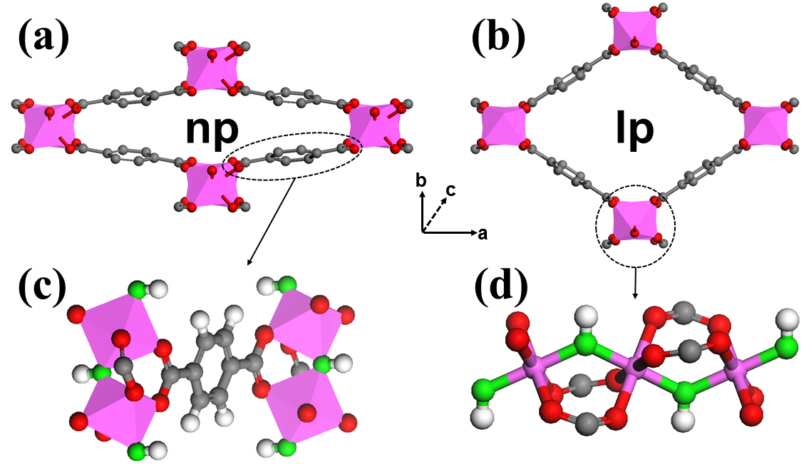
Figure 1: Schematic sub-structures of the (a) narrow pore (np), (b) large pore (lp) forms of MIL-53 type materials (hydrogen atoms are omitted for clarity) shown along the [001] zone axis, (c) the BDC²⁻ organic ligand linking two inorganic chains, and (d) the inorganic chain of metal cations. Metal cations are represented by purple octahedra, and oxygen atoms involved in the μ₂-OH⁻ inorganic linker are coloured in green in (c) and (d). Lattice vectors are shown in the inset. Red: oxygen; grey: carbon.
2. Computational Details
Full geometry optimizations, including lattice parameters and atomic positions, are performed using the hybrid density functional theory (DFT) method, HSE06,⁵⁵ together with Grimme’s D3 van der Waals correction.⁵⁶ We emphasise that a hybrid DFT method is necessary here to provide a faithful description of the electronic structures, band gaps and the magnetic interactions of several transition metals which contain unpaired electrons, e.g. Ti, V, Cr and Fe, and this recipe has been used successfully to predict the band gaps of varied materials including metal oxides^{55, 57} and MOFs.^{47, 58} We find that the D3 scheme in conjunction with the HSE06 functional yield accurate lattice parameters and density for the known np forms, in particular, which are stabilised by dispersion.^{35, 59} The HSE06+D3 scheme also reproduces the density of the known lp phases well. All electronic structure characterisations are performed at the same level of theory. To obtain a qualitative insight into tensile and compressive stresses, constrained cell optimizations were performed for both the np and lp forms of MIL-53-Al and MIL-53-Fe, in which the lattice parameter along the pore opening direction (i.e. lattice parameter b) was fixed to chosen values corresponding to different amounts of strain, and all other lattice parameters (with fixed crystal system) as well as atomic positions were relaxed. For MIL-53-Fe, strain along all the three lattice parameters were considered. For metal cations with unpaired electrons, including Ti³⁺ (3d¹, i.e. t_{2g}¹e_{g}⁰), V³⁺ (3d², i.e. t_{2g}²e_{g}⁰), V⁴⁺ (3d¹, i.e. t_{2g}¹e_{g}⁰), Cr³⁺ (3d³, i.e. t_{2g}³e_{g}⁰), and Fe³⁺ (3d⁵, i.e. t_{2g}³e_{g}²), an antiferromagnetic ordering of spins was considered, and for Fe³⁺, a high-spin case was considered. We note the antiferromagnetic ordering of spins was found to be the ground state of MIL-47-V in a recent theoretical study.⁶⁰ The initial structures that were optimized were taken from the observed crystal structures for the respective phases of MIL-53-Al.⁶¹ For MIL-53-Fe with guest molecules inside the pore, we take the experimentally reported structures (including water³⁹ and pyridine⁶²) as our initial structures, excepted for lutidine, in which case the experimental structure of MIL-53-Fe[pyridine] was chosen as the initial guess. All calculations have been performed using the CP2K code.⁶³⁻⁶⁴ More details of the calculations are included in the Supporting Information.
3. Results and Discussions
In Figure 2, we show the optimised volumes obtained for guest-free dense (np) and open (lp) structures compared with experimental data where available. Note that in several cases, the experimental structure contains guests whereas in all cases reported here, the computed volumes are guest-free. MIL-53-Al has been carefully prepared in anhydrous form and so the comparison of computation with experiment is very instructive. It can be seen that the discrepancy for dense and open phases is ~25 Å³, which is remarkably good considering the calculated volumes are obtained at an effective temperature of 0 K, whereas experimentally, the np and lp volumes were obtained at 77 K. For the other structures there is good general agreement between experiment and theory except for Cr and V where the np phases in particular are predicted to be too dense. These latter two cases are discussed in more detail later.
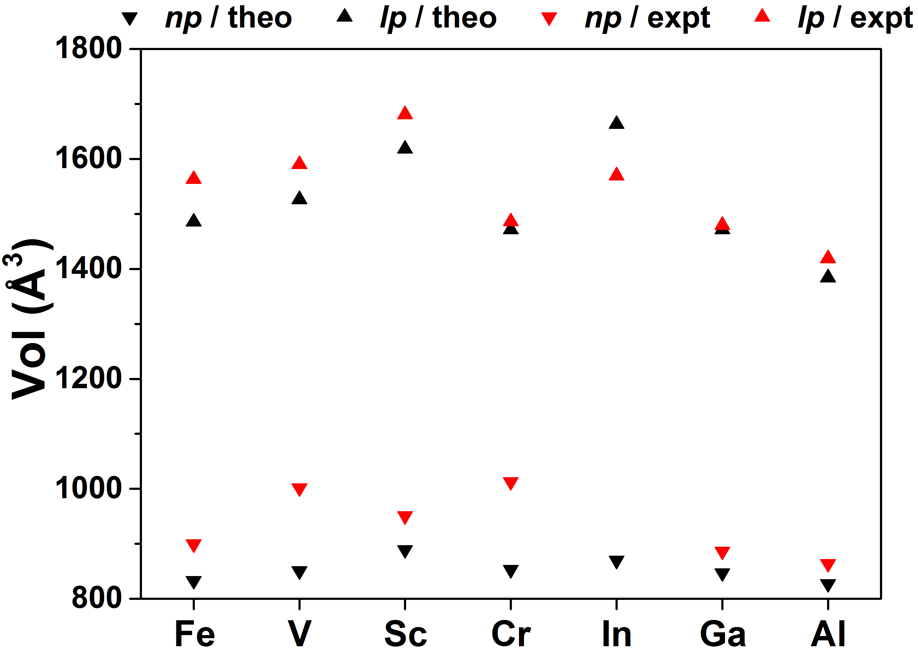
Figure 2: The total volumes of narrow pore (np), large pore (lp) forms of MIL-53 type materials from experiment with red triangles (see supporting information) and as found using HSE06+D3 in this work, black triangles. Note that in many cases the experimental volume is only known for guest-loaded structures whereas the simulated structure is guest-free. The only experimental guest-free structure is for MIL-53-Al for which the agreement between experiment and theory is excellent.
In Figure 3, we show the total energy difference between np and lp phases for some known and some yet-to-be-synthesised structures. In general, there is a clear correlation between the total energy difference and the volume difference between the np and lp phases. If we compare Al with Sc and In, it can be seen that the np volumes are rather similar but the lp volumes are substantially greater for Sc and In than Al. Qualitatively, Figure 3 gives an indication whether a MIL-53-M will show breathing behaviour. The AlF⁻ material in which the inorganic hydroxide anion has been substituted with fluoride shows the most negative energy difference for the np→lp transition suggesting that np is much more stable than lp. In fact, as we recently showed,³⁵ the transition to lp is never seen. Conversely, for MIL-53-In, the lp form has an unusually low density (due to the size of the In cation) and the np form is quite unfavourable, suggested by the large contraction that is necessary in order to form a np structure – experimentally no np has yet to be reported. Quantitatively, there is good agreement with the available energetic data from experimental calorimetry: MIL-53-Ga shows a np→lp difference of 1.51 kcal/mol whilst the experimental value is 1.34 kcal/mol.⁶⁵ For MIL-53-Cr, the enthalpy difference for np→lp is calculated to be 0.91 kcal/mol, which is remarkably close to the experimental value of 0.84 kcal/mol.⁶⁶ For MIL-53-Al, our theoretical enthalpy difference for np→lp is 0.86 kcal/mol, which is smaller but comparable with a very recent experimental estimation of the free energy difference which measured 1.79 kcal/mol.⁶⁷ Given the relatively small energy differences per unit cell, the energy differences are surprisingly well reproduced. We highlight the close agreement between available experimental calorimetry data and computed enthalpy differences between phases since the remainder of the manuscript focuses upon the relationship between the detailed electronic structure of a material and its density. The data presented in Figures 2 and 3 attests that our selected level of theory reproduces the experimental volumes of both np and lp states and the enthalpy difference between the np and lp states which establishes a firm theoretical foundation and suggests that we can confidently infer electronic energy quantities from structures over a substantial range in density.
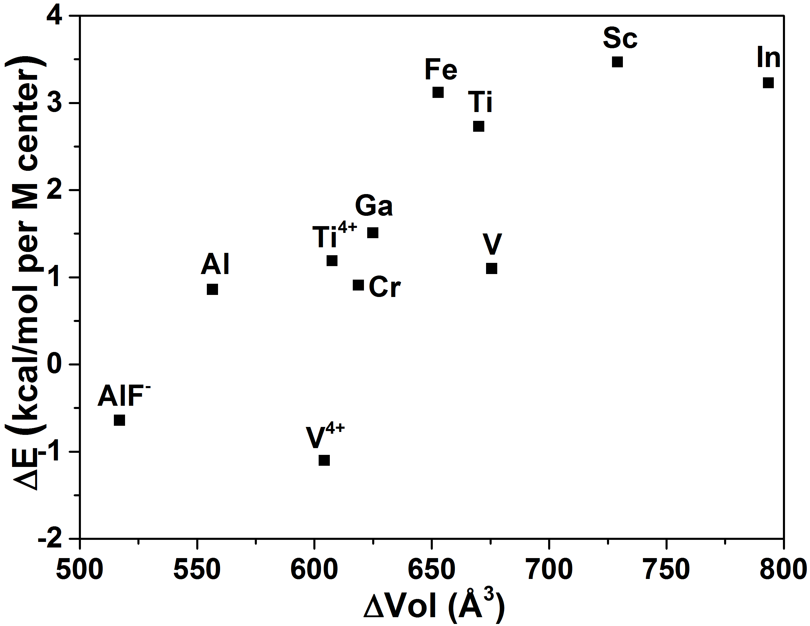
Figure 3: Total energy differences between np and lp MIL-53-M structures calculated at the HSE06+D3 level reported in kcal/mol per M centre.
We now show the calculated band gaps of the eight MIL-53 type (with M³⁺ metal cations and OH⁻ inorganic linker) and two MIL-47 (with M⁴⁺ metal cations and O²⁻ inorganic linker) materials with different metal cations in Figure 4, ordered by the band gaps of the np form of different materials. The most striking observation is that for all seven different known MIL-53 materials (with the exception of MIL-53-Ti), the np and lp forms have rather different band gaps, where the band gap of the dense np form is always smaller than the lp form. The difference in band gaps between np and lp forms ranges from 0.35 eV (for V³⁺) to a remarkable 1.39 eV (for In³⁺). The difference in band gap between known np structures spans 0.9 eV (2.70-3.62 eV). For MIL-53-Ti (Ti³⁺), the calculated band gaps of the np and lp forms are close, both of which are around 1.8~1.9 eV, with the band gap of the np form being smaller than that of the lp form by ~0.1 eV. Similar observations can also be made for the two MIL-47 type materials, the differences in band gaps between np and lp forms are 0.56 eV and 0.22 eV for Ti⁴⁺ and V⁴⁺, respectively. With a fundamental band gap below 3.0 eV, the np form of Fe³⁺, Ti⁴⁺ and V³⁺ might be considered for solar energy harvesting and photocatalytic applications. The variation in band gap is unexpectedly high and notably far greater than the enthalpic differences between the np and lp phases. If we take the case of np and lp forms of MIL-53-Al, which we emphasise have been isolated without guests, the band gap energy difference is 0.93 eV which is far greater than the enthalpy difference per cell of 0.30 eV (8 formula units multiplied by the enthalpy difference of 0.86 kcal/mol).
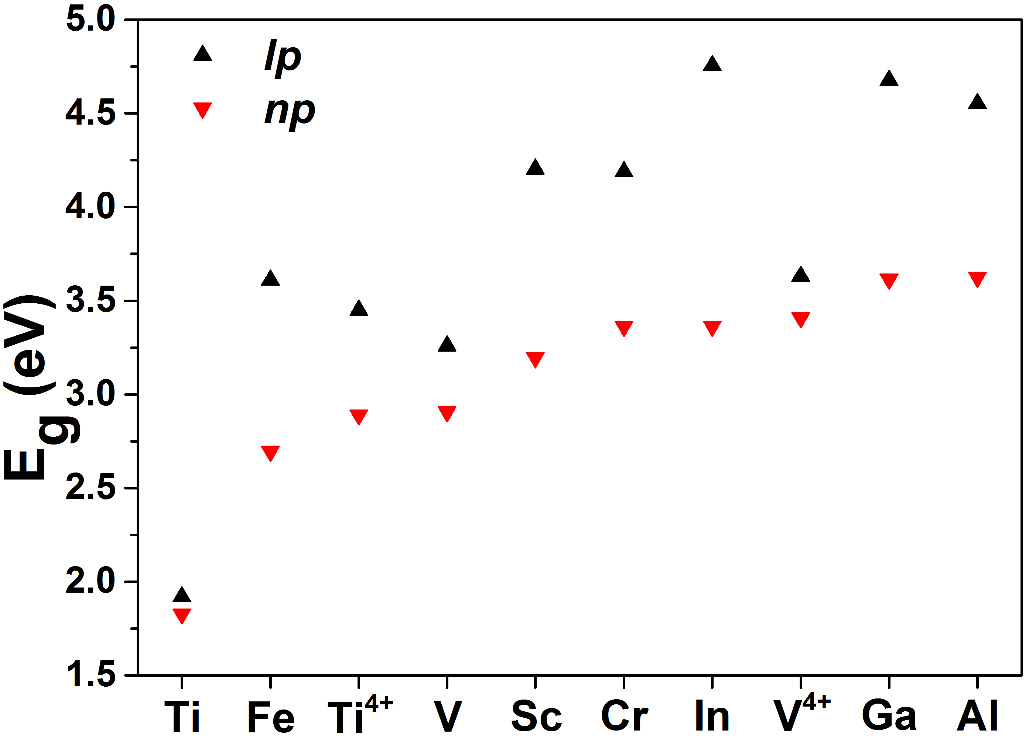
Figure 4: Calculated band gaps of the np and lp forms of eight MIL-53 type materials with different trivalent metal cations and two MIL-47 type materials featuring Ti⁴⁺ and V⁴⁺ tetravalent metal cations.
A close inspection of the electronic structures of the ten materials show that the nature of the top of the valence band (highest occupied molecular orbital, HOMO) and the bottom of the conduction band (lowest unoccupied molecular orbital, LUMO) of the five materials without magnetic centres (no unpaired electrons): Al³⁺, Ga³⁺, In³⁺, Sc³⁺ and Ti⁴⁺ are qualitatively different from those of the five materials with magnetic metal centres: Ti³⁺, V³⁺, V⁴⁺, Cr³⁺, and Fe³⁺. The HOMOs and the LUMOs of the non-magnetic Al³⁺, Ga³⁺, In³⁺ materials are dominated by the organic linkers (i.e. BDC²⁻), with the exception of the LUMOs of Sc³⁺ and Ti⁴⁺ in which metal d states are heavily involved, and the HOMOs and the LUMOs of the five anti-ferromagnetic materials show more complicated behaviour. While the LUMOs of Ti³⁺, V³⁺, V⁴⁺, Cr³⁺ and Fe³⁺ consist of mixed metal d states and states from the organic linkers, the HOMOs differ between each other. From Fe³⁺ to Cr³⁺ to V³⁺ to Ti³⁺, with decreasing magnetic moments and increasing ionic radius on the metal ions, there is an increasing metal d state character in the HOMOs. The case of V⁴⁺ is special, and the amount of metal d state character in the HOMOs sits between V³⁺ and Cr³⁺, possibly due to its slightly distorted octahedral geometry, being different from that of MIL-53 type materials featuring M³⁺ metal cations. This is a result of the different crystal field splitting in V⁴⁺, which features two O²⁻ anions in the axial position, so the hybridization of metal d orbitals and π orbitals of organic linkers would be different from that of M³⁺. For Fe³⁺ with five unpaired electrons on each metal cation, the HOMOs of both np and lp forms are dominated by organic linkers. For Cr³⁺ with three unpaired electrons on each metal cation, the HOMOs of the np form are dominated by organic linkers, and the HOMOs of the lp form consist of mixed metal d states and states from the organic linkers. For V³⁺ with two unpaired electrons and Ti³⁺/V⁴⁺ with one unpaired electron on each metal cation, the HOMOs of both np and lp forms are dominated by metal d states. We note Fe³⁺ (3d⁵, i.e. t_{2g}³e_{g}²) has no empty t_{2g} or e_{g} orbital, Cr³⁺ (3d³, i.e. t_{2g}³e_{g}⁰) has two empty e_{g} orbitals, V³⁺ (3d², i.e. t_{2g}²e_{g}⁰) has one empty t_{2g} and two empty e_{g} orbitals, and Ti³⁺/V⁴⁺ (3d¹, i.e. t_{2g}¹e_{g}⁰) has two empty t_{2g} and two empty e_{g} orbitals. The presence of different empty orbitals in different metal cations could affect the hybridization of metal d orbitals and π orbitals of organic linkers, and therefore affect the nature of the valence and conduction band edges. A detailed explanation of the different crystal field splitting and inorganic-organic hybridizations for different metal cations and inorganic linkers in MIL-53 and MIL-47, is beyond the scope of the current study and will be discussed in a future study.
Comparing each material, we find the nature of the HOMO and LUMO states are quite similar except for the HOMO states of MIL-53-Cr. With respect to the exact band gaps of the np form, we find MIL-53 materials with transition metal cations tend to have smaller band gaps than those of the 3p metal cations. While there is no obvious correlation between the differences in band gaps and ionic radius of the transition metals, for the three 3p metal cations, the differences in band gaps increase with ionic radius, i.e. Al³⁺ < Ga³⁺ < In³⁺. Moreover, for the three 3p metal cations, with increasing ionic radius, the absolute band gaps of the np form decrease, and the absolute band gaps of the lp form increase. These findings can be used to design MOF materials with desirable electronic properties in the future, e.g. a material with a band gap of ~3.0 eV, or the difference in band gaps between np and lp forms being as small as possible. We also note that partial substitutions of the metal cations,^{34, 68-70} i.e. a single MIL-53 material with a mixture of different types of metal cations in the same valence, or mixed MIL-53/47 material with different inorganic linkers (i.e. both OH⁻ and O²⁻ are present) and metal cations in different valences, can be achieved, and this could provide an additional route to tune the electronic properties of the material through precise control of the ratio between different types of metal cations.
To examine the origin of the different band gaps between the np and lp forms of MIL-53, we looked at the charges on different atoms in the np and lp forms of MIL-53-Al, using both Mulliken and Hirshfeld population analysis but found no significant difference between the np and lp forms. Since the HOMO and LUMO states are dominated by the organic linker in MIL-53-Al, we performed an additional analysis for the organic and inorganic parts of the material separately, following the approach first described in Harvey et al.⁷¹ For the organic part, we removed the inorganic chains consisting of Al/O octahedra and carboxylate groups, and we passivated the dangling carbon atoms with hydrogen atoms, leaving only benzene molecules in the cell, and for the inorganic part, we remove the benzene rings and we passivated the dangling carbon atoms belong to the carboxylate groups with hydrogen atoms, leaving only the one dimensional aluminium octahedral inorganic chains in the cell. We relaxed the positions of the added hydrogen atoms, while the positions of other atoms and the lattice constants were fixed. The band gaps of the resulting organic and inorganic solids with the geometric arrangements in the np and lp forms of MIL-53-Al were then calculated. We find the band gaps of the two different configurations of benzene solids differ by ~1.3 eV, which is bigger than the difference in band gaps of the np and lp forms of MIL-53-Al by ~0.5 eV. On the other hand, the band gaps of the two inorganic solids consisting of one dimensional aluminium octahedral inorganic chains are almost the same, both of which are ~6.7 eV. This indicates the different band gaps of the np and lp forms of MIL-53-Al are dominated by the different arrangements of the organic linkers in the np and lp forms, which produce different confinements to the electron density distributions. This effect could be further demonstrated by the correlation between the HOMO-LUMO gap of benzene dimer and the separation between two benzene monomers, which clearly shows that the HOMO-LUMO gap of benzene dimer increases with the separation between two benzene monomers (see Supporting Information). Similar observation can also found in studies of organic semiconductors.⁷² The change in the HOMO-LUMO gap of benzene dimer relates to the decreasing π-coupling due to the increasing monomer separations, which affect the HOMO/LUMO levels and therefore the HOMO-LUMO gaps. We note the electronic properties of both MOFs and organic semiconductors, featuring conjugated π structural components, can be affected by this mechanism. So, pore size has a strong influence on the band gaps of MIL-53-Al; a smaller pore (more compact packing of the organic linkers) tends to result in a smaller band gap, while a bigger pore (looser packing of the organic linkers) is results in a larger band gap. Note that for transition metal cations in MIL-53, metal d states are present in either the HOMO or the LUMO and the correlation of the band gap with the pore size is weaker and depends on the weight of the metal d states in the band edges. The stronger the presence of metal d states in the band edges such as in MIL-53-Ti, the weaker the correlation between the band gap and the pore size. Nevertheless, the pore size still has some influence on the band gaps of MIL-53 type materials with transition metal cations.
We have shown how the electronic properties and band gaps of MIL-53 type materials are strongly influenced and could be selected by the choice of metal cations. While different metal cations affect both the breathing behaviours and intrinsic chemical interactions between the organic and inorganic moieties of MIL-53 type materials, similar tuning can also be achieved by substitutions of the μ₂ inorganic linker (Figure 1) or the organic linker. For example, we consider two analogues of MIL-53-Al, one with μ₂-F inorganic linker, and another with NH₂ functionalized BDC²⁻ organic linker. We find that upon replacing μ₂-OH to μ₂-F, the band gap of the np form of MIL-53-Al increases by 0.34 eV to 3.96 eV, while a small reduction in the band gap, i.e. ~0.07 eV, is observed in the lp form. The former observation can be attributed to the slight increase in the volume of the np form, which is caused by weaker attractive forces between the μ₂-F and neighbours, than μ₂-OH and neighbours.³⁵ For MIL-53-Al with a NH₂ functionalized BDC²⁻ organic linker, we find the band gaps of the np and lp forms are reduced to 2.60 (2.30) and 3.16 (3.16) eV from 3.62 and 4.55 eV respectively, in fully relaxed cells and the numbers in parentheses are the band gaps with relaxed contents but fixed cells with the unmodified cell parameters. The calculations with fixed cells show the arrangement of organic linkers are similar before and after NH₂ functionalization, however the reductions in band gaps for the np and lp forms are substantial, 1.32 and 1.39 eV, respectively. The NH₂ groups contribute significantly to the HOMO of both np and lp forms and therefore, the reduction in band gaps is dictated by the smaller ionization potential of the NH₂ functionalized BDC²⁻ organic linker. The band gap reduction which we observed in MIL-53-Al upon NH₂ functionalization is in line with previous studies on NH₂-functionalized UiO-66⁷³ and MIL-125,^{47, 74} both of which are currently being considered as photocatalysts in the visible region. We further note that since the band edges of non-magnetic MIL-53 materials are dominated by states from the organic linkers, fine tuning of the band gaps, ionization potentials and electron affinities might be achieved easily through functionalization of the organic linkers, for example by modifying the organic linkers with groups to modify the ionization potentials and electron affinities of BDC²⁻ along a special direction. We show this trend by comparing the HOMO and LUMO levels of a series of functionalized BDC²⁻ molecules, which have been successfully incorporated into MIL-53,³⁶ in the Supporting Information.
To summarise thus far: we have shown that by means of intrinsic, internal forces, including substitution of the metal cation, the μ₂ inorganic linker or the organic linker, fine tuning of the breathing behaviours and therefore the electronic properties and band gaps of MIL-53 type materials can be achieved. We now turn to discuss extrinsic effects, those of external forces, including temperature, pressure and adsorption of guest molecules.
For MIL-53 type materials with empty pores, it has been found that by increasing the temperature, the np→lp phase transition can be promoted, and vice versa, e.g. MIL-53-Al undergoes np→lp phase transition gradually between 325 to 375 K, and lp→np phase transition between 125 to 150 K.⁶¹ Similar np→lp phase transitions were also observed in MIL-53-Cr²⁸ and MIL-53-Ga,^{65, 75} although at slightly higher temperatures. As it was shown in Figure 4, a direct consequence of the np↔lp phase transitions is the change in band gaps, and therefore, one would expect the band gaps of MIL-53 type materials can be easily selected by heating or cooling down the material.
Next, we consider how external mechanical pressure, which can be either tensile or compressive, affects the band gaps of MIL-53 type materials. It was recently demonstrated in an experimental study that MIL-53-Al exhibits negative linear compressibility, the material expands along a specific (b) direction while the total unit cell volume shrinks with increasing hydrostatic pressure.⁷⁶ In another theoretical study by Butler et al., it was shown that the band edges (HOMO/LUMO levels) of a series of MOFs can be deformed by isotropic lattice strain.⁷⁷ Taking MIL-53-Al as an example, we consider both the np and lp forms of MIL-53-Al undergoing different amounts (up to 40%) of tensile or compressive strain, as reflected by the change in lattice parameter b, which corresponds to the pore opening direction upon np→lp phase transition. We study how the volume and band gaps change with respect to the lattice parameter b, and we show our result in Figure 5, in which the equilibrium lattice parameters b of the np and lp forms of MIL-53-Al are indicated by red and black arrows, respectively. We find that the band gap of the np form can change by as much as 2.4 eV under different pressures, while the band gap of the lp form changes by less than 0.6 eV, which demonstrates that the electronic structure of the lp form is less sensitive to external pressure. This is consistent with the findings for MIL-53 type materials with 3p metal cations discussed in the previous sections. The band gaps of these materials are mainly determined by the arrangement of organic linkers, and the denser the material, the smaller the band gap. For the lp form of MIL-53-Al, the interaction between neighbouring organic linkers are relatively weak, thus a slight change in the pore size will not bring significant change to the band gap. On the other hand, the np form of MIL-53-Al is much denser and neighbouring organic linkers interact with each other, so a slight change in the pore size changes the band gap significantly. For MIL-53 type materials with transition metal cations (except Ti³⁺ and V³⁺), we expect similar behaviours can exist, based on our observations from Figure 4, although the extent of the change in band gaps can be slightly different due to different response of the unit cell volumes to external pressures.
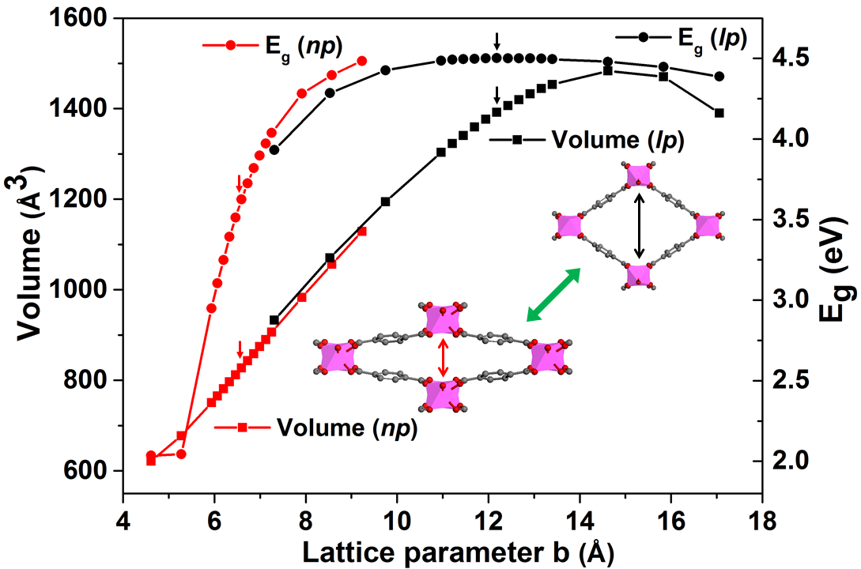
Figure 5: Correlations of unit cell volumes and band gaps with lattice parameter b of MIL-53-Al. The np and lp forms are shown in red and black plots, respectively.
In addition to MIL-53-Al, we also consider MIL-53-Fe, in terms of the electronic response under external mechanical pressure. The electronic structure of MIL-53-Fe is quite distinct from MIL-53-Al; the LUMO states of both np and lp forms of MIL-53-Fe are dominated by metal d states, and therefore tensile or compressive strain along the inorganic chain (i.e. lattice parameter c, see Figure 6) could result in electronic response which is different from that along lattice parameters a and b. As an additional reason to consider strain along all the three lattice parameters, it was found recently that some of the MOF materials, including MIL-53, show rather anisotropic elastic behaviours.⁷⁸ Motivated by that work, we consider how the electronic response of MIL-53-Fe correlate with its anisotropic elastic behaviours along different lattice parameters. We show our result in Figure 6, in which we consider up to 2% strain (one data point) for both np and lp forms of MIL-53-Fe along the three lattice parameters. It can be found that indeed, the unit cell volume changes differently along different lattice parameters, for both np and lp forms, MIL-53-Fe displays negative linear compressibility along lattice parameter a (see red solid lines in Figure 6) and positive linear compressibility along lattice parameters b and c (see black and blue solid lines in Figure 6 respectively). This is in line with a recent experiment on MIL-53-Al and NH₂-functionalized MIL-53-Al.⁷⁶ With respect to the band gaps, similar to MIL-53-Al, the lp form of MIL-53-Fe shows little response in band gaps with strains along different lattice parameters, and band gap change is within 0.02 eV. However, the band gaps of the np form of MIL-53-Fe change much more significantly with strains along different lattice parameters, i.e. compared with the cell with 0% strain, the biggest change in band gap, which is around 0.14 eV, is along lattice parameter a, and the smallest change in band gap, which is around 0.04 eV, is along lattice parameter c. The band gaps change in the same direction with unit cell volumes along lattice parameters a and b, i.e. the band gap increases with increasing unit cell volume, and along the lattice parameter c, the band gap decreases with increasing unit cell volume. This is similar to what we found in previous sections, i.e. the organic linkers contribute significantly to the frontier MOs of MIL-53, and stronger overlapping in electron densities between neighbouring organic linkers (smaller unit cell volume and shorter lattice parameter b) tends to produce smaller band gaps. The lattice parameter c corresponds to the direction of the inorganic chain, i.e. the Fe-O bond lengths will be affected by the strain along lattice parameter c, which might be responsible for the different behaviour of the electronic response to strain along lattice parameter c.
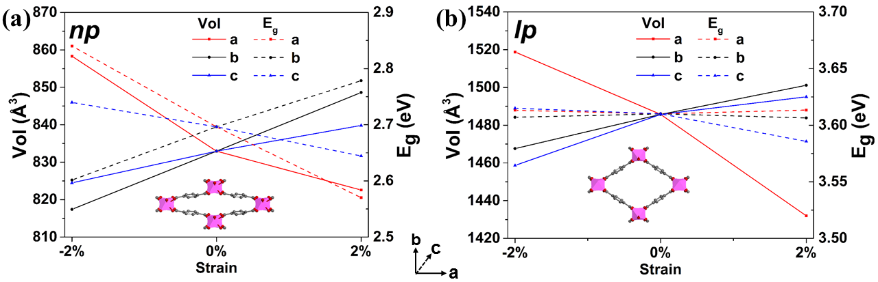
Figure 6: Correlations of unit cell volumes (solid lines) and band gaps (dashed lines) with lattice parameters a, b and c of the (a) np and (b) lp forms of MIL-53-Fe. Uniaxial strain was considered along each lattice vector independently and is shown in the inset.
Finally, we consider how adsorption of small molecules inside the host influences the electronic properties and band gaps of MIL-53 type materials. Taking MIL-53-Fe as an example, we consider adsorption of selected different molecules inside the pore; water, pyridine and lutidine, all of which have been extensively studied experimentally^{39, 62} and theoretically.⁷⁹ Full geometry relaxations have been performed to account for any changes in density due to the host-guest interactions. The total number of guests per supercell is 16 and identical for each sorbate, equivalent to one sorbate per metal centre. We summarize the calculated unit cell volumes and corresponding band gaps as well as binding energies of different guest molecules in Table 1. From Table 1, it can be seen both the structure/density and electronic structure including band gaps of MIL-53-Fe are sensitive by the nature of the guest molecules. Similar to the guest-free case, the band gaps of MIL-53-Fe with different guest molecules are reasonably correlated with the unit cell volumes with the notable exception of MIL-53-Fe with lutidine. This demonstrates the subtle role of the host-guest interactions, including electronic polarization and charge transfer, in determining band gaps when different molecules are adsorbed in MIL-53-Fe. To understand how the guest molecules contribute to the band edges (frontier MOs), we fixed the optimized atomic positions and lattice parameters and remove the guest molecules and then calculate the band gaps of the empty MIL-53-Fe structure. For water and pyridine, the host electronic structure and band gaps are not significantly influenced by removal of guest molecules. However, removing lutidine causes a band gap increase of ~0.7 eV. Interestingly, we found that the HOMO states of lutidine in MIL-53-Fe are mainly located on lutidine molecules, possibly due to relatively weak coupling of the host and guest and the lower ionization potential of lutidine in comparison with pristine MIL-53-Fe. Coulomb repulsion between the methyl groups of lutidine and the organic linkers of MIL-53-Fe, weaken the host-guest interactions between lutidine and MIL-53-Fe in comparison with pyridine and MIL-53-Fe, reflected by the slightly longer N···H distance of 2.01 Å for the lutidine, versus 1.67 Å in the case of pyridine. This shows that the host-guest interactions do not contribute directly to the band gaps of MIL-53-Fe with adsorbed molecules. Instead, the relative alignment between the frontier orbitals of adsorbed molecules and the band edges of empty MIL-53-Fe (at the geometry of MIL-53 with different sorbates), contribute more to the band gaps of MIL-53-Fe with adsorbed molecules. We note similar response in electronic structures upon uptake of fluorinated hydrocarbons in a porous molecular crystal has been reported quite recently.⁸⁰ Our current results can serve as potential guidelines on developing resistance based gas sensors with MOF materials.
Guest | Unit cell volume (Å³) | E_{g} (eV) | E_{b} (kcal/mol per Fe centre)
dehydrated (np) | 832.9 | 2.70 | -
water | 973.1 | 3.41 (3.30) | -14.82
pyridine | 1376.6 | 3.56 (3.56) | -21.79
lutidine | 1458.9 | 2.78 (3.51) | -18.50
dehydrated (lp) | 1541.1 | 3.60 | -
Table 1: Unit cell volumes, band gaps (E_{g}) and binding energies (E_{b}) of MIL-53-Fe with different guest molecules. Band gaps in the brackets indicate band gaps of MIL-53-Fe with guest molecules removed at fixed geometries.
Because electronic property measurements of MOFs are relatively rare, we are unable to correlate our theoretical predictions with experimental results directly. However, there are several indirect experiments which can be interpreted based on our current theoretical finding. In a recent experiment by Walton et al.,⁸¹ they have studied adsorption of N/S heterocycles in MIL-53-Fe, and they found that the volumes of the framework expanded following the adsorption of heterocycles inside the pore, and the colour of MIL-53-Fe changes from yellow to red (consistent with band gap decrease) with increasing concentration of benzothiophene. In the same study by Walton et al.,⁸¹ they also found that the adsorption of benzothiophene brings new absorption in the diffuse reflectance UV-vis spectra of MIL-53-Fe, i.e. another sign of change in the electronic structure of MIL-53-Fe due to adsorption of benzothiophene molecules. The colour change observed in MIL-53-Fe could be similar to that of nickel cyanide upon dehydration and rehydration,⁸² and HKUST-1 upon infiltration of TCNQ molecules which was observed by Allendorf et al.¹⁹ In the latter, the authors assigned the colour change to perturbation of the electronic structures of HKUST-1 with and without TCNQ molecules. We note the diffuse reflectance UV-vis spectra have been measured for several other MOFs, e.g. MIL-125(Ti) and NH₂-MIL-125(Ti),^{47, 83} Co(BDP),⁸⁴ and several Zn-based MOFs.¹⁴ Our approach and the findings drawn from MIL-53 could be useful for the interpretation of these experiments. We anticipate that future diffuse reflectance UV-vis spectroscopy experiments to be performed to validate our theoretical predictions of the changes in the electronic structures of MIL-53 upon pore opening/closing and upon adsorption of small molecules. In addition to MOFs, breathing behaviours have also been observed in several porous molecular crystals⁸⁵ and covalent organic frameworks (COFs) materials.⁸⁶ Since the difference in band gaps of the non-magnetic MIL-53 materials are mainly accounted by the difference in the arrangement of the organic linkers, similar results might also be observed in porous molecular crystals or COFs, i.e. the np form of a COF material might have smaller band gap compared with the same COF material in the lp form. Such properties might be used to develop new porous molecular crystal based or COF-based electronics where MOFs are not suitable. Structural changes in breathing flexible materials can be easily monitored in the experiment (e.g. by X-ray diffraction), and based on our finding presented in the previous section, in many cases, the structural response will result in significant changes in the electronic structures, an unusual property which could inspire future applications based on breathing materials.
We note that majority of the MOF materials which we have considered show similarly large variations in band gaps (e.g. 1.4 eV for MIL-53-In) upon breathing transitions. In dense inorganic solids, it is quite usual that the band gaps between different phases differ by a few tenths of eV, although there do exist exceptions. For example, it was reported that the band gaps of fluorite and baddeleyite TiO₂ are smaller than that of anatase TiO₂ by ~1.2 eV by accurate theoretical calculations.⁸⁷⁻⁸⁸ However, this example is quite unusual and more severe temperatures and pressures are typically needed in order to promote phase transitions in inorganic solids. For example, the fluorite and baddeleyite TiO₂ are formed at 60 and 20 GPa, respectively.⁸⁹⁻⁹⁰ However, the lp→np and np→lp phase transitions in MIL-53-Al occur at 33 and 7 MPa in silicone oil, respectively,⁶⁷ which are approximately three orders of magnitude smaller than the pressure required to form fluorite and baddeleyite TiO₂.
4. Conclusions
In summary, we show unexpectedly large changes in the electronic structures of MOFs associated with the breathing behaviours in MIL-53 type materials. Since the breathing of these materials can be easily induced by external stimuli, such as temperature, pressure or by adsorption of molecules, the properties of these materials could be tailored for new MOF-based applications in resistive switching, phase change memory, piezoresistor, gas sensing, and thermochromic materials. We also show that modulation of the electronic properties of many MOFs can be achieved, through host-guest interactions and functionalization of the framework. MIL-53 is an archetypal example of a breathing material and so the incredibly rich electronic landscape we have identified here indicates very promising potential for this and other breathing MOF materials towards the realisation of new functional materials.
Acknowledgements
We thank Dr Caroline Mellot-Draznieks for her helpful comments on the manuscript and Dr François-Xavier Coudert for useful discussions. This work is supported by EPSRC (EP/K039296/1). Through our membership of the UK's HPC Materials Chemistry Consortium, which is funded by EPSRC (EP/L000202), this work made use of the facilities of HECToR and ARCHER, the UK’s national high-performance computing service, which is funded by the Office of Science and Technology through EPSRC’s High End Computing Programme. Additionally, this work also made use of the resources awarded under the PRACE programme DECI-12 NANOMOF.
Supporting Information: Lattice parameters, relative energies, calculated band gaps of reported MOFs, additional computational details, complete author list for Refs 34, 36, 44, 65, 84 and 86, and a CP2K input example. This material is available free of charge via the Internet at http://pubs.acs.org.

References
1. Zhang, T.; Lin, W. Metal-Organic Frameworks for Artificial Photosynthesis and Photocatalysis. Chemical Society Reviews 2014, 43, 5982-5993.
2. Wang, C.; Xie, Z.; deKrafft, K. E.; Lin, W. Doping Metal-Organic Frameworks for Water Oxidation, Carbon Dioxide Reduction, and Organic Photocatalysis. Journal of the American Chemical Society 2011, 133, 13445-13454.
3. Vinogradov, A. V.; Zaake-Hertling, H.; Hey-Hawkins, E.; Agafonov, A. V.; Seisenbaeva, G. A.; Kessler, V. G.; Vinogradov, V. V. The First Depleted Heterojunction TiO₂-MOF-Based Solar Cell. Chemical Communications 2014, 50, 10210-10213.
4. Allendorf, M. D.; Houk, R. J. T.; Andruszkiewicz, L.; Talin, A. A.; Pikarsky, J.; Choudhury, A.; Gall, K. A.; Hesketh, P. J. Stress-Induced Chemical Detection Using Flexible Metal-Organic Frameworks. Journal of the American Chemical Society 2008, 130, 14404-14405.
5. Stavila, V.; Talin, A. A.; Allendorf, M. D. MOF-Based Electronic and Opto-Electronic Devices. Chemical Society Reviews 2014, 43, 5994-6010.
6. Foster, M. E.; Azoulay, J. D.; Wong, B. M.; Allendorf, M. D. Novel Metal–Organic Framework Linkers for Light Harvesting Applications. Chemical Science 2014, 5, 2081-2090.
7. Horiuchi, Y.; Toyao, T.; Takeuchi, M.; Matsuoka, M.; Anpo, M. Recent Advances in Visible-Light-Responsive Photocatalysts for Hydrogen Production and Solar Energy Conversion--from Semiconducting TiO₂ to MOF/PCP Photocatalysts. Physical Chemistry Chemical Physics: PCCP 2013, 15, 13243-13253.
8. Silva, C. G.; Corma, A.; García, H. Metal–Organic Frameworks as Semiconductors. Journal of Materials Chemistry 2010, 20, 3141-3156.
9. Kuc, A.; Enyashin, A.; Seifert, G. Metal−Organic Frameworks: Structural, Energetic, Electronic, and Mechanical Properties. Journal of Physical Chemistry B 2007, 111, 8179-8186.
10. Civalleri, B.; Napoli, F.; Noel, Y.; Roetti, C.; Dovesi, R. Ab-Initio Prediction of Materials Properties with Crystal: MOF-5 as a Case Study. CrystEngComm 2006, 8, 364-371.
11. Pham, H. Q.; Mai, T.; Pham-Tran, N.-N.; Kawazoe, Y.; Mizuseki, H.; Nguyen-Manh, D. Engineering of Band Gap in Metal–Organic Frameworks by Functionalizing Organic Linker: A Systematic Density Functional Theory Investigation. Journal of Physical Chemistry C 2014, 118, 4567-4577.
12. Fuentes-Cabrera, M.; Nicholson, D. M.; Sumpter, B. G.; Widom, M. Electronic Structure and Properties of Isoreticular Metal-Organic Frameworks: The Case of M-IRMOF1 (M=Zn, Cd, Be, Mg, and Ca). Journal of Chemical Physics 2005, 123, 124713.
13. Gascon, J.; Hernandez-Alonso, M. D.; Almeida, A. R.; van Klink, G. P.; Kapteijn, F.; Mul, G. Isoreticular MOFs as Efficient Photocatalysts with Tunable Band Gap: An Operando FTIR Study of the Photoinduced Oxidation of Propylene. ChemSusChem 2008, 1, 981-983.
14. Lin, C.-K.; Zhao, D.; Gao, W.-Y.; Yang, Z.; Ye, J.; Xu, T.; Ge, Q.; Ma, S.; Liu, D.-J. Tunability of Band Gaps in Metal-Organic Frameworks. Inorganic Chemistry 2012, 51, 9039-9044.
15. Brozek, C. K.; Dincă, M. Ti³⁺-, V^{2+/3+}-, Cr^{2+/3+}-, Mn²⁺-, and Fe²⁺-Substituted MOF-5 and Redox Reactivity in Cr- and Fe-MOF-5. Journal of the American Chemical Society 2013, 135, 12886-12891.
16. Chizallet, C.; Bats, N. External Surface of Zeolite Imidazolate Frameworks Viewed Ab Initio: Multifunctionality at the Organic−Inorganic Interface. Journal of Physical Chemistry Letters 2010, 1, 349-353.
17. Chizallet, C.; Lazare, S.; Bazer-Bachi, D.; Bonnier, F.; Lecocq, V.; Soyer, E.; Quoineaud, A.-A.; Bats, N. Catalysis of Transesterification by a Nonfunctionalized Metal-Organic Framework: Acido-Basicity at the External Surface of ZIF-8 Probed by FTIR and Ab Initio Calculations. Journal of the American Chemical Society 2010, 132, 12365-12377.
18. Kobayashi, Y.; Jacobs, B.; Allendorf, M. D.; Long, J. R. Conductivity, Doping, and Redox Chemistry of a Microporous Dithiolene-Based Metal−Organic Framework. Chemistry of Materials 2010, 22, 4120-4122.
19. Talin, A. A.; Centrone, A.; Ford, A. C.; Foster, M. E.; Stavila, V.; Haney, P.; Kinney, R. A.; Szalai, V.; El Gabaly, F.; Yoon, H. P.; Léonard, F.; Allendorf, M. D. Tunable Electrical Conductivity in Metal-Organic Framework Thin-Film Devices. Science 2014, 343, 66-69.
20. Allendorf, M. D.; Foster, M. E.; Léonard, F.; Stavila, V.; Feng, P. L.; Doty, F. P.; Leong, K.; Ma, E. Y.; Johnston, S. R.; Talin, A. A. Guest-Induced Emergent Properties in Metal–Organic Frameworks. Journal of Physical Chemistry Letters 2015, 6, 1182-1195.
21. Nie, X.; Kulkarni, A.; Sholl, D. S. Computational Prediction of Metal Organic Frameworks Suitable for Molecular Infiltration as a Route to Development of Conductive Materials. Journal of Physical Chemistry Letters 2015, 6, 1586-1591.
22. Park, S. S.; Hontz, E. R.; Sun, L.; Hendon, C. H.; Walsh, A.; Van Voorhis, T.; Dinca, M. Cation-Dependent Intrinsic Electrical Conductivity in Isostructural Tetrathiafulvalene-Based Microporous Metal-Organic Frameworks. Journal of the American Chemical Society 2015, 137, 1774-1777.
23. Sheberla, D.; Sun, L.; Blood-Forsythe, M. A.; Er, S.; Wade, C. R.; Brozek, C. K.; Aspuru-Guzik, A.; Dinca, M. High Electrical Conductivity in Ni(3)(2,3,6,7,10,11-Hexaiminotriphenylene)₂, a Semiconducting Metal-Organic Graphene Analogue. Journal of the American Chemical Society 2014, 136, 8859-8862.
24. Fernandez, C. A.; Martin, P. C.; Schaef, T.; Bowden, M. E.; Thallapally, P. K.; Dang, L.; Xu, W.; Chen, X.; McGrail, B. P. An Electrically Switchable Metal-Organic Framework. Scientific Reports 2014, 4, 6114.
25. Férey, G.; Serre, C. Large Breathing Effects in Three-Dimensional Porous Hybrid Matter: Facts, Analyses, Rules and Consequences. Chemical Society Reviews 2009, 38, 1380-1399.
26. Horike, S.; Shimomura, S.; Kitagawa, S. Soft Porous Crystals. Nature Chemistry 2009, 1, 695-704.
27. Coudert, F.-X. Responsive Metal–Organic Frameworks and Framework Materials: Under Pressure, Taking the Heat, in the Spotlight, with Friends. Chemistry of Materials 2015, 27, 1905-1916.
28. Serre, C.; Millange, F.; Thouvenot, C.; Noguès, M.; Marsolier, G.; Louër, D.; Férey, G. Very Large Breathing Effect in the First Nanoporous Chromium(III)-Based Solids: MIL-53 or Cr^{III}(OH)·{O₂C−C₆H₄ −CO₂}·{HO₂C−C₆H₄−CO₂H}_{x}·H₂O_{y}. Journal of the American Chemical Society 2002, 124, 13519-13526.
29. Serre, C.; Millange, F.; Surblé, S.; Férey, G. A Route to the Synthesis of Trivalent Transition-Metal Porous Carboxylates with Trimeric Secondary Building Units. Angewandte Chemie International Edition 2004, 43, 6285-6289.
30. Grosch, J. S.; Paesani, F. Molecular-Level Characterization of the Breathing Behavior of the Jungle-Gym-Type DMOF-1 Metal-Organic Framework. Journal of the American Chemical Society 2012, 134, 4207-4215.
31. Niekiel, F.; Ackermann, M.; Guerrier, P.; Rothkirch, A.; Stock, N. Aluminum-1,4-Cyclohexanedicarboxylates: High-Throughput and Temperature-Dependent in Situ Edxrd Studies. Inorganic Chemistry 2013, 52, 8699-8705.
32. Schneemann, A.; Bon, V.; Schwedler, I.; Senkovska, I.; Kaskel, S.; Fischer, R. A. Flexible Metal-Organic Frameworks. Chemical Society Reviews 2014, 43, 6062-6096.
33. Neimark, A. V.; Coudert, F.-X.; Boutin, A.; Fuchs, A. H. Stress-Based Model for the Breathing of Metal−Organic Frameworks. Journal of Physical Chemistry Letters 2010, 1, 445-449.
34. Nouar, F.; Devic, T.; Chevreau, H.; Guillou, N.; Gibson, E.; Clet, G.; Daturi, M.; Vimont, A.; Grenèche, J. M.; Breeze, M. I.; et al. Tuning the Breathing Behaviour of MIL-53 by Cation Mixing. Chemical Communications 2012, 48, 10237-10239.
35. Nanthamathee, C.; Ling, S.; Slater, B.; Attfield, M. P. Contradistinct Thermoresponsive Behavior of Isostructural MIL-53 Type Metal–Organic Frameworks by Modifying the Framework Inorganic Anion. Chemistry of Materials 2015, 27, 85-95.
36. Devic, T.; Horcajada, P.; Serre, C.; Salles, F.; Maurin, G.; Moulin, B.; Heurtaux, D.; Clet, G.; Vimont, A.; Grenèche, J.-M.; et al. Functionalization in Flexible Porous Solids: Effects on the Pore Opening and the Host-Guest Interactions. Journal of the American Chemical Society 2010, 132, 1127-1136.
37. Waser, R.; Dittmann, R.; Staikov, G.; Szot, K. Redox-Based Resistive Switching Memories - Nanoionic Mechanisms, Prospects, and Challenges. Advanced Materials 2009, 21, 2632-2663.
38. Wuttig, M.; Yamada, N. Phase-Change Materials for Rewriteable Data Storage. Nature Materials 2007, 6, 824-832.
39. Millange, F.; Serre, C.; Guillou, N.; Férey, G.; Walton, R. I. Structural Effects of Solvents on the Breathing of Metal-Organic Frameworks: An in Situ Diffraction Study. Angewandte Chemie International Edition 2008, 47, 4100-4105.
40. Yanai, N.; Kitayama, K.; Hijikata, Y.; Sato, H.; Matsuda, R.; Kubota, Y.; Takata, M.; Mizuno, M.; Uemura, T.; Kitagawa, S. Gas Detection by Structural Variations of Fluorescent Guest Molecules in a Flexible Porous Coordination Polymer. Nature Materials 2011, 10, 787-793.
41. Shan, X.-C.; Jiang, F.-L.; Yuan, D.-Q.; Zhang, H.-B.; Wu, M.-Y.; Chen, L.; Wei, J.; Zhang, S.-Q.; Pan, J.; Hong, M.-C. A Multi-Metal-Cluster MOF with Cu₄I₄ and Cu₆S₆ as Functional Groups Exhibiting Dual Emission with Both Thermochromic and near-IR Character. Chemical Science 2013, 4, 1484-1489.
42. Chen, L.; Mowat, J. P. S.; Fairen-Jimenez, D.; Morrison, C. A.; Thompson, S. P.; Wright, P. A.; Düren, T. Elucidating the Breathing of the Metal-Organic Framework MIL-53(Sc) with Ab Initio Molecular Dynamics Simulations and in Situ X-Ray Powder Diffraction Experiments. Journal of the American Chemical Society 2013, 135, 15763-15773.
43. Wang, X.; Eckert, J.; Liu, L.; Jacobson, A. J. Breathing and Twisting: An Investigation of Framework Deformation and Guest Packing in Single Crystals of a Microporous Vanadium Benzenedicarboxylate. Inorganic Chemistry 2011, 50, 2028-2036.
44. Yot, P. G.; Ma, Q.; Haines, J.; Yang, Q.; Ghoufi, A.; Devic, T.; Serre, C.; Dmitriev, V.; Férey, G.; Zhong, C.; et al. Large Breathing of the MOF MIL-47(V^{IV}) under Mechanical Pressure: A Joint Experimental–Modelling Exploration. Chemical Science 2012, 3, 1100-1104.
45. Barthelet, K.; Marrot, J.; Riou, D.; Férey, G. A Breathing Hybrid Organic–Inorganic Solid with Very Large Pores and High Magnetic Characteristics. Angewandte Chemie International Edition 2002, 41, 281-284.
46. Dan-Hardi, M.; Serre, C.; Frot, T.; Rozes, L.; Maurin, G.; Sanchez, C.; Férey, G. A New Photoactive Crystalline Highly Porous Titanium(IV) Dicarboxylate. Journal of the American Chemical Society 2009, 131, 10857-10859.
47. Hendon, C. H.; Tiana, D.; Fontecave, M.; Sanchez, C.; D'Arras, L.; Sassoye, C.; Rozes, L.; Mellot-Draznieks, C.; Walsh, A. Engineering the Optical Response of the Titanium-MIL-125 Metal-Organic Framework through Ligand Functionalization. Journal of the American Chemical Society 2013, 135, 10942-10945.
48. Gao, J.; Miao, J.; Li, P.-Z.; Teng, W. Y.; Yang, L.; Zhao, Y.; Liu, B.; Zhang, Q. A P-Type Ti(IV)-Based Metal-Organic Framework with Visible-Light Photo-Response. Chemical Communications 2014, 50, 3786-3788.
49. Robinson, W. R. The Crystal Structures of Ti₂O₃, a Semiconductor, and (Ti_{0.900}V_{0.100})₂O₃, a Semimetal. Journal of Solid State Chemistry 1974, 9, 255-260.
50. Sygusch, J. Refinement of β-Alum CsTi(SO₄)₂∙12H₂O. Acta Crystallographica Section B Structural Crystallography and Crystal Chemistry 1974, 30, 662-665.
51. Tregenna-Piggott, P. L. W.; Best, S. P.; O'Brien, M. C. M.; Knight, K. S.; Forsyth, J. B.; Pilbrow, J. R. Cooperative Jahn-Teller Effect in Titanium Alum. Journal of the American Chemical Society 1997, 119, 3324-3332.
52. Liu, L.; Wang, X.; Jacobson, A. J. AlF.1,4-Benzenedicarboxylate: Synthesis and Absorption Properties. Dalton Transactions 2010, 39, 1722-1725.
53. Couck, S.; Denayer, J. F.; Baron, G. V.; Remy, T.; Gascon, J.; Kapteijn, F. An Amine-Functionalized MIL-53 Metal-Organic Framework with Large Separation Power for Co2 and Ch4. Journal of the American Chemical Society 2009, 131, 6326-6327.
54. Ahnfeldt, T.; Gunzelmann, D.; Loiseau, T.; Hirsemann, D.; Senker, J.; Ferey, G.; Stock, N. Synthesis and Modification of a Functionalized 3d Open-Framework Structure with MIL-53 Topology. Inorganic Chemistry 2009, 48, 3057-3064.
55. Krukau, A. V.; Vydrov, O. A.; Izmaylov, A. F.; Scuseria, G. E. Influence of the Exchange Screening Parameter on the Performance of Screened Hybrid Functionals. Journal of Chemical Physics 2006, 125, 224106.
56. Grimme, S.; Antony, J.; Ehrlich, S.; Krieg, H. A Consistent and Accurate Ab Initio Parametrization of Density Functional Dispersion Correction (DFT-D) for the 94 Elements H-Pu. Journal of Chemical Physics 2010, 132, 154104.
57. Chevrier, V. L.; Ong, S. P.; Armiento, R.; Chan, M. K. Y.; Ceder, G. Hybrid Density Functional Calculations of Redox Potentials and Formation Energies of Transition Metal Compounds. Physical Review B 2010, 82, 075122.
58. Butler, K. T.; Hendon, C. H.; Walsh, A. Electronic Chemical Potentials of Porous Metal-Organic Frameworks. Journal of the American Chemical Society 2014, 136, 2703-2706.
59. Walker, A. M.; Civalleri, B.; Slater, B.; Mellot-Draznieks, C.; Corà, F.; Zicovich-Wilson, C. M.; Román-Pérez, G.; Soler, J. M.; Gale, J. D. Flexibility in a Metal-Organic Framework Material Controlled by Weak Dispersion Forces: The Bistability of MIL-53(Al). Angewandte Chemie International Edition 2010, 49, 7501-7503.
60. Vanpoucke, D. E. P.; Jaeken, J. W.; De Baerdemacker, S.; Lejaeghere, K.; Van Speybroeck, V. Quasi-1d Physics in Metal-Organic Frameworks: MIL-47(V) from First Principles. Beilstein Journal of Nanotechnology 2014, 5, 1738-1748.
61. Liu, Y.; Her, J.-H.; Dailly, A.; Ramirez-Cuesta, A. J.; Neumann, D. A.; Brown, C. M. Reversible Structural Transition in MIL-53 with Large Temperature Hysteresis. Journal of the American Chemical Society 2008, 130, 11813-11818.
62. Millange, F.; Guillou, N.; Medina, M. E.; Férey, G.; Carlin-Sinclair, A.; Golden, K. M.; Walton, R. I. Selective Sorption of Organic Molecules by the Flexible Porous Hybrid Metal−Organic Framework MIL-53(Fe) Controlled by Various Host−Guest Interactions. Chemistry of Materials 2010, 22, 4237-4245.
63. VandeVondele, J.; Krack, M.; Mohamed, F.; Parrinello, M.; Chassaing, T.; Hutter, J. Quickstep: Fast and Accurate Density Functional Calculations Using a Mixed Gaussian and Plane Waves Approach. Computer Physics Communications 2005, 167, 103-128.
64. Hutter, J.; Iannuzzi, M.; Schiffmann, F.; VandeVondele, J. CP2K: Atomistic Simulations of Condensed Matter Systems. Wiley Interdisciplinary Reviews: Computational Molecular Science 2014, 4, 15-25.
65. Boutin, A.; Bousquet, D.; Ortiz, A. U.; Coudert, F.-X.; Fuchs, A. H.; Ballandras, A.; Weber, G.; Bezverkhyy, I.; Bellat, J.-P.; Ortiz, G.; et al. Temperature-Induced Structural Transitions in the Gallium-Based MIL-53 Metal–Organic Framework. Journal of Physical Chemistry C 2013, 117, 8180-8188.
66. Beurroies, I.; Boulhout, M.; Llewellyn, P. L.; Kuchta, B.; Férey, G.; Serre, C.; Denoyel, R. Using Pressure to Provoke the Structural Transition of Metal-Organic Frameworks. Angewandte Chemie International Edition 2010, 49, 7526-7529.
67. Rodriguez, J.; Beurroies, I.; Loiseau, T.; Denoyel, R.; Llewellyn, P. L. The Direct Heat Measurement of Mechanical Energy Storage Metal-Organic Frameworks. Angewandte Chemie International Edition 2015, 54, 4626-4630.
68. Kozachuk, O.; Meilikhov, M.; Yusenko, K.; Schneemann, A.; Jee, B.; Kuttatheyil, A. V.; Bertmer, M.; Sternemann, C.; Pöppl, A.; Fischer, R. A. A Solid-Solution Approach to Mixed-Metal Metal-Organic Frameworks - Detailed Characterization of Local Structures, Defects and Breathing Behaviour of Al/V Frameworks. European Journal of Inorganic Chemistry 2013, 2013, 4546-4557.
69. Breeze, M. I.; Clet, G.; Campo, B. C.; Vimont, A.; Daturi, M.; Grenèche, J.-M.; Dent, A. J.; Millange, F.; Walton, R. I. Isomorphous Substitution in a Flexible Metal-Organic Framework: Mixed-Metal, Mixed-Valent MIL-53 Type Materials. Inorganic Chemistry 2013, 52, 8171-8182.
70. Leclerc, H.; Devic, T.; Devautour-Vinot, S.; Bazin, P.; Audebrand, N.; Férey, G.; Daturi, M.; Vimont, A.; Clet, G. Influence of the Oxidation State of the Metal Center on the Flexibility and Adsorption Properties of a Porous Metal Organic Framework: MIL-47(V). Journal of Physical Chemistry C 2011, 115, 19828-19840.
71. Harvey, H. G.; Slater, B.; Attfield, M. P. Rational Design of the Pore System within the Framework Aluminium Alkylenediphosphonate Series. Chemistry - A European Journal 2004, 10, 3270-3278.
72. Hutchison, G. R.; Ratner, M. A.; Marks, T. J. Intermolecular Charge Transfer between Heterocyclic Oligomers. Effects of Heteroatom and Molecular Packing on Hopping Transport in Organic Semiconductors. Journal of the American Chemical Society 2005, 127, 16866-16881.
73. Gomes Silva, C.; Luz, I.; Llabres i Xamena, F. X.; Corma, A.; Garcia, H. Water Stable Zr-Benzenedicarboxylate Metal-Organic Frameworks as Photocatalysts for Hydrogen Generation. Chemistry - A European Journal 2010, 16, 11133-11138.
74. Fu, Y.; Sun, D.; Chen, Y.; Huang, R.; Ding, Z.; Fu, X.; Li, Z. An Amine-Functionalized Titanium Metal-Organic Framework Photocatalyst with Visible-Light-Induced Activity for CO₂ Reduction. Angewandte Chemie International Edition 2012, 51, 3364-3367.
75. Volkringer, C.; Loiseau, T.; Guillou, N.; Férey, G.; Elkaïm, E.; Vimont, A. XRD and IR Structural Investigations of a Particular Breathing Effect in the MOF-Type Gallium Terephthalate MIL-53(Ga). Dalton Transactions 2009, 2241-2249.
76. Serra-Crespo, P.; Dikhtiarenko, A.; Stavitski, E.; Juan-Alcaniz, J.; Kapteijn, F.; Coudert, F. X.; Gascon, J. Experimental Evidence of Negative Linear Compressibility in the MIL-53 Metal-Organic Framework Family. CrystEngComm 2015, 17, 276-280.
77. Butler, K. T.; Hendon, C. H.; Walsh, A. Electronic Structure Modulation of Metal-Organic Frameworks for Hybrid Devices. ACS Applied Materials & Interfaces 2014, 6, 22044-22050.
78. Ortiz, A. U.; Boutin, A.; Fuchs, A. H.; Coudert, F.-X. Anisotropic Elastic Properties of Flexible Metal-Organic Frameworks: How Soft Are Soft Porous Crystals? Physical Review Letters 2012, 109, 195502.
79. Ling, S.; Walton, R. I.; Slater, B. Theoretical Study of Conformational Disorder and Selective Adsorption of Small Organic Molecules in the Flexible Metal-Organic Framework Material MIL-53-Fe. Molecular Simulation 2015, DOI: 10.1080/08927022.2015.1036266.
80. Hendon, C. H.; Wittering, K. E.; Chen, T. H.; Kaveevivitchai, W.; Popov, I.; Butler, K. T.; Wilson, C. C.; Cruickshank, D. L.; Miljanic, O. S.; Walsh, A. Absorbate-Induced Piezochromism in a Porous Molecular Crystal. Nano Letters 2015, 15, 2149-2154.
81. Van de Voorde, B.; Munn, A. S.; Guillou, N.; Millange, F.; De Vos, D. E.; Walton, R. I. Adsorption of N/S Heterocycles in the Flexible Metal-Organic Framework MIL-53(Fe^{III}) Studied by in Situ Energy Dispersive X-Ray Diffraction. Physical Chemistry Chemical Physics: PCCP 2013, 15, 8606-8615.
82. Hibble, S. J.; Chippindale, A. M.; Pohl, A. H.; Hannon, A. C. Surprises from a Simple Material—the Structure and Properties of Nickel Cyanide. Angewandte Chemie International Edition 2007, 119, 7246-7248.
83. Nasalevich, M. A.; Goesten, M. G.; Savenije, T. J.; Kapteijn, F.; Gascon, J. Enhancing Optical Absorption of Metal-Organic Frameworks for Improved Visible Light Photocatalysis. Chemical Communications 2013, 49, 10575-10577.
84. Salles, F.; Maurin, G.; Serre, C.; Llewellyn, P. L.; Knöfel, C.; Choi, H. J.; Filinchuk, Y.; Oliviero, L.; Vimont, A.; Long, J. R.; et al. Multistep N₂ Breathing in the Metal-Organic Framework Co(1,4-Benzenedipyrazolate). Journal of the American Chemical Society 2010, 132, 13782-13788.
85. Raatikainen, K.; Rissanen, K. Breathing Molecular Crystals: Halogen- and Hydrogen-Bonded Porous Molecular Crystals with Solvent Induced Adaptation of the Nanosized Channels. Chemical Science 2012, 3, 1235-1239.
86. Jones, J. T. A.; Holden, D.; Mitra, T.; Hasell, T.; Adams, D. J.; Jelfs, K. E.; Trewin, A.; Willock, D. J.; Day, G. M.; Bacsa, J.; et al. On-Off Porosity Switching in a Molecular Organic Solid. Angewandte Chemie International Edition 2011, 50, 749-753.
87. Zhu, T.; Gao, S.-P. The Stability, Electronic Structure, and Optical Property of Tio2 Polymorphs. Journal of Physical Chemistry C 2014, 118, 11385-11396.
88. Buckeridge, J.; Butler, K. T.; Catlow, C. R. A.; Logsdail, A. J.; Scanlon, D. O.; Shevlin, S. A.; Woodley, S. M.; Sokol, A. A.; Walsh, A. Polymorph Engineering of TiO₂: Demonstrating How Absolute Reference Potentials Are Determined by Local Coordination. Chemistry of Materials 2015, 27, 3844-3851.
89. Sato, H.; Endo, S.; Sugiyama, M.; Kikegawa, T.; Shimomura, O.; Kusaba, K. Baddeleyite-Type High-Pressure Phase of Tio2. Science 1991, 251, 786-788.
90. Lagarec, K.; Desgreniers, S. Raman Study of Single Crystal Anatase TiO₂ up to 70 GPa. Solid State Communications 1995, 94, 519-524.

Table of Contents (TOC) Image
