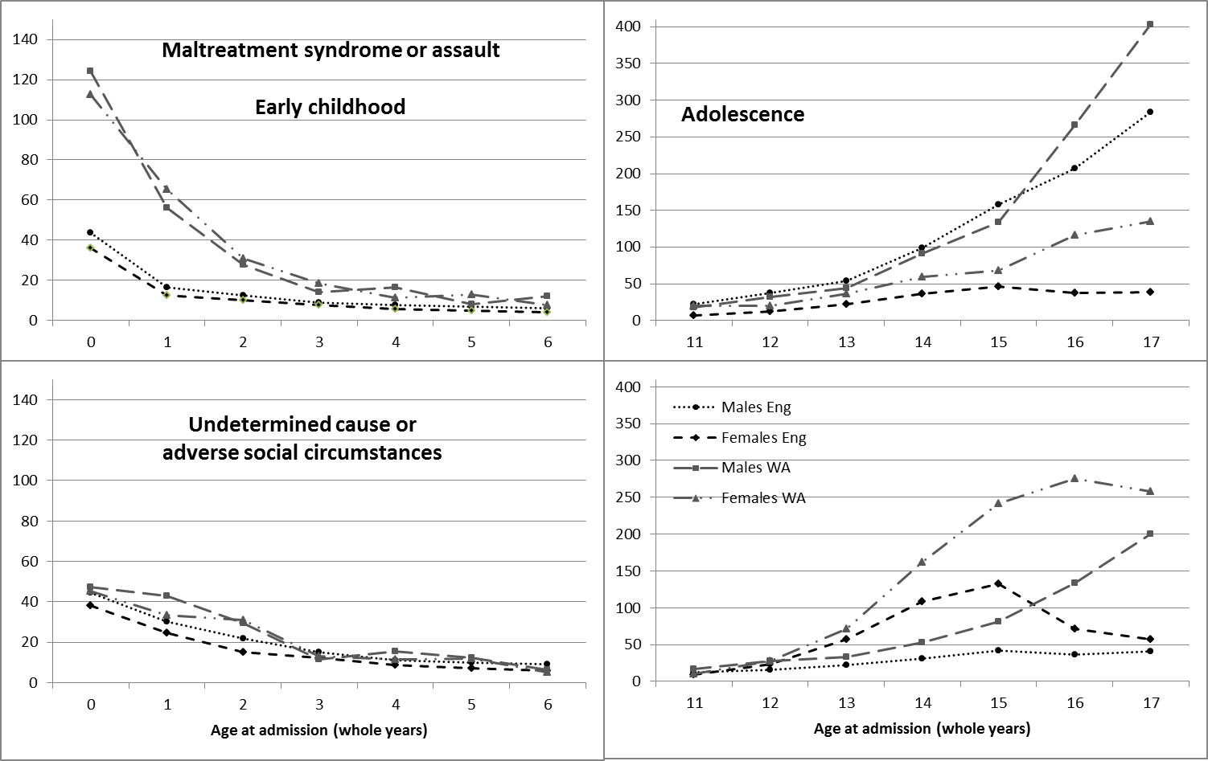
Figure S1 Incidence of victimisation-related injury at the extremes of the age range of study by country and gender: maltreatment-syndrome or assault (top row) and undetermined cause or adverse social circumstances (bottom row), in early childhood (left column) and adolescence (right column)

