Supplemental Materials for
Electrographic Features of Catatonia with and without Comorbid Delirium
James Luccarelli, MD, DPhil^{a,b*}, Joshua R. Smith, MD^{c,d}, Niels Turley, BS^{e}, Jonathan P. Rogers MBBChir, PhD^{f}, Haoqi Sun, PhD^{a,e}, Samuel I. Kohrman, MD^{a,b}, Gregory Fricchione, MD^{a,b}, M Brandon Westover, MD, PhD^{a,e}

Author Affiliations:
ªHarvard Medical School, Boston, MA, USA
^{b}Department of Psychiatry, Massachusetts General Hospital, Boston, MA, USA
^{c}Division of Child and Adolescent Psychiatry, Department of Psychiatry and Behavioral Sciences; Vanderbilt University Medical Center at Village of Vanderbilt, 1500 21st Avenue South, Suite 2200, Nashville, Tennessee, 37212
^{d}Vanderbilt Kennedy Center, Vanderbilt University; 110 Magnolia Circle, Nashville, TN, 37203
^{e}Department of Neurology, Beth Israel Deaconess Medical Center, Boston, MA, USA
^{f}Division of Psychiatry, University College London, London, UK

 | Delirium without catatonia |  | No delirium, no catatonia
N | 10 |  | 24
Male Sex | 4 | 40% | 15 | 63%
Age (yrs; mean ± SD) | 47.3 ± 27.6 |  | 41.3 ± 21.0
Race
White | 7 | 70% | 14 | 58%
Black | 2 | 20% | 7 | 29%
Asian | 0 | 0% | 1 | 4%
Other | 1 | 10% | 2 | 8%
Hispanic (yes) | 1 | 10% | 2 | 8%
Study Site
1 | 2 | 20% | 2 | 8%
2 | 8 | 80% | 22 | 92%
Primary Diagnosis
Psychiatric | 3 | 30% | 15 | 63%
Medical | 7 | 70% | 9 | 38%
EEG Type
Spot | 6 | 60% | 24 | 100%
LTM | 4 | 40% | 0 | 0%
Catatonic (yes) | 0 | 0% | 0 | 0%
Delirious (yes) | 10 | 100% | 0 | 0%
BFCSI Features (mean ± SD) | 2.7 ± 0.5 |  | 2.1 ± 0.9
BFCRS Features (mean ± SD) | 4.5 ± 1.2 |  | 3.7 ± 1.4
Hospital Day of EEG (mean ± SD) | 12.0 ± 9.0 |  | 4.5 ± 4.1
Hospital Length of Stay (mean ± SD) | 28.7 ± 19.5 |  | 12.9 ± 10.9

Table S1: demographics of patients without catatonia, stratified by delirium status.

Psychiatric |  | Medical
N | Diagnosis | N | Diagnosis
40 | Catatonic Schizophrenia | 10 | Altered Mental Status
12 | Bipolar Disorder | 7 | Infection
10 | Catatonia (unspecified) | 6 | Encephalopathy/Delirium
9 | Unspecified psychosis | 5 | Renal disorders
6 | Major Depressive Disorder | 5 | Substance use/withdrawal
3 | Autism Spectrum Disorder | 4 | NMDA Encephalitis
2 | Schizoaffective Disorder | 4 | Epilepsy
2 | Delusional Disorder | 3 | Brain injury
1 | Unspecified Mood Disorder | 2 | Cancer
 |  | 2 | PE
 |  | 2 | Fracture
 |  | 2 | Endocrine disorders
 |  | 2 | Movement Disorders
 |  | 1 | Burn
 |  | 1 | Aspiration pneumonitis
 |  | 1 | Rhabdomyolysis
 |  | 1 | Neuroleptic Malignant Syndrome
 |  | 1 | Dementia

Table S2: Primary discharge diagnoses for patients with catatonia with primary psychiatric and medical diagnoses.
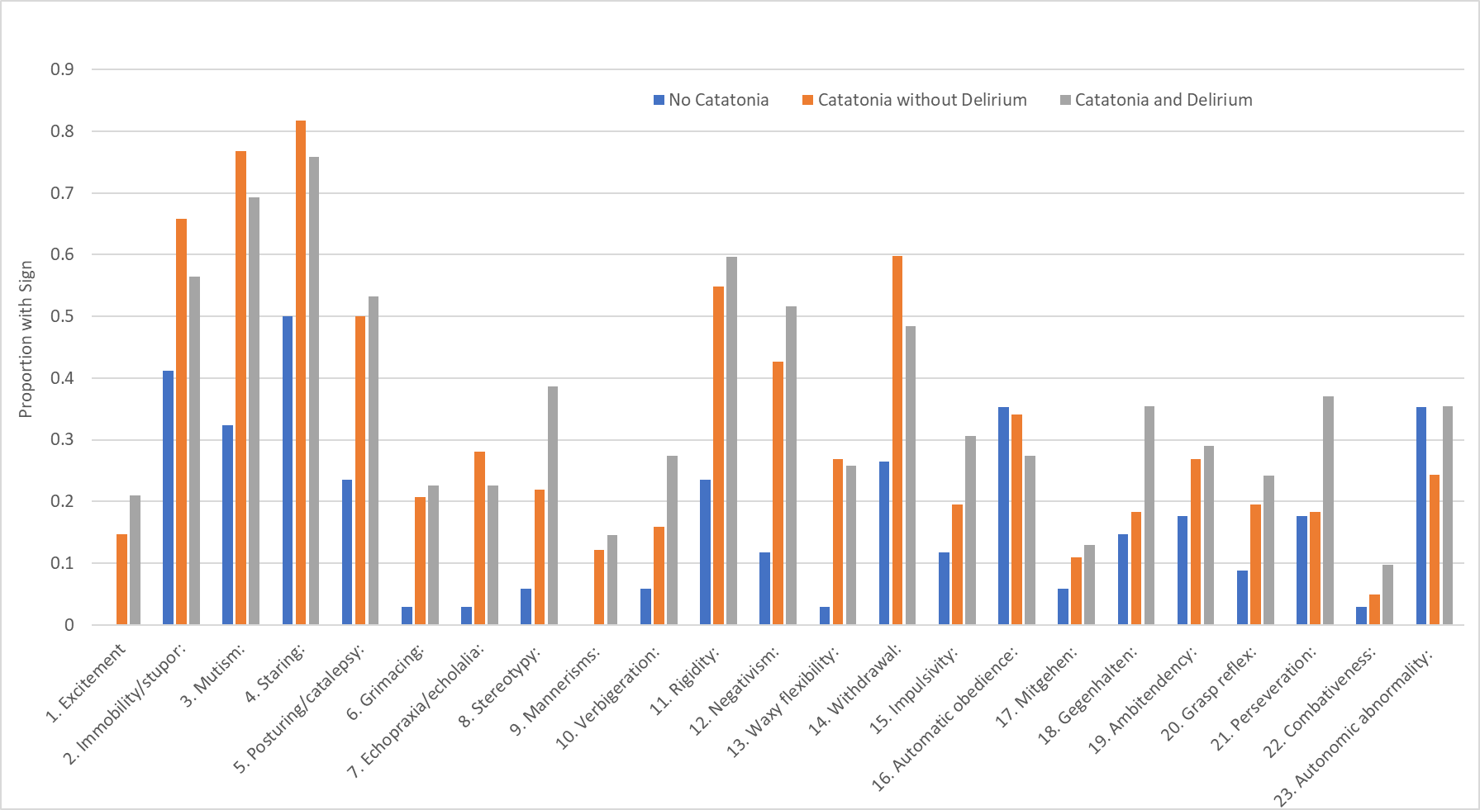
Figure S1: Proportion of patients without catatonia, with catatonia and no delirium, and catatonia with delirium exhibiting each catatonic sign on the BFCRS.

