Supplementary appendix

**eTable 1: Implantable loop recorder (Medtronic LINQ) programming settings**

**eTable 2: Mean AF burdens at baseline and 6 months in each group**

**eTable 3: Mean AF burdens at baseline and 6 months in each subgroup (paroxysmal and persistent)**

**eTable 4: Hazard ratios and 95% confidence intervals for time to event outcomes**

**eFigure 1: Time to any atrial tachyarrhythmia (lasting more than 30 seconds)**

**eFigure 2: Time to any atrial tachyarrhythmia (lasting more than 7 days)**

**eFigure 3: Time to any symptomatic atrial tachyarrhythmia (determined by ILR activation only)**

**eTable 5: AFEQT Overall, Symptoms, Daily Activities, and Treatment Concern Scores in the SHAM-PVI Trial**

**eFigure 4: Estimated difference of AFEQT scores at 3 months**

**eTable 6: AFEQT treatment satisfaction scores at 3 months and 6 months**

**eTable 7: Individual and total MAFSI frequency scores in the SHAM-PVI Trial**

**eTable 8: Individual and total MAFSI severity scores in the SHAM-PVI Trial**

**eFigure 5: Estimated difference of individual MAFSI scores at 3 months**

**eFigure 6: Estimated difference of individual MAFSI scores at 6 months**

**eTable 9:36-Item Short Form Survey (SF-36) Scoring in the SHAM-PVI study**

**eFigure 7: Estimated difference of SF-36 scores at 3 months**

**eTable 10: Number of activations and AF episodes during follow up**

**eTable 11: EHRA scores at baseline**

**eTable 12: EHRA scores at 3 months**

**eTable 13: EHRA scores at 6 months**

**eTable 14: Healthcare utilisation and medication use in follow-up**

**eTable 15: Blinding assessment frequency scores and Bang index**

**eTable 1: Implantable loop recorder (Medtronic LINQ) programming settings**

|  |  |
| --- | --- |
| **Parameter** | **Setting** |
| AF detection threshold | Balanced Sensitivity |
| Ectopy rejection | Nominal |
| Episode storage threshold | All |
| Tachycardia detection | Interval = 400 ms duration 16 beats |

Note: The ILR insertion timing recommendation was reduced to a minimum of 2 weeks before the ablation/sham procedure date. During 2021, there was uncertainty regarding further surges in COVID-19 and the impact this would have on the study. Thus the ILR insertion was also allowed to be performed at the time of the ablation/sham procedure. This would have reduced the requirement for patients to isolate before entering hospital sites. However this was not required in any patient and all patients had their ILR inserted before the ablation/sham procedure allowing a pre-procedure AF burden in all patients.”

**Primary outcome AF burden data**

The following tables contain the AF burden at baseline and 6 months in each group and in each sub group (PAF and persistent)

**eTable 2: Mean AF burdens at baseline and 6 months in each group**

|  |  |  |  |
| --- | --- | --- | --- |
| **Group** | **Timepoint** | **Mean** | **Standard deviation** |
| Ablation | Baseline | 78.52 | 37.68 |
| 6 months | 18.21 | 36.31 |
| Sham intervention | Baseline | 78.19 | 39.54 |
| 6 months | 43.19 | 44.75 |

**eTable 3: Mean AF burdens at baseline and 6 months in each subgroup (paroxysmal and persistent)**

|  |  |  |  |  |
| --- | --- | --- | --- | --- |
| **Group** | **Type of AF** | **Timepoint** | **Mean** | **Standard deviation** |
| Ablation | PAF | Baseline | 16.93 | 22.71 |
| 6 months | 0.80 | 2.12 |
| Persistent | Baseline | 94.21 | 20.69 |
| 6 months | 22.82 | 39.63 |
| Sham intervention | PAF | Baseline | 6.91 | 6.83 |
| 6 months | 9.72 | 10.62 |
| Persistent | Baseline | 97.10 | 15.29 |
| 6 months | 52.25 | 46.20 |

**eTable 4: Hazard ratios and 95% confidence intervals for time to event outcomes**

|  |  |  |  |
| --- | --- | --- | --- |
| Event | Hazard ratio | Lower 95% CI | Upper 95% CI |
| Time to any AF ( >30 seconds) | 0.439 | 0.286 | 0.674 |
| Time to persistent AF ( > 7 days) | 0.392 | 0.202 | 0.759 |
| Time to symptomatic AF | 0.468 | 0.230 | 0.952 |

**eFigure 1: Time to any atrial tachyarrhythmia (lasting more than 30 seconds)**

**eFigure 2: Time to any atrial tachyarrhythmia (lasting more than 7 days)**

**eFigure 3: Time to any symptomatic atrial tachyarrhythmia (determined by ILR activation only)**

**eTable 5: AFEQT Overall, Symptoms, Daily Activities, and Treatment Concern Scores in**

**the SHAM-PVI Trial**

|  |  |  |
| --- | --- | --- |
|  | **Ablation** | **Sham intervention** |
| **Mean overall score (sd)** |  |  |
| Baseline | 53.3 (16.3) | 51.3 (18.1) |
| 3 months | 73.3 (22.4) | 58.3 (24.4) |
| 6 months | 77.4 (20.4) | 58.3 (25.2) |
| **Mean symptoms score (sd)** |  |  |
| Baseline | 62.0 (21.8) | 58.5 (22.2) |
| 3 months | 82.5 (22.4) | 66.7 (26.4) |
| 6 months | 81.2 (23.0) | 66.6 (25.7) |
| **Mean daily activities score (sd)** |  |  |
| Baseline | 44.5 (23.6) | 41.0 (23.4) |
| 3 months | 69.5 (30.4) | 52.6 (29.9) |
| 6 months | 74.9 (27.7) | 50.1 (32.3) |
| **Mean treatment concern score (sd)** |  |  |
| Baseline | 59.0 (18.0) | 55.1 (21.6) |
| 3 months | 71.5 (21.3) | 61.1 (24.3) |
| 6 months | 74.9 (21.5) | 62.9 (23.9) |
| **Mean how well current treatment controls AF score (sd)** |  |  |
| Baseline | 48.7 (24.7) | 53.5 (20.3) |
| 3 months | 73.2 (29.2) | 62.0 (25.1) |
| 6 months | 74.5 (24.3) | 57.7 (28.3) |
| **Mean extent to which treatment has relieved symptoms score (sd)** |  |  |
| Baseline | 47.7 (23.5) | 51.9 (23.0) |
| 3 months | 74.1 (28.7) | 61.5 (27.8) |
| 6 months | 75.3 (26.1) | 57.9 (28.5) |

**eFigure 4: Estimated difference of AFEQT scores at 3 months**

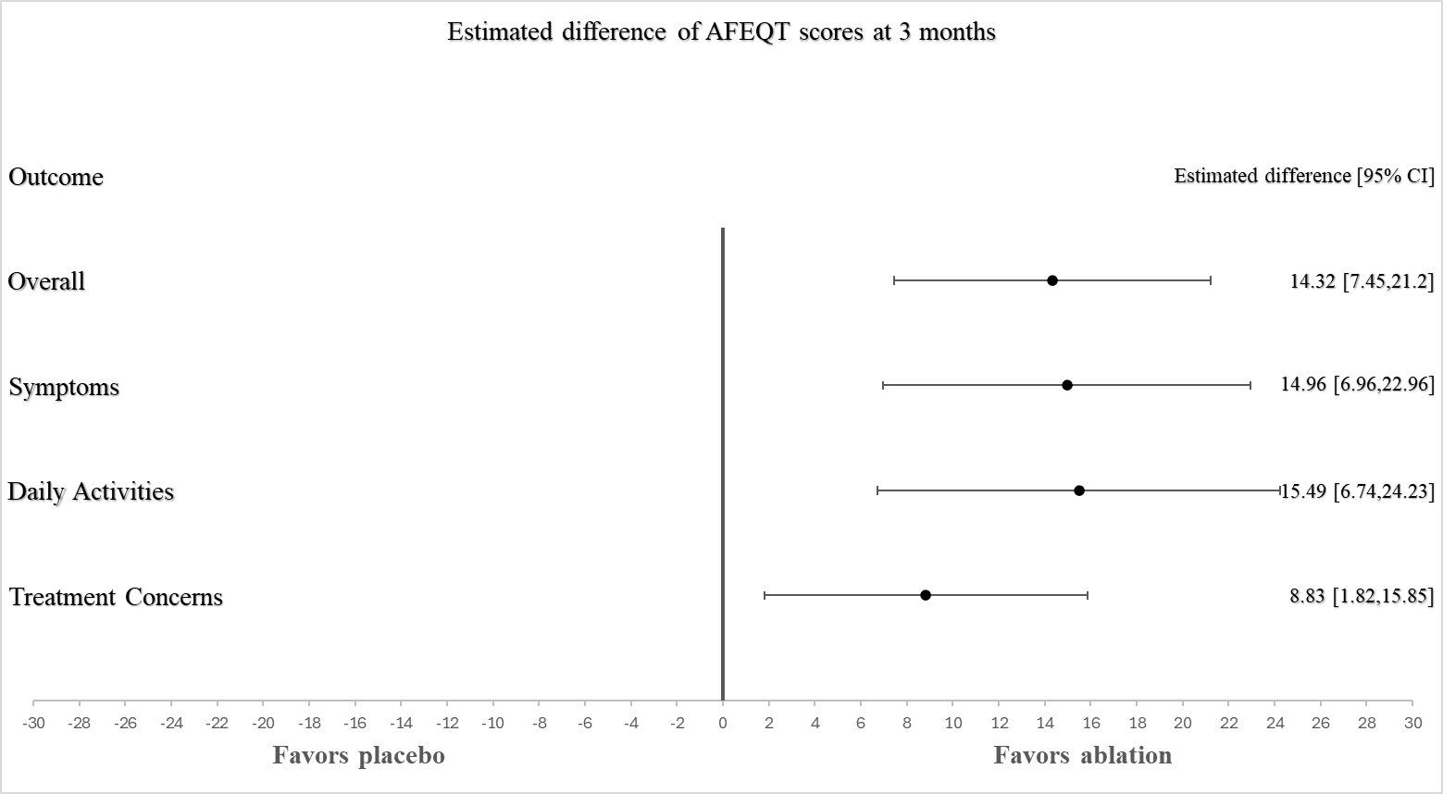

**eTable 6: AFEQT treatment satisfaction scores at 3 months and 6 months**

Note the last two questions of the AFEQT relate to treatment satisfaction and are not included as part of the overall score.

|  |  |  |  |  |
| --- | --- | --- | --- | --- |
| Estimate | Time | Difference | Lower CI | Upper CI |
| How well your current treatment  controls your atrial fibrillation? | 3 months | 12.46 | 3.88 | 21.04 |
| How well your current treatment  controls your atrial fibrillation? | 6 months | 17.56 | 8.94 | 26.18 |
| The extent to which treatment  has relieved your symptoms of  atrial fibrillation? | 3 months | 13.38 | 4.34 | 22.42 |
| The extent to which treatment  has relieved your symptoms of  atrial fibrillation? | 6 months | 17.93 | 9.00 | 26.87 |

**eTable 7: Individual and total MAFSI frequency scores in the SHAM-PVI Trial**

|  |  |  |
| --- | --- | --- |
|  | **Ablation** | **Sham intervention** |
| **Mean palpitations score (sd)** |  |  |
| Baseline | 2.2 (1.0) | 2.0 (1.2) |
| 3 months | 1.0 (1.0) | 1.6 (1.3) |
| 6 months | 1.1 (1.1) | 1.6 (1.2) |
| **Mean slow heart rate score (sd)** |  |  |
| Baseline | 1.1 (1.0) | 1.1 (1.1) |
| 3 months | 0.6 (1.0) | 1.1 (1.3) |
| 6 months | 0.5 (0.8) | 1.0 (1.2) |
| **Mean fainting score (sd)** |  |  |
| Baseline | 0.1 (0.4) | 0.1 (0.3) |
| 3 months | 0.0 (0.2) | 0.0 (0.2) |
| 6 months | 0.0 (0.2) | 0.1 (0.5) |
| **Mean dizziness score (sd)** |  |  |
| Baseline | 1.4 (0.9) | 1.7 (1.0) |
| 3 months | 0.9 (1.1) | 1.4(1.0) |
| 6 months | 0.7 (0.9) | 1.6 (1.1) |
| **Mean chest pain score (sd)** |  |  |
| Baseline | 0.9 (0.9) | 0.9 (1.0) |
| 3 months | 0.4 (0.9) | 0.7 (0.9) |
| 6 months | 0.4 (0.7) | 0.8 (1.0) |
| **Mean shortness of breath score (sd)** |  |  |
| Baseline | 2.1 (1.1) | 2.4 (1.1) |
| 3 months | 1.3(1.2) | 1.9 (1.4) |
| 6 months | 1.0 (1.1) | 2.2 (1.3) |
| **Mean unable to exercise score (sd)** |  |  |
| Baseline | 1.8 (1.3) | 2.1 (1.3) |
| 3 months | 0.9 (1.3) | 1.5 (1.4) |
| 6 months | 0.7 (1.1) | 1.7 (1.5) |
| **Mean tiredness score (sd)** |  |  |
| Baseline | 2.4 (1.1) | 2.6 (1.1) |
| 3 months | 1.7 (1.2) | 2.1(1.2) |
| 6 months | 1.3 (1.3) | 2.3(1.2) |
| **Mean weakness score (sd)** |  |  |
| Baseline | 1.8 (1.2) | 2.0 (1.2) |
| 3 months | 0.9 (1.2) | 1.6 (1.3) |
| 6 months | 0.7 (1.0) | 1.6(1.3) |
| **Mean flushed score (sd)** |  |  |
| Baseline | 1.6 (1.2) | 1.3 (1.1) |
| 3 months | 0.7 (1.0) | 0.9 (1.2) |
| 6 months | 0.7 (1.0 | 1.0 (1.2) |
| **Mean total frequency score (sd)** |  |  |
| Baseline | 15.5 (5.8) | 16.1(6.2) |
| 3 months | 8.48 (7.2) | 12.7 (7.7) |
| 6 months | 7.21 (6.5) | 13.9 (7.3) |

The MAFSI frequency scores were collected with a 5-item Likert scale ranging from 0 (never) to 4 (always) and summed to generate a summary frequency score that has a theoretical range from 0 (no AF symptoms) to 40 (all 10 symptoms constant).

**eTable 8: Individual and total MAFSI severity scores in the SHAM-PVI Trial**

|  |  |  |
| --- | --- | --- |
|  | **Ablation** | **Sham intervention** |
| **Mean palpitations score (sd)** |  |  |
| Baseline | 1.6 (0.8) | 1.4 (0.9) |
| 3 months | 0.8 (0.9) | 1.1 (1.0) |
| 6 months | 0.8 (0.9) | 1.2 (0.9) |
| **Mean slow heart rate score (sd)** |  |  |
| Baseline | 0.7 (0.8) | 0.7 (0.8) |
| 3 months | 0.3 (0.6) | 0.7 (0.8) |
| 6 months | 0.3 (0.6) | 0.6 (0.8) |
| **Mean fainting score (sd)** |  |  |
| Baseline | 0.1 (0.4) | 0.1 (0.3) |
| 3 months | 0.1(0.2) | 0.0 (0.1) |
| 6 months | 0.0 (0.2) | 0.1 (0.5) |
| **Mean dizziness score (sd)** |  |  |
| Baseline | 1.1 (0.8) | 1.2 (0.8) |
| 3 months | 0.6 (0.8) | 0.9 (0.8) |
| 6 months | 0.5 (0.6) | 1.1 (0.8) |
| **Mean chest pain score (sd)** |  |  |
| Baseline | 0.6 (0.7) | 0.7 (0.8) |
| 3 months | 0.4 (0.7) | 0.5 (0.7) |
| 6 months | 0.4 (0.7) | 0.7 (0.8) |
| **Mean shortness of breath score (sd)** |  |  |
| Baseline | 1.6 (0.9) | 1.8 (0.9) |
| 3 months | 0.9 (0.9) | 1.3 (1.1) |
| 6 months | 1.0 (1.2) | 2.2 (1.3) |
| **Mean unable to exercise score (sd)** |  |  |
| Baseline | 1.3 (1.0) | 1.5 (1.0) |
| 3 months | 0.7 (1.0) | 1.1 (1.1) |
| 6 months | 0.6 (0.9) | 1.4 (1.1) |
| **Mean tiredness score (sd)** |  |  |
| Baseline | 1.8 (0.8) | 1.9 (0.7) |
| 3 months | 1.1 (0.9) | 1.4 (0.9) |
| 6 months | 0.9 (0.9) | 1.7 (0.8) |
| **Mean weakness score (sd)** |  |  |
| Baseline | 1.3 (0.8) | 1.3 (0.9) |
| 3 months | 0.7 (0.8) | 1.0 (0.9) |
| 6 months | 0.6 (0.7) | 1.2 (0.9) |
| **Mean flushed score (sd)** |  |  |
| Baseline | 1.0 (0.9) | 0.9 (0.8) |
| 3 months | 0.5 (0.8) | 0.7 (0.9) |
| 6 months | 0.4 (0.6) | 0.8 (0.9) |
| **Mean total severity score (sd)** |  |  |
| Baseline | 11.3 (4.7) | 11.3 (4.6) |
| 3 months | 6.22 (5.3) | 8.72 (5.6) |
| 6 months | 5.24 (4.8) | 10.2 (5.4) |

The MAFSI severity score was collected with a 3-item Likert scale from 1 (mild) to 3 (severe) and summed to generate a summary score with a theoretical range from 0 (no AF symptoms) to 30 (all 10 symptoms at the most severe level).

**eFigure 5: Estimated difference of individual MAFSI scores at 3 months**

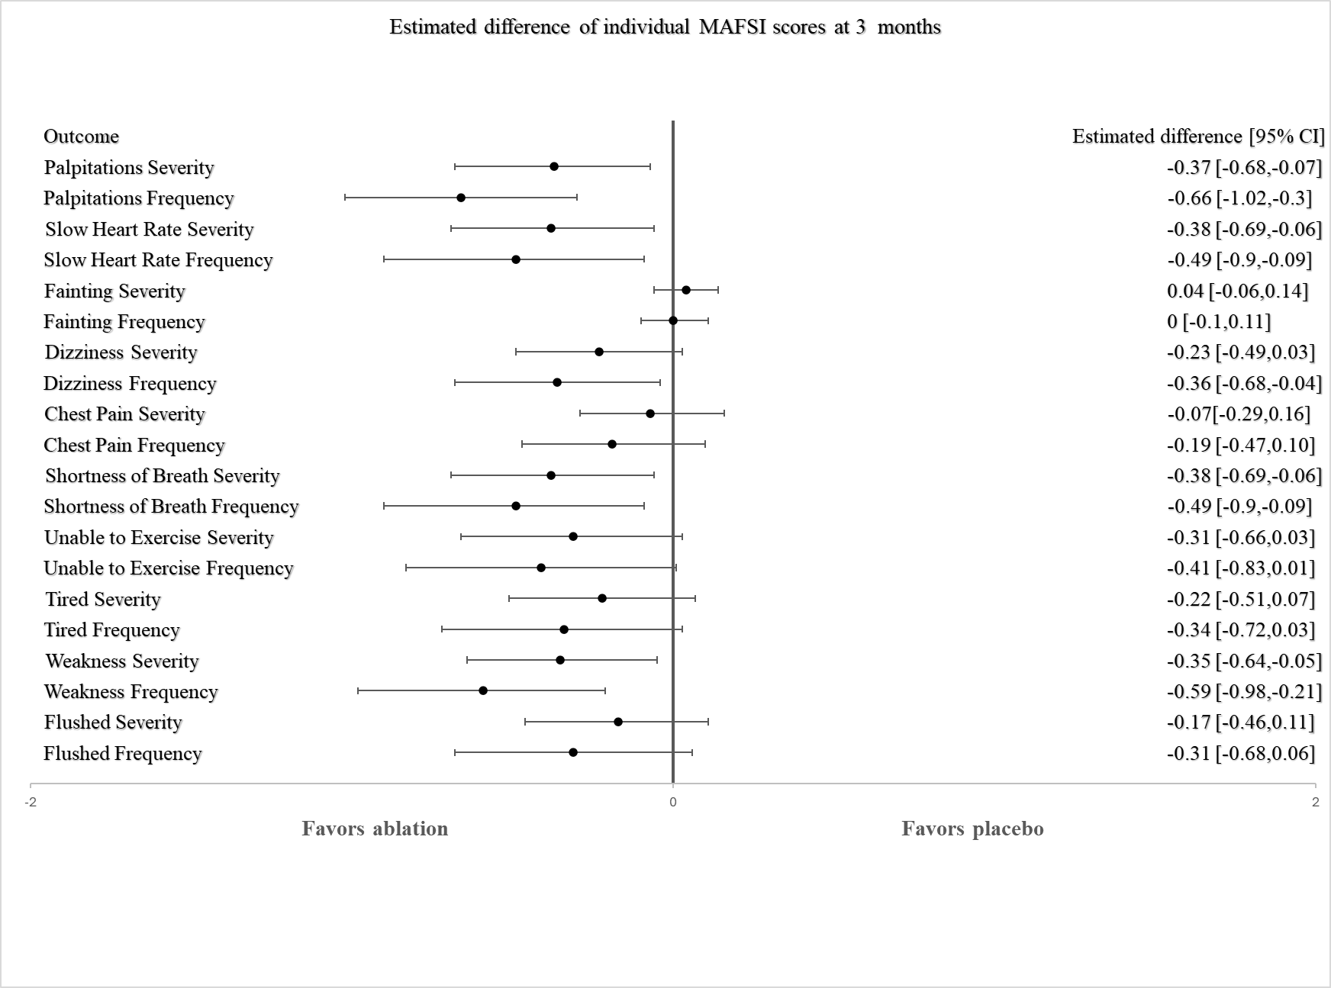

**eFigure 6: Estimated difference of individual MAFSI scores at 6 months**

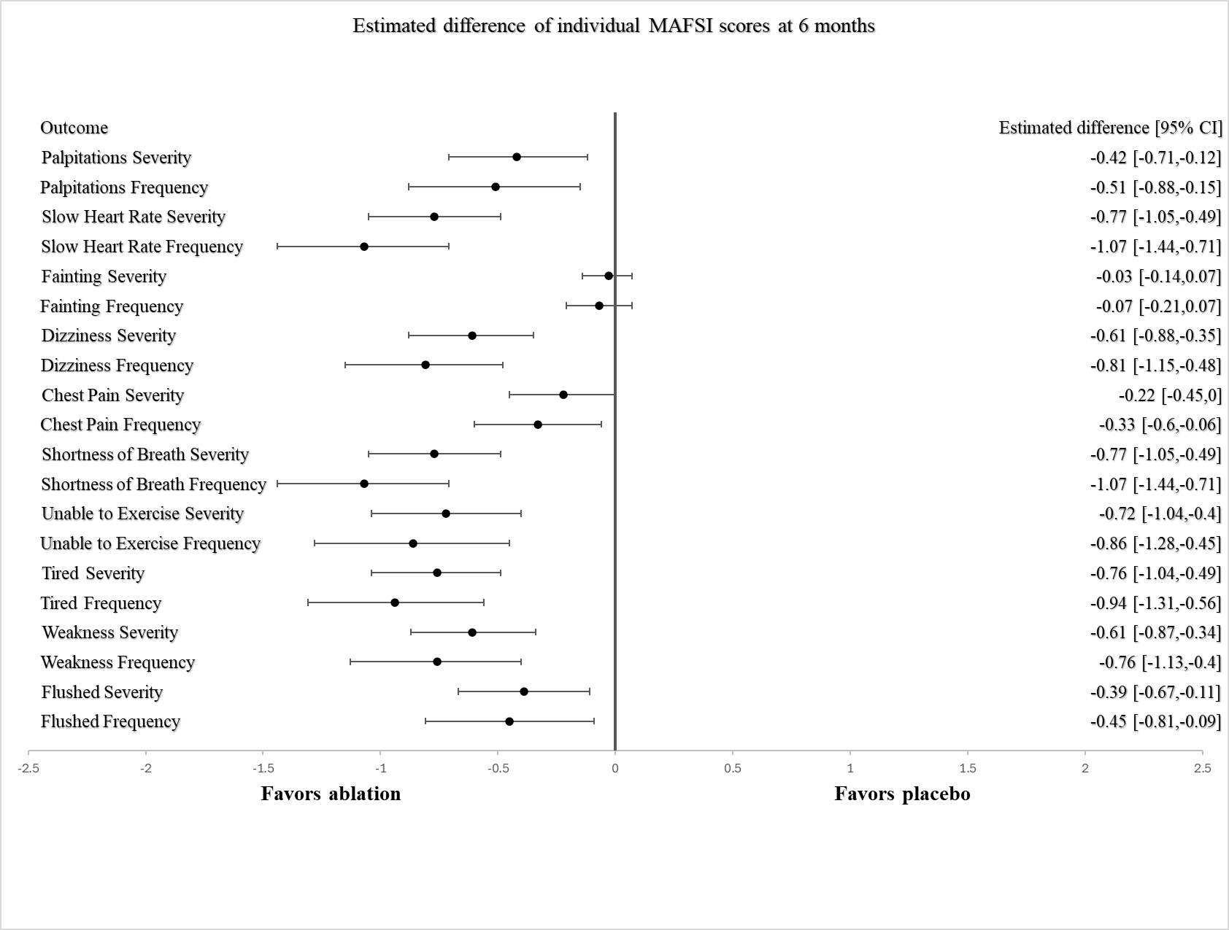

**eTable 9: 36-Item Short Form Survey (SF-36) Scoring in the SHAM-PVI study**

|  |  |  |
| --- | --- | --- |
|  | **Ablation** | **Sham intervention** |
| **Mean physical functioning score (sd)** |  |  |
| Baseline | 56.0 (22.6) | 53.3(24.7) |
| 3 months | 71.2 (25.6) | 55.4 (28.9) |
| 6 months | 73.3 (24.9) | 56.5 (29.1) |
| **Mean role limitations due to physical health score (sd)** |  |  |
| Baseline | 31.7 (38.1) | 33.1 (37.8) |
| 3 months | 56.0 (45.5) | 45.5 (41.2) |
| 6 months | 63.9 (40.1) | 36.1 (43.9) |
| **Mean role limitations due to emotional problems score (sd)** |  |  |
| Baseline | 61.0 (41.8) | 62.4 (41.2) |
| 3 months | 79.9 (33.7) | 68.8 (41.3) |
| 6 months | 83.2 (31.3) | 64.5 (43.4) |
| **Mean energy / fatigue score (sd)** |  |  |
| Baseline | 40.2 (20.6) | 40.4 (16.8) |
| 3 months | 51.9 (22.4) | 44.6 (20.0) |
| 6 months | 53.5 (22.3) | 44.9 (21.5) |
| **Mean emotional well-being score (sd)** |  |  |
| Baseline | 72.2 (15.9) | 72.6 (16.1) |
| 3 months | 78.2 (16.3) | 73.8 (15.8) |
| 6 months | 80.8 (13.5) | 74.4 (15.5) |
| **Mean emotional well-being score (sd)** |  |  |
| Baseline | 64.2 (24.4) | 62.6 (24.6) |
| 3 months | 76.1 (28.1) | 69.4 (25.2) |
| 6 months | 82.0 (22.7) | 68.6 (26.3) |
| **Mean pain score (sd)** |  |  |
| Baseline | 73.0 (24.0) | 71.1 (27.0) |
| 3 months | 72.9 (27.1) | 66.2 (25.4) |
| 6 months | 74.5 (24.8) | 61.3 (24.0) |
| **Mean general health score (sd)** |  |  |
| Baseline | 54.2 (20.1) | 51.4 (18.6) |
| 3 months | 55.2 (20.5) | 48.9 (20.5) |
| 6 months | 58.3 (20.3) | 47.2 (20.7) |
| **Mean health change score (sd)** |  |  |
| Baseline | 34.4 (20.2) | 36.2 (21.1) |
| 3 months | 61.9 (28.0) | 52.0 (27.1) |
| 6 months | 67.0 (25.4) | 52.5 (27.6) |

**eFigure 7: Estimated difference of SF-36 scores at 3 months**

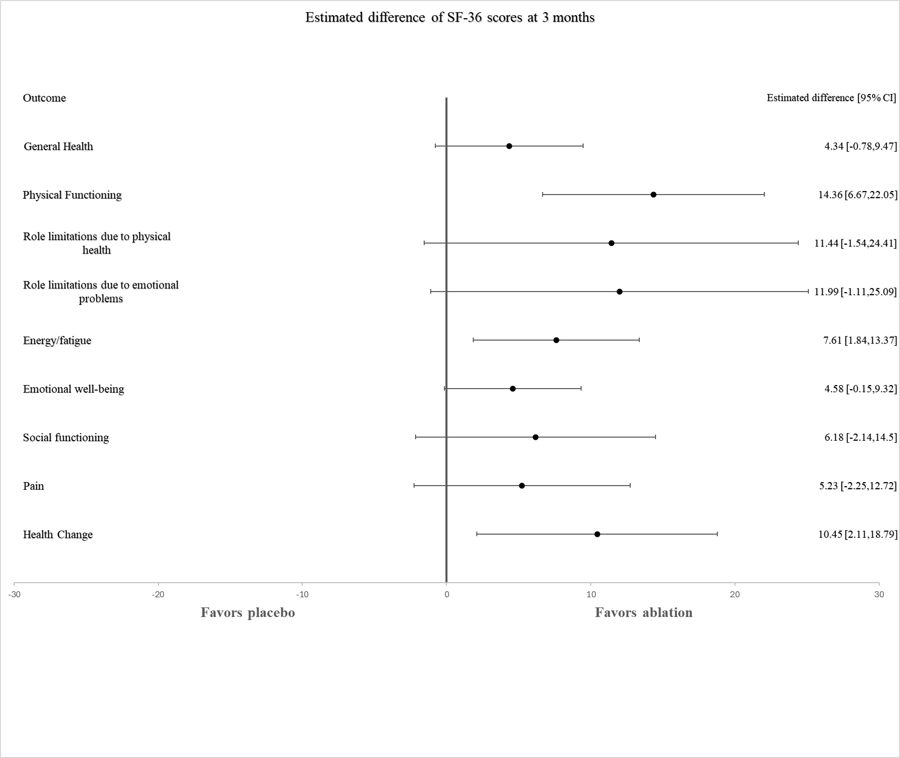

**eTable 10: Number of activations and AF episodes during follow up**

|  |  |  |  |  |
| --- | --- | --- | --- | --- |
| Count | Time | Geometric Mean | Lower 95% CI | Upper 95% CI |
| AF activations | 3 months | 0.758 | 0.637 | 0.902 |
| AF activations | 6 months | 0.454 | 0.359 | 0.574 |
| AT activations | 3 months | Not estimable |  |  |
| AT activations | 6 months | Not estimable |  |  |
| SR / ST activations | 3 months | 0.257 | 0.167 | 0.394 |
| SR / ST activations | 6 months | 0.214 | 0.133 | 0.344 |
| Ectopy activations | 3 months | 0.737 | 0.447 | 1.213 |
| Ectopy activations | 6 months | 1.300 | 0.700 | 2.417 |
| AF episodes | 3 months | 0.780 | 0.648 | 0.939 |
| AF episodes | 6 months | 0.755 | 0.622 | 0.916 |
| PAF episodes | 3 months | 0.839 | 0.685 | 1.029 |
| PAF episodes | 6 months | 0.914 | 0.740 | 1.130 |
| Persistent AF episodes | 3 months | 0.587 | 0.371 | 0.928 |
| Persistent AF episodes | 6 months | 0.416 | 0.214 | 0.808 |

Accounting for different observation times pre procedure using loge(days) as offset variable.

**eTable 11: EHRA scores at baseline**

|  |  |
| --- | --- |
|  |  |

|  |  |  |  |  |  |
| --- | --- | --- | --- | --- | --- |
|  | **EHRA score** | | | | |
| **Group** | **1** | **2** | **3** | **4** | **Total** |
| **Ablation (%)** | 1 (1.56) | 34 (53.13) | 25 (39.06) | 4 (6.25) | 64 |
| **Sham intervention (%)** | 0 (0.00) | 27 (43.55) | 30 (48.39) | 5 (8.06) | 62 |
| **Total** | 1 (0.79) | 61 (48.41) | 55 (43.65) | 9 (7.14) | 126 |

**1 No symptoms**

**2** **Mild symptoms; normal daily activity not affected.**

**3 Severe symptoms; normal daily activity affected.**

**4** **Disabling symptoms; normal daily activity discontinued.**

**eTable 12: EHRA scores at 3 months**

|  |  |  |  |  |  |
| --- | --- | --- | --- | --- | --- |
|  | **EHRA score** | | | | |
| **Group** | **1** | **2** | **3** | **4** | **Total** |
| **Ablation (%)** | 20 (31.75) | 34 (53.97) | 7 (11.11) | 2 (3.17) | 63 |
| **Sham intervention (%)** | 6 (9.84) | 24 (39.34) | 28 (45.90) | 3 (4.92) | 61 |
| **Total** | 26 (20.97) | 58 (46.77) | 35 (28.23) | 5 (4.03) | 124 |

**eTable 13: EHRA scores at 6 months**

|  |  |  |  |  |  |
| --- | --- | --- | --- | --- | --- |
|  | **EHRA score** | | | | |
| **Group** | **1** | **2** | **3** | **4** | **Total** |
| **Ablation (%)** | 27 (43.55) | 26 (41.94) | 8 (12.90) | 1 (1.61) | 62 |
| **Sham intervention (%)** | 9 (14.75) | 28 (45.90) | 21 (34.43) | 3 (4.92) | 61 |
| **Total** | 36 (29.27) | 54 (43.90) | 29 (23.58) | 4 (3.25) | 123 |

**eTable 14: Healthcare utilisation and medication use in follow-up**

|  |  |  |
| --- | --- | --- |
| **Outcome** | **Ablation (%)** | **Placebo (%)** |
| DCCV 0-3 months | 25 (39.7%) | 30 (48.4%) |
| ED Attendance 0-3 months | 1 (1.6%) | 1 (1.6%) |
| DCCV 3-6 months | 4 (6.5%) | 6 (9.8%) |
| ED Attendance 3-6 months | 1 (1.6%) | 1 (1.6%) |
| Bisoprolol 0-3 months | 26 (41.3%) | 25 (41.0%) |
| Sotalol 0-3 months | 19 (30.2%) | 21 (34.4%) |
| Flecainide 0-3 months | 13 (20.6%) | 16 (26.2%) |
| Dronedarone 0-3 months | 2 (3.2%) | 1 (1.6%) |
| Amiodarone 0-3 months | 2 (3.2%) | 0 (0%) |
| Diltiazem 0-3 months | 0 (0%) | 2 (3.3%) |
| Digoxin 0-3 months | 0 (0%) | 1 (1.6%) |
| Bisoprolol 3-6 months | 19 (30.7%) | 23 (37.7%) |
| Sotalol 3-6 months | 9 (14.5%) | 18 (29.5%) |
| Flecainide 3-6 months | 7 (11.3%) | 13 (21.3%) |
| Dronedarone 3-6 months | 1 (1.6%) | 3 (4.9%) |
| Amiodarone 3-6 months | 3 (4.8%) | 2 (3.3%) |
| Diltiazem 3-6 months | 2 (3.2%) | 1 (1.6%) |
| Digoxin 3-6 months | 0 (0%) | 0 (0%) |

**eTable 15: Blinding assessment frequency scores and Bang index**

The Bang index was used to assess blinding in patients and staff. The blinding index is scaled to an interval of -1 to 1, 1 being complete lack of blinding, 0 indicating perfect blinding and -1 indicating opposite guessing which may be related to unblinding. A band index greater than 0.20 indicated unblinding. At 3 and 6 months medical staff were asked to guess assignment before speaking to patients.

|  |  |  |  |  |  |
| --- | --- | --- | --- | --- | --- |
|  | Ablation | Sham | Don’t know | Total | Bang index |
| **Patients post procedure** |  |  |  |  |  |
| Ablation | 3 | 2 | 59 | 64 | 0.016 (-0.053 - 0.084) |
| Sham | 3 | 1 | 58 | 62 | -0.032 (-0.095 - 0.030) |
| **Patients at 3 month follow up** |  |  |  |  |  |
| Ablation | 25 | 8 | 30 | 63 | 0.270 (0.104 - 0.436) |
| Sham | 8 | 18 | 35 | 61 | 0.164 (0.005 - 0.323) |
| **Patients at 6 month follow up** |  |  |  |  |  |
| Ablation | 24 | 8 | 30 | 62 | 0.258 (0.091 - 0.425) |
| Sham | 11 | 18 | 32 | 61 | 0.115 (-0.056 - 0.285) |
| **Medical staff post procedure** |  |  |  |  |  |
| Ablation | 1 | 0 | 63 | 64 | 0.016 (- 0.015 - 0.046) |
| Sham | 0 | 0 | 62 | 62 | N/A |
| **Medical staff at 3 month follow up** |  |  |  |  |  |
| Ablation | 1 | 1 | 61 | 63 | 0 (-0.044 - 0.044) |
| Sham | 1 | 1 | 59 | 61 | 0 (-0.045 - 0.045) |
| **Medical staff at 6 month follow up** |  |  |  |  |  |
| Ablation | 2 | 1 | 59 | 62 | 0.016 (-0.038 - 0.071) |
| Sham | 1 | 2 | 58 | 61 | 0.016 (-0.039 - 0.072) |