Prospective, non-randomized, multicenter, phase 2 trial of crizotinib in patients with advanced, inoperable inflammatory myofibroblastic tumor with and without anaplastic lymphoma kinase gene alterations: EORTC study 90101 "CREATE"

Prof Patrick Schöffski, MD^{1,2}*, Jozef Sufliarsky, MD³, Prof Hans Gelderblom, MD⁴, Prof Jean-Yves Blay, MD⁵, Sandra J Strauss, MD⁶, Silvia Stacchiotti, MD⁷, Prof Piotr Rutkowski, MD⁸, Prof Lars H Lindner, MD⁹, Michael G Leahy, MD¹⁰, Prof Antoine Italiano, MD¹¹, Nicolas Isambert, MD¹², Prof Maria Debiec-Rychter, MD¹³, Prof Raf Sciot, MD¹⁴, Thomas Van Cann, MD^{1,2} , Sandrine Marréaud, MD¹⁵, Axelle Nzokirantevye, MSc¹⁵, Sandra Collette, MSc¹⁵, Agnieszka Wozniak, PhD²

¹University Hospitals Leuven, Department of General Medical Oncology, Leuven Cancer Institute, Leuven, Belgium
²KU Leuven, Laboratory of Experimental Oncology, Department of Oncology, Leuven, Belgium
³National Cancer Institute, Bratislava, Slovakia
⁴Department of Medical Oncology, Leiden University Medical Center, Leiden, Netherlands
⁵Centre Léon Bérard & Université Claude Bernard Lyon I, Department of Medical Oncology, Lyon, France
⁶University College London Hospitals NHS Trust, Department of Oncology, London, United Kingdom
⁷IRCCS Fondazione Istituto Nazionale Tumori, Department of Medical Oncology, Milano, Italy
⁸Maria Sklodowska-Curie Institute-Oncology Center, Department of Soft Tissue/Bone Sarcoma and Melanoma, Warsaw, Poland
⁹Klinikum der Universität München, Medizinische Klinik III, Campus Grosshadern, München, Germany
¹⁰The Christie NHS Foundation Trust, Manchester, United Kingdom
¹¹Sarcoma Unit, Institut Bergonié, Bordeaux, France
¹²Centre Georges François Leclerc, Department of Medical Oncology, Dijon, France
¹³KU Leuven, Department of Human Genetics, Leuven, Belgium
¹⁴University Hospitals Leuven, KULeuven, Department of Pathology, Leuven, Belgium
¹⁵European Organization for Research and Treatment of Cancer, Brussels, Belgium

*Correspondence to: Professor Dr. P. Schöffski, MD, MPH, Department of General Medical Oncology, Leuven Cancer Institute, University Hospitals Leuven, and Laboratory of Experimental Oncology, KU Leuven, Herestraat 49, B-3000 Leuven, Belgium. Tel. +32-16-346900; Fax +32-16-346901; Email: patrick.schoffski@uzleuven.be
Abstract

Background: EORTC 90101 CREATE assessed the activity and safety of crizotinib in patients with advanced inflammatory myofibroblastic tumor (IMFT), a disease characterized by anaplastic lymphoma kinase (ALK) rearrangements. The main aim of the study was to determine the objective response rate (ORR) in patients with or without ALK alterations, with a focus on ALK positive (+) IMFT.

Methods: Patients with the local diagnosis of advanced or metastatic IMFT, measurable disease, an age of ≥15 years, an Eastern Cooperative Oncology Group (ECOG) performance status 0-2, and adequate hematological, renal, and liver function were enrolled in this study. After central reference pathology for confirmation of the diagnosis, eligible ALK+ and ALK negative (-) patients received oral crizotinib 250 mg twice daily, administered on a continuous daily dosing schedule. ALK positivity was assessed centrally using immunohistochemistry and fluorescence in situ hybridization based on archival tumor tissue, and was defined as either ALK immunopositivity or rearrangement in >15% of tumor cells. The study was an open-label, two-stage phase 2 trial. If >2 out of the first 12 eligible and evaluable ALK+ patients achieved a confirmed RECIST 1.1 partial or complete response (PR, CR), a maximum of 35 patients were to be enrolled. If >6 ALK+ patients achieved a confirmed response, the trial would be deemed successful. The primary endpoint was ORR per RECIST version 1·1 with response confirmation, assessed by the local investigator. The activity and safety endpoints were analyzed in the per protocol population and this paper presents the final analysis of this completed clinical trial (EORTC 90101, NCT01524926).

Findings: Among 35 recruited patients with local diagnosis of IMFT, 20 had a centrally confirmed IMFT and received treatment with crizotinib. Among 12 eligible and evaluable ALK+ patients, 6 achieved a confirmed PR or CR, one a non-confirmed PR and 5 had stable disease (SD) (ORR: 50·0%, 95% confidence interval (CI): 21·1-78·9%). Further efficacy endpoints in patients with ALK+ tumors were a disease control rate (DCR=CR, PR, or SD) of 100·0% (95% CI: 73·5-100·0%), a 1-year progression-free survival rate (PFR) of 73·3 % (95% CI: 37·9-90·6%) and a 1-year OS rate (OSR) of 81·8% (95% CI: 44·7-95·1%). Among 7 eligible and evaluable ALK- patients, one achieved PR, 5 had SD and one had progressive disease (ORR: 14·3%, 95% CI: 0·0-57·9%). Further efficacy endpoints in ALK- cases were a DCR of 85·7% (95% CI: 42·1-99·6%), a 1-year PFR of 53·6 % (95% CI: 13·2-82·5%) and 1-year OSR of 83·3% (95% CI: 27·3-97·5%). Common adverse events included nausea (11/20 [55%]), fatigue (9/20 [45%]), blurred vision (9/20 [45%]), vomiting (7/20 [35%]), and diarrhea (7/20 [35%]). Treatment-related grade 3/4 adverse events were fatigue, weight gain, and hepatic failure/sepsis (one patient each). A total of 8 serious adverse events were observed in 5 patients, which included cases of pneumonia, fever of unknown cause, a heart attack with increase in creatinine and possible sepsis, abdominal abscess with acute renal insufficiency, and one patient with QT prolongation.

Interpretation: With an ORR of 50%, a DCR of 100% and long-lasting progression arrest in the vast majority of ALK+ patients, crizotinib met the pre-specified success criteria in this trial. To the best of our knowledge, EORTC 90101 is the largest prospective series of treated IMFT cases in the literature, and the results presented here support the rationale for inhibiting ALK in this disease. Crizotinib should be considered standard-of-care for ALK+ IMFT patients who do not qualify for curative surgery.

Funding: This trial was investigator-initiated trial with EORTC as the legal sponsor. The study was supported by Pfizer Inc., and the company provided the investigational agent.

Prior presentations: None

Introduction

Inflammatory myofibroblastic tumor (IMFT) is a rare mesenchymal neoplasm that primarily occurs in children and adolescents.¹⁻⁶ IMFTs are commonly found in the lung, retroperitoneum, or abdominopelvic region.¹ IMFTs are considered to be resistant to conventional chemotherapy and radiation, and surgical excision is the mainstay of treatment.^{2,7} However, IMFTs have a tendency for local recurrence after initial surgery, the incidence of which can vary according to anatomical site.^{1,2,5-7}

Due to their proximity to vital structures, complete resection of IMFT tumors may not always be possible.⁸ If curative surgery is not possible, local recurrence can occur with tumors invading adjacent structures.⁸ IMFT tumor-related deaths are usually due to local invasion, and not due to distant metastases.¹ Radiotherapy and chemotherapy are not successful in most IMFT patients, making the management of these tumors challenging. For patients with unresectable and/or advanced disease, treatment options are limited.³

The predominant genetic lesion underlying IMFTs are fusions involving the anaplastic lymphoma kinase (ALK) gene.⁷ About 50% of IMFTs have translocations involving ALK, with more recent data showing that an additional subset of IMFTs have ALK fusions with noncanonical breakpoints, which suggests the involvement of ALK signaling in most of these tumors.^{1-3,5,7} The chromosomal translocation results in expression of ALK fusion protein which exhibits ligand-independent kinase activity leading to autophosphorylation of the chimeric protein, which ultimately results in prolonged tumor cell survival, increased proliferation, and enhanced cell migration.^{1,5,7,9-17}

The presence of specific genetic alterations in IMFT provides a strong rationale to therapeutically target ALK in this disease. Crizotinib (Xalkori®, PF-02341066, Pfizer Inc., New York (NY), United States of America) is a small molecule tyrosine kinase inhibitor (TKI) targeting ALK, MET, ROS proto-oncogene 1 receptor tyrosine kinase (ROS1), and RON (Recepteur d’Origine Nantais).^{1,18-21} In non-small cell lung cancer (NSCLC) with ALK rearrangements, crizotinib demonstrated striking clinical activity.¹ Crizotinib interferes with the ALK pathway by competitively inhibiting adenosine triphosphate (ATP) from binding to the receptor, therefore abrogates its phosphorylation, blocking the downstream cascade of events, thereby inhibiting the growth and survival of ALK dependent cells.¹⁸⁻²¹ Crizotinib is approved for the treatment of patients with advanced NSCLC whose tumors are either ALK-positive or ROS1-positive, and the recommended oral dose in adult patients is 250mg twice daily.¹⁹

In 2010, Butrynski et al. published a first case of an ALK+ IMFT patient responding to crizotinib in the context of a phase 1 clinical trial.¹ The European Organization for Research and Treatment of Cancer (EORTC) initiated a multinational, multi-tumor, prospective phase 2 clinical trial (EORTC 90101 “CREATE”) to evaluate the efficacy and safety of crizotinib in patients with advanced tumors characterized by ALK and/or MET alterations. CREATE included 6 tumor types, and we report here the results of the independent IMFT cohort. To our knowledge, this trial cohort is the first prospective disease-specific study in adult patients with IMFT with and without ALK alterations, and thus serves as a landmark of prospective clinical research in this orphan malignancy.

Methods

Study design

This was a multicentre, biomarker-driven, single agent, non-randomized, open-label, two-stage phase 2 trial assessing the activity and safety of crizotinib in patients with locally advanced or metastatic IMFT after central reference pathology confirmation of the diagnosis. The IMFT patient population was divided by protocol into ALK altered (ALK+) and ALK non-altered (ALK-) sub-cohorts, which were analyzed separately.

Ethics approval was obtained for this study (ClinicalTrials.gov identifier NCT01524926), which was conducted in accordance with the Declaration of Helsinki, International Conference on Harmonization-Good Clinical Practice, and participating country and institution regulations.

Patient enrolment

Patient enrolment was based on a multi-step registration procedure. Step 1 prerequisites for registration were a local diagnosis of advanced and/or metastatic IMFT deemed incurable by conventional surgery, radiotherapy or systemic therapy, the availability of a formalin-fixed paraffin embedded (FFPE) tumor-containing tissue block from primary tumor and/or metastatic site for trial purposes and written informed consent of the patient for central collection of the tissue and all other trial-specific procedures.

Criteria for step 2 included receipt of the tissue by a central biorepository (BioRep, Milan, Italy) with presence of tumor in the shipped material and confirmation of the correct diagnosis of IMFT by central reference pathology. The reference pathology review was based on the diagnostic criteria for IMFT as described by Coffin and Fletcher (2013).²²

Screened patients were treated after completion of both steps, provided all other eligibility criteria were met: age ≥15 years, Eastern Cooperative Oncology Group (ECOG) performance status 0-2, adequate hematological, renal, and liver function and measurable disease according to Response Evaluation Criteria In Solid Tumors (RECIST) 1·1. There was no limitation in terms of previous systemic or local treatment for IMFT, only prior exposure to crizotinib or other specific ALK-inhibiting agents was not allowed. Exclusion criteria included acute or chronic severe gastrointestinal conditions, current congestive heart failure or cardiac dysrhythmias National Cancer Institute Common Toxicity Criteria (NCI CTCAE) grade >2 including uncontrolled atrial fibrillation. Further details on the patient selection are described in the study protocol (available at: http://www.eortc.be/services/doc/protocols/90101v10.0.pdf)

Documentation of the presence of a specific ALK alteration was not required for a patient to enter the clinical screening and treatment phase (step 3). The central molecular/genetic analysis was done while patients were already receiving therapy, and in many cases results of local ALK testing were available. The attribution of patients to the ALK+ or ALK- subcohorts was based exclusively on central testing.

Treatment, safety and efficacy assessment

Eligible patients with centrally confirmed diagnosis of IMFT were treated with oral crizotinib at a starting dose of 250 mg twice daily. This dose was based on the approved crizotinib adult dose for ALK+ NSCLC.¹⁹ Crizotinib was administered orally at approximately the same time each day on a continuous daily dosing schedule, i.e. no break in dosing, in the absence of drug related toxicity. Crizotinib was provided as capsules containing 200 or 250 mg of study medication. Capsules were stored at room temperature (15 to 30°C). One treatment cycle was defined as 21 days in duration. Treatment was continued until documented disease progression, unacceptable toxicity, or patient refusal. Treatment dose and schedule modifications were defined in the protocol.

Safety information was collected at baseline, day 15 of cycle 1 and 2, and at the end of every cycle using Common Terminology Criteria for Adverse Events (CTCAE) criteria version 4·0. Tumor assessments were performed every other cycle by the local investigator or his/her radiologist according to RECIST 1·1 on the basis of computer tomography or magnetic resonance imaging. Digital images were collected and objective responses were centrally reviewed.

Assessment of ALK alterations

According to protocol, patients were attributed to ALK+ or ALK- IMFT sub-cohorts based on fluorescence in situ hybridization (FISH) and/or immunohistochemistry. ALK positivity was defined as at least 15% of tumor cells with rearrangement using the Vysis LSI ALK Dual Color Break Apart Rearrangement Probe (Abbott Molecular) using FISH and/or positivity on immunohistochemistry using the ALK monoclonal antibody Clone CD246 (DAKO). The molecular and immunohistochemical testing was done centrally at the University Hospitals Leuven (Belgium), using on average 4 unstained 4µm slides from archival primary or metastatic FFPE tissue provided by the local investigators to a central biorepository in Milan (Italy).

Outcomes

The main objective was to study the anti-tumor activity of crizotinib in ALK+ IMFT patients. The primary endpoint was the objective response rate (ORR) per RECIST version 1·1 with response confirmation, assessed by the local investigator. This endpoint was chosen based on response pattern seen with crizotinib in the labelled indication of NSCLC and due to the absence of reliable reference data on progression-free survival (PFS) or progression-free survival rate (PFR) in this rare disease when the protocol was written. Secondary endpoints included: duration of response (DOR), disease control rate (DCR), PFS, PFR, overall survival (OS), safety, and correlative or translational research endpoints. DCR was defined as the percentage of patients achieving either a complete (CR) or partial response (PR) or stable disease (SD).

Statistical analysis

A Simon's optimal two-stage design was implemented separately for the IMFT ALK+ and ALK- sub-cohorts with the aim of excluding an ORR ≤10% under the alternative assumption that a 30% ORR can be achieved with crizotinib. The type I and type II errors were set at 10%. The study was conceptually focused on ALK+ disease, while ALK- patients served as a non-randomized, treated internal control. The entry of “all comers”, independent of their ALK status, served the main purpose to provide reference data for future research for both subsets in the absence of other, specific prospective trials in IMFT in the literature. The entry of ALK- cases was considered ethical due to the lack of validated treatment alternatives for this disease.

In stage 1, if at least two out of the first 12 eligible and evaluable IMFT ALK+ patients achieved a confirmed RECIST PR or CR, a maximum of 35 patients were to be enrolled. In stage 2, if less than 6 out of the 35 eligible and evaluable patients responded, the treatment was declared ineffective. If at least 6 out of the 35 patients responded, further study of crizotinib in IMFT was warranted.

The protocol also defined stopping rules for low incidence of ALK positivity in the study population. If the true prevalence of ALK+ cases was ≤25% of all patients with confirmed IMFT, inclusion was to be stopped due to non-feasibility. In case of closure of the ALK+ sub-cohort, further recruitment to the ALK- group had to be discontinued as well, in the absence of non-anticipated activity of crizotinib in this sub-cohort.

All activity endpoints were analyzed in the per protocol population, defined here as all eligible patients with centrally confirmed diagnosis of IMFT who started crizotinib, with imaging assessment at baseline and at least another imaging assessment after two or more cycles of crizotinib; PFS and OS were estimated using the Kaplan Meier method. The safety was analyzed in all patients who started treatment. A descriptive analysis was used to assess the ALK status as a predictor for treatment response.

Analyses were performed by EORTC using the SAS software version 9·4 (SAS Institute, Cary, United States). Patient accrual, eligibility and safety data were monitored on a regular basis by the EORTC medical review team and the study coordinator, and a trial steering committee was involved in all critical decisions.

Role of funding source

EORTC 90101 CREATE was sponsored by EORTC and supported by Pfizer. This work was an investigator-initiated trial. EORTC was the legal sponsor. Pfizer Inc. provided the investigational agent and funding, but had no role in the study design, data collection, analysis, interpretation, writing of the report, or decision to publish this report. The database is held by EORTC, and EORTC statisticians performed the analysis.
PS had the original idea for this trial, proposed it to EORTC and Pfizer, developed and designed the study, and searched the published works. Protocol writing was a collaboration effort between PS, EORTC Headquarters staff and AW. AW coordinated the molecular analysis. RS was responsible for reference pathology and MDR did the FISH analysis. PS, JS, HG, JYB, SJS, SiS, PR, LHL, MGL, AI and NI contributed to data collection and patient accrual. AN maintained the trial database. SC did the data analysis and PS and SM oversaw the management of the clinical trial and data collection. AW and PS coordinated reference pathology, FISH testing and the central review of radiological responses (TvC) and reported results to EORTC. All authors made substantial contributions to the concept and design of the study, contributed to the interpretation of the data, were involved in the preparation of the manuscript, contributed to revisions of the manuscript and approved the final version of the manuscript. The corresponding author had full access to the data and was responsible for providing regular information to the relevant committees monitoring this trial, and final responsibility for the decision to submit for publication. This article was reviewed and approved by all authors.

Results

Patient disposition, reference pathology, clinical screening and enrolment

Between October 03, 2012 and April 12, 2017, 13 study sites in eight European countries recruited 35 patients with the local diagnosis of IMFT. Only 24 (68·6%) of these patients had a centrally confirmed IMFT. These patients were eligible for screening and potential treatment in this trial.

Reference pathology was completed within a median time of 3·5 days (range: 1-8) after receipt of technically useful slides from the central biorepository. Among the 11 non-confirmed, non-eligible cases, 9 patients had other diagnoses and from two patients the tissue samples were not available. The misclassified cases included one case of myoepithelioma, one case of a presumed calcifying fibrous pseudotumour and 7 cases not matching the morphological and immunohistochemical criteria of Coffin and Fletcher (2013).²² The reference pathologist did not establish an alternative diagnosis in the latter cases. None of these patients entered the screening or treatment phase of the trial.

Twenty of the 24 patients with centrally confirmed IMFT were enrolled in the study and started treatment with crizotinib. Reasons for not entering the treatment phase in the four remaining patients were death (n=2), consent withdrawal, or start of another treatment. Nineteen out of the 20 eligible patients with confirmed IMFT who started treatment with crizotinib were evaluable for the primary and secondary endpoints of this trial. The trial profile is shown in figure 1.

Molecular characterization and epidemiology

Immunohistochemistry and FISH testing were done within 4·5 days (range: 1-8 days).

Among the 24 patients with centrally confirmed IMFT diagnosis, 16 (66·7%) were defined as ALK+ cases, 11 based on FISH and immunohistochemistry, three based on immunohistochemistry only, and two based on FISH only. Eight patients (33·3%) were ALK-. An overview on the molecular findings is shown in table 1.

Recruitment to both the ALK+ and ALK- IMFT sub-cohorts of EORTC trial 90101 was suspended on June 30, 2017. The trial was stopped without having reached the recruitment of a maximum of 35 ALK+ patients, as patient entry was slow due to the low incidence of IMFT and because both the stage 1 and stage 2 success criteria of the trial were already met (at least 2 objective responses among the first 12 eligible and evaluable patients, and at least 6 responses in the stage 2 population). This pragmatic decision was endorsed by the trial steering committee and the EORTC Independent Data Monitoring Committee.

Patient characteristics

Among the total group with confirmed diagnosis of IMFT, 12 patients with ALK+ disease were treated and 8 patients with ALK- IMFT entered the treatment phase. Characteristics of the 20 treated patients are shown in table 2. The median age was 45·5 years (range: 15·0-78·0), 40·0% (8/20) had an ECOG PS of 1, half of the patients had prior major surgery but only 40·0% (8/20) had received prior systemic therapy, the latter illustrating the limited systemic treatment options for this malignancy. Prior systemic treatments in these patients mainly included doxorubicin/ifosfamide-based chemotherapy combinations (5 patients) and single cases of treatments with trabectedin, gemcitabine/docetaxel, pazopanib, carboplatinum/paclitaxel, trofosfamide, single-agent doxorubicin and some experimental agents. The only documented objective response to prior chemotherapy among 8 treated cases was a single PR in an ALK+ patient who responded to doxorubicin/ifosfamide.

Crizotinib treatment

As of November 09, 2017, and with a median follow-up of 863 days (range 168-1438 days) in the treated patients, 35·0% (7/20) were still receiving active treatment. The mean relative dose intensity achieved was 94·4%, with 5 out of 20 treated patients (25·0%) requiring dose reductions or dose interruption. The total treatment duration ranged from 1·3 to 28·3 months, with a median duration of 7·2 and 4·1 months in the ALK+ and ALK- populations, respectively. A total of 9 patients came off study due to disease progression (6 with radiological evidence, 3 without), one due to adverse events, two due to patient’s decision, and one due to surgery (table 3).

Activity of crizotinib

Objective confirmed responses (CR and PR) were observed in six out of 12 ALK+ patients (50·0% ORR; 95% confidence interval (CI) 21·1-78·9%) and in one out of seven ALK- patients (14·3%; 95% CI 0·0-57·9). One ALK+ patient had a non-confirmed PR.

RECIST SD as best response was observed in 5 out of 12 ALK+ patients (41·7%) and in 5 out of seven ALK- patients (71·4%). Disease progression as best response was seen in 1 out of 7 ALK- patients (14·3%) but not in ALK+ patients.

Disease control (CR+PR+SD as best response) was achieved in all 12 ALK+ patients (100·0%; 95% CI 73·5-100·0%) and in 6 out of 7 ALK- patients (85·7%; 95% CI 42·1-99·6%).

The median DOR was 9·0 months in the ALK+ patients (range 1·4 - 41·6 months). In the responding ALK- patient, the DOR was 7·6 months. At the data cut-off of November 09, 2017, 4 ALK+ responders are still responding and receiving active treatment. Key efficacy data are summarized in table 4.

The 1-year PFR was 73·3% (95 % CI 37·9-90·6) in ALK+ patients and 53·6% (95% CI 13·2-82·5%) in ALK- cases (figure 2).

The 1-year OSR was 81·8% (95% CI 44·7-95·1%) in ALK+ patients and 83·3% (95% CI 27·3-97·5%) in ALK- cases (table 4 and figure 3).

Figure 4 illustrates the maximum target lesion shrinkage, figure 5 summarizes the clinical course of the treated IMFT patients.
Interpretation of a subgroup analysis by site of the primary tumor at diagnosis and response to crizotinib therapy would be limited due to the small patient numbers of this type of sub-analysis. However, table 1 provides details on the site of the primary tumor at diagnosis per patient and the subsequent response to crizotinib therapy (ORR, OS, and current survival status). Interestingly, in 4 patients with thoracic primary tumors at diagnosis (consisting of two ALK+ and two ALK- patients), one of the ALK- patients experienced a PR and the other three patients experienced SD (table 1).

Safety and toxicity

The most common adverse events related to crizotinib were nausea (11/20 [55%]), fatigue (9/20 [45%]), blurred vision (9/20 [45%]), vomiting (7/20 [35%]), and diarrhea (7/20 [35%]).
The reported treatment-related grade 3/4 adverse events were fatigue (one patient), weight gain (one patient), hepatic failure and sepsis (one patient). Adverse events details are shown in tables 5 and 6. No new or unexpected safety signals were detected in IMFT patients.

A total of 8 serious adverse events were observed in 5 patients. These included individual cases of pneumonia, fever of unknown cause, a heart attack with increase in creatinine and possible sepsis, abdominal abscess with acute renal insufficiency, and one case of QT prolongation. No death occurred on treatment or within 4 weeks of treatment discontinuation.

Discussion

The main findings of this study showed that crizotinib is an active treatment in ALK+ IMFT patients with objective responses seen in 6/12 ALK+ patients (50·0% ORR; 95% CI: 21·1-78·9%), with disease control achieved in all 12 ALK+ patients (100·0%; 95% CI: 73·5-100·0%), a 1-year PFR of 73·3 % (95% CI: 37·9-90·6%) and a 1-year OSR of 81·8% (95% CI: 44·7-95·1%). In ALK- patients, 1/7 patients had an objective response (14·3%; 95% CI: 0·0-57·9), DCR was achieved in 6/7 ALK- patients (85·7%; 95% CI: 42·1-99·6%), with a 1-year PFR of 53·6% (95% CI: 13·2-82·5%) and an OSR of 83·3% (95% CI: 27·3-97·5%). The main objective of this prospective trial was to study the anti-tumor activity of crizotinib in patients with locally advanced or metastatic ALK+ IMFT. The primary endpoint (ORR per RECIST 1·1) was chosen based on the response pattern seen with crizotinib in the labelled indication of ALK driven NSCLC and due to the absence of reliable reference data on PFS, PFR and OR in this rare disease when the protocol was conceived. In general, PFS and PFR are regarded as more reliable endpoints when exploring new agents in mesenchymal malignancies, as objective responses in soft tissue sarcoma trials tend to occur only in a minority of patients. We also decided not to test crizotinib in IMFT in a randomized trial, considering the epidemiology of this orphan malignancy and the absence of a reliable reference treatment. The entry of both ALK+ and ALK- cases, however, allowed us to assess the activity and safety of crizotinib in two important subsets of this rare cancer in parallel, and to use the ALK- cases as a non-historical control population. As there is no established standard of care for advanced, inoperable ALK- IMFT, this study also assessed the effectiveness of crizotinib in this subset of IMFT patients. The ALK- subgroup also provides valuable insight on the selectivity of crizotinib and our understanding of this disease.

Limitations of this study include that it is a non-comparative, single-arm study with patient numbers that would be considered small in relation to the typical phase 3 clinical trials with other tumor types, such as NSCLC or breast cancer. However, from an epidemiological point of view, IMFT is an extremely rare type of cancer with a prevalence ranging from 0.04-0.7% of the world population.²³ Thus, with this rare disease, it is not possible to conduct the typical large randomized trials that occur with the more prevalent tumor types. Our study is the largest prospective series of IMFT cases and a non-randomized cohort study is likely the best evidence that will ever be generated by the sarcoma community in this rare malignancy. Of note, the National Comprehensive Cancer Network, a not-for-profit alliance of 27 leading cancer centers, already recommends in their Clinical Practice Guidelines the use of crizotinib as a systemic treatment for IMFT with ALK translocation.²⁴ This recommendation was based on only two cases, one ALK+ and one ALK-, treated with crizotinib in the context of a Phase 1 trial.¹ In our phase 2 study, we present evidence from 19 prospectively treated IMFT patients in a disease-specific trial who were evaluable for all primary and secondary endpoints, with centralized tissue collection, reference pathology and FISH testing. It is very unlikely that there will be further attempts to run a similar or even larger trial in this orphan disease with this drug.

The study met all its scientific objectives, but patient recruitment was slow, confirming the orphan character of IMFT. Among 35 patients with the local diagnosis of IMFT in the 13 involved high-volume sites, the diagnosis could not be confirmed by central reference pathology in 9 cases, illustrating the complexity of proper morphological classification of such tumors. Misclassification of diseases is a common finding in sarcoma trials, given the orphan character of mesenchymal malignancies and their morphological and genetic heterogeneity, with more than 70 entities described in the literature. IMFT, one of the rarest of soft tissue sarcomas, can have a very variable clinical presentation and can occur throughout the body, which makes the diagnosis even more difficult. The World Health Organization (WHO) refers to 6 different synonyms for this diagnosis (plasma cell granuloma; inflammatory myofibrohistiocytic proliferation; omental mesenteric myxoid hamartoma; inflammatory pseudotumour; inflammatory fibrosarcoma; inflammatory myofibroblastic sarcoma), illustrating the difficulty to classify IMFT properly.²² WHO also highlights that pseudosarcomatous myofibroblastic proliferations can be difficult to distinguish from IMFT. There is also some overlap with IgG4-related sclerosing disease, another rare entity subdivided into 5 microscopic subtypes, all of them showing inflammatory cell populations. The diagnosis of IMFT is relatively easy if ALK positivity is confirmed by immunohistochemistry and/or fluorescence in situ hybridization. As our trial accepted both ALK+ and ALK- cases, so the reference pathologist had the difficult task to confirm the diagnosis based on morphological features in the ALK- cases using archival tissue. If there were no convincing arguments for IMFT, the cases were rejected for study entry, as we wanted to have a very well defined patient population and wanted to reduce the number of patients who were unlikely to respond to an ALK/ROS1 inhibitor.

The frequency of ALK alterations in our patients with confirmed IMFT diagnosis was more or less in line with the literature, with 66·7% of patients being ALK+ based on immunohistochemistry and/or FISH. We cannot exclude some preselection of patients in the involved academic study sites, as ALK testing has become part of the diagnostic routine in presumed IMFT cases, and the investigators were aware of the potential molecular targets of crizotinib.

In NSCLC, crizotinib is known to be highly effective in patients with ALK+ disease,^{15,18,21} and we also found this to be the case in ALK+ IMFT, considering both the primary and multiple secondary endpoints used in this trial. Among 12 eligible and evaluable ALK+ patients, 6 achieved a confirmed PR or CR, one a non-confirmed PR and 5 had SD, translating in an ORR of 50·0%, disease control in 100·0% of patients, a 1-year PFR of 73·3 % and 1-year overall survival of 81·8%. Considering the fact that only one patient in the total series had previously responded to conventional systemic chemotherapy, this is a spectacular result. This is also reflected in the duration of treatment or number of treatment cycles in the ALK+ patient subset. The median duration on trial was 7·2 months, ranging from 3·4 to 42·3 months, also illustrating that crizotinib was well tolerated with very high dose intensity over a long period of time. Four patients were still on active treatment when performing the statistical analysis for this publication. A notable finding in this trial is the consistency of the efficacy signal achieved with crizotinib in ALK+ IMFT, irrespective of the endpoint (ORR, DCR, DOR, PFR and survival), which provides strong evidence for the activity of the compound in this setting even in the absence of a randomized control group.

In ALK-driven NSCLC crizotinib achieves a high rate of objective responses. Among 149 ALK+ patients enrolled in the initial Phase 1 study, 87 of 143 patients had an objective response (60·8%, 95% CI 52·3-68·9), including three CR and 84 PR.²⁵ Responses were durable with a median DOR of 49·1 weeks. Results observed in EORTC 90101 in ALK+ IMFT are very similar, with an ORR of 50·0% (95% CI 21·1-78·9%) and a median DOR of 9·0 months. Of note, 7 IMFT patients are still receiving active treatment as of November 09, 2017, after having achieved either RECIST PR or SD. Some of these patients are still having progressive shrinkage of their RECIST target lesions, may still convert to a PR/CR and the final DOR may be even longer than the reported 9·0 months.

Further supportive evidence is coming from Mossé et al., who recently published complementary data from 14 pediatric and adolescent patients with ALK+ IMFT. In their patient population they saw robust clinical responses to crizotinib with an ORR of 86% (12/14) including 36% (5/14) CR.⁷ The number of prospective, disease-specific clinical trials of crizotinib in IMFT is very limited. With the exception of the pediatric trial by Mossé et al.,⁷ there have been no disease-specific prospective trials in IMFT with crizotinib, but a small number of multi-tumor studies have allowed entry of ALK-driven IMFTs. EORTC 90101 is a unique, academic, multinational trial in both ALK+ and ALK- IMFT with prospective tissue collection, reference pathology, centralized ALK testing. With only one prospective, disease-specific pediatric trial recently published by Mossé et al. plus a series of non-controlled case reports since Butrinsky’s original two-case initial observation,^{1,7} our study provides novel insights into the treatment of adult IMFT patients with ALK+ and ALK- disease.

The excellent series published by Mossé et al. ⁷ is very different from our EORTC 90101 study and both trials provide complementary scientific information. Major differences between the Mossé et al. ⁷ and the EORTC 90101 studies, respectively, include: pediatric (median age 7 years) vs. predominantly an adult patient population (median age 45·5 years); US vs. Europe study centers; IMFT as an “add-on” to an anaplastic lymphoma trial vs. IMFT as part of the original disease-specific study design; confirmation of IMFT only based on pathology report vs. prospective reference pathology based on archival material; PET CT vs. CT or MRI for response assessment; ALK+ only vs. ALK+ and ALK- subcohorts; 14 vs. 19 cases; higher response rate in pediatric (12/14 [85·7%]) vs adult patients (6/12 [50·0%] in ALK+ patients and 14·3% in ALK- patients); relatively short vs. very long follow-up; crizotinib dosing per m² vs. flat dosing: (86% of pediatric patients treated at 280 mg/m²) vs. standard crizotinib adult treatment dose (250 mg twice daily); a longer median duration of therapy of 1·63 years vs. a median duration of 7·2 and 4·1 months in the ALK+ and ALK- adult populations respectively, etc. Both Mossé et al and our study provide new insights into the treatment of IMFT pediatric and adult patients, respectively, and these studies support the rationale for inhibiting ALK in IMFT.
The safe dose for crizotinib in pediatric patients was only established while EORTC 90101 CREATE had already started accruing. For this reason the original version of the protocol focused on adult patients. While the trial was running, the Children’s Oncology Group completed a pediatric dose finding study. In that study, crizotinib was well tolerated and the recommended pediatric phase 2 dose was 280 mg/m² twice daily.²⁶ EORTC 90101 was then amended to allow inclusion of pediatric patients. We included IMFT patients in the age range of 15-78 years, with a median age of 45·5. Of note, the vast majority of patients in EORTC 90101 were adults and were treated with a flat dose of crizotinib, in contrast to the dosing schedule used in Mossé’s pediatrics phase 1 and 2 trials with the agent.^{7,26}
Objective confirmed responses were observed in 6 out of 12 ALK+ patients (50·0% ORR; 95% confidence interval (CI) 21·1-78·9%) and in one out of 7 ALK- patients (14·3%; 95% CI 0·0-57·9) in our trial. One ALK+ patient had a non-confirmed PR. RECIST SD as best response was observed in 5 out of 12 ALK+ patients (41·7%) and in 5 out of 7 ALK- patients (71·4%). Disease progression as best response was seen in one out of 7 ALK- patients (14·3%) but not in ALK+ patients. In the recent publication by Mossé et al., the objective response rate to crizotinib in ALK+ pediatric IMFT patients was 86% (95% confidence interval 57-98%).⁷ In the Mossé series, two IMFT patients were still continuing treatment at the data cut-off. ⁷ In EORTC 90101, 35·0% (7 patients) are still receiving active treatment as of November 09, 2017, after having achieved either RECIST PR or SD. Some of these patients are still having progressive shrinkage of their RECIST target lesions while continuing treatment with crizotinib, including patients currently treated by the first author of this manuscript. It is likely that some patients with RECIST SD still convert to PR or CR, which will lead to a higher ORR than currently reported. From a scientific point of view we should not try to perform cross-trial comparisons, as patient selection criteria and trial methodology in EORTC 90101 and Mossé et al. were different.⁷ The key message from both trials is that a significant proportion of pediatric and adult IMFT patients derive dramatic benefit from crizotinib treatment, reflected by a high frequency of objective response and long term disease control.

The outcome of the 7 fully eligible and evaluable patients with ALK- IMFT in our series was different from results observed in the larger ALK+ sub-cohort. Results with crizotinib were clearly better in ALK+ disease in terms of objective responses, DCR, and the different survival estimates we looked at. This supports the original hypothesis of this precision medicine trial that the inhibition of the genetically altered ALK pathway with crizotinib would translate into clinically relevant and target-specific antitumor effects. Only one patient with ALK- IMFT had an objective response in our cohort trial, however other patients benefitted from the treatment clinically and radiologically. Tumor shrinkage observed in ALK- cases as illustrated in our waterfall plot (figure 4) could either be explained by limitations of the immunohistochemistry and FISH testing used in this trial (including the cut-offs defined for ALK positivity per protocol), or the presence of other targets of crizotinib in these tumors (e.g. ROS1 alteration, which can also be present in IMFT).³

The ALK- subgroup taught us a lot about the selectivity of crizotinib in ALK+ vs ALK- patients. The interaction between crizotinib and ALK in IMFT is more complex than originally thought. While the original Butrynski et al. series (n=2 patients, 1 ALK+, 1 ALK-) suggested a strong selective effect,¹ we documented that a few ALK- patients can also derive some benefit from such treatment, albeit fewer than ALK+ patients. Some of the potential reasons for activity in ALK- patients may include the multiple partners ALK potentially has in this disease and other drugable kinases can play a role, which may impact on the differential sensitivity to crizotinib. Furthermore, there are limitations of current ALK testing. ALK positivity was defined in our trial as at least 15% of tumor cells with rearrangement using the Vysis LSI ALK Dual Color Break Apart Rearrangement Probe (Abbott Molecular) using FISH and/or positivity on immunohistochemistry using the ALK monoclonal antibody Clone CD246 (DAKO). Other laboratories apply other assays and different cutoffs, and significant variation has been observed in the reporting of ALK FISH and ALK immunohistochemistray in clinical routine in patients with ALK-driven malignancies (lung, lymphoma, IMFT, etc.) depending on the used methodology and the involved diagnostic laboratory. Thus, a patient defined by one laboratory as ALK+ can be ALK- in the other laboratory. We cannot exclude limitations of the assays and cutoffs that we have used in our trial, but the assay was standardized and centralized, and biological material was kept for validation if required.
Eight patients (33·3%) with confirmed diagnosis of IMFT in our trial were ALK- according to the criteria described in the protocol. More than a third of them (3/8 patients) showed tumor shrinkage during crizotinib treatment (including 1 PR). A further analysis of the archival tissue from ALK- patients was not part of EORTC 90101. The protocol however allows us to perform an in-depth molecular/genetic analysis of all cases, and the according work is currently in the planning phase and will be part of separate publications.

In the labelled indication of NCSCL it is very well known that discordances can occur comparing immunohistochemistry with FISH, and comparing different commercially available FISH assays with each other. Cabillic et al published the experience in 3244 NSCLC patients that around a quarter of patients with ALK+ NSCLC can be missed when relying only on either immunohistochemistry or FISH as a single diagnostic assay.²⁷ In many countries crizotinib is only reimbursed for ALK+ NSCLC when a positive ALK immunohistochemistry result (used as a prescreening test) has been confirmed by a positive ALK FISH result (confirmatory test). In lung cancer, many patients with ALK+ NSCLC are still not diagnosed because of a false negative immunohistochemistry results (quality of the tissue sample and/or other technical or biological reasons). As part of our exploratory work we are considering the following using left over material from this trial: repeat ALK immunohistochemistry with a more sensitive ALK antibody (e.g. D5F3 from Ventana or 5A4 from Novocastra); to perform a reliable ROS1 immunohistochemistry assay (e.g. using the D4D6 clone from Cell Signalling); add FISH for ROS1 (e.g. from Abbott, Cytocell or Zytovision/Zytomed); run next generation fusion assays (e.g. Thermo Fisher's Oncomine Fusion panel that includes ALK and ROS1 fusions). Of note, such additional work may only be done with full approval by the EORTC Headquarters, which is pending, and requires additional funding, for which we are currently applying.
IMFT can have a very variable clinical presentation and natural course, shows morphological overlap with some other diseases and possibly represents a spectrum of different entities which are yet to be defined. Based on our current knowledge we cannot exclude that ALK- IMFT may be an independent disease, with a different natural history and clinical course. In this context it is important to highlight the disease stabilization rate observed in EORTC 90101 in ALK- patients. During treatment with crizotinib, disease control was achieved in 6 out of 7 ALK- patients (85·7%; 95% CI 42·1-99·6%), one patient had an objective response lasting 7·6 months and the 1-year PFR in the ALK- subset according to protocol was 53·6% (95% CI 13·2-82·5%). Some of these data may be a reflection of a somewhat indolent character of ALK- IMFT, or may be the result of therapeutic effects of crizotinib on targets other than ALK, such ROS1, MET or similar. Given the limitations of immunohistochemistry and FISH described above, in theory the ALK- subset of EORTC 90101 may have included patients with ALK+ disease not detected by the diagnostic tools that were used in this trial, and may also have had tumors with other relevant driver mutations that may be inhibited by crizotinib.

Due to the long follow-up of patients in our prospective series, our trial will be a key reference for future research in this field, as we are providing not only response data, but also PFS and OS estimates for a well-defined, mainly adult patient population with advanced, inoperable IMFT, both for ALK+ and the rare ALK- cases. Furthermore, we have collected tissue blocks from all patients in the trial. This material is a precious resource for planned exploratory work. Together with the clinical data from EORTC 90101, this biorepository will enable us to perform further studies on the biology of IMFT. Furthermore, we will also be performing correlative studies evaluating mutational status and the genomic profile, as well as research on the protein level using tissue microarrays to better understand the molecular background of IMFT. This will help us to identify potential markers of sensitivity for crizotinib and novel targets for therapy in this rare malignancy.
The findings of EORTC 90101 as the largest prospective trial performed so far in IMFT are supported by a number of case reports that have been published in the literature since Butrinsky’s first observation of an objective response in an ALK+ patient. Responses have not been restricted to crizotinib but have also been seen with other ALK/ROS1 inhibitors, and some patients had benefit from sequential treatment with different ALK inhibitors. The role of ROS1 as a driver and a potential target in this disease has been documented in single cases. Responses have also been observed in difficult to treat anatomical localizations, such as brain, orbita and conjunctiva. Responses have been seen in tumors driven by a variety of alternative gene fusions involving ALK.
A variety of different mechanisms mediating acquired resistance to crizotinib inhibition of ALK have been described, mainly in NSCLC patients. In lung cancer, resistance is mediated by secondary mutations in the ALK kinase domain, impairing binding of the inhibitor to the ALK receptor, or by ALK fusion gene amplification. In addition, the activation of compensatory alternative oncogenic drivers, such as epidermal growth factor receptor, insulin growth factor 1 receptor, MET and AXL have been observed (“bypass pathways”). In a crizotinib-resistant IMFT case with RANBP2-ALK fusion gene, an acquired ALK p.F1174L point mutation was identified in one out of three progressing lesions observed after an initial PR which lasted 8 months. This mutation confers primary resistance to crizotinib in neuroblastoma, was found to activate AXL and to induce epithelial-to-mesenchymal transition.

In the absence of validated treatment alternatives for patients with IMFT, and considering the methodological limitations of non-randomized drug testing in such orphan malignancy, we propose to define crizotinib as the standard of care for patients with locally advanced or metastatic, ALK+ inflammatory myofibroblastic tumor who do not qualify for curative surgery. The role of crizotinib in ALK- remains to be determined. Based on the current regulatory environment, we believe that crizotinib qualifies for accelerated approval in ALK+ cases, given the unprecedented activity, the good safety profile and the unmet medical need in this disease.

Panel: Research in context

Evidence before this study

When the study protocol EORTC 90101 CREATE was written in 2010, we searched the literature for data on the use of crizotinib in IMFT. The source searched was Pubmed, and the search included: no time limit; all languages; the search term inflammatory myofibroblastic tumor; and the search term crizotinib. Data were limited to the publication of one ALK+ and one ALK- case treated by Butrynski JE et al.¹ treated in the context of the phase 1 dose finding trial NCT00585195 with crizotinib in patients with advanced cancers. Subsequently, Mossé et al. recently published in 2017 results from a study that included 14 pediatric and adolescent patients with ALK+ IMFT, which showed robust clinical responses to crizotinib.⁷

Added value of this study

This prospective, non-randomized cohort trial provides very strong evidence that crizotinib should be considered as the systemic standard of care treatment for ALK+ IMFT.

Implications of all available evidence

EORTC can perform precision medicine phase 2 trials in ultra-rare cancers such as IMFT, with mandatory collection of tissue blocks, real time reference pathology and genetic profiling. With an ORR of 50% and a DCR of 100% in ALK+ disease, crizotinib met pre-specified response rate criteria in this IMFT trial. The drug achieves long-lasting disease control in the vast majority of ALK+ patients. Sporadic responses and disease stabilization in ALK- cases either suggest limitations of the used FISH and immunohistochemical assays and their cut-offs for target positivity, or the presence of other oncogenic drivers that are sensitive to crizotinib. While Mossé et al. evaluated ALK+ IMFT pediatric patients and this EORTC 90101 CREATE study evaluated ALK+ and ALK- IMFT adult patients, and both studies differ in many aspects, the evidence from these two trials support the rationale for inhibiting ALK in patients with IMFT. Both the Mossé et al. and the EORTC 90101 CREATE studies achieved 100% disease control in IMFT patients with ALK+ disease. Crizotinib should be considered as the standard of care for patients with locally advanced or metastatic, ALK+ IMFT who do not qualify for curative surgery.

Other local investigators

Germany: Prof Bernd Kasper, MD
Belgium: Thierry Gil, MD
Both registered patients who were not treated.

Declaration of interest

PS: received an institutional travel grant from Pfizer Inc.
AW: no competing interest
HG: no competing interest, research support to the institution outside of the scope of this study
JYB: Research support and honoraria from Pfizer outside the scope of this study
SJS: no competing interest
SiS: Research support from Pfizer outside the scope of this study
PR: received honoraria from Pfizer outside the scope of this study
LHL: no competing interest
MGL: no competing interest
AI: no competing interest
NI: no competing interest
MDR: no competing interest
RS: no competing interest
TVC: no competing interest
SM: no competing interest
AN: no competing interest
SC: no competing interest
JS: no competing interest

Acknowledgements

We thank the involved patients and their families for participating in this study. We thank multiple colleagues involved in EORTC 90101 over time at EORTC Headquarters, investigators, nurses, and other study staff for their contributions to this trial. P. Schöffski personally funded editorial support, and J. O’Regan (Bingham Mayne and Smith Ltd.) coordinated the final submission. This publication was supported by the EORTC Cancer Research Fund. Support was provided to SJS by the NIHR, the University College London Hospitals Biomedical Research Centre.

References

- Butrynski JE, D'Adamo DR, Hornick JL, et al. Crizotinib in ALK-rearranged inflammatory myofibroblastic tumor. N Engl J Med 2010; 363: 1727–1733.
- Sanjivini JV, John RD, Angerika KY, Williams WD, Liu C, Vila Duckworth L. An Unusual Case of Systemic Inflammatory Myofibroblastic Tumor with Successful Treatment with ALK-Inhibitor. Case Reports in Pathology 2014; Article ID 470340. Available at http://dx.doi.org/10.1155/2014/470340 (last accessed 15 November 2017).
- Lovly CM, Gupta A, Lipson D, et al. Inflammatory myofibroblastic tumors harbor multiple potentially actionable kinase fusions. Cancer Discov. 2014; 4: 889–895.
- Lin J, Liu H, Zhuang Y, et al. Inflammatory myofibroblastic tumor of the thigh without bone involvement: a case report. World Journal of Surgical Oncology 2014; 12: 208. doi:10.1186/1477-7819-12-208
- Gleason BC, Hornick JL. Inflammatory myofibroblastic tumours: where are we now? J Clin Pathol. 2008; 61: 428–37.
- Janik JS, Janik JP, Lovell MA, Hendrickson RJ, Bensard DD, Greffe BS. Recurrent inflammatory pseudotumors in children. J Pediatr Surg 2003; 38: 1491–1495.
- Mossé YP, Voss SD, Lim MS, et al. Targeting ALK with crizotinib in pediatric anaplastic large cell lymphoma and inflammatory myofibroblastic tumor: A Children's Oncology Group Study. J Clin Oncol. 2017; 35: 3215–3221.
- Bridge JA, Kanamori M, Ma Z, et al. Fusion of the ALK gene to the clathrin heavy chain gene, CLTC, in inflammatory myofibroblastic tumor. Am J Pathol 2001; 159: 411–415.
- Cools J, Wlodarska I, Somers R, et al. Identification of novel fusion partners of ALK, the anaplastic lymphoma kinase, in anaplastic large-cell lymphoma and inflammatory myofibroblastic tumor. Genes Chromosomes Cancer 2002; 34: 354–362.
- Debiec-Rychter M, Marynen P, Hagemeijer A, Pauwels P. ALK-ATIC fusion in urinary bladder inflammatory myofibroblastic tumor. Genes Chromosomes Cancer 2003; 38: 187–190.
- Panagopoulos I, Nilsson T, Domanski HA, et al. Fusion of the SEC31L1 and ALK genes in an inflammatory myofibroblastic tumor. Int J Cancer 2006; 118: 1181–1186.
- Giuriato S, Faumont N, Bousquet E, et al. Development of a conditional bioluminescent transplant model for TPM3-ALK-induced tumorigenesis as a tool to validate ALK-dependent cancer targeted therapy. Cancer Biology & Therapy 2007; 6: 1324–1329
- Coffin CM, Hornick JL, Fletcher CD. Inflammatory myofibroblastic tumor: Comparison of clinicopathologic, histologic, and immunohistochemical features including ALK expression in atypical and aggressive cases. Am J Surg Pathol 2007; 31: 509–520
- Griffin CA, Hawkins AL, Dvorak C, Henkle C, Ellingham T, Perlman EJ. Recurrent involvement of 2p23 in inflammatory myofibroblastic tumors. Cancer Res. 1999; 59:2776–80
- Tothova Z, Wagner AJ. Anaplastic lymphoma kinase directed therapy in inflammatory myofibroblastic tumors. Current Opinion in Oncology 2012; 24: 409–413.
- Ladanyi M. Aberrant ALK Tyrosine Kinase Signaling. Am J Pathol. 2000; 157: 341–345.
- Firat O, Ozturk S, Akalin T, Coker A. Inflammatory myofibroblastic tumour. Can J Surg. 2009; 52: E60–E61
- Rodig SJ, Shapiro GI. Crizotinib, a small-molecule dual inhibitor of the c-Met and ALK receptor tyrosine kinases. Curr Opin Investig Drugs 2010; 11: 1477–1490.
- Crizotinib Summary of Product Characteristics (SPC). Available at: http://www.ema.europa.eu/ema/index.jsp?curl=pages/medicines/human/medicines/002489/human_med_001592.jsp&mid=WC0b01ac058001d124 (Last accessed 13 November 2017)
- Yung-Jue Bang. The potential for crizotinib in non-small cell lung cancer: a perspective review. Ther Adv Med Oncol. 2011; 3: 279–291.
- Sahu A, Prabhash K, Noronha V, Joshi A, Desai S. Crizotinib: A comprehensive review. South Asian J Cancer. 2013; 2: 91–97.
- Coffin CM, Fletcher JA. Inflammatory myofibroblastic tumour. In: Fletcher CDM, Bridge JA, Hogendoorn PCW, Mertens F, editors. WHO Classification of Tumours of Soft Tissue and Bone. International Agency for Research on Cancer (IARC Press), Lyon, France; 2013.
- Panagiotopoulos N, Patrini D, Gvinianidze L, Woo WL, Borg E, Lawrence D. Inflammatory myofibroblastic tumour of the lung: a reactive lesion or a true neoplasm? Thorac Dis. 2015; 7: 908–911
- NCCN Clinical Practice Guidelines in Oncology (NCCN Guidelines). Soft Tissue Sarcoma. Version 1.2018. Available at: http://www.nccn.org/professionals/physician_gls/pdf/sarcoma.pdf. Last accessed February 2018
- Camidge DR, Bang YJ, Kwak EL, et al. Activity and safety of crizotinib in patients with ALK-positive non-small-cell lung cancer: updated results from a phase 1 study. Lancet Oncol. 2012; 13: 1011–1019.
- Mossé YP, Lim MS, Voss SD, et al. Safety and activity of crizotinib for paediatric patients with refractory solid tumours or anaplastic large-cell lymphoma: a Children's Oncology Group phase 1 consortium study. Lancet Oncol. 2013; 14: 472–480

- Cabillic F, Gros A, Dugay F, at al. Parallel FISH and immunohistochemical studies of ALK status in 3244 non-small-cell lung cancers reveal major discordances. J Thorac Oncol. 2014; 9: 295–306

Figure 1. Trial profile of the inflammatory myofibroblastic tumor (IMFT) cohort of EORTC 90101.

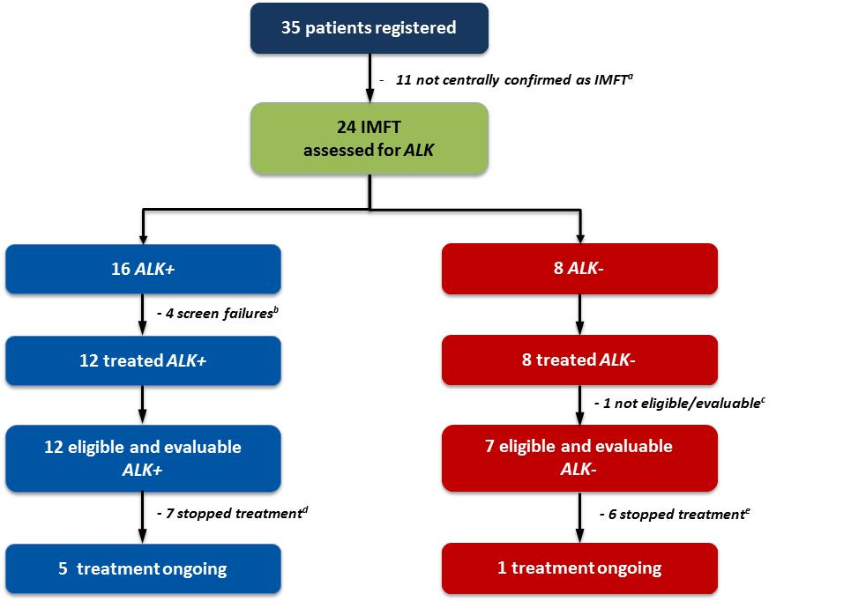

Legend: ª: 9 IMFTs not confirmed, 2 tissue not available; ^{b}: 2 patients died, 1 patient withdrew consent, 1 patient started another treatment; ^{c}: no suitable lesion for response evaluation – treatment still ongoing; ^{d}: 2 progression, 2 symptomatic progression without radiological evidence, 2 patient decision, 1 treatment stop due to surgery; ^{e}: 4 progression, 1 symptomatic progression without radiological evidence, 1 toxicity

Table 1. Molecular characteristics of IMFT tumors and their response to crizotinib.
Patient number | Primary site at diagnosis | Origin of tested archival tumor material | ALK gene rearrangements by FISH in % | ALK protein expression by IHC | Treatment status | Duration of treatment |  | Best  RECIST  response | Survival status | Overall survival (days)
 |  |  |  |  |  | Cycles | Days
ALK+ patients
1 |  | metastatic | - | 1 | Not started |  |  | Missing | Death
30 | Retro-intra abdominal | primary | 18 | 1 | Stopped | 33 | 678 | Partial response | Alive | 1304
38 |  | primary | 26 | 1 | Not started |  |  | Missing | Death
64 | Other (right breast) | metastatic | 11 | 1 | Ongoing | 49 |  | Complete response | Alive | 1324
116 | Missing‡ | primary | 42 | 1 | Stopped | 34 | 700 | Partial response | Alive | 1106
132 | Upper extremity | primary | 27 | 1 | Stopped | 6 | 126 | Stable disease | Lost to follow-up | 302
137* | Thorax | metastatic | 21 | 0 | Stopped | 8 | 168 | Stable disease | Alive | 414
157 | Missing | primary | 0 | 1 | Stopped | 5 | 104 | Partial response | Death | 273
180 |  | primary | 27 | 1 | Not started |  |  | Missing | Alive
182 |  | primary | 23 | 1 | Not started |  |  | Missing | Alive
186* | Thorax | metastatic | 15 | 0 | Stopped | 5 | 106 | Stable disease | Alive | 376
190 | Visceral gastrointestinal | primary | 29 | 1 | Ongoing | 14 |  | Partial response | Alive | 295
192 | Retro-intra abdominal | metastatic | 85 | 1 | Ongoing | 18 |  | Complete response | Alive | 358
193 | Visceral gynecological | primary | 85 | 1 | Ongoing | 15 |  | Partial response | Alive | 299
194 | Missing | primary | 20 | 1 | Stopped | 7 | 129 | Stable disease | Death | 176
197 | Lower extremity | primary | 23 | 1 | Ongoing | 9 |  | Stable disease | Alive | 169
ALK- patients
29 | Trunk | primary | 0 | 0 | Stopped | 6 | 105 | Stable disease | Alive | 1438
88* | Other (left lung) | primary | 0 | 0 | Stopped | 23 | 480 | Partial response | Death | 809
118 | Retro-intra abdominal | metastatic | 0 | 0 | Stopped | 8 | 168 | Stable disease | Death | 615
122 | Trunk | primary | 0 | 0 | Stopped | 4 | 85 | Stable disease | Death | 240
161 | Retro-intra abdominal | primary | 0 | 0 | Stopped | 2 | 43 | Stable disease | Alive | 897
163 | Retro-intra abdominal | metastatic | 12 | 0 | Ongoing | 42 |  | Not evaluable | Alive | 863
188 | Visceral genitourinary | primary | 0 | 0 | Stopped | 2 | 41 | Progressive disease | Alive | 373
196* | Thorax (lung) | metastatic | 0 | 0 | Ongoing | 8 |  | Stable disease | Alive | 168
Legend: *Four patients with thoracic primary tumors, two of whom were ALK+ and the other two were ALK-. ‡Diagnosis: low-grade myofibroblastic tumor originating in the left retromolar area (at enrolment: progressive disease in maxillectomy bed and lung). ALK, anaplastic lymphoma kinase; IHC, immunohistochemistry; RECIST, Response Evaluation Criteria in Solid Tumors.
Table 2. Key characteristics of IMFT patient treated with crizotinib.

 | ALK status |  | Total  (N=20)
 | ALK+  (N=12) | ALK-  (N=8)
Age (years)
Median | 35·5 | 59·5 | 45·5
Range | 21·0 - 69·0 | 15·0 - 78·0 | 15·0 - 78·0
Eastern Cooperative Oncology Group performance status
0 | 7 (58·3) | 4 (50·0) | 11 (55·0)
1 | 5 (41·7) | 3 (37·5) | 8 (40·0)
2 | 0 (0·0) | 1 (12·5) | 1 (5·0)
Sex
Male | 6 (50·0) | 5 (62·5) | 11 (55·0)
Female | 6 (50·0) | 3 (37·5) | 9 (45·0)
Any previous major surgery | 7 (58·3) | 3 (37·5) | 10 (50·0)
Any prior systemic anticancer therapy | 6 (50·0) | 2 (25·0) | 8 (40·0)
Chemotherapy | 5 (41·7) | 2 (25·0) | 7 (35·0)
Other anticancer therapy | 2 (16·7) | 1 (12·5) | 3 (15·0)
Prior systemic treatments
Neo Adjuvant | - | - | -
Adjuvant | 1 (8·3) | 0 (0·0) | 1 (5·0)
Maintenance | - | - | -
1st line | 5 (41·7) | 2 (25·0) | 7 (35·0)
2nd line | 2 (16·7) | 2 (25·0) | 4 (20·0)
3rd line | 1 (8·3) | 0 (0·0) | 1 (5·0)
4th line | 1 (8·3) | 0 (0·0) | 1 (5·0)
5th line | 1 (8·3) | 0 (0·0) | 1 (5·0)
Primary site at diagnosis
Trunk | 0 (0.0) | 2 (25.0) | 2 (10.0)
Thorax | 2 (16.7) | 1 (12.5) | 3 (15.0)
Retro-intra abdominal | 2 (16.7) | 3 (37.5) | 5 (25.0)
Lower extremity | 1 (8.3) | 0 (0.0) | 1 (5.0)
Upper extremity | 1 (8.3) | 0 (0.0) | 1 (5.0)
Visceral genitourinary | 0 (0.0) | 1 (12.5) | 1 (5.0)
Visceral gastrointestinal | 1 (8.3) | 0 (0.0) | 1 (5.0)
Visceral gynecological | 1 (8.3) | 0 (0.0) | 1 (5.0)
Other | 1 (8.3) | 1 (12.5) | 2 (10.0)
Missing | 3 (25.0) | 0 (0.0) | 3 (15.0)

Table 3. Study treatment.

 | ALK status |  | Total  (N=20)
 | ALK+  (N=12) | ALK-  (N=8)
Treatment, dose intensity and dose adjustments
Relative Dose Intensity (%)
Median | 100·0 | 100·0 | 100·0
Range | 81·7 - 100·0 | 52·4 - 100·0 | 52·4 - 100·0
Number of patients with at least one treatment modification | 2 (16·7) | 3 (37·5) | 5 (25·0)
Reduction to dose level -1 (200 mg twice daily) | 2 (16·7) | 2 (25·0) | 4 (20·0)
Reduction to dose level -2 (250 mg once daily) | 0 (0·0) | 1 (12·5) | 1 (5·0)
Other dose level modification | - | - | -
Interruption of treatment | 0 (0·0) | 3 (37·5) | 3 (15·0)
Treatment duration:
Duration of treatment (months)
Median | 7·2 | 4·1 | 5.5
Range | 3·4 - 42·3 | 1·3 - 28·3 | 1·3 - 42·3
Number of cycles
Median | 11·5 | 7·0 | 8·0
Range | 5·0 - 49·0 | 2·0 - 42·0 | 2·0 - 49·0
Reasons for treatment discontinuation:
Treatment status
Ongoing | 5 (41·7) | 2 (25·0) | 7 (35·0)
Stopped | 7 (58·3) | 6 (75·0) | 13 (65·0)
Major reason for protocol treatment discontinuation
Progression of IMFT | 2 (28·6) | 4 (66·7) | 6 (46·2)
Symptomatic deterioration without radiological evidence of progression of IMFT | 1 (14·3) | 0 (0·0) | 1 (7·7)
Toxicity | 0 (0·0) | 1 (16·7) | 1 (7·7)
Patient's decision | 2 (28·6) | 0 (0·0) | 2 (15·4)
Other | 2 (28·6) | 1 (16·7) | 3 (23·1)

Table 4. Response assessment and efficacy summary, according to investigator assessment.

 | ALK status
 | ALK+  (N=12) | ALK-  (N=7) | Total  (N=19)
Best RECIST 1.1 response
Confirmed complete response | 2 (16·7) | 0 (0·0) | 2 (10·5)
Confirmed partial response | 4 (33·3) | 1 (14·3) | 5 (26·3)
Non-confirmed partial response | 1 (8·3) | 0 (0·0) | 1 (5·3)
Stable disease | 5 (41·7) | 5 (71·4) | 10 (52·6)
Progressive disease | 0 (0·0) | 1 (14·3) | 1 (5·3)
Objective confirmed response rate | 50·0% | 14·3% | 36·8%
(95% CI) | 21·1-78·9% | 0·0-57·9% | 16·3-61·6%
Disease control rate | 100·0% | 85·7% | 94·7%
(95% CI) | 73·5-100·0% | 42·1-99·6% | 74·0-99·9%
Progression-free survival
Alive without progression of IMFT | 8 (66·7) | 3 (42·9) | 11 (57·9)
Progression of IMFT or died | 4 (33·3) | 4 (57·1) | 8 (42·1)
12-months progression-free survival rate | 73·3% | 53·6% | 66·5%
(95% CI) | (37·9-90·6) | (13·2-82·5) | (39·9-83·5)
Survival status
Alive | 10 (83·3) | 4 (57·1) | 14 (73·7)
Dead | 2 (16·7) | 3 (42·9) | 5 (26·3)
Reason of death
Progression of IMFT | 1 (8·3) | 3 (42·9) | 4 (21·1)
Cardiovascular disease | 1 (8·3) | 0 (0·0) | 1 (5·3)
12-months survival rate | 81·8% | 83·3% | 82·4%
(95% CI) | (44·7-95·1) | (27·3-97·5) | (54·7-93·9)

Legend: CI, confidence interval
Figure 2. Kaplan-Meier estimates for progression-free survival for the ALK+ and ALK- sub-cohorts per protocol.

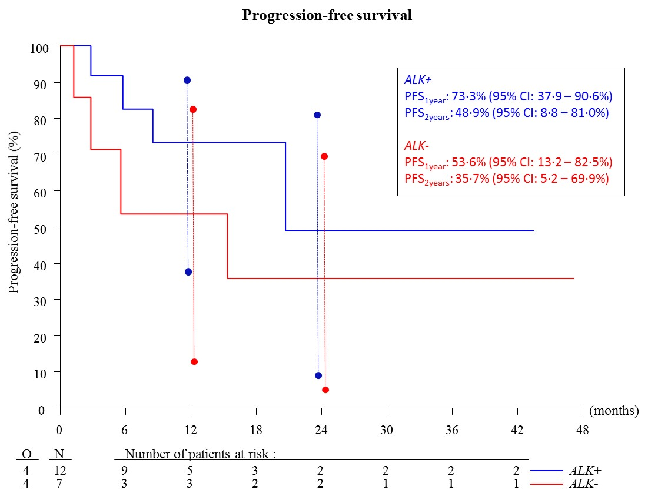
Legend: The vertical bars represent the 95% confidence intervals (CI) for the 1-year and 2-years progression-free survival rates (in blue for ALK+ and in red for ALK- patients).

Figure 3. Kaplan-Meier estimates for overall survival for the ALK+ and ALK- sub-cohorts per protocol.

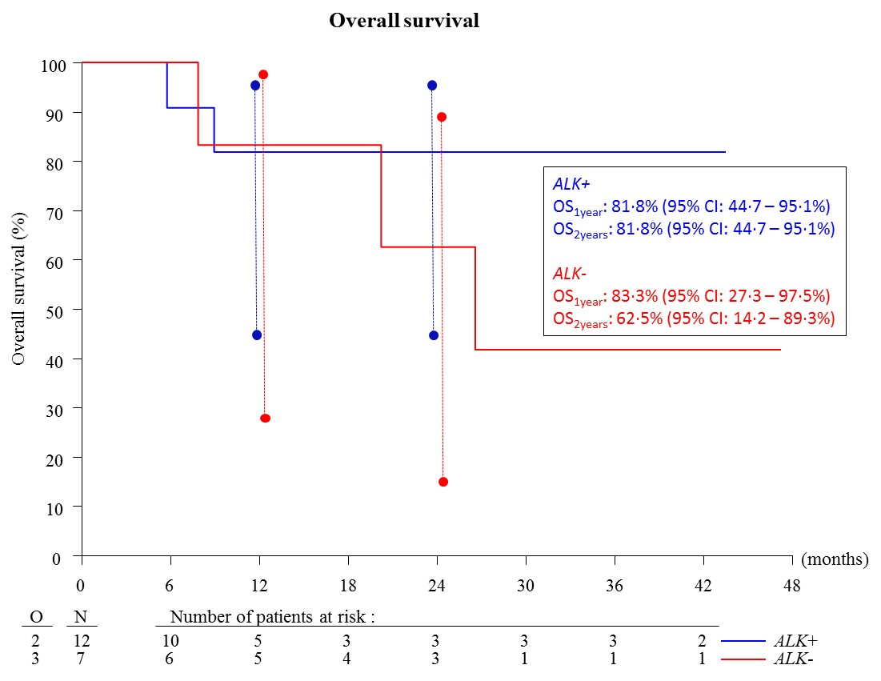
Legend: The vertical bars represent the 95% confidence intervals (CI) for the 1-year and 2-years overall survival rates (in blue for ALK+ and in red for ALK- patients).

Figure 4: Maximum shrinkage of target lesions (per protocol) in the ALK+ and ALK- sub-cohorts, according to local investigator’s assessment.

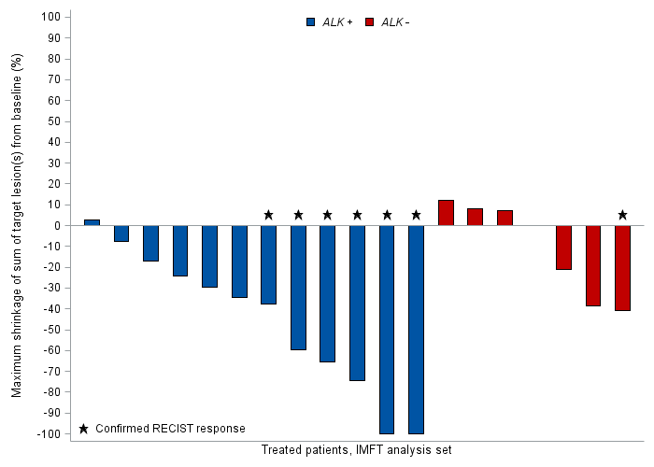
Legend: In ALK+ patients: two patients had a confirmed complete response, 4 patients had a confirmed partial response, one patient had a non-confirmed partial response, and 5 patients had stable disease. In ALK- patients: one patient had a confirmed partial response, five patients had stable disease*, and one patient had progressive disease. *In the ALK- patients with stable disease, one patient had a partial response - based on target lesions - but had new lesions in the liver and this patient had stable disease as best overall response.

Figure 5. Clinical course of patients in the IMFT ALK+ and ALK- sub-cohorts.

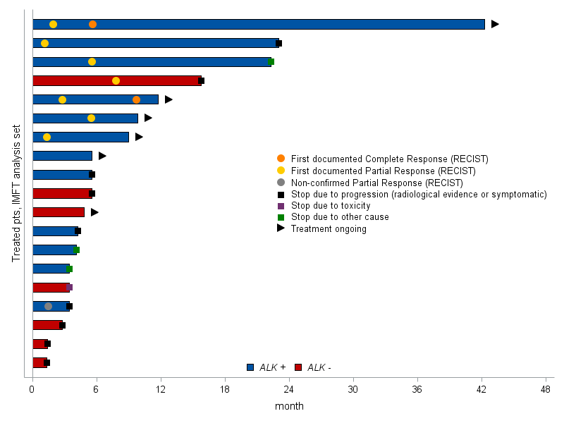
Legend: x-axis shows time in months; pts, patients; RECIST, Response Evaluation Criteria in Solid Tumors.
Table 5. Non-hematological adverse events that occurred in ≥ 10% of patients.

Treatment-related non-hematological AE
(N=20)
CTC + MedDRA Term | Grade 1  N (%) | Grade 2  N (%) | Grade 3  N (%) | Grade 4  N (%)
NUMBER OF PATIENTS WITH AE's | 9 (45·0) | 6 (30·0) | 2 (10·0) | 1 (5·0)
CARDIAC DISORDERS
Sinus tachycardia | 1 (5)
Other AE | 1 (5)
EYE DISORDERS
Blurred vision | 8 (40) | 1 (5)
Conjunctivitis | 1 (5)
Dry Eye | 2 (10) | 2 (10)
Flashing lights | 3 (15)
Optic nerve disorder | 2 (10)
Other AE | 5 (25)
GASTROINTESTINAL DISORDERS
Abdominal pain | 1 (5)
Bloating | 1 (5)
Constipation | 3 (15) | 2 (10)
Diarrhea | 6 (30) | 1 (5)
Dyspepsia | 2 (10) | 1 (5)
Esophagitis | 2 (10)
Flatulence | 2 (10)
Mucositis oral | 2 (10)
Nausea | 6 (30) | 5 (25)
Vomiting | 5 (25) | 2 (10)
GENERAL DISORDERS AND ADMINISTRATION SITE CONDITIONS
Edema limbs | 5 (25)
Fatigue | 5 (25) | 3 (15) | 1 (5)
Fever | 1 (5)
Pain | 2 (10)
Other AE | 1 (5)
HEPATOBILIARY DISORDERS
Other AE |  |  | 1 (5)
INFECTIONS AND INFESTATIONS
Other AE
INVESTIGATIONS
Gamma GT increased | 1 (5)
Weight gain |  |  | 1 (5)
Weight loss | 1 (5) | 1 (5)
METABOLISM AND NUTRITION DISORDERS
Anorexia | 1 (5) | 1 (5)
MUSCULOSKELETAL AND CONNECTIVE TISSUE DISORDERS
Arthralgia
Other AE | 1 (5) | 1 (5)
NEOPLASMS BENIGN, MALIGNANT AND UNSPECIFIED (INCL CYSTS AND POLYPS)
Tumor Pain
NERVOUS SYSTEM DISORDERS
Dizziness | 2 (10)
Dysgeusia | 5 (25)
Headache | 1 (5) | 1 (5)
Peripheral motor neuropathy | 3 (15)
Peripheral sensory neuropathy
PSYCHIATRIC DISORDERS
Anxiety
RESPIRATORY, THORACIC AND MEDIASTINAL DISORDERS
Cough |  | 1 (5)
Dyspnea |  | 1 (5)
SKIN AND SUBCUTANEOUS TISSUE DISORDERS
Alopecia | 3 (15)
Dry Skin | 2 (10)
Pruritus | 2 (10)
Rash maculo-papular | 3 (15)
Other AE | 1 (5) | 1 (5)
VASCULAR DISORDERS
Hypertension | 1 (5) | 1 (5)
Legend: AE, adverse event; CTC, Common Terminology Criteria.

Table 6. Hematological and biochemical adverse events that occurred in ≥ 10% of patients.

 | Grade 1 | Grade 2 | Grade 3 | Grade 4 | N (%)
Lymphopenia |  | 3 |  |  | 3 (15·0)
Alkaline phosphatase | 3 | 2 | 1 |  | 6 (30·0)
SGOT | 8 | 3 | 1 |  | 12 (60·0)
SGPT | 10 | 2 | 1 |  | 13 (65·0)
Hypocalcemia | 8 | 5 |  |  | 13 (65·0)
Serum creatinine | 6 | 3 |  |  | 9 (45·0)
Hyperglycemia | 6 | 1 |  |  | 7 (35·0)
Hypoglycemia | 2 | 3 |  |  | 5 (25·0)
Anemia |  | 1 | 2 |  | 3 (15·0)
Hyperkalemia | 5 | 3 |  |  | 8 (40·0)
Hyponatremia | 7 |  | 1 |  | 8 (40·0)

Legend: Treatment emergent effects. Relationship not collected for these events. SGOT, serum glutamic oxaloacetic transaminase; SGPT, serum glutamic-pyruvic transaminase.

