The Case of the Wildcat Sailors: The Hybrid Lore and Multimodal Languages of the Playground
In Darian-Smith, K and Pascoe, C (eds) (2012) Children, Childhood and Cultural Heritage. London: Routledge, pp 55-73

Childlore is a contradictory, magpie culture. The picture that emerged from the work of British folklorists Iona and Peter Opie testifies to this (Opie & Opie, 1959; 1985). The integrity and attention to detail of their research compels them both to celebrate the continuity of tradition, and to reveal the hybridity of cultural influences which children draw on to compose, adapt and ceaselessly transform the games, songs, rhymes and rituals they perform. The concept of ‘childlore’ is effectively a fusing of folklore with childhood, and it implies the passing on of a corpus of folkloric material through forms of oral transmission. However, when it becomes clear, as it was to the Opies, that this body of material draws as much on children’s media cultures as on traditional games and songs, then notions of tradition and lore become problematic. Furthermore, the collection of this material has tended to privilege language: the words of the games, songs, chants and jokes. This is partly for practical reasons: the Opies began by noting down the words, and only later moved on to transcribe melodies of songs. It is partly also because of a linguistic approach to folklore, however, which seeks to establish the progress of tradition through historical comparison of textual variants. However, the culture of play and playgrounds combines many elements to make new meanings out of old resources: words, melody, gesture, dance, objects and artefacts both found and manufactured, and the built and natural environment. This complex mix of the intangible legacies of word, song and game structure with the tangible assets of the immediate context is what constitutes the cultural moment for the child.
This chapter will explore some of this odd combination of continuity and hybridity, from two angles. One will consider the provenance of the cultural forms found on today’s playgrounds. The other will look at the combination of semiotic modes employed by the children. These considerations have been amongst those at the centre of a recent research project in the UK, which has both explored the Opies’ legacy and sought to update the picture through ethnographies of two playgrounds. The project, entitled Children’s Playground Games and Songs in the Age of New Media, was funded by the UK’s Arts and Humanities Research Council. I will begin by describing the project, in order to provide a context for the chapter, and also to indicate briefly some main outcomes. I will then move on to consider one detailed example, of three girls working out a dance routine on the playground during a lunch break.
Children’s Playground Games and Songs in the Age of New Media
This project was inspired initially by a collection donated by Iona Opie to the National Sound Archive at the British Library. ‘The Opie Collection of Children’s Games and Songs’ The collection was created from the late 1960s through to the early 1980s and captures the songs, games, jokes, rhymes and voices of children from across the country.
One of the insights of the Opies’ work was to look beyond earlier assumptions that the culture of the playground was purely a folkloric culture. While their dominant interest was, perhaps, in the traditions of oral culture, and to the folkloric elements of playground games and songs, they also recognised that children drew inventively on anything that came to hand, including their media cultures. In The Lore and Language of Schoolchildren (1959), various examples are cited, and they reflect, of course, the media of the time, including for example the Ballad of Davy Crockett, a hit song on the radio in 1955, and the theme song of the hugely popular TV mini-series imported from the US in the 50s. By the 1980’s, when The Singing Game was published (Opie & Opie, 1985), the media influences reflect in particular the pop song culture of the time. The Opie archive at the British Library includes, for example, a group of girls in 1974 in London’s Coram Fields, performing the 1974 hit ‘Ma, He’s Making eyes at Me’ by Lena Zavaroni, who won the popular television talent show Opportunity Knocks in the same year.
Taking our cue from the Opies’ eclectic approach to the influences of playground lore, then, our project’s central question asked what the relation was between playground games and songs and their media cultures. We assumed that, in the thirty years or so since the collection was made that media cultures would, like folkloric repertoires, have both remained the same in some respects (films, TV shows, pop songs, adverts, comics), and have changed markedly in others (computer games, social media, mobile phones) as a result of the expansion of new media technologies in children’s lives, and a general social shift from outdoor play to the media cultures of the bedroom.
We went about the investigation into new media in children’s play in four ways. Firstly, we interrogated the Opie archive, looking for examples of the influence of media cultures beyond those cited in The Singing Game. The archive contains a good deal of material never published before, revealing some new themes: the more extreme scatological and taboo‐busting songs and rhymes the Opies collected; the wide range of variations on ‘classic’ singing and other games; and the great variety of media influences that informed the culture of play. This revealed a considerably broader media landscape than emerges in the published work, making reference to what were then popular TV drama series (The Saint), peak-time game shows (Larry Grayson’s Shut That Door), talent shows (Opportunity Knocks) and, of course, pop music such as Abba and Gary Glitter (Jopson, 2010). It is not clear why these references to contemporary media cultures were not included in publications such as The Singing Game, though a reasonable assumption is that the Opies’ interest lay in the development of tradition: the growth over time of durable forms of childlore. In the chapter in The Singing Game entitled ‘Impersonations and Dance Routines’, for example, the songs and performances included are all adaptations and transformations of older popular songs: ‘She Wears Red Feathers’ from 1952 (Opie & Opie, 1985: 425); ‘Sunny Side Up’ from 1929 (Opie & Opie, 1985: 429); The Tennessee WigWalk from 1953 (Opie & Opie, 1985: 432). Meanwhile, performances of the hits of the 70s are omitted; though it is notable that the Opies found them worth recording and archiving.
Secondly, we conducted a two-year ethnographic study of two school playgrounds, one in London, one in Sheffield. These studies, again, produced rich and varied data demonstrating how children integrate their playground and media cultures, one example of which will be explored in more detail in the second section of this chapter. The ethnographic study has in many ways extended the observation and recording of play to be found in the history of this field of study. It has recorded many instances of games, songs and rhymes recognisable as latter‐day versions of the Opie ‘canon’, demonstrating continuity as well as change. Versions of many of the clapping games published in The Singing Game were found (Figure 1), as well as examples of counting‐out rhymes, skipping games, chasing games and ball games. At the same time, it was clear that some genres had diminished: hopscotch, conkers and French skipping, for example (though reports of hopscotch were documented on the Sheffield playground).

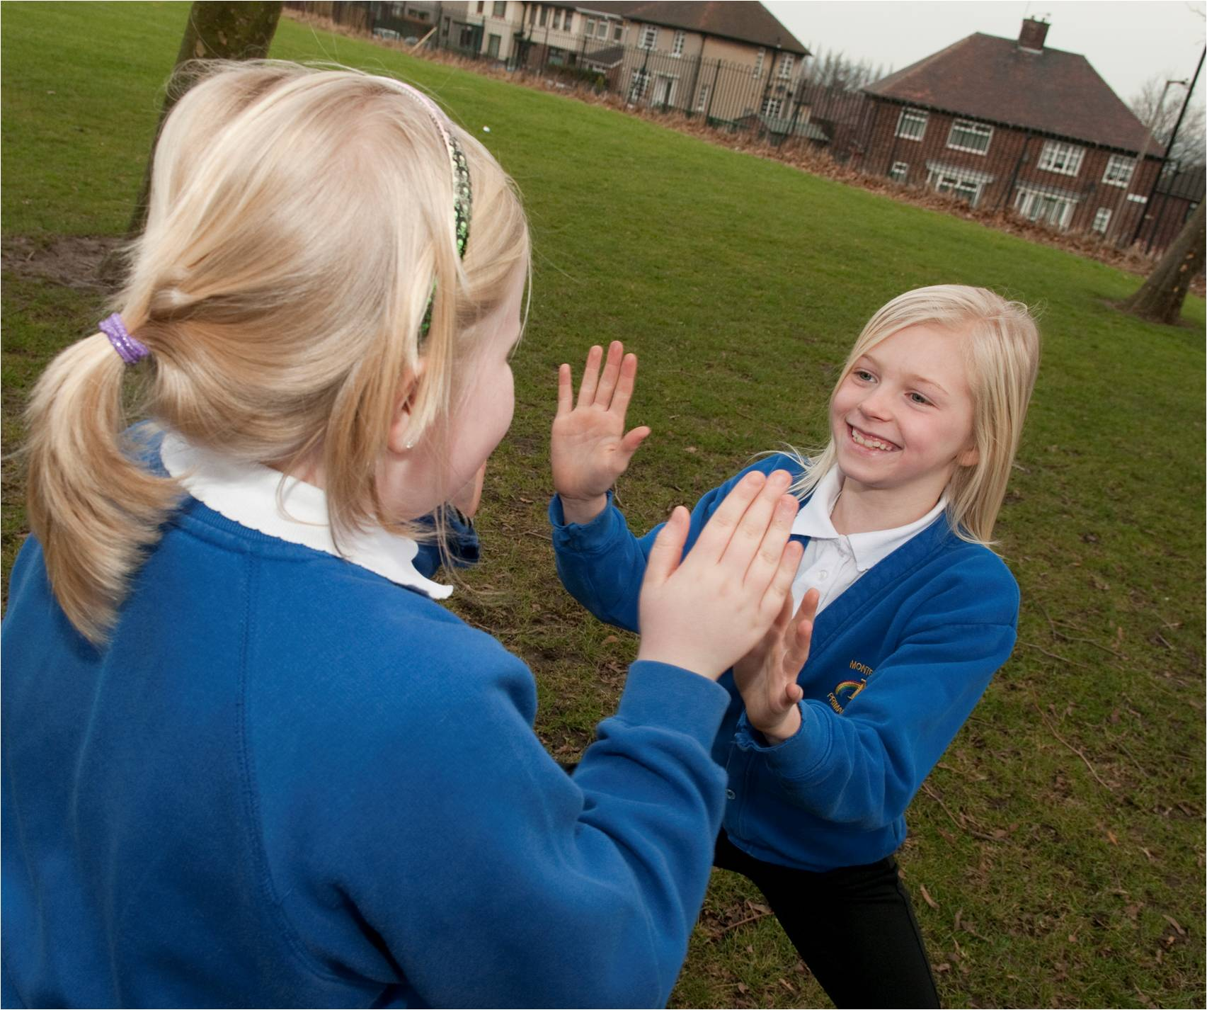
FIGURE 1– A clapping game at Monteney Primary School, Sheffield
Meanwhile, the project found many new instances of play, documenting in particular a rich variety of play informed by children’s media cultures (computer games, reality TV, pop songs, musicals and films), and pretend play scenarios which often intermingle domestic and fantasy settings: families, superheroes, fairies, witches and zombies. The studies also conducted surveys of the children in the two schools, partly to get a sense of the favourite games of all the children (rather than just the ones who are filmed or interviewed); and partly to get a picture of the media cultures that lie beyond the playground, in children’s media consumption at home. The forms of play particular to the bedroom, and not possible on the playground, are those involving the technologies of new media: DVD players, MP3 players, PCs, and game consoles.
Thirdly, we made a documentary film of the playground games, charting the range of types and genres, and the social contexts in which they occurred, and interviewing children about them. The 50 minute documentary film Ipidipidation, My Generation (Mitchell, forthcoming) draws on ethnographic and observational methods and provides a detailed overview of playground culture and the diversity and variety of forms of play in the two primary school playgrounds in London and Sheffield. In doing so it follows in the tradition of filming and photographing children’s games, such as The Dusty Bluebells, the 1971 film of Belfast children’s street games by David Hammond.
The documentary film, like the rest of our project, updates the current scholarship, showing how children draw both on the long historical tradition of games passed from child to child, generation to generation and from adult to child; and also on the resources of their own contemporary media cultures. Like the website and the playground research, the film aims to give children’s voices the dominant role in describing and interpreting their play.
Fourthly, we developed a prototype for a computer game adaptation, the ‘Game-Catcher’. This adapts the motion sensitive videogame controllers of the Nintendo Wii and Microsoft Kinect to create an application which allows the recording, playback, archiving and analysis of playground games in 3D.
This had two main aims. One was to develop a proof of concept of a system which would provide researchers in the arts and humanities with new and improved ways of archiving and analysing movement‐based activities. The archiving of playground games currently relies upon video, or previously, as in the Opie and Damian Webb collections, upon audio recording supplemented by still photographs (see description of the Damian Webb collection below). These provide an incomplete record – even video only records the events from a single viewpoint and can therefore leave details obscured or off‐screen. The Game Catcher avoids these shortcomings by recording the position in 3D space of every joint. By recording the raw data, the movement can then be viewed from any angle and any distance and other alternative forms of visualisation – for instance tracing the path taken by the hands throughout the entire game – also become possible.
In parallel with this, the Game Catcher had a second aim, which was to develop a new and innovative type of computer game. This exercise is partly intended as a form of cultural intervention. We have become too used to cordoning off these ‘traditional’ games and songs as if they represent some purer folkloric form of play, untainted by the commercial interests of the media, and placing them in opposition to electronic or computer games which embody a more modern and more sedentary form. These polarised popular views relate to historic constructions of idealised childhood and their opposite, childhood as uncivilised or as in a state of original sin (James, Jenks & Prout, 1998; Buckingham, 2000). By developing a computer game version of a playground clapping game, we were able to explore the tensions between these fields, as well as the areas for overlap and both actual and potential synergies (clapping games were chosen as they contain fast movement within a constrained physical space, thereby offering a suitable level of technical challenge).
Finally, we developed a website at the British Library: Playtimes: a century of children’s playground games and rhymes (accessible at www.bl.uk/playtimes). This was intended to display selections from the Opie archive alongside samples of play video‐recorded during the ethnographic studies. In this way, we intended to represent the historical changes and continuities evident across the Opie collection and today’s playgrounds. In fact, we have discovered new material during the project which has significantly enhanced the content of the website. Most importantly, we have collaborated with the Bodleian Library in Oxford, to whom the Opies donated their manuscript archive; and the Pitt Rivers museum, also in Oxford, which holds an important collection of the folklorist and photographer Father Damian Webb. The Bodleian collection provided valuable examples of written accounts of games sent by children and teachers to the Opies; while the Damian Webb collection provided examples of high‐quality audio recordings from the mid‐twentieth century, as well as strikingly beautiful black‐and‐white photographs of children at play (Figure 2).
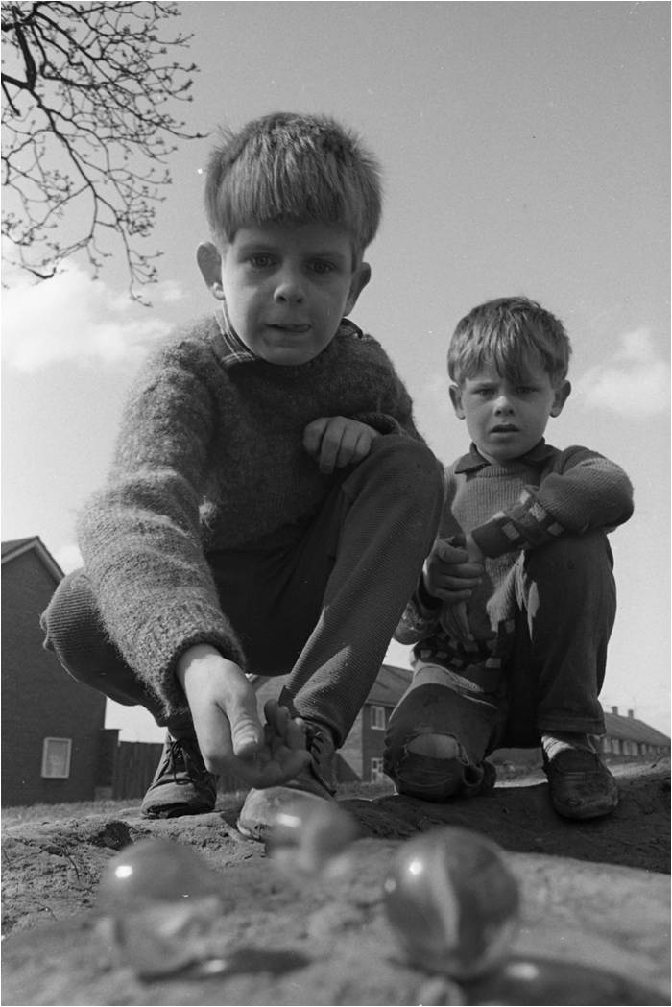

FIGURE 2 - Boys playing marbles. Leyland, Lancashire, UK.
Photo by Fr Damian Webb, 1967
Courtesy Pitt Rivers Museum, University of Oxford [2003.88.2626]

The organisation of the Playtimes website content proved to be a valuable part of the research collaboration in its own right. Two examples will make this point effectively. One is the process by which the collection of material was categorised. The project team was well aware of earlier taxonomies, both in the work of the Opies themselves, and in later publications (eg Bishop & Curtis, 2001). However, a series of categories appropriate for the combination of historical and contemporary material represented on the website needed to be developed, and the project team and children’s panels negotiated these categories over several months (Figure 3). The categories are not dissimilar from those used by earlier scholars: the main difference is the children’s influence on the terminology, so that adult terms such as the Opies’ category of ‘Buffoonery’ (Opie & Opie, 1985: 391 ff)_are avoided. The eventual list was:
- Clapping games
- Skipping Games
- Ball Games
- Games with Things
- Running Around
- Pretend Play
- Singing and Dancing
- Jokes and Rude Rhymes
- Counting‐out rhymes
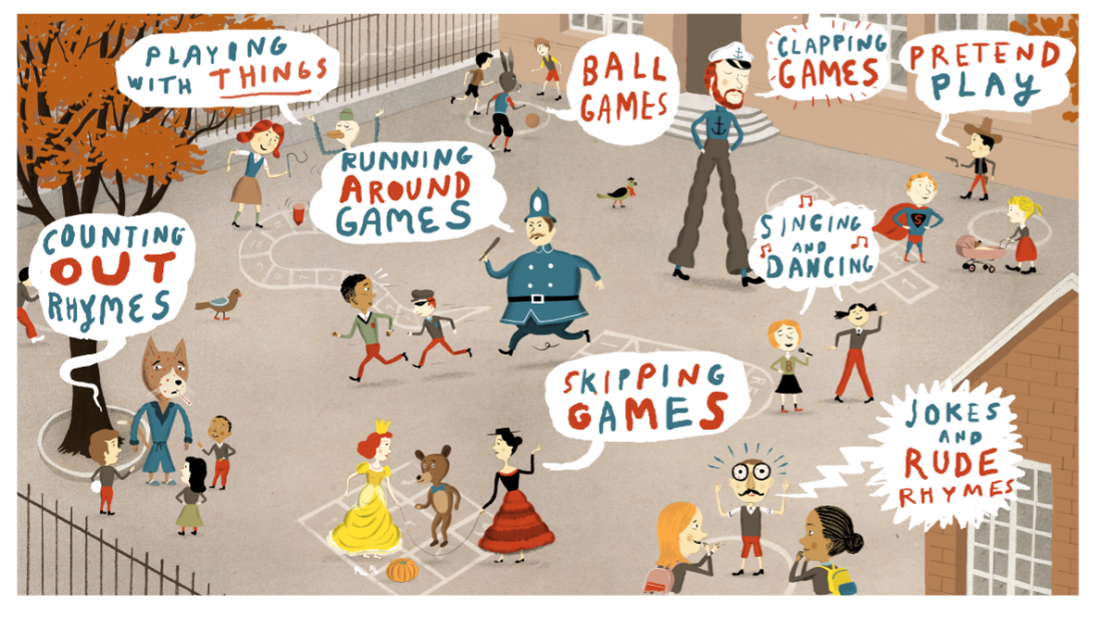
FIGURE 3 - The homepage of the Playtimes website at the British Library, showing the categories of play around which the site is organised.
A second example of negotiation, this time between researchers is the process which produced the to-camera pieces spoken by the poet and children’s author Michael Rosen, who kindly agreed to act as presenter for these introductions to the categories of play on the route through the site intended mainly for adults. The script for these pieces was contributed to by members of the research team, then edited in collaboration with Rosen and with Steve Roud, the historian of folklore (Roud, 2010).
Studies of childlore have tended to be about children rather than with them, but this project differed by trying to actively involve children in curating the online presence. The design of the website has been an innovative form of library exhibition, in terms of the extensive consultation carried out with children in our partner schools. We have held workshops with the panels of children in the schools (essentially the school councils, representing all classes), and have involved them in three ways: as researchers, designers and curators. They have contributed significantly to the research and collection of their own games. They have contributed concept drawings for the visual design and navigational structure of the website. They have produced animations which introduce the nine categories of play in the children’s route through the site, serving as a form of curatorial interpretation (see Potter, 2010, on children’s curatorial practices). Children’s culture is commonly observed, collected, interpreted, curated and archived by adults: these animations, along with other elements of the project such as the involvement of children in the videoing of playground games, was an attempt to redress this imbalance. The animations incorporate historical information gathered by the children through interviews with Steve Roud; and with their own parents, as well as spoken comments on, and visual representations of, the contemporary forms of play they have found on their own playgrounds.
This, then, provides the ‘big picture’, and hopefully gives some sense of the scope of the Children’s Playground Games project. A further point to make, perhaps, is its inter-disciplinarity. Childlore has been studied from a range of different angles in the past: psychology, linguistics, sociology, folklore studies and music. The team in this project represented media and cultural studies, computer science, musico-ethnology, folklore studies, and the sociology of childhood. This brings together different methods and theoretical frameworks in ways which can be uncomfortable; though my own experience of it has been an extremely productive sense of scholarly exchange, useful challenge to old preconceptions and settled conventions, and generally a rounder sense of what we have in front of us and how we might interpret it.
With this in view, the next section will look at an example of a play episode which occurred during a lunchbreak in the London school.

Wildcats, Sailors, Egyptians and Michael Jackson: improvisation, composition and cultural provenance
This episode was filmed by the London ethnographer, Chris Richards. One of Chris’s approaches was to film very long takes, aiming to capture more of the context of the games and other practices than would be the case if the recording was confined to the few minutes of a particular game, as most of the Opie recordings are. In this case, the boundaries of the form of play involved run for the full length of the half-hour lunchbreak.
In the foreground of the film, we see three Year 3 (7-8 years) girls, Diella, Rachel and Alia,working out a dance routine. The sequence seems instantly recognisable as a cheerleader routine, partly because the girls are using cheerleading pom-poms, one of the play resources available on this playground; and partly because the movements of the routine resemble, at first glance, generic moves of cheerleading.
It is also obvious that the development of the routine is happening partly by experiment, repetition and incremental addition of new moves; and partly by the direction of one of the girls, Diella, who seems to be in a lead role, even a kind of peer teaching role.
There is a strong sense of commitment. The girls stick at the routine for the whole lunchbreak, unconcerned by the (extremely loud) noise around them, by a wide range of other kinds of play also visible in the frame, and by the occasional disruption of a boy charging through their space .
Meanwhile, among the other play activities happening around them, in the background of the video record can be seen a succession of young girls playing clapping games. This genre is a well-documented form of game, strongly represented in The Singing Game, one of the forms growing in popularity in the recent history of playground culture (Roud, 2010), and well-represented in our collection of games from these two playgrounds (Bishop, 2010). The words and tune can just be heard over the noise of the playground, even though they are further from the camera than the cheerleaders. It is the well-known clapping game, ‘A Sailor Went to Sea, Sea, Sea’ (Opie & Opie, 1985; Curtis, 2004).
At first glance, then, it seems that the dual subject of our enquiry, the ‘traditional’ games of the playground and those derived from children’s media cultures, are entirely separate here. Towards the end of the lunchbreak, however, the cheerleaders move to a different spot, and their routine changes into A Sailor Went to Sea, but still with the cheerleading pom-poms. It appears to be a brief hybridising of forms, perhaps as a kind of performative joke – there is a good deal of laughter and exaggeratedly raucous delivery of the tune and words. However, it represents two of the ways in which Bishop et al propose that children employ references to media sources: by synthesising them with established games, and by parody (Bishop et al, 2006).
As we studied the video sequence, our first concern was where the cheerleading sequence had come from. This was the first question in a follow-up interview, and the girls confirmed that the sequence was informed by the Wildcats chorus from High School Musical (2006), one of the most popular films choices indicated by girls in the survey.
It might seem, then, to a casual adult observer, that this sequence is no more or less than a form of straightforward imitation: three girls copying a routine from their favourite film. We checked the video of their performance against the Wildcats chorus in the film of High School Musical. The style, tempo and rhythm of the piece was very similar. To see exactly how similar, we extracted the audio-track from the film sequence and laid it under the video of the girls’ performance. It fitted exactly, both in rhythm and tempo. Clearly, then, these elements (and possibly the words and tune, which they might have been singing), were derived from the film. However, none of the movements resembled those performed by the girls. What, then, was their origin? Were they just ‘made up’?
In a later interview, the girls offer some clues. Rachel tells the interviewer that they had just been doing dance in PE (which is where Dance in the English National Curriculum is located):
R I think we might have had PE just in front of it so we did some dancing or something, so it might have got us into….
Interviewer Started you thinking about kind of moving in a certain way.
D Yeah. We got started like we were trying to do something then we got …started dancing then we came up with the idea.
Two of the girls, Diella and Rachel, say they like dancing in their own time. The third, Alia, doesn’t. Diella is particularly enthusiastic:
D I dance anywhere
....
D I dance in disco’s anywhere. I’m not really shy.
R Last year when we were in our Year 2 well one of our teachers let us stay in and put some Abba music on and some people just stayed up there and did dancing to loads of different music and things.
D We took off our shoes.
Interviewer Do you do that on the playground sometimes too? Make up …
D Yeah yeah.
Diella is regarded by the other two as an expert, a leader, even a teacher in this field:
R Remember a few days ago that they were teaching
D Yeah they were trying to learn a Michael Jackson song.
R ….yeah she’s trying to teach us some dancing.
Interviewer Who was?
D Me.
Interviewer You were trying …to dance like Michael Jackson?
D And the song yeah because they wanted to know Billy Jean.
A So she started teaching us then.
Her interest in Michael Jackson continues as a theme of the interview, which provides some idea of the provenance of these songs and dance routines:
D I know all of the song of You’re Not Alone.
Interviewer Billy Jean?
D No, You’re Not Alone.
Voices You’re Not Alone.
D All of it.
Interviewer Is that a Michael Jackson song?
D Yeah. I know nearly all of the songs of him.
Interviewer Where did you?
D Sometimes…I just learned them, I don’t know. I hear them in everywhere.
Interviewer Do you watch MTV, is that how you see his dance moves as well?
D No…
Interviewer You Tube?
D No me and my cousins we go on the computer because our favourite singer like Michael Jackson from the moment. So we’ve seen lots of videos and we just get the moves.
Interviewer And then you teach them to Alia and Rachel?
D Yeah because they want to know.
Interviewer Can you do Moon Walking and everything?
D Yeah.
It is notable here that Diella feels that she learns this material rather mysteriously, in a way which recalls the cumulative processes of accretion through which oral tradition works: “I don’t know, I just learned them. I hear them in everywhere.” At the same time, she is also able to give the example of watching online videos with her cousins to “get the moves”. We might see this as a difference between the age of new media and the 1970s media cultures of the Opies’ respondents. Song and dance routines learned from television could not be constantly revisited and called up on demand in the way that Diella and her cousins are able to do online, for example. However, in many ways both eras display a migration of popular cultural repertoires from the commercial media of radio and television (and then the internet) to the improvisatory bricolage of oral transmission and its equivalent in choreographed movement.
We also discover from the interview that the girls had been learning about Egypt recently, which also seems to have inspired some of the moves in the routine. At one point in the sequence, Diella introduces the ‘Walk like an Egyptian’ movement. However, it is also worth noting that the moves of the dance, popularised in the Bangles’ hit record of 1986, are also employed by Michael Jackson in his 1992 song and video, ‘Remember the Time’, and it seems quite possible, given her viewing of Jackson videos online, that Diella may have seen this.
We also learn that, while they are all fans of High School Musical, Rachel has actually been a cheerleader: “We had loads and loads of cheers and my uniform was blue and white and my team was called the Marlins.”
In general, then, it seems to be the case that the girls’ dance routine consists of specific features from a range of different sources: the tempo and rhythm of the Wildcats chorus; moves from their PE lesson; Michael Jackson moves; “Walk Like an Egyptian”. This assemblage of source material, re-worked and integrated by Diella and taught to the other two, challenges the casual assumption that the girls are simply copying a routine from their favourite musical. Rather, they are making something new out of fragments: a choreographic equivalent of the process of composition-in-performance attributed in language and music to the oral formulaic tradition, and applied to the musical aspects of children’s singing games by Marsh (2006).
Developed originally to explain and analyse the Homeric epics, oral-formulaic theory proposed that certain formulaic structures enabled the poet to compose in performance, (Parry, 1930). It was later applied to Serbo-Croatian narrative poems (Lord, 1960). Later adaptations of its use are relevant to our project. Finnegan, in particular (1977), connects the textual theory of the oral-formulaic to a sociological emphasis on social context. In this view, the composition and performance of oral poetry only makes full sense in relation to the social conditions in which they occur.
Furthermore, Finnegan asserts the diversity and heterograneity of oral poetry and narrative, arguing thatthat genres, structures and cultural influences overlap, infiltrate and hybridise (1977: 15). Again, this is clearly a feature of our project, where it has proved it impossible, indeed undesirable, to police distinctions between supposedly folkloric forms and contemporary media forms. As the Opies demonstrated, once material from popular media have been absorbed into children’s repertoires, it is subject to oral transmission just as folkloric material is transmitted. Everything becomes assimilated to this process, so that the apparently clear distinctions between folk culture for folklorists, and popular culture for sociologists, becomes not only fuzzy but barely tenable.
Finnegan’s account is particularly instructive for our study. The social contexts of play have emerged as all-important, identifying the very particular sets of circumstances in which a child’s memories of a particular text, or her learnt repertoire of moves, or the hoop, pom-pom or wooden plank to hand, have converged with a moment of boredom, or of excited creative impulse, or of friendship through play, or of transgressive fantasy, to produce a unique event, albeit one which is dense with history and cultural reference. In Diella’s dance routine, similarly, a concatenation of different social moments: watching Michael Jackson with her cousins; dancing in PE; making stuff up with her friends; performing for the boys. In some respects, it resembles the oral-formulaic process: particular formulaic memes are shuffled around and adapted, easy to recall, re-make and perform, both for teacher and learner, performer and audience. In other ways, though, it resembles an informal version of the choreographer, patiently assembling an expert repertoire for teaching through demonstration to pupils. And, of course, it resembles the work of the media fan, emulating the routines of the star performer.
More generally in our project, we have seen similar transformative processes deploying resources as diverse as fairytales and horror films, musicals and shoot-em-up computer games, texts as wildly different as Kurosawa’s film Seven Samurai (1954) and the first-person shooter videogame Call of Duty: Modern Warfare 2 (2009), scenarios that yoke together fantasy families and fantasy superheroes, zombies and ghosts, Harry Potter and Tig. In all of this, while particular cultural sources carry with them particular styles and structures of play, it is the heterogeneity that Finnegan emphasises which is so striking. And, while it is often a vague and unhelpful metaphor, the image of the bricoleur which Bishop et al invoke is inescapable. But the bricolage is more substantially multimodal than the research has hitherto recognised: to address it, we need to move beyond the familiar territory of language and music, and look at the improvisatory grammars of dance, gesture, movement, and the elusive cultural histories that lie behind them, questions which the next section will address.

Multimodal Performance
Multimodal theory (Kress & van Leeuwen, 2001) proposes that contemporary acts of communication typically use a range of semiotic modes and material media, which integrate in complex ways to form the specific kinds of representation and interaction the sign-maker wishes to convey. In relation to children’s playground games, this highlights the fact that, in the history of collecting, transcription, analysis and anthologising that has conserved and interpreted these cultural forms, some modes have been privileged. The Opies’ work, for example, began with written notation, focusing mainly on the linguistic features of the games, and it is these features which are interrogated in most detail in their historical analyses of change and continuity over, in some cases, centuries of play. The reason for this is simple: that the changing linguistic forms are relatively well-documented. The Opies also notated the music, though they relied on a colleague for the transcriptions. By the time of The Singing Game, they were using analogue tapes, both reel-to-reel and cassette. This, as we have discovered in our exploration of the archive, captured a far greater range of musical variation than was ever transcribed or published. More recently, the study of linguistic features of the games has continued (eg Widdowson, 2001), as has study of the musical features (Marsh, 2008; Bishop, 2010).
When it comes to physical movement, the picture looks considerably more sparse. The Opies noted with care the clapping routines, identifying the three-way clap that often, interestingly, accompanies songs in duple time. Other commentators have explored this in more detail since and found that children’s musical play is considerably more complex rhythmically than conventional models of music education imagine (eg Marsh, 2008; Arleo, 2001).
Beyond the clapping repertories, however, there lies a greater range of movement, gesture, dramatic action, mimicry, dance, and embodied expression generally than studies so far have been able to analyse. This is partly because of the lack of conventional frameworks of notation, transcription and analysis of the kind that language and music can, to some degree, take for granted. To analyse this and other sequences, then, we experimented in our project with the frameworks of multimodal analysis suggested by the work of, among others, Kress and van Leeuwen (2001), Finnegan (2002), and Burn & Parker (2003). The analytical grid used here is adapted from the work of Roberta Taylor (cf Taylor, 2006). Its function is to identify specific modes in play at each moment of the sequence. The modes represented are: speech, action/gesture, gaze, facial expression, proxemics and music. Figure 1 shows an extract of four minutes from the grid used to analyse the Cheerleaders’ sequence.

Time | Vocalisation/ speech | Action /gesture | Gaze | Facial expression | Proxemics | Music
00.10-00.19 | (inaudible) singing of the Wildcats chorus | Girl 1 – r-hand in, l-hand in, both hands above head, jump up, touch ground  Girl 2 out of shot  Girls 3 – waving pom-pom with r-hand – jumping | G1 at At Girl 2  G3 at other 2. | G1 – serious, intent  G3 smiling. | G1 and 2 facing each other – dyad – G3 behind/at the side. | 4/4 rhythm of the Wildcats chorus
00.20-00.45 |  | G1 repeats the routine.  Then improvises – alternate arms, and high leg kicks.  G2 out of shot.  G3 beginning to imitate the alternating r and l hands. | G1 at G2  G3 at other 2. | G1 serious at first, then smiling as she improvises.  G3 smiling. | As above.
00.45-00.57 |  | G1 – shaking pom-poms down; jump up. Kick both legs out. |  |  | Dyad
1.35-1.42 |  | G1 – r-hand in, l-hand in; cross arms, both hands down, shake to l, shake to r, jump up legs apart. |  |  | Dyad
1.43-1.55 |  | G1 and G2 face each other, arms above head, ready to try something. | G1 and 2 at each other. G3 at them.  Then all 3 at each other. |  | Dyad – then G1 and 2 turn to include G3 in a triad.
1.55 - |  | G1 crouches, pushing the other two’s pom-poms up – trying something new? | All 3 at each other. |  | Triad
 |  | G2 jumps up – all 3 put arms/pom-poms in the middle to begin the routine – do alternate hands in to the middle  – boy jumps in the middle, interrupts. | All 3 at each other. |  | Triad
2.29 |  | G1 & 2 do shake-down to l and r, jump/legs apart, point at each other, G2 crossed hands. | G1 and 2 at each other |  | Revert to G1 & 2 dyad.
3.00 |  | Repeating the shake-down movement.  G1 tries the ‘egyptian’, jokily. | At each other. | G1 laughing. | Move to another part of the space; still moving between dyad and triad.
 |  | Routime firms up – r hand, l hand, shake-down l and r, jump up/legs apart, now Egyptian incorporated.  G2 following closely; G3 increasingly imitating the movements. | At each other. |  | Still moving between dyad and triad.
4.00 |  | 2 boys appear and seem interested. G1 does demo of routine so far, with extra elements improvised.  G2 & 3 join in. | Girl 1 at boys. Boys at G1. |  | G1 facing the boys; other 2 girls join in. Girls move to face ‘outward’

Figure 4: multimodal analysis grid of 4 minutes of the cheerleaders sequence
G1: Diella, G2: Rachel, G3: Alia
We have already discussed the choreographed moves led by Diella, and can see here some of the detail. Though we do not have the additional information to match the moves to Michael Jackson videos, or the girls’ PE lesson, or other sources, this information in principle would allow us to do that, and trace the provenance of the movements in that way.
The speech and music columns are mostly blank, because we were unable, amid the noise of the playground, to hear their singing of the Wildcats chorus; though again the interview helps us to fill in some of the missing information. If we add in the music from High School Musical, we can say something about the form of the movement, the tempo and the rhythm. But what can we say about the meaning?
Van Leeuwen’s account of the social semiotics of sound and music (1999), gives the example of how, in the mediaeval church, the papal authorities prohibited the use of measured time, whether duple or triple, which represented the secular, and permitted only unmeasured time (as in plainchant), which represented the infinite nature of the sacred. These apparently formal qualities of music are never simply aesthetic categories, but express particular social meanings.
What, then, might the tempo and rhythm of the cheerleaders’ routine signify? In general terms, the 4/4 march time typical of cheerleading, and found in these girls’ routines, has quasi-military associations, in keeping with the uniforms, group formations and team support values of cheerleaders in American football. However, in films such as High School Musical, it is made to carry other meanings: of desirable teenage female identity, for example, attractive to the tween audiences who aspire to older identities and cultural properties (Willett, 2009).
Meanwhile, these meanings, as we have seen, are combined with others. The appeal of a cult pop star like Michael Jackson, various moves from PE and disco, and the humorous incorporation of the Egyptian dance, may all subtly change the social meanings bound up in this improvisatory process.
The other columns in the grid serve to alert us to the work of other modes employed by the girls. Proxemics refers to the disposition of bodies in space: how they relate to each other, what degrees of proximity, and so on. Two patterns are evident here. One is an oscillation between dyad and triad, showing how the third girl, Alia, is at times distanced from the action: not exactly excluded, but briefly separate, and then moving in, or invited in, to become part of the threesome. There is a kind of hierarchy here, in which the relationship between Diella as choreographer and teacher with the other two as loyal supporters, students, fellow-dancers, is the important function.
The Proxemics column also identified the movement of the girls between an inward-facing circle and an outward-facing line. The former is not at all typical of cheerleading, which is always performed in outward-facing lines. It is typical, however, of other playground games, especially clapping games, where any kind of performance is for the group itself, not for an external audience. It is also, arguably, indicative of the compositional process here, where the girls have to see each other in order to repeat moves demonstrated by Diella, and to keep together, evaluate, iterate. It is not clear that they ever really intend it for an external audience, in fact. In the interview they say they might have shown it to the class, but never got that far:
V Yeah, maybe to show the class or something.
Interviewer Did you ever show the class?
All: No.
Interviewer Did you do this again?
Voices: Well -la
A We said we were going to but then it turned out we didn’t actually…
D Well we did it a little bit the next day but we didn’t know what to do anymore because it became a bit boring.
However, on the playground, there seems to be a fluid movement between the inward-facing game-rehearsal circle and the outward-facing line, which seems to move towards a presentational formation, with passing boys as a provisional audience. The Gaze column reinforces this physical disposition of the girls. Their gaze is directed at each other when in the circle, and outwards or at the boys when they re-form in a line. Other than this, it provides evidence of their concentration, which barely wavers throughout the half-hour episode.
Finally, the Facial expression column displays an oscillation between serious facial expressions , whichseem to express the concentration of composition, and laughter or smiling which accompanies performance, and pleasure in the humorous coupling of the clapping game and the pom-poms at the end of the episode.
Conclusion: the absorptive power of childlore
To return to our main question, what have we learned, across the whole project, about the relation between children’s cultural heritage of play, game and song, and their media cultures; and what in particular can we say on the basis of this example of the Wildcat Sailors?
Bishop et al (2006) proposed four kinds of ways in which children’s play and games might draw on their media culture: allusion, synthesis, mimicry and parody. In many ways, the Wildcat Sailors episode bears out these categories; but the analysis of movement here adds to them. In terms of allusion, firstly, Bishop et al give several examples of linguistic allusion: names of media characters or stars, phrases from media texts, and so on. They also propose that allusion can be made through musical quotation. We had several examples in the project, and in the Opie archive, such as a version of When Susie was a Baby which used the theme tune of the 1960s TV series, The Saint. In the Wildcat Sailors episode, the children seem to be singing some of the Wildcat chorus, and so allusion is made to High School Musical in word and tune. However, Bishop et al begin to probe how physical movement can also form specific allusions: they give examples of characteristic gestures, such as those accompanying catchphrases.
Here, however, something more sustained is going on. The dance moves are more deeply intertwined in the structure of the whole piece, rather than supplementary. They form allusion, as we have seen, to choreographed movements in popular cultural texts such as Michael Jackson’s dance moves. They are not, however, simply ‘lifted’, but rather creatively adapted. Bishop et al give several examples of dance routines emulated by children in their ‘mimicry’ category, as well as citing the Opies’ discussions of dance routines based on pop stars. Again, however, the Wildcat Sailors routine is clearly not an emulation of a single routine, but rather an original composition incorporating many different sources, identifiable to a greater or lesser extent.
As for Bishop et al’s final category, parody, this does not seem to appear here until the final section, when the routine is hybridised with a Sailor Went to Sea. It seems to be this, the traditional clapping game, which is the subject of parody, as they exaggerate the moves and scream out the song, perhaps suggesting that this is a routine for smaller girls which they have outgrown.
Overall, then, this sequence appears to exemplify the four processes Bishop et al propose: it makes passing allusion to media texts, it synthesises such material with a traditional game, it mimics specific routines of pop and film stars, and it parodies. However, it seems to go further. Bishop et al debate whether such processes are in the end transformative: they settle in the end for the lesser claim of re-contextualisation. Here, by contrast, the compositional work of Diella, Rachel and Alia is clearly transformative: cultural sources and influences are significantly re-worked, re-combined and made into something new, not as a huge, high status cultural event, but as an almost casual, experimental improvisation, easy enough to discard.
What exactly is this transformative process, then? And is it legitimate to call it creative, a word which Bishop et al use at times, despite their qualified judgment about the transformations? Since we have described such play as multimodal, it follows that transformation and creativity can occur in any or all of the semiotic modes in play, or across them. In this case, there is some evidence of transformation in the words: the girls say in the interview that they are spelling out their names in word and gesture. There is no evidence of transformation in some aspects of the movement: tempo and gesture. As we have seen, these are completely faithful to the original Wildcats chorus. But it is in other aspects of the choreography, the dance movements themselves, that the real creativity and transformation happens.
In this example, as is the case with all the data produced in our project, there is a critical intersection of the synchronic purposes to which these resources are put at this moment, in this social context, and the diachronic processes out of which the resources and their associated cultural practices emerge. There are complex histories behind Diella’s improvisatory choreography: the sedimented practices of handclapping games and of cheerleading routines; the cultural history of Michael Jackson; the historic constructions of dance in the school curriculum; the life-histories of these girls and their fandoms, creative skills, friendships and school lives.
Finally, there is an elusive interplay between the durable and the ephemeral, a marked pattern throughout our project. It is the very ephemerality of childlore which makes it, like other forms of intangible cultural heritage, so challenging to preserve, research or exhibit. In Between 2009 and 2011 we have seen games, routines and songs virtually identical to those the Opies collected thirty or more years ago, but with minor variations which may continue or may disappear after a week’s experimentation. We have seen play based on computer game franchises which may last only as long as the franchise is popular (though that may last for decades). And these routines of the Wildcat Sailors incorporate moves which have decades of history with ones which may have a much shorter provenance. The patterns of continuity and change testify both to the robustness of childlore and to its persistently protean nature. It works in the service of these children, in this playground, at this moment: but the echoes of earlier moments, voices, movements and tunes ripple through its fabric, perhaps unseen and forgotten by these children, but potent nevertheless, absorbed into the play of game, skill and identity which inevitably lives in an eternal present, forgetful of its own history. This kind of persistent amnesia which children routinely express, insisting that they ‘just made it up’, is repeatedly noted by researchers. For this reason, the need to observe, collect, archive and curate the residual legacy of the secret cultures of the playground is particularly important. If children can take an active part in these activities, gaining some explicit understanding of their own play, then the ethnographic process of the interpretation of culture need not be left entirely to adults as it has been in the past.

REFERENCES
Arleo, A (2001) ‘The Saga of Susie: the dynamics of an international handclapping game’. In Bishop, J and Curtis, M (eds) (2001) Play Today in the Primary School Playground. Buckingham: Open University Press.
Bishop, J.C. (2010) .Eeny-Meeny Dessameeny: continuity and change in the ‘backstory’ of a children’s playground rhyme’. Children’s Playground Games and Songs in the New Media Age, Interim Conference, London Knowledge Lab, February 2010.
Bishop, J and Curtis, M (eds) (2001) Play Today in the Primary School Playground. Buckingham: Open University Press.
Bishop, J. and Curtis, M. with Woolley, H.; Armitage, M.; and Ginsborg, J. (2006). Participation, popular culture and playgrounds: Children’s uses of media elements in peer play at school. Paper presented at the Folklore Society Conference, Folklore, Film and Television: Convergences in Traditional Cultures and Popular Media, 31 March – 1 April 2006, London.
Buckingham, D. (2000) After the Death of Childhood: Growing up in the Age of Electronic Media, Cambridge: Polity.
Burn, A & Parker, D (2003) Analysing Media Texts. London: Continuum.
Curtis, M (2004) ‘A Sailor Went to Sea: theme and variations’. Folk Music Journal, Col. 8, No. 4. 421-437.
Finnegan, R (1977) Oral Poetry: Its Nature, Significance and Social Context. Bloomington: Indiana University Press
Finnegan, R (2002) Communicating: the Multiple Modes of Human Interconnection. London: Routledge
Grugeon, E (2001) ‘We like singing the Spice Girl songs . . . and we like Tig and Stuck in the Mud’: girls’ traditional games on two playgrounds’. In Bishop, J and Curtis, M (eds) (2001) Play Today in the Primary School Playground. Buckingham: Open University Press
James, A. Jenks, C. and Prout, A. (1998) Theorizing Childhood, Cambridge: Polity Press.
Jopson, L (2010) ‘The Opie Recordings: What’s Left to be heard?’ Children’s Playground Games and Songs in the New Media Age, Interim Conference, London Knowledge Lab, February 2010.
Kress, G and van Leeuwen, T (2001) Multimodal Discourses: the modes and media of contemporary communication.
Lord, Albert B. (1960) The Singer of Tales. Cambridge: Harvard University Press
Marsh, K. (2008) The Musical Playground. Oxford: Oxford University Press.
Mitchell, G (forthcoming) ‘Children on Camera: video-documenting play and games’. In Burn, A (ed) Children’s games in the new media age: Childlore, Media and the Playground. Farnham: Ashgate
Ong, W. (1982) Orality and Literacy: the Technologizing of the Word, London, Methuen
Opie, I & Opie, P (1959) The Lore and Language of School Children. Oxford: Oxford University Press
Opie, I & Opie, P (1985) The Singing Game. Oxford: Oxford University Press
Opie, I (1993). The People in the Playground, Oxford Univrsity Press.memoir of more recent research.
Parry, Milman (1930) ‘Studies in the Epic Technique of Oral Verse-Making. I: Homer and Homeric Style’. Harvard Studies in Classical Philology Vol. 41, 73–143.
Potter, J. (2009), Curating the self: Media literacy and identity in digital video production by young learners. Institute of Education, University of London, London.
Roud, S (2010) The Lore of the Playground. London: Random House
Taylor, R. (2006) Actions Speak As Loud As Words; a multimodal analysis of boys' talk in the classroom. English in Education 40.3 p66-82
van Leeuwen, T (1999) Speech, Music, Sound, London: Macmillan
Widdowson, J.D.A. (2001) .Rhythm, Repetition and Rhetoric: learning language in the school playground’. In Bishop, J and Curtis, M (eds) (2001) Play Today in the Primary School Playground. Buckingham: Open University Press.
Willett, R. (2009) Parodic practices: Amateur spoofs on video-sharing sites. In Buckingham, D. And Willett, R (eds)(2009) Video Cultures: Media Technology and Everyday Creativity. Basingstoke: Palgrave Macmillan

The project ‘Children’s Playground Games and Songs in the Age of New Media’ was funded by the UK’s Arts and Humanities Research Council. It was a large project within a wider programme entitled ‘Beyond Text’.
‘The Opie Collection of Children’s Games and Songs’ is a collection of recordings originally held on 88 open reel and cassette tapes deposited with the British Library in 1998. A practical core element of our project, then, was to digitise the collection, making it available as an online resource for scholars worldwide. Collection details can be accessed at the Sound Archive Catalogue (collection number ‘C898’). The entire collection is also available worldwide as streamed audio and as downloads to UK HEI researchers at the Archival Sound Recordings website.
Monteney Primary School in Sheffield and Christopher Hatton Primary School in London. The Sheffield school is located in a large housing estate serving a primarily white, working class community. The London school is on the edge of Clerkenwell, close to the British Library, serving a multiethnic community.
Conkers is the UK children’s game which uses horsechestnuts threaded on a string, with children taking turns to try and crack the opponent’s conker. ‘Elastics’, also known as French skipping, is a form of long rope skipping using elastic ropes or loops.
Details of the Webb photographic collection, prints, contact sheets and related manuscripts, can be found at http://www.prm.ox.ac.uk/manuscripts/webbpapers.html. The entire photographic collection of 8265 photographs is viewable online at http://databases.prm.ox.ac.uk/fmi/iwp/cgi?-db=Photos_PRM&-loadframes.
Pseudonyms have been used for all participants

