Questionnaire used in the nationwide survey
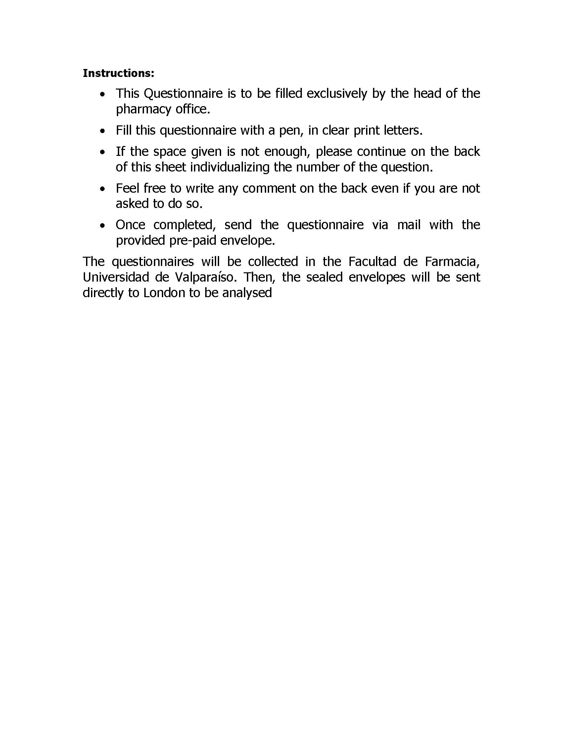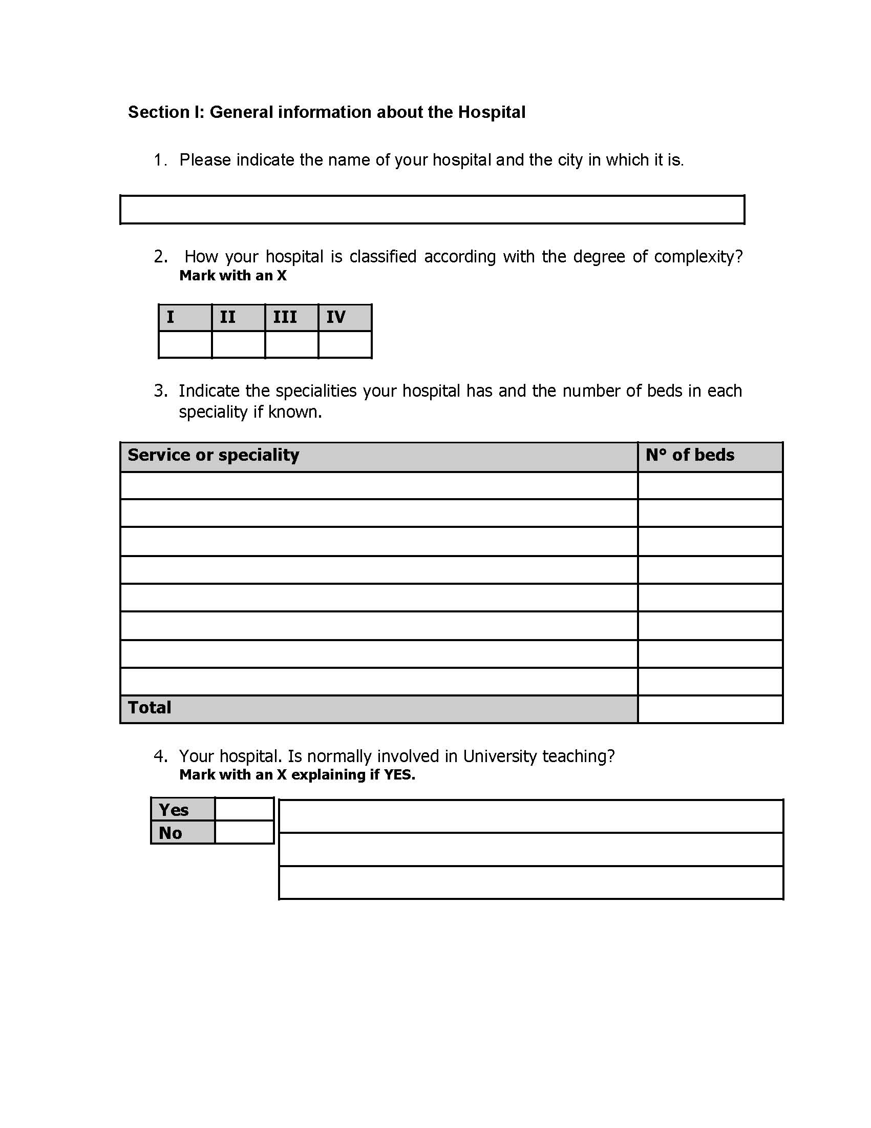

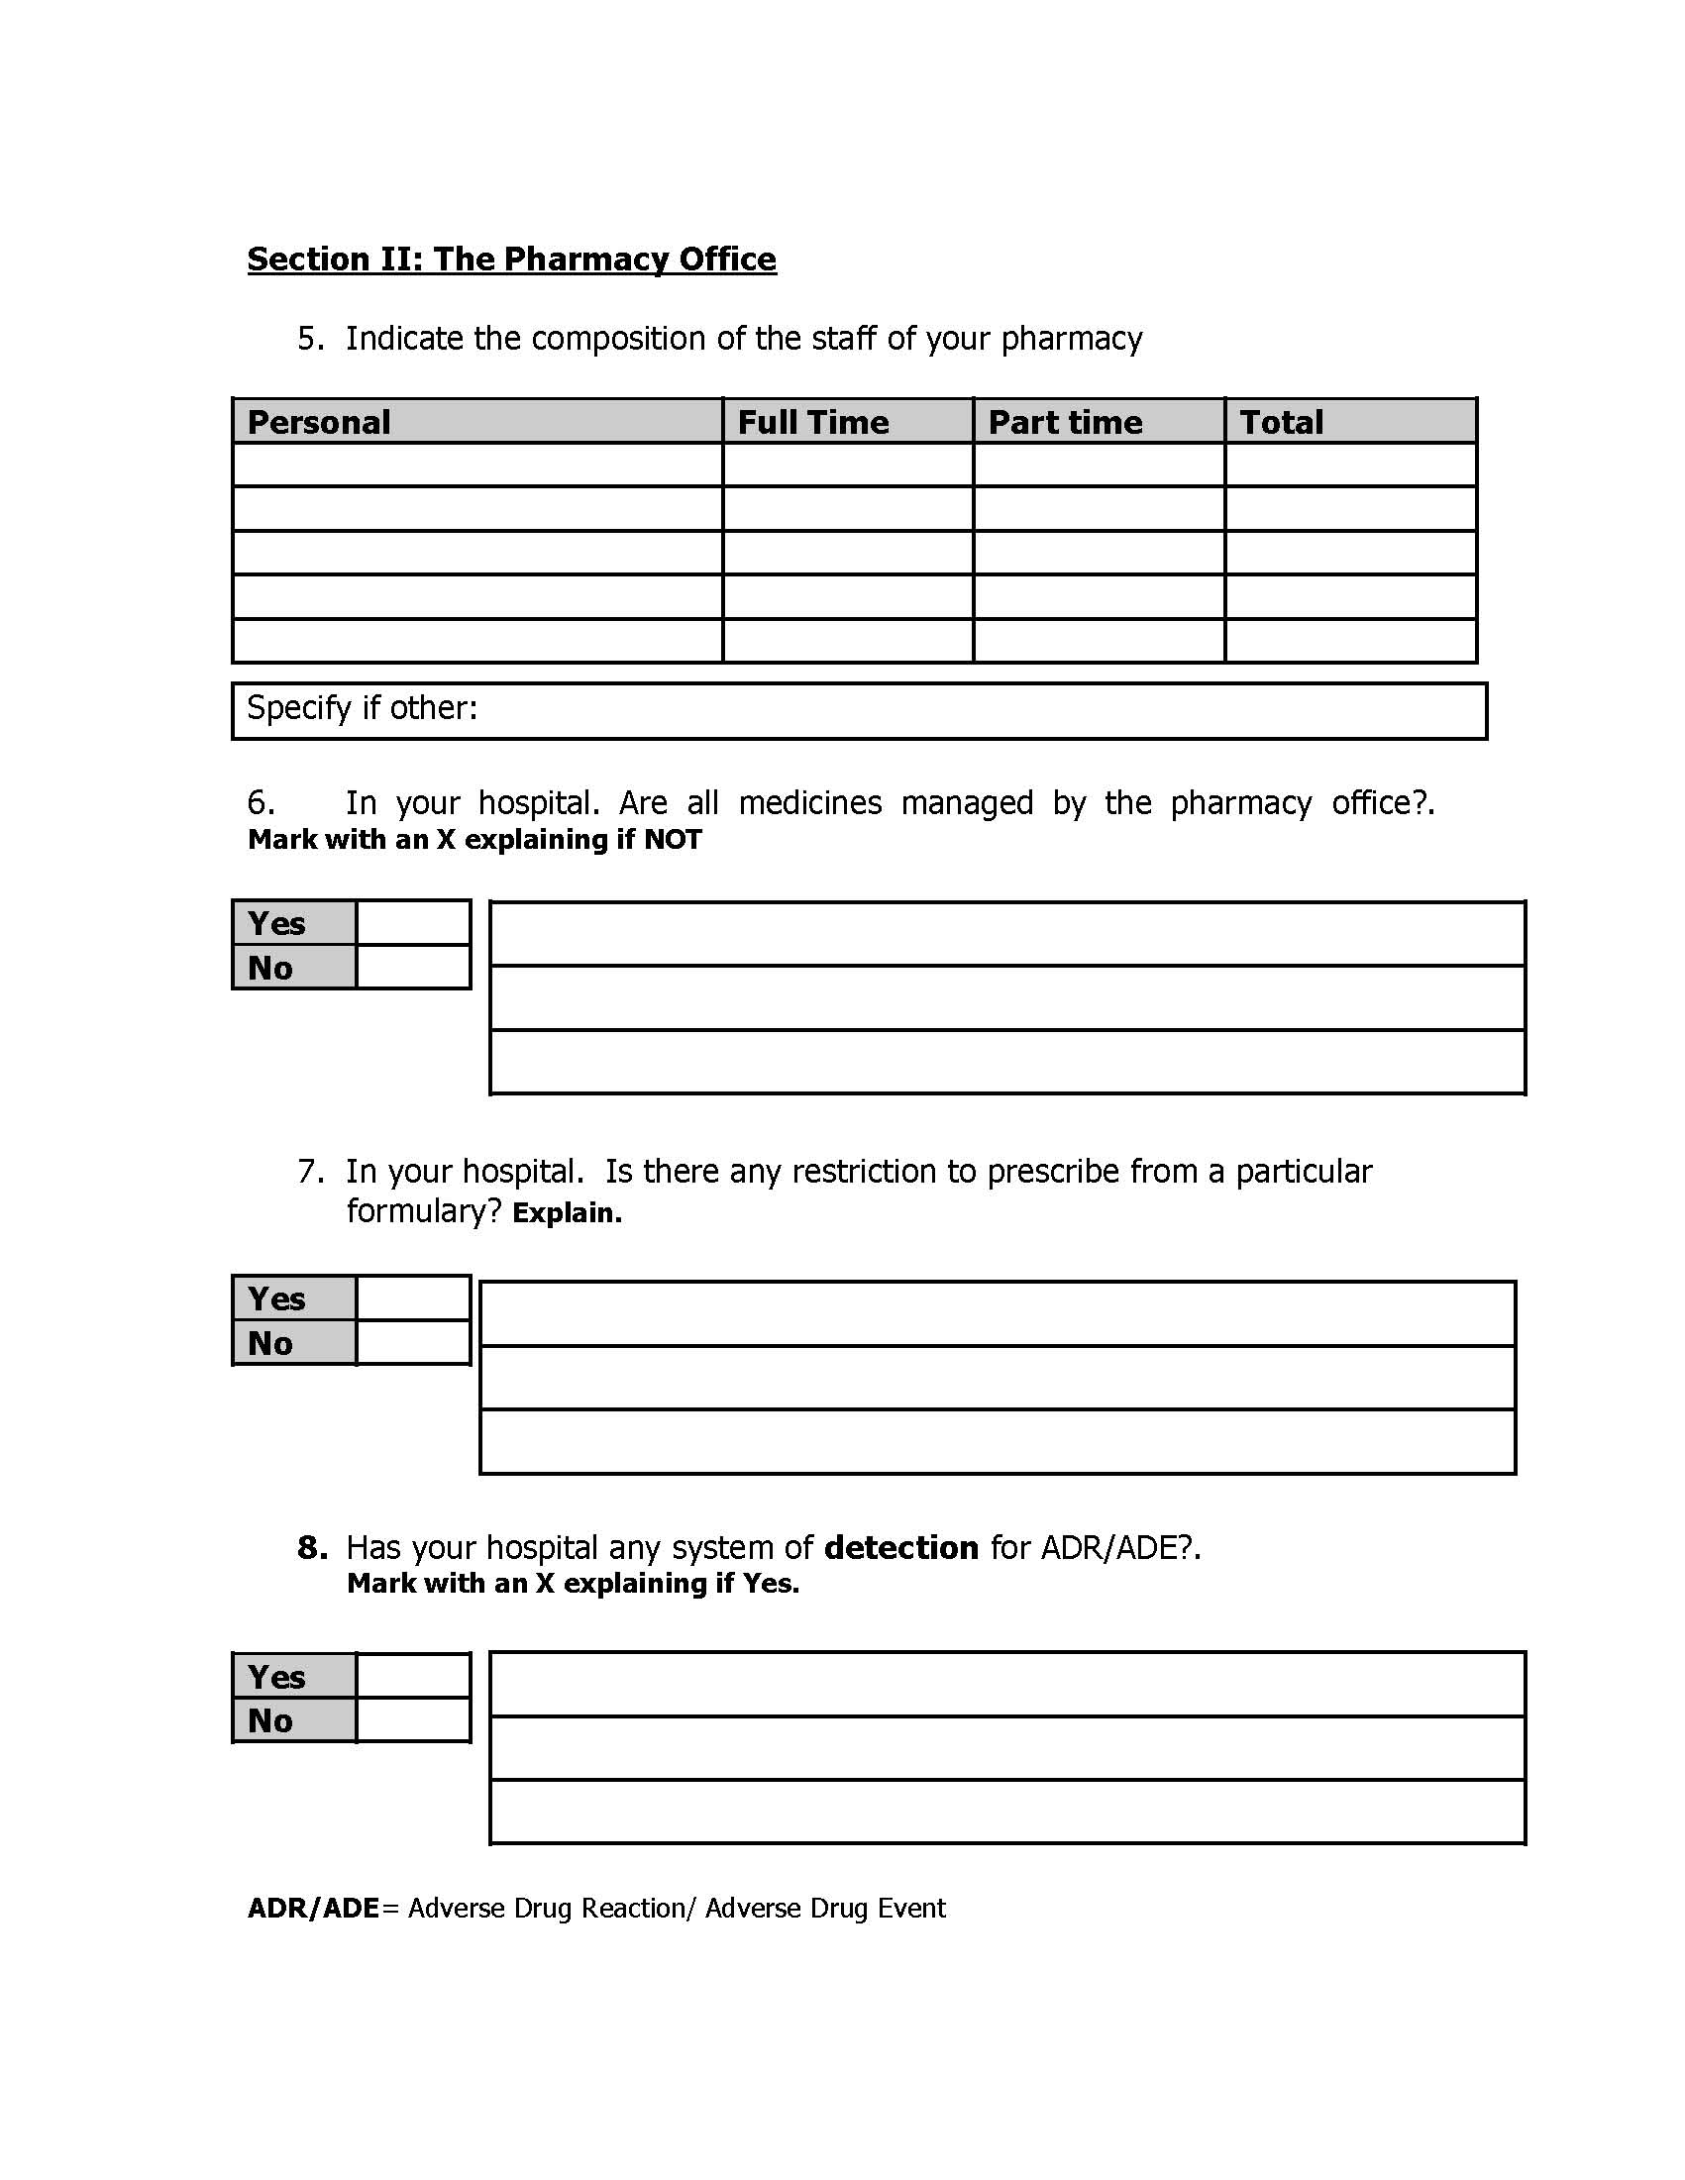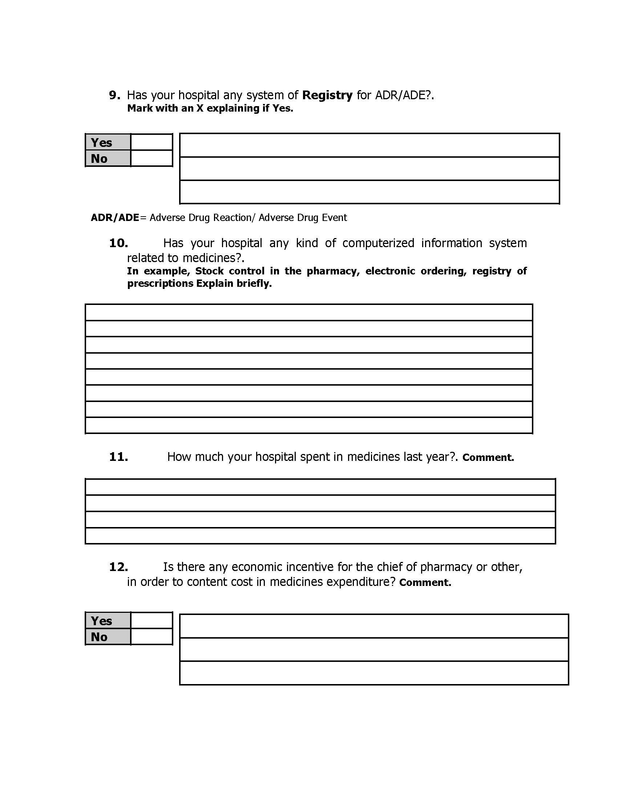

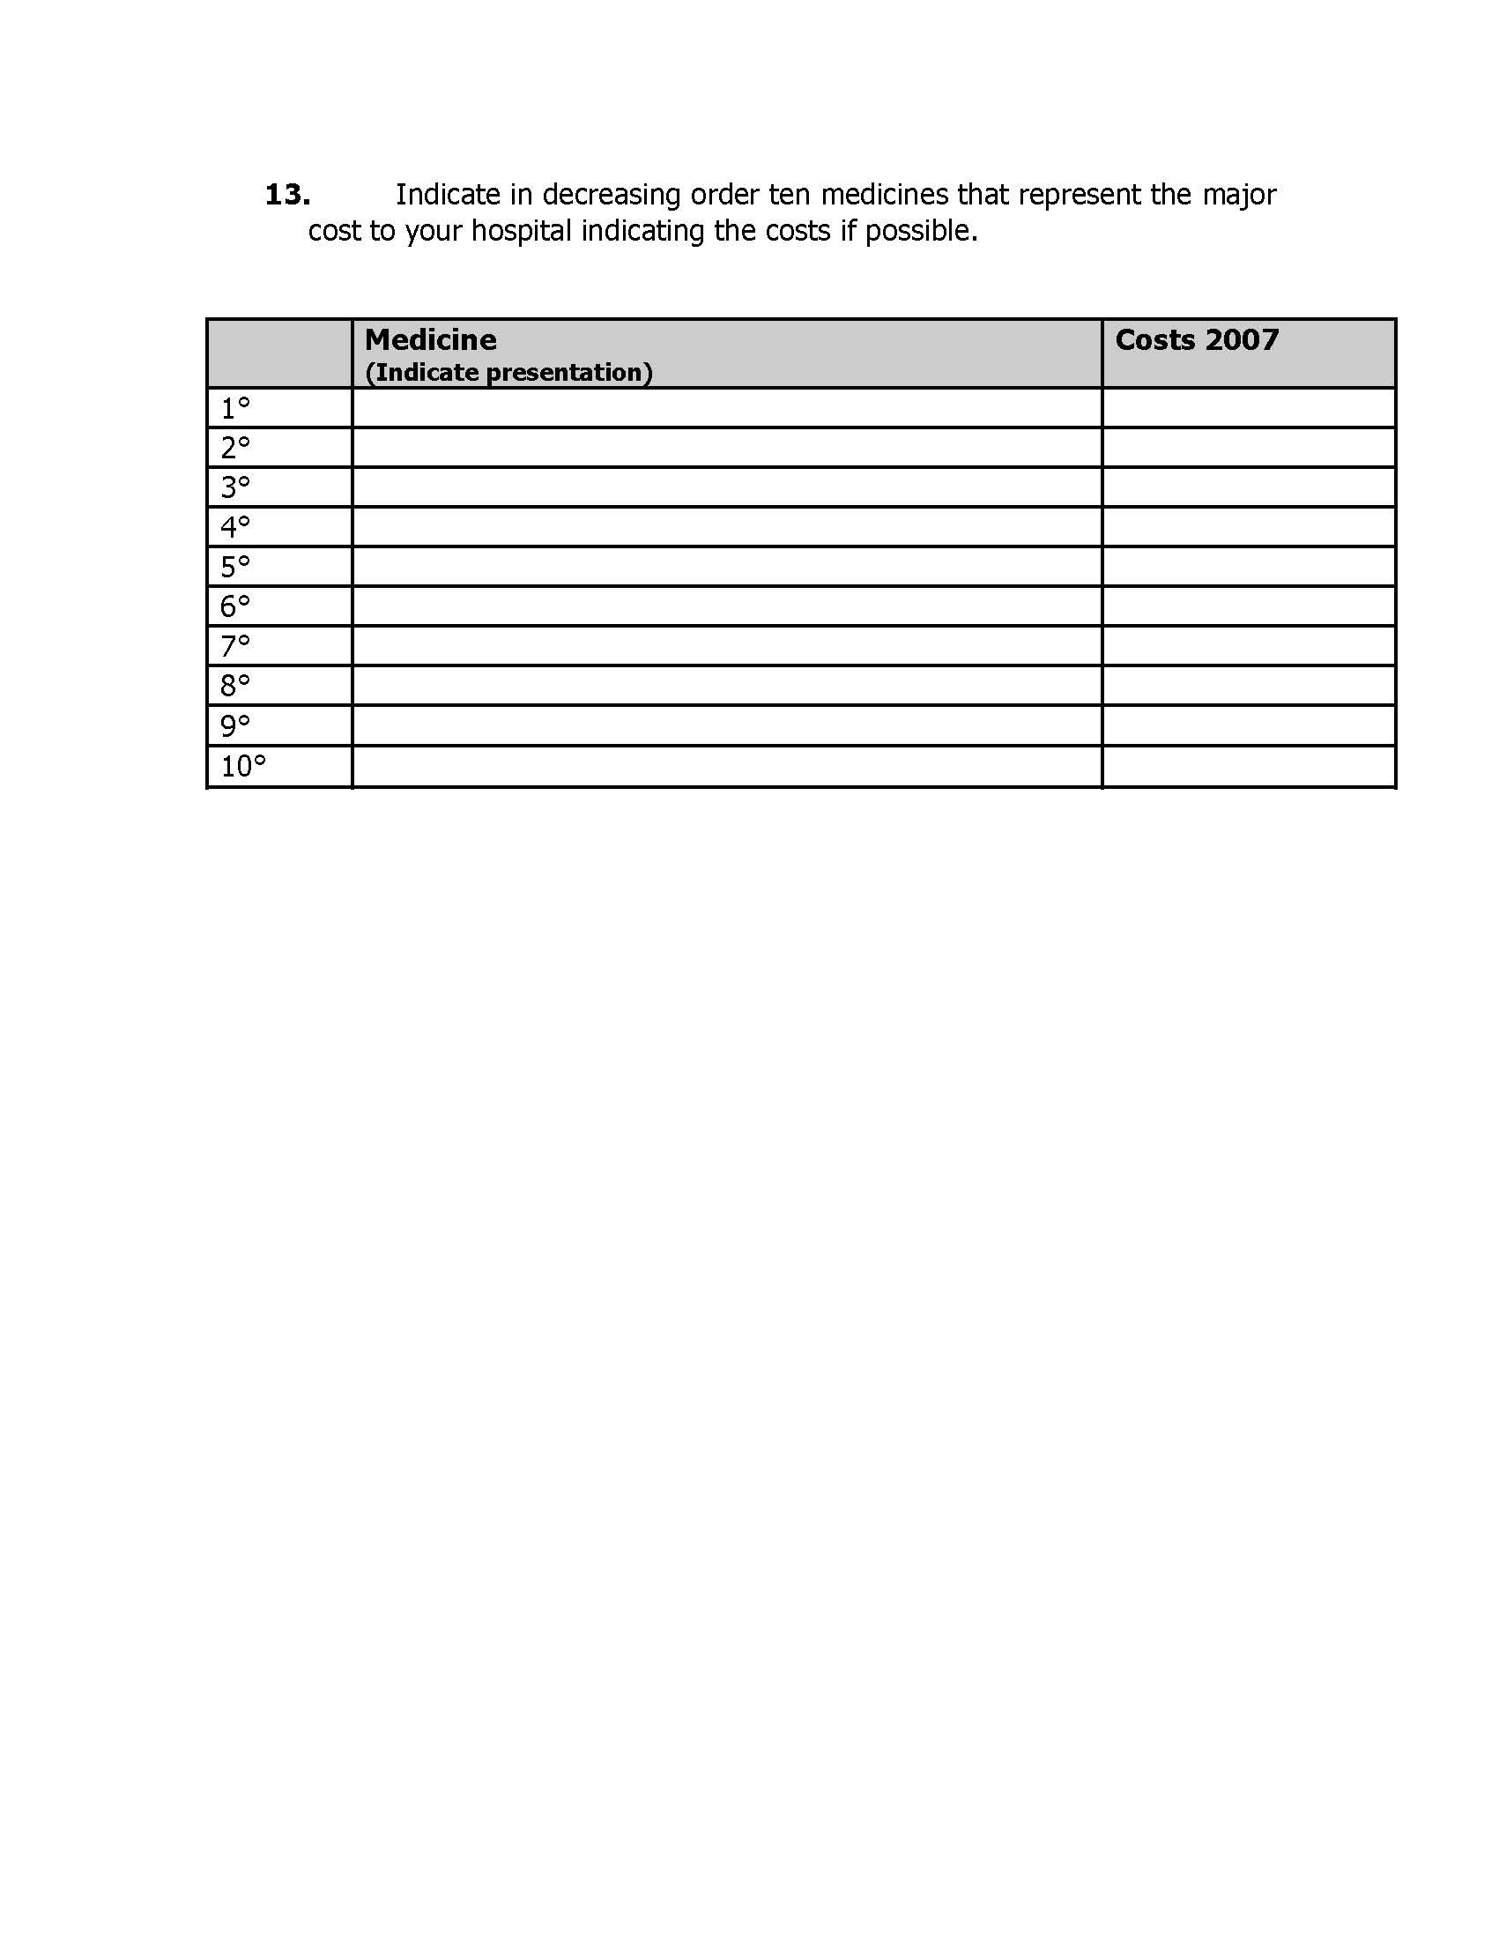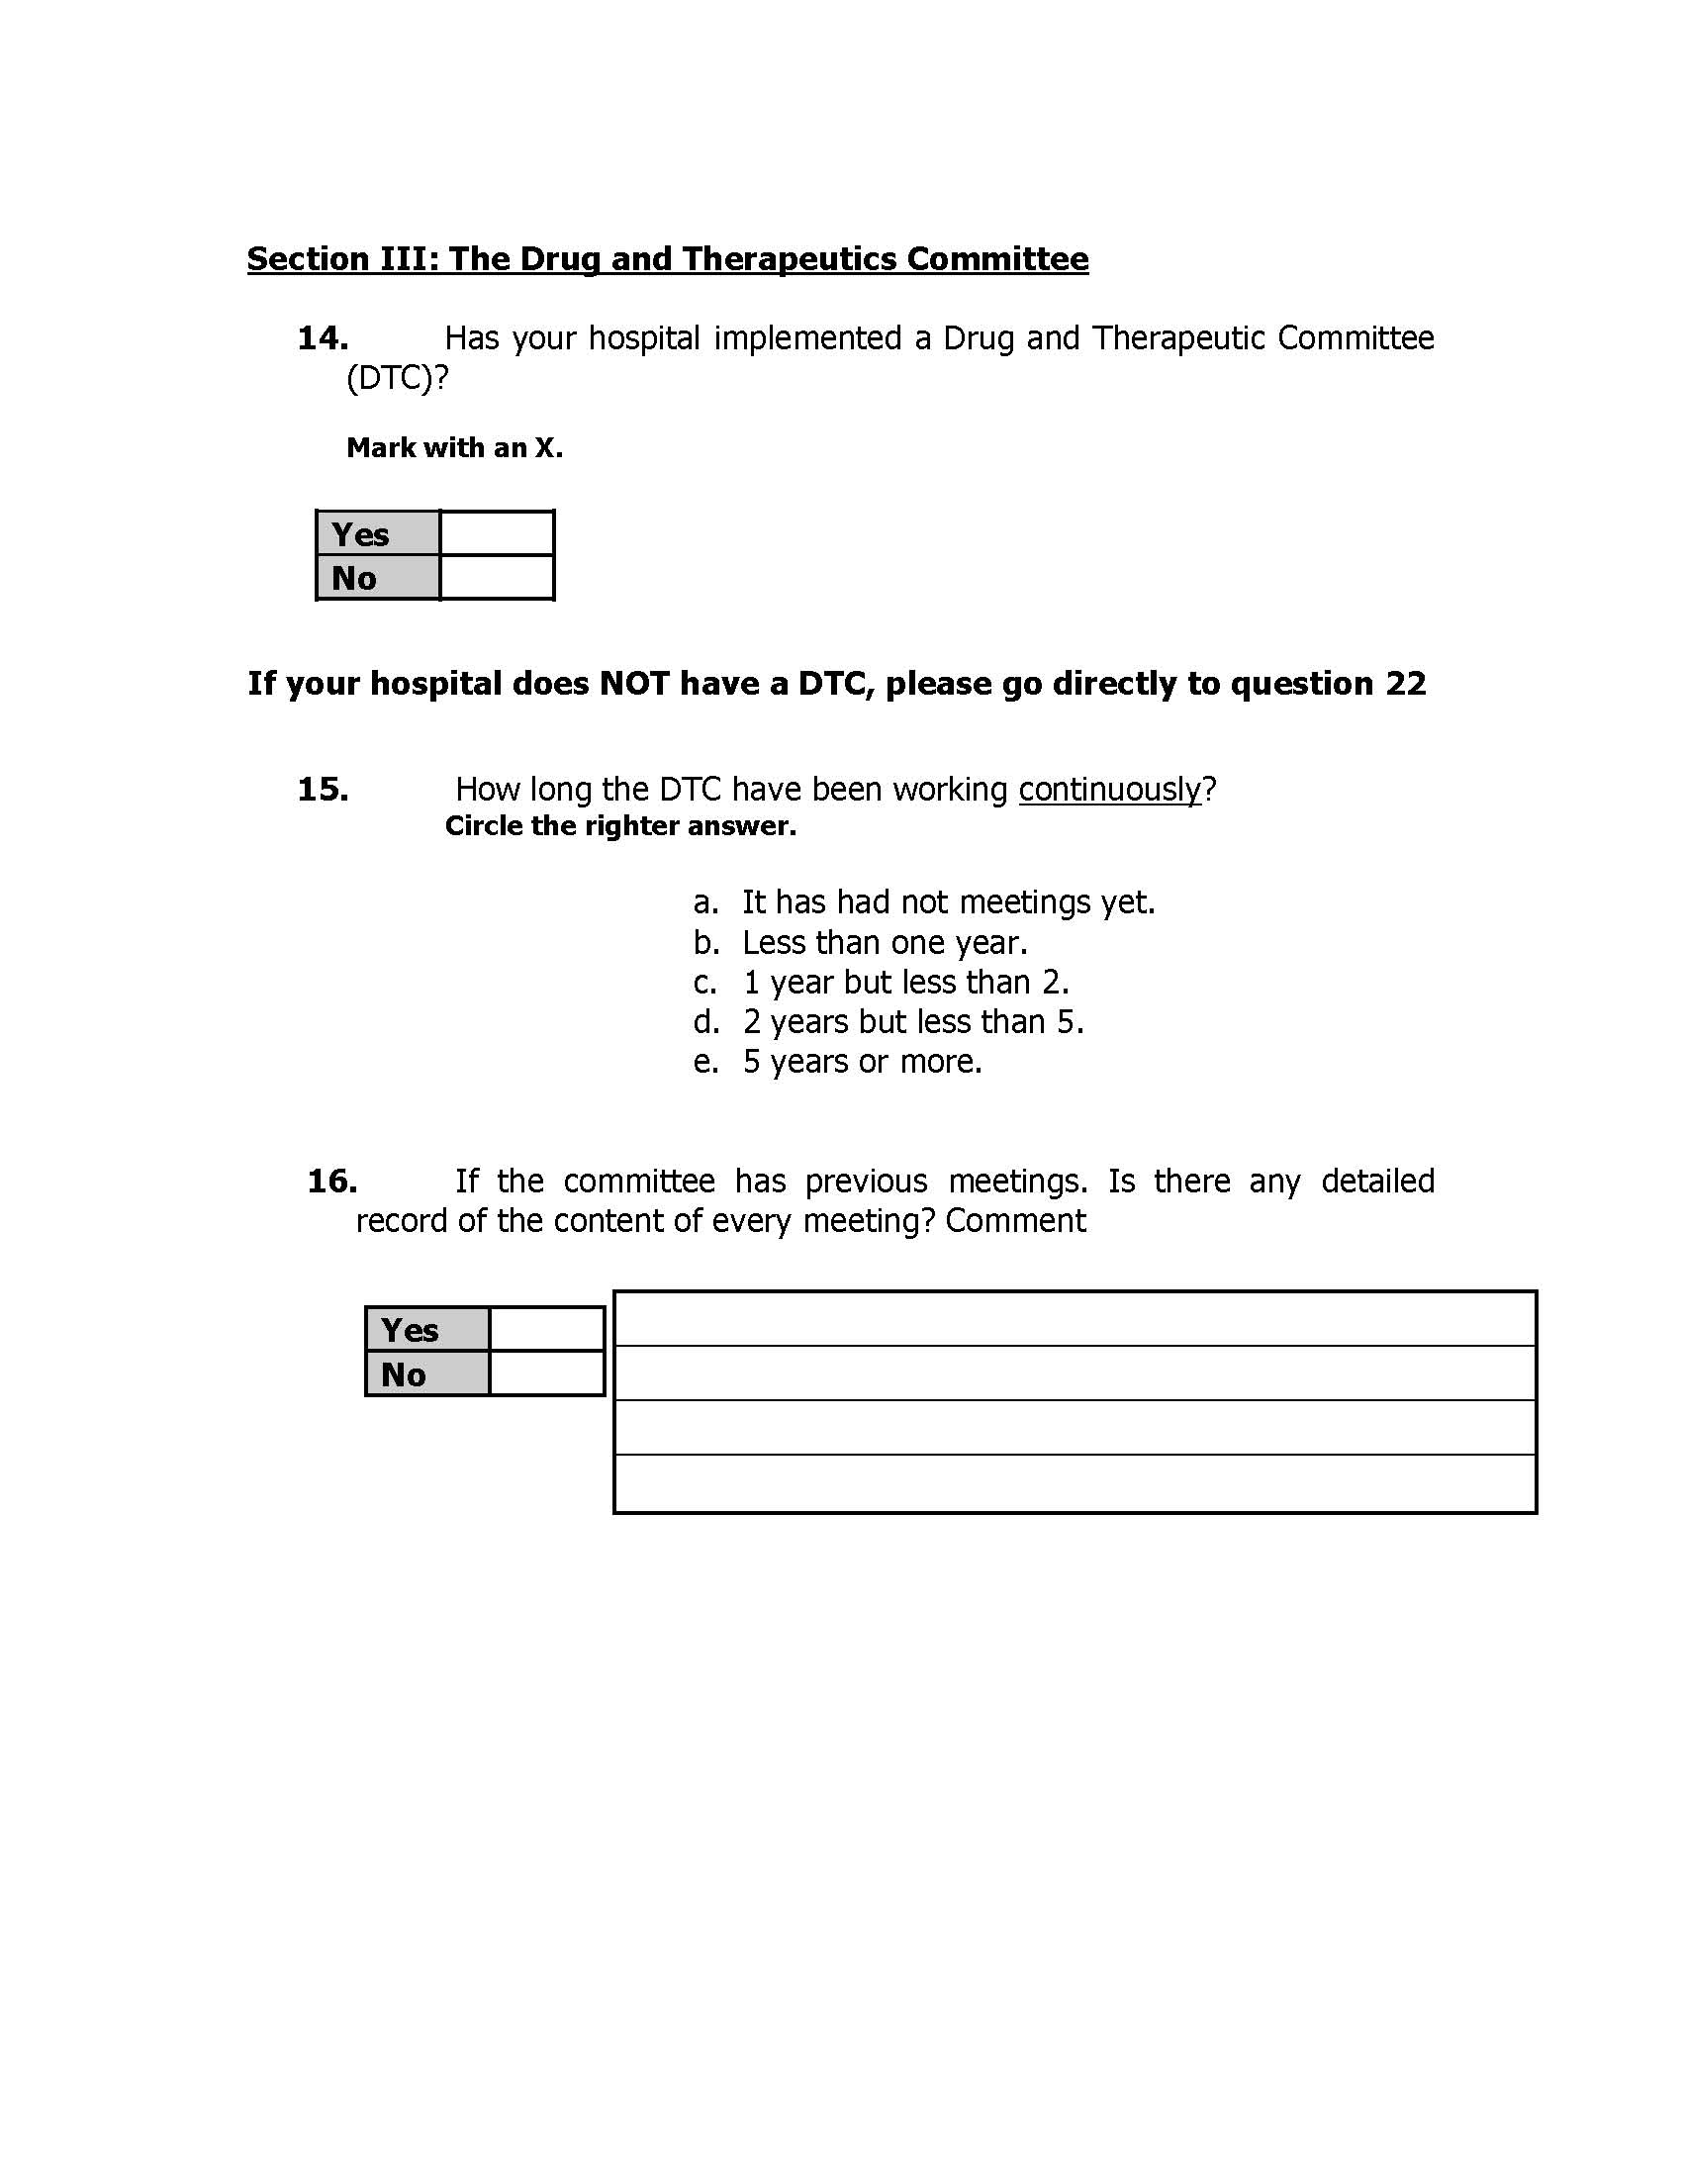

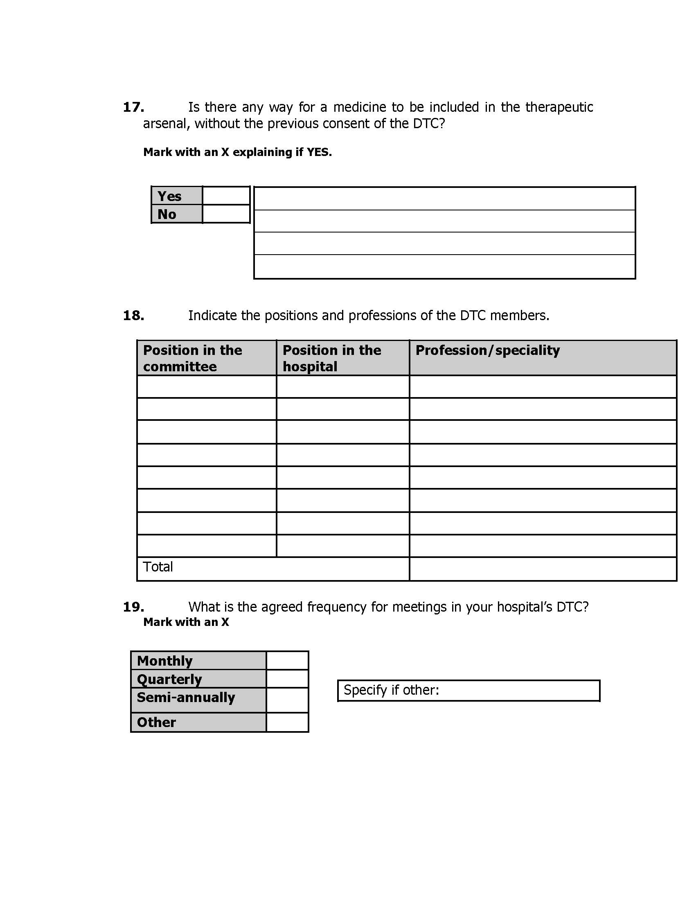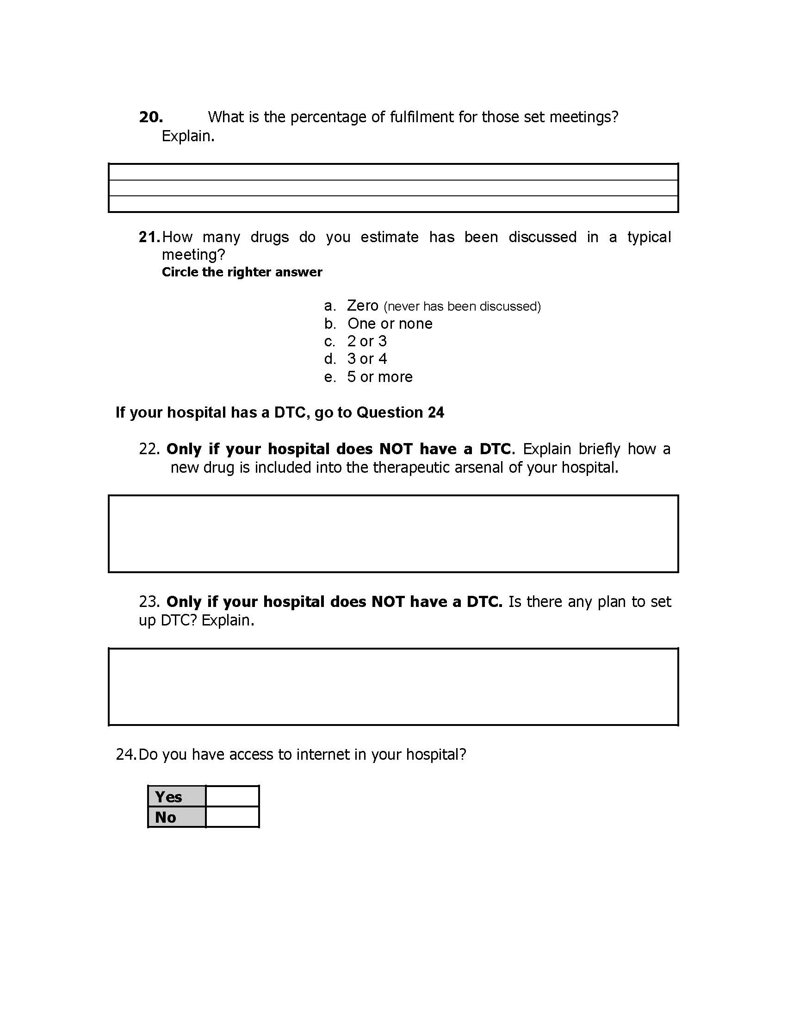

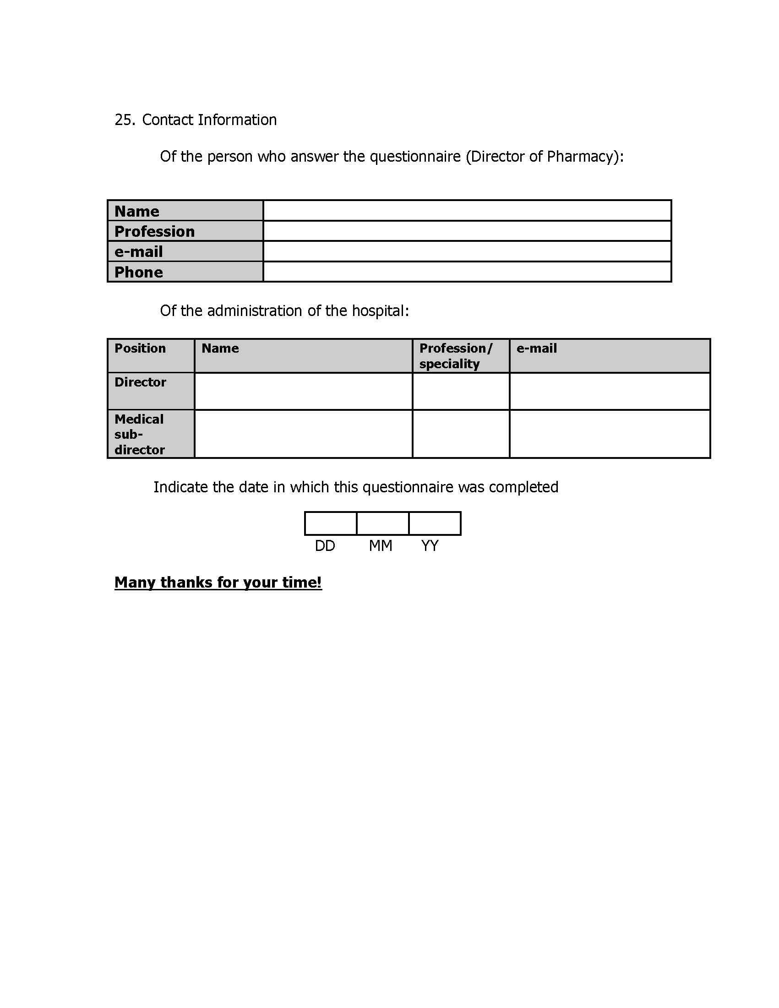

Interview Schedules used during the fieldwork of the Qualitative Research
Interview with the Chief pharmacist
- Policies regarding incorporation of new drugs.
  - Can you describe current national and/or regional policies regarding adoption of new drugs?
  - Can you comment positive aspects of these policies?
  - Can you comment negative aspects of these policies?
  - Can you describe local policies for the adoption of a new drug?
  - Can you comment positive aspects of these policies?
  - Can you comment negative aspects of these policies?
  - What is the policy of hospital regarding visits of drug representatives? Comment.
  - Do you think this policy is fulfilled in the practice?
  - Do these policies affect in the practice decisions about new drugs? How?
- Decision-making about new drugs.
  - When deciding to incorporate a medicine in the arsenal. Is there a special treatment for decisions regarding new drugs?
  - Where decisions are taken to incorporate or reject a new drug for you hospital?
  - Are there any exceptions to this rule?
  - What about drugs used for AUGE plan?
  - Is there any way in which a new medicine not previously approved by the DTC may be prescribed to an in-patient? In example, if the patient buy the drug outside the hospital.
  - What is the policy of the hospital in that regard?
  - Would you describe the process by which a new drug is proposed to the DTC?
  - Who is entitled to do the application?
  - Who is not entitled?
  - Is there any form for the application?
  - Does the applicant need to attach any antecedent to the application?
  - Who are members of the DTC in your hospital?
  - Would you describe the process inside the DTC to decide about a new drug that has been proposed?
  - Are there any exceptions to this rule? Explain.
  - Is there any written statement about the roles of members of the DTC?
  - What is your role inside the DTC?
  - What is the information that the DTC take into account when deciding about a new drug? Explain.
  - Who is the most influent member of the DTC when deciding about a new drug? Explain

- Purchases of drugs
  - What was the budget/expenditure for 2007?
  - Would you please describe how the drug budget is defined in your hospital?
  - What are the mechanisms the hospital has to purchase medicines?
  - What are the methods of payment the hospital have?
  - Would you please mention main providers the hospital has?
  - Does the hospital have any preference for some of these providers? Why?
  - How is the stock of medicines defined?
  - Is there any financial incentive for members of the DTC for cost-containment?
- The Pharmacy office.
  - How many people work in the pharmacy office?
  - Can you name their professions and positions?
  - What are the normal duties of the pharmacy office?
  - Does the pharmacy office keep any statistic of drug use? Explain.
  - To what extent this statistics include all medicines used inside the hospital?
  - Does the pharmacy office make any kind of following up for drugs? Explain.
  - May you mention computational systems the pharmacy office have and its functions.
  - Does the hospital have any kind of system for pharmacovigilance? Explain.
  - Is there any procedure by which a drug may be removed from the therapeutic arsenal? Explain.
  - What would be reasons to remove a drug from the therapeutic arsenal?

Interviews with members of the DTC
- Policies Regarding incorporation of new drugs
  - Can you please describe current national and/or regional policies regarding adoption of new drugs?
  - Can you comment positive aspects of these policies?
  - Can you comment negative aspects of these policies?
  - Can you describe local policies for the adoption of a new drug?
  - Can you comment positive aspects of these policies?
  - Can you comment negative aspects of these policies?
  - What is the policy of the hospital regarding visits of drug representatives?
  - Do you think this policy is fulfilled in the practice?
- Do you think these policies affect in the practice decisions about new drugs? How?
- Decision-making about new drugs.
  - What is your position in the DTC?
  - What is your role in the DTC?
  - Would you describe the process inside the DTC to decide about a new drug that has been proposed?
  - Are there any exceptions to this rule? Explain.
  - What is the information that the DTC take into account when deciding about a new drug? Explain.
  - How the final decision about new drugs is reached in the DTC?
  - Who is the most influent member of the DTC when deciding about a new drug? Explain.
  - Is there any way in which a new medicine not previously approved by the DTC may be prescribed to an in-patient? In example, if the patient buy the drug outside the hospital.
  - What is the policy of the hospital in that regard?
  - Would you describe the process by which a new drug is proposed to the DTC?
  - Who is entitled to do the application?
  - Who is not entitled?
  - Is there any form for the application?
  - Does the applicant need to attach any antecedent to the application?
  - Would you please describe how the drug budget is defined in your hospital?
  - What are the mechanisms the hospital has to purchase medicines?
  - What are the methods of payment the hospital have?
  - Would you please mention providers the hospital has?
  - Does the hospital have any special agreement with some of those providers?
  - Does the hospital have any preference for some of these providers? Why?
  - Is there any financial incentive for members of the DTC for cost-containment?
  - Is there any procedure by which a drug may be removed from the therapeutic arsenal? Explain.
  - What would be reasons to remove a drug from the therapeutic arsenal?
- General information about the member of DTC
  - What is your profession and academic degree?
  - Do you have any postgraduate studies? Explain.
  - Do you attend scientific or professional conferences regularly? Can you mention recent conferences you have attended?

Interviews with physicians
- Applicants for new drugs
- Application process
  - Would you describe the process by which a new drug is proposed to the DTC?
  - Is there any form for the application?
  - Do you need to attach any antecedent to the application?
  - How did you first hear about the last drug you apply for at the DTC?
  - Were did you get information about the mentioned drug that make you decide to apply for?
  - As a decision-maker. Can you mention the positive and the negative aspects of the DTC?
  - As a policy-maker. Can you mention the positive and the negative aspects of the DTC?
- Clinicians
- General matters
  - What do you think about local policies regarding incorporation of new drugs?
  - What can you do if you think a new drug must be in the therapeutic arsenal?
  - Can you apply the drug to the DTC?
  - Is there any way by which you can prescribe a new drug that it is not already in the therapeutic arsenal? Explain.
  - As a decision-maker. Can you mention the positive and the negative aspects of the DTC?
  - As a policy-maker. Can you mention the positive and the negative aspects of the DTC?

Interview with the head of the Department of Pharmaceutical Policies in the Health Ministry of Chile
- About the department of pharmaceutical policies and medical professions.
  - What are the goals of the Department?
  - Can you tell me about how policies are set?
  - What kind of information is used to set these policies?
  - Would you tell me about how decisions about new drugs are taken in Chilean Hospitals?
  - What are the current policies about incorporation of new drugs in hospitals?
  - Do you have any feedback mechanism to know about how these policies work in the practice?

Figure 4: Interview Schedule for Complementary Interviews
Second Interview with the Chief Pharmacist
- What can you tell me about the number of Forms #1 and Forms #3 that are normally received in the pharmacy office?
- How often do you think that requests for Exceptional Purchase are approved by the director?
  - What are your impressions about this procedure?
- Is there any therapeutic class that is more commonly requested through Exceptional Purchase?
- When a drug that has been constantly requested through exceptional purchase, do you include it in the formulary?
  - How often does this happen?
  - Is there any particular therapeutic class that is more often included this way?
- Is there any list of drugs in your hospital that have restrictions to be prescribed?
- Who is in charge of the supply of medicines in your hospital?
- What is his/her profession?
- Who is in charge of setting the technical requirements for bids placed in Chilecompras?
- What technical requirement(s) do you have to ensure quality of medicines?
Interview with the Chief Nurse
- Are there medicines bought privately in your department?
  - What do you think are the reasons for buying medicines outside the hospital?
  - How many patients are today being treated with medicines bought privately?
  - Is there a particular therapeutic class that is more commonly purchased privately?
- What are your perceptions about buying medicines privately?

