Supplementary Material

1. Lesion analysis of responders vs. non-responders

A post-hoc analysis of lesions of patients who responded to rotigotine versus those who did not was performed. These data necessarily need to be assessed with caution. Given the relatively small sample size, they might well not replicate or generalize.

Voxel-based lesion symptom mapping (VLSM) analysis was performed using MRIcron’s non-parametric mapping software (www.mccauslandcenter.sc.edu/mricro/npm/).

Cases 1, 3, 9, 11, and 13 were considered to show beneficial response to treatment and all other patients were considered as non-responders. Fig S1 illustrates the results.

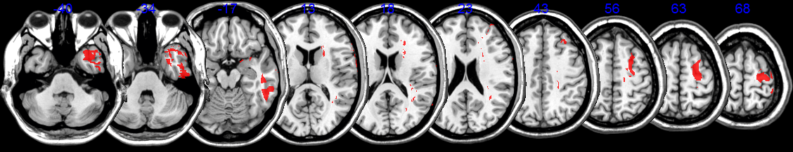

Fig. S1 Lesions of responders to rotigotine compared to non-responders.

The analysis results suggest that damage to areas in right superior frontal cortex, temporal pole and smaller posterior temporal and frontal white matter areas might predict positive response to rotigotine in visual search.

While these findings are interesting, particularly in view of the fact that the superior frontal region would involve the frontal eye field, we would urge caution in interpretation given the relatively small sample size.

2. Lesion analysis according to involvement of superior parietal lobe.

Although our original hypothesis was based on prefrontal cortex (PFC) involvement, it is also potentially interesting to determine whether degree of right superior parietal lobe (rSPL) integrity had any effect on response to rotigotine. We divided the patients into two subgroups, according to high or low degree of rSPL involvement, as shown in the table S1 below (order of subjects is the same as in Table 1 in the manuscript).

rSPL here is defined as Brodmann areas 5 and 7, and the procedure followed to characterise the extent of its involvement in the lesion was the same as described for the rPFC in our Methods. Overlap of lesions with rSPL is shown in Fig S2. Subjects were divided in two equal subgroups according to % of rSPL involvement. Analysis of performance in the behavioural measures in each rSPL subgroup was carried out as for the rPFC subgroups.

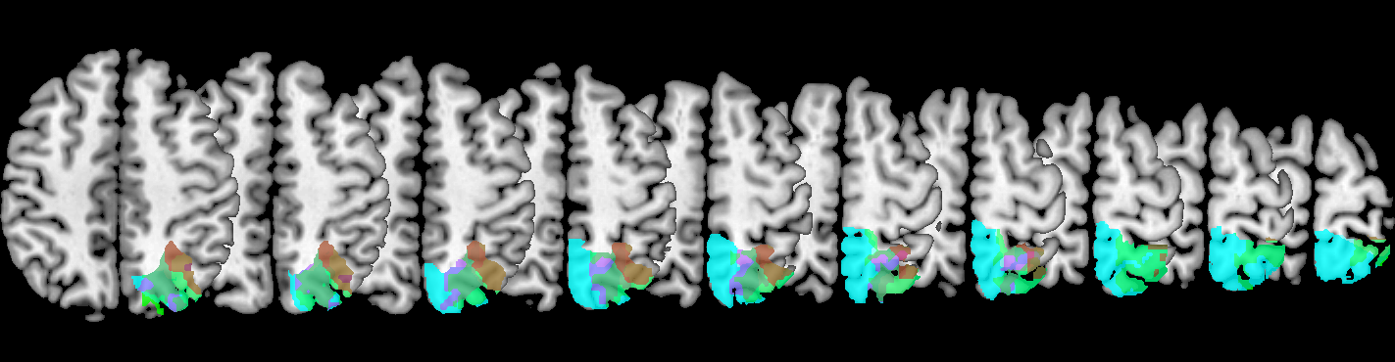

Fig. S2 SPL lesion involvement.

Patient | rSPL %lesioned | Stratum | Mesulam L targets OFF drug | Mesulam L targets ON drug | Mesulam R targets OFF drug | Mesulam R targets ON drug
1 | 14.59% | High | 13.25 | 22 | 26.5 | 26
2 | 0.27% | Low | 24.75 | 22.5 | 25.5 | 27.5
3 | 46.29% | High | 1.5 | 5 | 24.5 | 27
4 | 25.61% | High | 0.25 | 0 | 20.75 | 23
5 | 0.00% | Low | 0 | 0 | 13.5 | 13
6 | 100.00% | High | 1 | 0 | 18 | 19
7 | 0.03% | Low | 1.75 | 2.5 | 16.75 | 16
8 | 6.65% | High | 9.75 | 10.5 | 22 | 19.5
9 | 0.00% | Low | 22 | 28 | 27 | 29
10 | 4.65% | Low | 0 | 0 | 16.25 | 8
11 | 16.32% | High | 10.75 | 20.5 | 23.25 | 25.5
12 | 0.40% | Low | 2 | 0.5 | 26 | 28
13 | 5.83% | High | 2 | 8 | 25.5 | 22
14 | 6.32% | High | 22.75 | 23 | 24.25 | 26
15 | 1.35% | Low | 6.5 | 7 | 23.25 | 23
16 | 5.15% | Low | 11.75 | 13 | 20.25 | 18

Table S1 SPL lesion involvement for each patient and Mesulam search task performance to left and right, on and off rotigotine.

In the subgroup with minimal superior parietal involvement, rotigotine was associated with significant improvement in the number of targets found on the left in the Mesulam search task when compared to both phases off the drug combined (P=0.04). There was less rightward bias as measured by the lateralisation ratio, but this result was of borderline significance (P=0.056). No other measures were significantly different on and off rotigotine in this subgroup.

In the subgroup with extensive superior parietal involvement, improvement with rotigotine in number targets found on the left in the Mesulam search task when compared to both phases off the drug combined was of borderline significance (P=0.078), as was a reduction in the rightward bias as measured by the lateralisation ratio (P=0.078). Again, no other measures were significantly different on and off rotigotine in this subgroup.
Additionally, inspection of the data in Table S1 reveals that patients who demonstrate clear benefit from the drug in visual search can be found both in the minimal SPL (e.g. patient 9) and in the extensive SPL subgroups (e.g. patient 3). In conclusion, stratification according to rSPL involvement does not provide a clear prediction as to which patients improved on treatment with rotigotine.

