- Scale errors in young children
In adults and older children, the perception of an object and the organization of object-related actions are smoothly integrated (e.g., Bertenthal, 2008; Bruno & Battaglini, 2008; Nardini et al., 2008). Young children, however, sometimes make serious attempts to perform impossible actions on miniature objects as if they were full-size objects (e.g., Brownell, Zerwas & Ramani, 2007; DeLoache, Uttal & Rosengren, 2004; Rosengren, Carmichael, Schein, Anderson, Gutierrez, 2009; Rosengren, Schein, & Gutierrez, 2010; Ware, Uttal, DeLoache, 2010). Examples include children’s attempts to sit in a tiny chair, put doll shoes on their own feet or get inside toy cars. Importantly, the information about the object size seems to be neglected only when planning the object-related action, but not during the action execution: indeed the child’s motor interactions with the object are finely and accurately scaled to its actual size.
These curious action errors, called scale errors, appear as early as 12 months, reach the peak around 20 - 24 months, and decrease by 36 months (e.g., Ware, Uttal, DeLoache, 2010). Scale errors are not limited to actions that involve the child’s body. Toddlers perform scale errors also when an action involves two objects, for example, when trying to put a doll into a bed that is too small to accommodate the doll’s size (Ware, Uttal, Wetter & DeLoache, 2006), as well as when trying to use a net for scooping fake fish that is too big to fit into the aquarium (Casler, Eshleman, Greene & Terziyan, 2011). These object scale errors, as opposed to body scale, can be found as early as 18 months (data for younger children are missing), are very frequent at 42 months (Casler et al., 2011), and under certain circumstances can be seen even in adults (Casler, Hoffman & Eshleman, 2014). They are also more frequent than body scale errors. In Casler et al.’s study (2011), almost all children (with one exception) made scale errors, with on average 2.6 errors per child as compared to the original DeLoache et al.’s study (2004) in which only half of the children made scale errors with an average of 0.74 errors per child.
Several explanations for scale errors have been offered so far. One possibility is they are caused by occasional failures in the integration of the object identity and its size for action planning, combined with weak inhibitory control (DeLoache et al., 2004). According to this explanation, the visual information from the miniature replica activates the child’s mental representation of general category of objects, along with a motor plan for interacting with the typical exemplars inherent in this representation. In principle, the available size information should inhibit the activated motor plan, preventing the child from committing a scale error. Due to immature inhibitory systems, sometimes the inhibition fails leading the child to form an action plan based on the original object or general category of objects.
Yet another explanation is that young children might make scale errors because of a rapidly developing bias to view objects teleofunctionally, that is, as existing for a particular purpose (e.g., a chair is for sitting, a paintbrush for painting) (Casler et al., 2011; Oláh, Elekes, Pető, Peres, & Király, 2016). Children (and also adults, see Casler, Hoffman & Eshleman, 2014) have difficulty to decouple an object from its function, even though the object has the wrong size to successfully achieve the goal. In other words, when children see an object, its function is immediately invoked (i.e., the motor plan associated with the object), an ability which seems to unique to the human cognitive system (Casler & Kelemen, 2007). Similar to the suggestion by DeLoache et al. (2004), when the object is too big or too small, children’s weak inhibitory system prevents them from inhibiting the activated motor plan, resulting in an attempt to use the object for its typical purpose.
Finally, an alternative explanation proposed that children’s scale errors could be caused by their lack of understanding of their own body size and its relation to the size of the objects in the world (Brownell et al., 2011). Rather than neglecting the size information for action planning, children would be acting based on the difficulty to adjust the representation of their own body to their rapid physical changes. However, this explanation does not address object scale errors.
These apparently different explanations of children’s scale errors share one component: they all assume that children perform scale errors because of decreased attention, either to object size information for action planning (DeLoache et al., 2004; DeLoache, LoBue, Vanderborght & Chiong, 2013; Glover, 2004), body size information (Brownell et al., 2011) or object size information due to increased attention to object function (Casler et al., 2011; Oláh et al., 2016). However, none of the studies so far has explicitly tested attention to size information in young children who perform scale errors.
There are at least two ways in which attention to object size could be compromised in young infants performing scale errors. First, attention to object size information could be outweighed by an increased attention to objects’ shape. A large literature has suggested an increase of children’s attention to object shape in the context of early word learning (e.g. Imai, Gentner, & Uchida, 1994; Smith, Jones, Landau, Gershkoff-Stowe, & Samuelson, 2002). Landau, Smith and Jones (1988) showed that children generalized the name to test objects that were the same shape as the exemplar, but not to test objects that were different in shape. In that study, the attention to shape strongly overrides size information: children extended the novel name to same-shape test object even though the test object was 100 times the size of the original. The second possibility is that children’s attention to object size is decreased due to an increase in their attention to object function. This is in line with the teleofunctional account of scale errors that highlights the strong link between the category of the object and its function (Casler et al., 2011). These two possibilities, increased attention to shape and function, are not mutually exclusive as shape is a powerful cue for object function. Taken together, these findings raise the possibility that children who make scale errors attend less to object size information.
This study examined visual perception of actions on objects of adequate or inadequate sizes. Children took part in an experiment that used an adapted version of the violation-of-expectation method (e.g., Baillargeon, 1994), in which eye-tracking was used to examine their looking time towards characters on a screen performing actions with objects of different size or colour. Specifically, children were familiarised with a character performing an action with an object of an adequate size, and tested with a change in object size (too small or too big), or colour as a control condition (with size unchanged). In addition, we tested these children in an action task to identify those producing scale errors with real objects at that particular moment in their development, by using a similar setting as in DeLoache et al. (2004). If children’s scale errors are caused by a decreased attention to object size information in action context, we expect a different pattern of responses to size change versus colour change in scale error performers and non-scale error performers. Specifically, we would expect the non-scale error performers to allocate more attention to size changes than colour changes – the latter depicting impossible or unlikely events – whereas the difference between the two conditions might be less important in scale error performers, to the extent that they might actually pay more attention to colour changes than size changes.
Two age groups were targeted: 18 to 25 months, and 47 to 60 months. The youngest age range corresponds to the age at which scale errors are usually investigated, while the oldest range corresponds to the age at which scale errors are anticipated to disappear (or be minimal) based on past studies (e.g. Brownell et al., 2007; DeLoache et al., 2004; DeLoache et al., 2013; Rosengren, Gutierrez, Anderson, & Schein, 2009). The older age group was included to act as a benchmark for the behavior of the younger non-scale error performers. Although we would expect in principle a similar pattern of attention allocation for these two groups, the younger non-scale error group could also stand halfway between the older age group and the younger scale error group. This would be taken as an indication that attention to size information in an action context is not fully mature between 18 and 25 months, irrespective as to whether children perform scale errors in the lab situation.
To sum up, we aimed at expanding our understanding of the mechanisms underlying children’s scale errors by examining how scale error performers perceive size information when looking at actions with adequate versus inadequate object sizes, as compared to non-scale error performers.

2. Method
Children were tested in two consecutive tasks. In the action task, the children played first with three child size toys (a slide, a chair and a toy car). Then the toys were replaced with miniature replicas and the child was encouraged to play with them, similarly as in the scale error elicitation situation described in DeLoache et al. (2004). In the looking task, the children watched on a computer screen a series of cartoon animations depicting a boy or a girl performing an action with an object. Each animation was made of a familiarisation trial followed by a test trial. In the familiarisation trial, the action was performed with an adequate full-size object (e.g. a girl using a telephone). In the immediately following test trial, the same action was presented but the object was either much bigger or smaller than a typically sized object (with no hypothesis as to which change would be more salient), or at the same size as in the baseline phase but in a different colour. Half of the selected objects were familiar objects (e.g. book, hat) for which we expected children to have knowledge of their name and associated actions, while the other half were objects less common in the child’s immediate environment and whose name children did not know yet (e.g. bandage, skateboard). Familiarity to objects and their names was assessed by parental questionnaires (see below). This familiarity variable was introduced to ascertain that children’s attention to size information in an action context would be a general property of their developing cognitive processing rather than linked to specific, overlearned, word-action pairings.

2.1. Participants
Ninety-six healthy monolingual young children (18 – 25 months) and 36 older children (47 – 60 months) living in the UK were recruited through the Babylab database. Eleven young children were excluded from the analysis because of excessive fussiness and ten because of technical problems with the use of the eye-tracker. After inspection of the eye movement data from the looking task of the 75 remaining young children, 23 were excluded because their data did not meet our set of quantitative and qualitative criteria (more details in data processing section). The final sample of young children consisted of 52 children (age M = 22.1 months, SD=2.3; 33 girls).
Out of the 36 older children, eye-tracking data from 13 children who did not meet our data quality criteria were excluded, leaving a final sample of 23 children (M = 51.7 months, SD=3.6; 8 girls). The large number of participants excluded based on their eye-tracking data (30% of young children and 36% of older children) is common in eye-tracking studies (e.g., Daum, Attig, Gunawan, Prinz, & Gredebäck, 2012; McMurray & Aslin, 2004; Navab, Gillespie-Lynch, Johnson, Sigman, & Hutman, 2012).

2.2. Stimuli and material
Action task: Three large play toy objects were selected: a slide (128 x 76 x 76 cm) that children could climb up and slide down, two child-sized chairs (49.5 x 24.5 x 19.0 cm) that they could sit in, and a car (74.9 x 41.9 x 85.1 cm) that they could enter and propel around the room with their feet. We also used three miniature replicas that were identical to their larger counterparts except for size: slide (24.3 x 12.7 x 15.24 cm), a chair (6.0 x 5.5 x 6.5 cm) and toy car (15.24 x 7.62 x 16.51 cm). Figure 1 shows the toys and their miniature replicas.
Looking task:
Each animation was made up of a baseline familiarization trial depicting a boy or a girl performing an action with a full-size object, followed by a test trial. In the latter, the action was identical to that displayed in the baseline, the only difference was the size of the object (it became bigger/smaller than its normal size) or its colour (it had a different colour but the same size). These conditions are referred to as Big, Small and Colour change.
The stimuli were animated drawings on a white background centrally presented on a 22″ computer display (screen resolution 1280x960). The average size of the animation was 414 by 459 pixels, resolution 72 ppi (pixel per inch), and frame rate 2 fps. The average size of objects used in animations in the baseline (and Colour change) was 186 by 174 pixels (SD width = 162.40, SD height = 112.60), in Big change it was 384 by 352 pixels (SD width = 241.95, SD height = 161.53), and in Small change it was 74 by 60 pixels (SD width = 73.09, SD height = 39.54). In order to examine whether children would have detected the small objects, we calculated the visual angle corresponding to the smallest object in the stimuli, which was 1.4 (width) x 0.5 cm (height) on the screen, that gives a visual angle of 0.01 rad or 0.5 deg for a child (assuming that children were seated 60 cm from the eye-tracker). In optometry acuity is measured in MAR (minimal angle resolution), and for adults, the MAR is 1 min arc (1/60 deg). Lithander (1997) provides norms of development of MAR for children aged 24 months to 4 years and shows that at 24 months, MAR is at 2.10, that is, 0.035 deg, and 14 times smaller than the 0.5 deg used in our experiment. We are therefore confident that children could see the small objects. In relative area, Small objects were 7 times smaller than baseline, and Big objects were 4 times larger than baseline. The choice of these ratios was driven by piloting data showing that these changes were necessary for the resulting action to appear impossible to an adult observer.
The average length of an animation was 8.66 s (SD = 1.62), but for a given item (e.g., a car), all three animations (colour change car, big car and small car) were of the same duration. They were created with Adobe Illustrator software for Macintosh operating system. The drawings used for animations were taken from Open Clipart gallery (free for non-commercial use image gallery, https://openclipart.org/).
The screen was placed at a distance of 70 cm to the child. Stimuli were animations (baseline followed by Big, Small, or Colour change) created for 36 different objects.
Parental reports indicated a variety of miniature objects that elicited scale errors that involved categories such as clothing, vehicles, furniture (Ware, Uttal & DeLoache, 2010). Half of the animations in our study included a target object whose name was supposedly familiar to the child; these objects were typically associated with scale errors equally distributed from household objects, clothes, vehicles, and furniture (e.g., bicycle, cup). For the other half the target objects were selected within similar categories but such that the child would not know their names yet (e.g., duster, whisk). An unavoidable confound here is that objects for which children have no name yet are necessarily less common in their environment, and therefore their function is also less familiar to the children. If children do not pay attention to size changes for these objects, one could argue that this is simply because of ignorance of their function. One way to test for this would have been to introduce a third category, i.e. made-up objects, which would allow to tease apart the weight of specific object function knowledge from general knowledge of object affordance for human action. This was however beyond our goal which was simply to control that children neglect size information irrespective of their degree of knowledge with object/action pairings, by using objects which are not usually child-friendly yet present in the environment. To select objects whose name (and necessarily, function) were familiar to 18 – 25 month olds, we used the normative word data collected through the Oxford Communicative Development Inventory (OCDI; Hamilton, Plunkett & Schafer, 2000) for children aged 8 – 25 months that were known by at least 75% of 18-month-olds. For unfamiliar objects we chose the words that were known only to the children in the top quartile of the MacArthur-Bates Communicative Development Inventory III (an extension for children 30 – 37 months of age) normative data (Fenson et al., 2007). Then, on the day of the testing, parents assessed the child’s familiarity with these objects in terms of name and function, by rating each item on a scale of 0 to 3 (unfamiliar: 0; object known: 1; name of object known for less than a month: 2; for more than a month: 3). These ratings were used to adjust familiarity categories for each child in the analyses.
Based on the detailed parental reports of scale errors (Ware, Uttal & DeLoache, 2010), most of errors associated with the presented objects actions involved an animated character trying to get into or onto objects. The list of objects along with their categories and their respective actions can be found in Table 1.

2.3. Procedure
Prior to the study, all parents were asked to read and sign the consent form and fill out the object familiarity questionnaire. Then the child and the parent were invited to a quiet room dedicated to the action task.
Action task: We used the methodology described in the original DeLoache et al. (2004). All sessions were video-recorded. The parent was instructed to observe but not to comment on the size of the objects and the child was allowed to play naturally with the three child-size toys (a chair, a slide, and a car) that were in the room. The child was encouraged to play with each of the three toys by the experimenter saying, for example, “Do you want to go on the slide?” or “Look at these chairs. Do you want to play with them?” After about 5-7 min of play, the child was escorted from the play room, and the large target objects were replaced with their miniature counterparts, without the child knowing. Then, the child was invited again in the room. If the child did not spontaneously interact with the replica objects, the researcher drew the child’s attention to them by saying, for example, “Look at the slide”, “Where are the chairs?”, but without commenting on their size. This task lasted for 5-7 min. Before leaving the room, the child was shown again the original toys.
The family was then escorted into the eye-tracker room for the looking task. The order of task presentation was fixed because the first task, the action task, was merely a replication of DeLoache et al. (2004) aimed at enhancing our chances to observe an effect of scale error performance in the critical, looking task.
Looking task: Eye movements were measured using an SMI 500 near infrared eye-tracker (Sensomotoric Instruments) at a sampling rate of 500 Hz. The children in the young group were placed in a car seat attached to a wooden table and were secured by a seatbelt. The older children in the control group were asked to sit in a normal chair. During the study, the parent sat next to the child and was instructed not to comment on the size of the objects. After a standard five-point child calibration was completed, a series of animations was presented. The average duration of the entire presentation was 360 s (SD = 2.98 s). Each child saw a set of 20 animation trials. Each trial was introduced by a female voice saying “Look at the little boy” (or “Look at the little girl”) and on the screen a baseline animation was presented, followed by an inter-stimulus pause (1 s blank screen), and a test animation (Figure 2). There was a 3 s break in between the trials.
The first two trials were warm-up trials, the same across all participants and subsequently discarded prior to analysis. The remaining 18 trials consisted of 9 trials with familiar objects and 9 trials with unfamiliar objects. Therefore, the child saw 3 different alternations of object property for familiar and unfamiliar objects, resulting in a total of 6 big, 6 small, and 6 colour changes in the test phases. The order of the trials was randomized with no more than 3 consecutive similar changes in the test phase. Changes in size and colour were counterbalanced across all children, so that none of the children saw the same object twice. The entire testing session (action and looking tasks) lasted about 40 – 45 min in total.

2.4. Coding and data processing
Action task: Sessions were videotaped and coded offline. For each child the number of scale errors per object was coded. We followed here the definition of scale error as provided by DeLoache et al. (2004). That is, a scale error was counted for any instance of a behavior where the child seriously attempted to perform with a miniature object some or all of the same actions they had directed toward its larger counterpart. For example, those instances would include behaviors such as sitting on the miniature chair, trying to go down the slide or trying to insert a foot into the car. Only serious (not pretend) efforts to carry out the behavior were taken into account. Particularly clear signs of serious attempt were persistence in trying to carry out the impossible action and cases in which children fell off the object while trying to perform an action on it (while for example trying to sit on the tiny chair or going down the slide) or asking the parent or experimenter for help. All sessions were recoded for reliability by two independent coders; inter-coder agreement was high (Kappa = .831, p<.001). After the reliability check, for any disagreements found both coders had to agree on the incidence of scale errors or the error was discarded as such.

Looking task: The eye-tracking data (i.e. the coordinates and durations of fixations of both eyes) were exported to text files using the BeGaze software provided by Sensomotoric Instruments and processed further in Matlab (Mathworks). To validate the data, we set a number of qualitative and quantitative criteria. After removing all trials that had no fixations either in the baseline or in the test phase, we required the child to have an overall looking time higher than the overall looking time of the corresponding group minus one standard deviation. We used this conservative criterion as looking times measured by the eye-tracker varied greatly between children. The minimum overall looking time was calculated separately for 18- to 25-month-olds and 47- to 60-month-olds as follows. First, for each child, the overall looking time corresponding to the sum of durations of all detected fixations during the experiment was computed. The mean overall looking time was found to be 138.9 s (SD = 77.1 s) for the young children and 115.2 s (SD = 76.8 s) for the older children. Then, children with a minimum overall looking time lower than the mean looking time for the group minus one standard deviation were excluded (minimum threshold for young children: 61.8 s, and for older children: 38.9 s). This resulted in the exclusion of 23 young children (out of 75) and 13 older children (out of 36). After removing these data, the mean overall looking time for younger children was 180.6 s (SD = 50.0 s), and for older children 160.8 s (SD = 49.8 s), which did not differ significantly (t(73)=1.6, ns.).
In the younger group, altogether this resulted in the removal of 139 trials out of 936; the average number of rejected trials per child was 2.67 (SD = 2.17; range from 0 to 8) out of 18. In the older group, we removed 76 trials out of 414; the average number of rejected trials per child was 3.30 (SD = 2.48, range from 0 to 9) out of 18. The remaining average numbers of remaining trials (and SD) per child in the younger group were as follows: Big: 5.13 (0.86); Small: 5.0 (1.08); Colour: 5.19 (0.99), whereas in the older group they were: Big: 5.0 (1.0); Small: 4.74 (1.05); Colour: 4.96 (0.98). The number of to-be-analysed trials was equally distributed among the different conditions for younger and older children.

3. Results

First, we analyzed the results of the action task to identify children who made scale errors. Based on behavioral coding, it was found that 24 out of the 52 younger children (46.15%) committed at least one scale error, with a mean number of scale errors of 2.25 (SD = 1.29). The number of scale errors did not differ significantly with age or gender within the younger group (age: r= -.07, n.s.; gender: t(50) <1). In the group of older children, 5 children out of 23 (21.7%) committed at least one scale error, and the average number of scale errors for those children was 2.0 (from 1 to 3). The proportion of children performing scale errors was, as expected, greater in the younger group than the older one (Fischer exact probability test: p = .038, one-tailed), although a surprisingly high number of older children still performed scale errors.

3.1. Effect of size and colour changes in the younger group
To investigate whether children who perform scale errors pay less attention to size changes than children who do not perform any scale errors, we divided the younger group into two sub-groups based on the observations from the action task, with 24 children in the scale error group (those who did at least one scale error) and 28 in the no-scale error group. As anticipated, the proportion of older children who produced scale errors was not enough to warrant similar a grouping in that age range.
On average parents reported that 18- to 25–month-old children were familiar with 60.0% (SD = 11.7%) of the objects from our total stimuli list (see Table 1, Supplementary material). There was no difference in Object Familiarity between the Scale errors and No scale errors groups (t(50) = 1.01, p = .32, ns).
For each child and each trial, the dependent variable was the reaction to change (RC) obtained by subtracting the amount of time spent looking at the test animation minus to that spent looking at the baseline animation, divided by the total duration of the animation. In the first analysis, an ANCOVA on RC was run with object Familiarity (Familiar, Unfamiliar) and Change (Small, Big, Colour) as within subject factors, Scale error group (Scale errors, No Scale errors) as a between subject factor, and Age as a covariate.
As Familiarity did not have any effect nor interacted with any other factor, it was removed from any further analysis and the ANCOVA was re-run. An effect of the covariate Age (F(1,49) = 6.1, p = .017, η2= .11) was found, due to older children paying more attention to changes overall than younger children (correlation between age and mean RC: r = .32, p = .021), together with a significant interaction between Change and Scale error group (F(2,98) = 3.30, p = .041, η2 = .063) and no other significant effects or interactions. This interaction, illustrated in Figure 3, is due to children in the No Scale errors group showing a larger reaction to big size changes (M=0.11) than colour changes (M=0.021; paired t(27) = 3.13, p = .004 significant for a threshold at .017 with Bonferroni correction). No other 2 by 2 comparison between conditions within each scale error group was significant. Children in the No Scale errors group showed a larger interest in big size changes (M=0.11) than those in the Scale errors group (M = 0.027; t(50) = 2.13, p = .038) but did not differ for small size changes (M=0.068 vs 0.042; t(50) < 1) or colour changes (M=0.021 vs 0.056, t(50) <1).
3.2. Comparison of the younger and the older group
To examine any developmental effect of attention to size change in the absence of scale errors, we compared RC values in the no-scale error young group (N = 28) and the no-scale error older children group (N = 18). An ANOVA with Change (Small, Big and Colour) as within-subject factor and Age group (Younger, Older children) as a between-subject factor was run on RC. The analysis yielded a significant main effect of Age group, F(1,44) = 6.19; p = .017, η2 = .012, due to young children looking longer at test animations than baseline (M = .066; SD = .016) as compared to older children (M = .003; SD = .020). A main effect of Change was also found F(2, 88) = 4.83, p = .010, η2 =.099, due to big size changes eliciting more attention (M=0.083) than colour changes (M=0.013; paired t(45) = 3.08, p = .003 significant for a threshold at .017 with Bonferroni correction) and small size changes (M=0.029; paired t(45) = 2.53, p = .015 sig at .017). No interaction was found between Age and Change F(2,88) = 1.50, p = .23, suggesting that the pattern of reaction to changes was similar in both age groups.

4. Discussion
The aim of this study was to examine how children who commit scale errors attend to size information when watching actions performed with adequate to inadequate size objects. Scale errors were first elicited in a play situation (action task) with toys and their miniature replicas (DeLoache et al.,2004), and as expected, young children (18-25 months) produced more scale errors than older children (47-60 months). Following this, all children took part in a looking task where fixations towards size changes (from adequate to big or adequate to small) were compared to fixations towards control, colour changes. The main result is that whereas young children who did not make scale errors in the action task paid more attention to big size changes over colour changes, similar age children who made scale errors appeared to be equally attentive to both types of changes, big size or colour. In addition, this behaviour was found to be independent of familiarity with the object and/or its name. Finally, those young children who did not perform scale errors showed a similar pattern of reactions to change than older children (albeit older children paid less attention overall to changes), suggesting that a similar level of perceptual/attentional maturity to size information can be observed at both ages.
Before discussing how these results fit in with the explanations for the origins of scale errors, three secondary findings need commenting: the substantial number of older children performing scale errors, the absence of scale error/no scale error effects for small size changes and the absence of object familiarity effects.
First, the fact that scale errors were found in children substantially older than those studied by DeLoache et al. (2004) was surprising. Based on previous studies we expected to find the peak of scale error incidence at 24 months and its decline or even absence when children grow past the age of 4 years, when the rapid growth in executive function skills takes place. Although we replicated DeLoache et al. (2004) by showing that children produce most scale errors within the targeted age range, the data of our older group showed that children continued making scale errors – although significantly less - over a longer developmental period. This finding is however in line with recent findings showing that even adults under certain circumstances are inclined to perform scale errors. Casler, Hoffman and Eshleman (2014) reported that adults frequently selected a tool that typically is used in a given context, even though it was too small or too big for the task, over a perfectly suitable alternative tool. As the authors suggest scale errors may result from a strong “teleofunctional” bias to view objects as existing for a particular purpose even when objects have inappropriate size.
Second, contrary to big size changes, small size changes did not elicit a different response in young children performing scale errors and in those who did not. At first sight, this could suggest that young children (both scale errors performers and non-scale errors performers) could not have detected the small objects on the screen, and therefore, the small change did not elicit any response. This, however, is not the case. In the view of the norms provided by Lithander (1997), our smallest object would have to be 14 times smaller for the children to be unable to see it. Another suggestion could be that this lack of differential response in young children towards small objects can be accounted for by a simple explanation in terms of perceptual bias towards big objects, supported by the fact that young infants prefer to look at big objects over small ones (Newman, Atkinson, & Braddick, 2001). However, if children simply preferred looking at big objects, then scale error performers in our study would also look more at big size changes, which is not what we observed. A more convincing explanation for the different reactions to small and big size changes has to do with perceptual saliency: small size changes may have been simply less prominent than big size changes, a suggestion which is supported by the fact that older children show more reaction to colour changes than small size changes.
Finally, as expected, we did not find any effect of object familiarity in children’s reaction to changes, which can be taken as evidence that the modulation of children’s attention to size information in early childhood is a general property of their developing cognitive processing rather than linked to specific, overlearned, word-action pairings. However, because we selected unfamiliar objects amongst those found in most home environments (razor, lipstick, frying pan, etc), it remains possible that children would have seen related actions on occasion. A more complete test of the role of familiarity, which is beyond the scope of the current study, would have been to present made-up objects to control for individual exposure.
Our key finding confirms the existing assumptions in the existing research that scale errors may result from decreased attention to size information (Brownell et al., 2011; Casler et al., 2011; DeLoache et al., 2004; DeLoache, LoBue, Vanderborght & Chiong, 2013; Glover, 2004). Children who make scale errors in our study paid less attention to size changes than non-scale errors performers, which is in line with DeLoache et al.’s (2004) suggestion that scale errors result from the immaturity of the perceptual system. However, while DeLoache et al. (2004) proposed that in scale errors information about the object size is neglected only for action selection, our experiment showed that this information is also neglected during passive observation of an action, suggesting a more general basis for perceptual immaturity.
A possible origin of this phenomenon could be the increase of attention to shape between 18 and 30 months (Landau, Smith, Jones, 1988; Pereira & Smith, 2009; Samuelson & Smith, 2000; Smith, 2003; Yoshida & Smith, 2005). Interestingly, this temporary attentional shape bias emerges when children have between 50 and 150 words in their expressive lexicon (Pereira & Smith, 2009). The interpretation is that giving a name to the objects forces children to attend more to its categorical and functional properties related to shape information and neglect other objects’ physical features such as colour, texture, and size. Hence, it is possible that children make scale errors because of their increased attention to object shape relative to size information. This possibility is corroborated by our findings that scale errors performers attend equally to colour and size changes contrary to the non-scale errors performers. This hypothesis is also supported by recent evidence showing that scale errors are modulated by linguistic information (Hunley & Hahn, 2016). More specifically, Hunley & Hahn (2016) have shown that introducing labels in a tool-based scale errors scenario increased the production of scale errors. Similarly, children who had more nouns in their lexicon (as opposed to verbs or adjectives) were shown to be more inclined to commit scale errors than children whose lexicon contained fewer nouns (Grzyb, Cattani, Cangelosi & Floccia, 2014). Future research should investigate in more detail the influence of language development on scale errors in general, and the relationship between shape bias and scale errors in particular.
Finally, one important result of our finding is that it sheds light on the reason why children are inconsistent in their production of scale errors, that is, why only a fraction of children in a particular age group produces scale errors in laboratory situation. An immediate possibility is that this inconsistency is a simple statistical artefact: if we waited long enough or provided additional toys, all kids at a given age would produce these errors. Our study shows, however, that it is not necessarily the case: scale error performers are behaving consistently differently from the other kids when tested in the subsequent looking task, suggesting that only they are in the scale errors phase – possibly also in the shape bias phase - at that point in time.

References
Baillargeon, R. (1994). How do infants learn about the physical world? Current Directions in Psychological Science, 3(5), 133-140.
Bertenthal, B. I. (2008). Perception and action. In M. M. Haith & J. B. Benson (Eds.), Encyclopedia of infant and early childhood development (pp. 510-522). San Diego: Elsevier/Academic Press.
Brownell, C., Zerwas, S., & Ramani, G. B. (2007). “So big”: the development of body self-awareness in toddlers, Child Development, 78(5), 1426–1440.
Bruno N. & Battaglini P. P. (2008). Integrating perception and action through cognitive neuropsychology (broadly conceived). Cognitive Neuropsychology, 25, 879-90.
Casler, K., Eshleman, A., Greene, K., & Treysi, T. (2011). Children’s scale errors with tools, Developmental Psychology, 47(3), 857–866. doi: 10.1037/a0021174.
Casler, K., Hoffman, K., & Eshleman, A. (2014). Do adults make scale errors too? How function sometimes trumps size, Journal of Experimental Psychology: General, 143(4), 1690-1700. doi: 10.1037/a0036309.
Casler, K., & Kelemen, D. (2007). Reasoning about artifacts at 24 months: The developing teleo-functional stance. Cognition, 103(1), 120-130.
Daum, M. M., Attig, M., Gunawan, R., Prinz, W. & Gredeback, G. (2012). Actions seen through babies’ eyes: a dissociation between looking time and predictive gaze. Frontiers in Psychology, 3(370), 1- 13. doi: 10.3389/fpsyg.2012.00370.
DeLoache, J. S., LoBue, V., Vanderborght, M., & Chiong, C. (2013). On the validity and robustness of the scale error phenomenon in early childhood, Infant Behavior and Development, 36(1), 63 – 70. doi: 10.1016/j.infbeh.2012.10.007
DeLoache, J. S., Uttal, D. H., & Rosengren, K. S. (2004). Scale errors offer evidence for a perception-action dissociation early in life, Science, 304 (5673), 1027 - 1029.
Fenson, L., Marchman, V. A., Thal, D. J., Dale, P. S., Reznick, J. S., & Bates, E. (2007). MacArthur-Bates Communicative Development Inventories: User's guide and technical manual (2nd ed.). Baltimore, MD: Brookes.
Glover, S. (2004). What causes scale errors in children? Trends in Cognitive Sciences, 8(10), 440–442.
Hamilton, A., Plunket, K., & Schafer, G. (2000). Infant vocabulary development assessed with a British communicative development inventory. Journal of Child Language, 27 (3), 689 – 705.
Hunley, S. B. & Hahn, E. R. (2016). Labels affect preschooler’s tool-based scale errors, Journal of Experimental Child Psychology, 151, 40-50. http://dx.doi.org/10.1016/j.jecp.2016.01.007
Imai, M., Gentner, D., & Uchida, N. (1994). Children's theories of word meaning: The role of shape similarity in early acquisition. Cognitive Development, 9(1), 45-75.
Landau, B., Smith, L. B., & Jones, S. S. (1988). The importance of shape in early lexical learning. Cognitive Development, 3, 299 – 321.
Lithander, J. (1997). Visual development in healthy eyes from 24 months to four years of age, Acta Ophthalmologica Scandinavica, 75(3), 275 - 276.
McMurray, B., & Aslin, R. N. (2004). Anticipatory eye movements reveal infants’ auditory and visual categories, Infancy, 6(2), 203- 229.
Nardini, M., Braddick, O., Atkinson, J., Cowie, D. A., Ahmed, T., & Reidy, H. (2008). Uneven integration for perception and action cues in children’s working memory. Cognitive Neuropsychology, 25, 968 – 984.
Navab, A. & Gillespie-Lynch, K., Johnson, S. P., Sigman, M. & Hutman, T. (2012). Eye-tracking as a measure of responsiveness to joint attention in infants at risk for autism, Infancy, 17 (4), 416 – 431. doi: 10.1111/j.1532-7078.2011.00082.x
Newman, C., Atkinson, J., & Braddick, O. (2001). The development of reaching and looking preferences in infants to objects of different sizes. Developmental Psychology, 37(4), 561–572.
Oláh, K., Elekes, F., Pető, R., Peres, K., & Király, I. (2016). 3-Year-Old Children Selectively Generalize Object Functions Following a Demonstration from a Linguistic In-group Member: Evidence from the Phenomenon of Scale Error. Frontiers in Psychology, 7: 963.
Pereira, A., & Smith, L. B. (2009). Developmental changes in visual object recognition between 18 and 24 months of age. Developmental Science, 12, 57-80. PMCID:PMC2888029
Rosengren, K. S., Carmichael, C., Schein, S. S., Anderson, K. N., & Gutierrez, I. T. (2009). A method for eliciting scale errors in preschool classrooms. Infant Behavior and Development, 32, 286 – 290. doi:10.1016/j.infbeh.2009.03.001
Rosengren, K. S., Gutierrez, I. T., Anderson, K. N., & Schein, S. (2009). Parental reports of children’s scale errors in everyday life, Child Development, 80(6), 1586 - 1591. doi: 10.1111/j.1467-8624.2009.01355.x
Rosengren, K. S., Schein, S. S., & Gutierrez, I. T. (2010). Individual differences in children’s production of scale errors, Infant Behavior and Development, 33, 309 - 313. doi:10.1016/j.infbeh.2010.03.011
Samuelson, L. K., & Smith, L. B. (2000). Children's attention to rigid and deformable shape in naming and non-naming tasks. Child Development, 71(6), 1555-1570.
Smith, L. B. (2003). Learning to recognize objects, Psychological Science, 14(3), 244 – 250.
Smith, L. B., Jones, S. S., Landau, B., Gershkoff-Stowe, L., & Samuelson, L. (2002). Object name learning provides on-the-job training for attention. Psychological Science, 13(1):13–19.
Ware, E. A., Uttal, D. H., DeLoache, J. S. (2010). Everyday scale errors, Developmental Science, 13(1), 28 – 26. doi: 10.1111/j.1467-7687.2009.00853.x.
Ware, E. A., Uttal, D. H., Wetter, E. K., &DeLoache. J. S. (2006). Young children make scale errors when playing with dolls. Developmental Science, 9(1), 40-45.
Yoshida, H., & Smith, L. B. (2005). Linguistic cues enhance the learning of perceptual cues. Psychological Science, 16(2), 90-95. PMCID:PMC3474534

Tables

Table 1
Familiar and unfamiliar objects with their respective actions in the looking task
Familiar Objects | Unfamiliar Objects
Bicycle (getting on), boat (getting on), book (turning pages), hat (putting on the head), bathtub (getting in), toothbrush (moving towards the mouth and brushing the teeth), mobile phone (moving towards the ear), swing (getting on and swinging), coat (putting on the body), shoe (putting on the foot), cup (moving towards the mouth and drinking), spoon (putting inside a cup and stirring it), key (inserting into a door lock), bottle (moving towards the mouth and drinking), chair (sitting on), brush (painting a fence), glasses (putting on the head), hand watch (putting on the wrist) | Bandage (putting on the arm), medal (putting on the neck), spatula (inserting into a pot and stirring), duster (dusting the books), apron (putting on the body), vest (putting on the body), skate (putting on the foot), hammock (getting on and swinging), frying pan (frying an egg), lipstick (moving towards the mouth and applying to the lips), flute (playing it), buggy (pushing it forward), wagon (pushing it forward), ladder (getting on), hose (hosing), hoover (hoovering), razor (moving towards the face and shaving), hand fan (moving in front of the face),

Figure captions
Figure 1. The child-size toys and their miniature replicas used in the action task.
Figure 2. Example of a test trial used in the looking task.
Figure 3. Mean Reaction to Change (RC) for size changes (baseline to small or baseline to big) and colour (baseline to colour change) for younger children (18 – 25 months) who produced at least one scale error in the action task (right, N = 24) or did not produce any scale error (left, N = 28). RC for the subgroup of older children (47-60 months) who did not produce any scale error is represented on the right hand side (N=18).

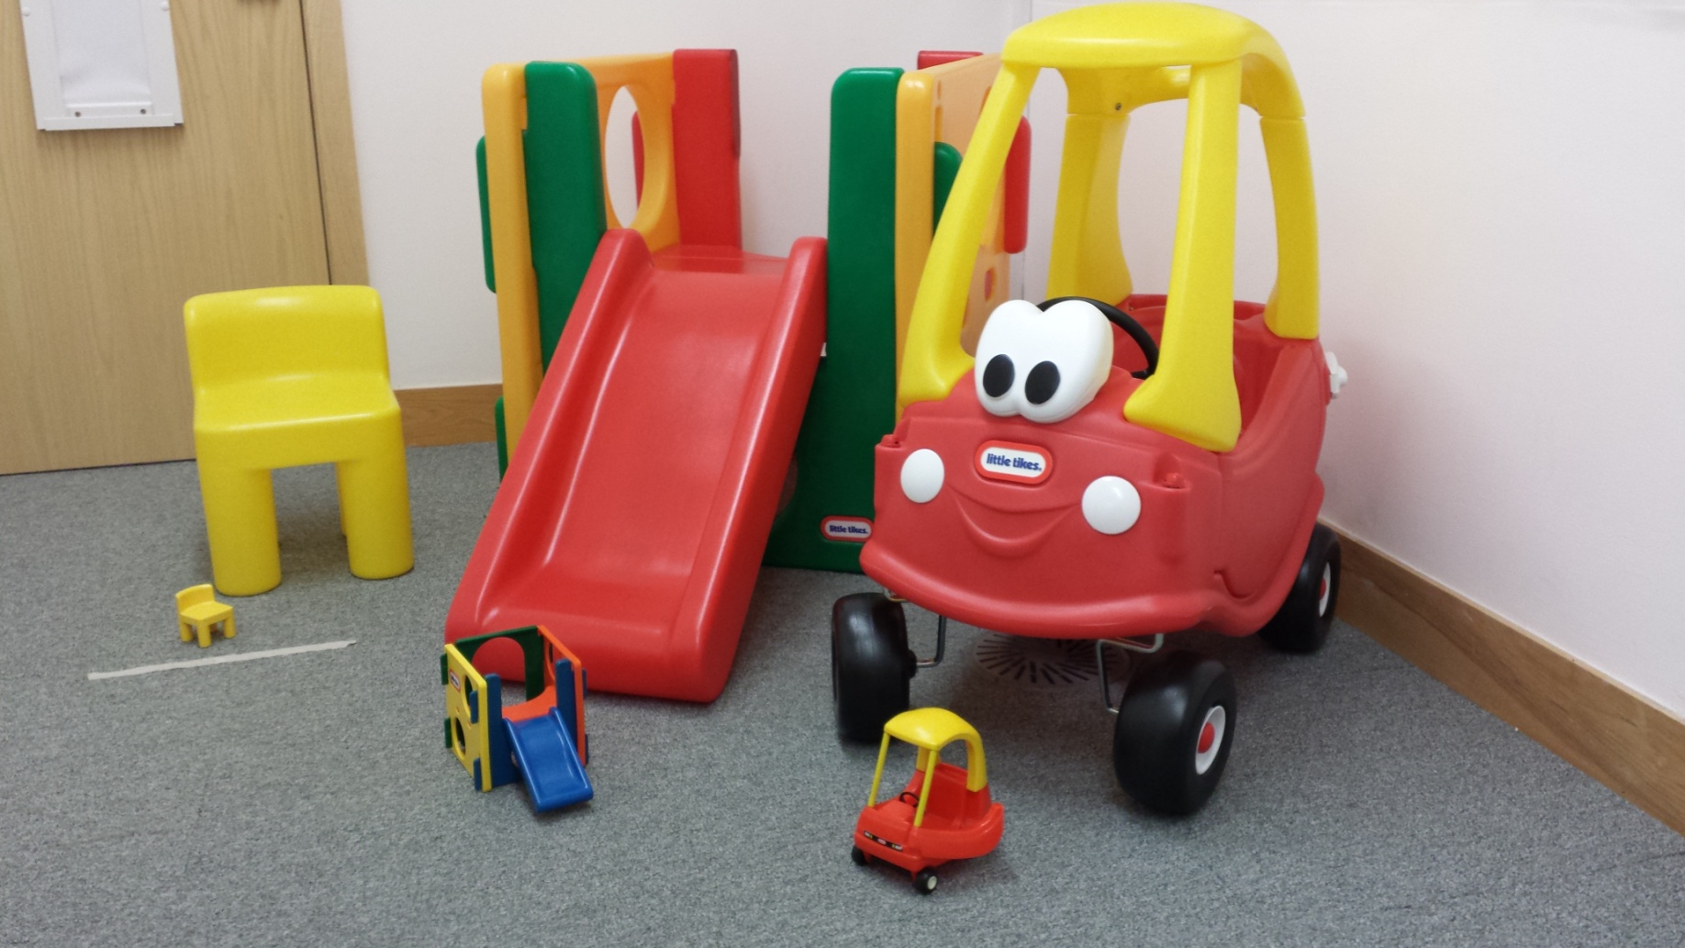

Figure 1
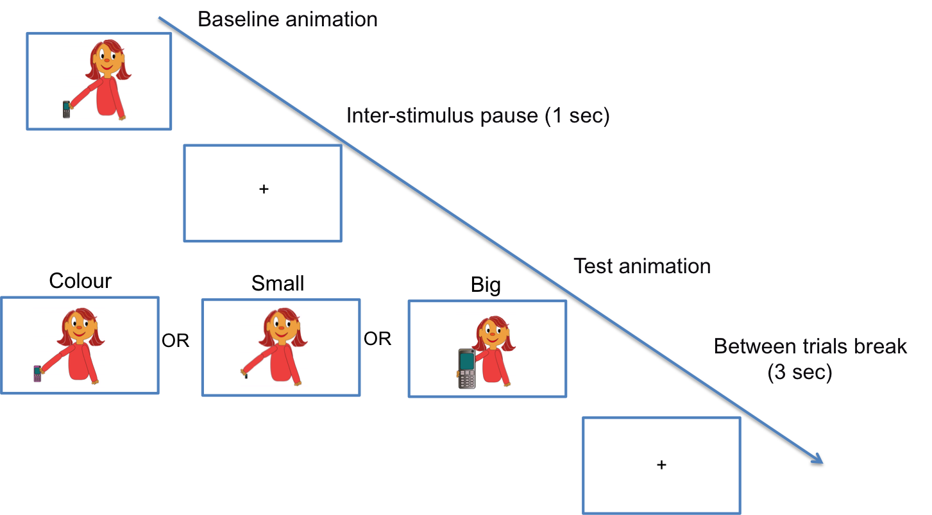

Figure 2

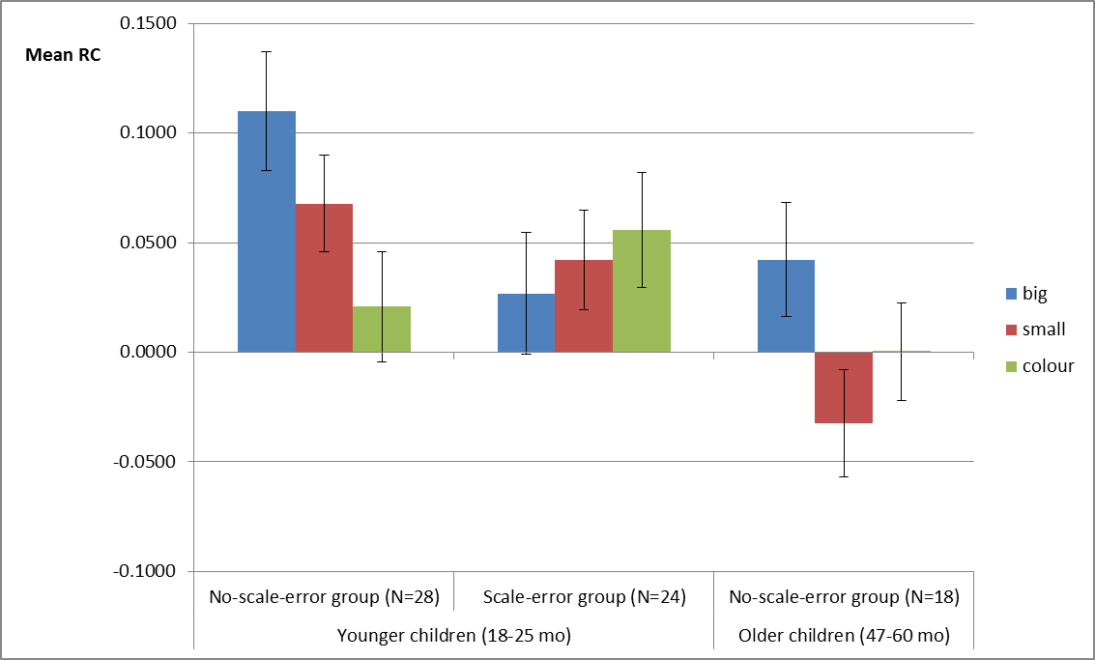

Figure 3

Appendix 1
Table 1
Familiarity of the objects for younger and older children as reported by parents.
Object | Younger children (18 – 25 months) |  | Older children (47 – 60 months)
 | Non-scale errors performers | Scale errors performers
Apron | 0.36 | 0.21 | 1.00
Bandage | 0.07 | 0.08 | 0.97
Bathtub | 1.00 | 0.96 | 0.91
Bicycle | 0.82 | 0.88 | 1.00
Boat | 0.89 | 1.00 | 1.00
Book | 1.00 | 1.00 | 1.00
Bottle | 0.96 | 0.92 | 1.00
Brush | 0.89 | 0.88 | 0.97
Buggy | 0.96 | 0.79 | 0.91
Chair | 0.96 | 1.00 | 1.00
Coat | 0.93 | 0.83 | 1.00
Cup | 0.93 | 0.92 | 1.00
Duster | 0.29 | 0.17 | 0.77
Flute | 0.04 | 0.08 | 0.71
Frying pan | 0.04 | 0.08 | 0.49
Hammock | 0.43 | 0.25 | 0.94
Hand fan | 0.93 | 0.88 | 1.00
Hat | 0.00 | 0.00 | 0.60
Hoover | 1.00 | 1.00 | 1.00
Hose | 0.93 | 0.79 | 1.00
Key | 0.29 | 0.33 | 0.89
Ladder | 0.96 | 0.96 | 1.00
Lipstick | 0.50 | 0.54 | 0.97
Medal | 0.04 | 0.21 | 0.83
Razor | 0.11 | 0.08 | 0.97
Shoe | 0.04 | 0.04 | 0.60
Skateboard | 1.00 | 1.00 | 1.00
Spoon | 0.25 | 0.17 | 0.94
Swing | 0.96 | 0.96 | 1.00
Telephone | 0.89 | 0.79 | 1.00
Toothbrush | 1.00 | 0.96 | 1.00
Vest | 1.00 | 1.00 | 1.00
Wagon | 0.71 | 0.38 | 0.97
Watch | 0.04 | 0.04 | 0.57
Whisk | 0.71 | 0.58 | 0.97

Object familiarity was coded as 0 from the parental questionnaire when the child did not know the object at all (rating ‘0’ in questionnaire) and as 1 in the three other cases (ratings ‘1’, ‘2’ and ‘3’ in questionnaire). Results are similar if the full scale of familiarity ratings is injected in the data.
As expected, older children knew 91.3% of stimuli (SD 7.8%), preventing any meaningful analysis of the effect of familiarity.

