**How teachers learn to use complex new technologies in secondary mathematics classrooms - The notion of the hiccup**

Alison Clark-Wilson

Institute of Education, University of London, UK

*This paper reports the outcomes of a longitudinal doctoral study which sought to illuminate the process through which secondary mathematics teachers learned to use a complex new multi-representational technology, the TI-Nspire handheld and software. The research examined the trajectories of fifteen teachers, with a focus on the pedagogical approaches that privileged the exploration of mathematical variance and invariance. Analysis of the data reveals the importance of the notion of the ‘hiccup’; that is the perturbation experienced by teachers during lessons stimulated by their use of the technology, which illuminates discontinuities within teachers’ knowledge.*

## Keywords: classrooms; handheld technology; hiccup; mathematics; teachers.

**ACKNOWLEDGEMENT**: The data collection carried out during Phase One of the study (and part of the data collection in Phase Two) was funded by Texas Instruments within two evaluation research projects.

## Introduction

Most studies concerning the appropriation of technological tools within mathematics classrooms have been approached from the students’ perspectives and far less is known about teachers’ epistemological developments, i.e. the process through which their mathematical, pedagogical and technical knowledge develops over time as a result of their use of mathematical digital technologies. The opportunity provided by a funded project in which a group of English secondary school teachers were introduced to the TI-Nspire handheld and software environment provided the context for this study. For the teachers, this involved both learning about the affordances of the new technology and then devising teaching activities and approaches that utilised these affordances in ways that had educational legitimacy in their classroom settings. The outcomes of these classroom activities led to the development of ‘instrument utilisation schemes’, which provided the platform from which to observe and evidence teacher learning (Verillon & Rabardel, 1995).

The TI-Nspire handheld and software is described throughout this paper as a ‘multi-representational technological’ tool as it is an environment which incorporates numeric, syntactic, geometric and graphical applications that can be dynamically linked through the definition of variables. These variables can either be defined by the user or captured from existing objects within an application and hence the multi-representational technology (MRT) offered a new condition for organising teachers’ actions.

## THEORETICAL FRAMEWORK

The research was underpinned by Verillon and Rabardel’s theory of instrumented activity, which seeks to explain the process through which humans interact with technological tools (Verillon & Rabardel, 1995). Their ‘triad of instrumented activity’ was adapted for the context of the study, resulting in the diagram shown in Figure 1 below. Consequently, the instrument (in a Vygotskian sense) incorporated the use of the MRT, the subject was considered to be ‘teachers as learners’ and the object was ‘teachers’ learning about the teaching and learning of mathematics through the exploration of mathematical variance and invariance’.

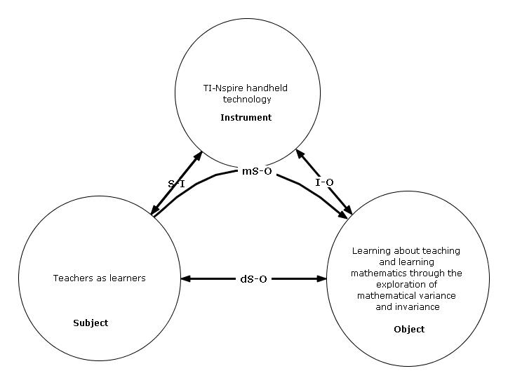

Figure 1 The adapted triad characteristic of Instrumented Activity Situations. The arrows indicate the interactions between Subject and Instrument (S-I), Instrument and Object (I-O) and, in the case of the Subject and the Object, the direct interaction (dS-O) and the mediated interaction (mS-O) (Verillon & Rabardel, 1995).

The research was also influenced by three key themes from the literature, which concerned: the appropriation of technological tools and the role this plays in teachers’ subject and pedagogic knowledge development (Guin & Trouche, 1999; Pierce & Stacey, 2009; Ruthven & Hennessy, 2002; Stacey, 2008); the development of representation systems for mathematics (Kaput, 1986, 1989; Mason, 1996) and the interpretations of knowledge and the processes involved in mathematics teachers’ professional learning (Polanyi, 1966; Rowland, Huckstep, & Thwaites, 2005; Shulman, 1986).

## RESEARCH methodology

As a researcher, I adopted the perspective that reality is socially constructed and I sought to privilege the voices, actions and meanings of the teachers as the main data sources and ensure the reliability of the study through a robust and systematic process of data analysis leading to a valid set of conclusions. (See Clark-Wilson (2008b) for more detail). The research was carried out in two phases, (Jul 2007 – Nov 2008 and Apr – Dec 2009 and, in each of these phases, a group of teachers was selected and a series of methodological tools developed to capture rich evidence of their use of the technology in classrooms to enable the aims of the study to be realised. Hence this was a situated exploratory study in which the unit of analysis was (secondary mathematics teachers + mathematics + activity design) that sought to expand the discourse on teachers’ appropriation of technology tools; that is how they adapt and mould the tool for their own use. The research lens was trained on the trajectory of the teachers’ interpretations of variance and invariance.

### Phase one of the study

During the first phase, fifteen teachers were introduced to the technology and encouraged to develop activities for the classroom, which they then trialled with their students and reported the outcomes of these trials to the study. The teachers reported a total of sixty-six activities and the research data comprised: teacher questionnaires, which included a mandatory detailed lesson evaluation; teachers’ lesson plans, pupil resources and software files; and teachers’ presentations during project meetings. The data analysis of the first phase of the study (using Nvivo8) revealed the trends in the teachers’ interpretations of variance and invariance and the emergence of nine different instrument utilisation schemes (IUS), within their ‘intended’ lesson activities. As these lessons were not observed, it cannot be assumed that they correspond to the students’ actual utilisation schemes.

Table 1 Summary of the instrument utilisation schemes in the lesson activities designed by the teachers (n=66)

| **Instrument utilisation scheme (IUS)** | **Frequency of use**  **(n=66)** |
| --- | --- |
| IUS1: Vary a numeric or syntactic input and use the instrument’s functionality to observe the resulting output in numeric, syntactic, tabular or graphical form. | 37 |
| IUS2: From a given set of static geometric objects, make measurements and tabulate data to explore variance and invariance within the measured data in numeric and tabular forms. | 4 |
| IUS3: Vary the position of an object (by dragging) that has been constructed in accordance with a conventional mathematical constraint and observe the resulting changes. (Use another representational form to add insight to or justify/prove any invariant properties). | 13 |
| IUS4: Vary a numeric input and drag an object within a related mathematical environment and observe the resulting visual output. | 2 |
| IUS5: Vary a numeric or syntactic input and use the instrument’s functionality to observe the resulting output in numeric, syntactic, tabular or graphical form. Use another representational form to add insight/justify/prove any invariant properties. | 8 |
| IUS6: Vary the position of an object that has previously been defined syntactically (by dragging) to satisfy a specified mathematical condition. | 1 |
| IUS7: Construct a graphical and geometric scenario and then vary the position of geometric objects by dragging to satisfy a specified mathematical condition. Input syntactically to observe invariant properties. | 1 |
| IUS8: (Construct a geometric scenario and then) vary the position of objects (by dragging) and automatically capture measured data. Use the numeric, syntactic, graphical and tabular forms to explore, justify (and prove) invariant properties. | 2 |
| IUS9: (Construct a graphical or geometric scenario and then) vary the position of a geometric object by dragging to observe the resulting changes. Save measurements as variables and test conjectures using a syntactic form. | 3 |

There were three outcomes of the first phase of the study: a clearer understanding of the ways that the teachers used the multi-representational environment to emphasise different conceptions of variance and invariance; the identification of the teachers who would become the subjects of the research in its second phase; and the emergence of my interest in the instances in the classroom where the teachers were perturbed (in an epistemological sense) as a result of using the MRT with their students. I use the word epistemological to mean that the teachers underlying knowledge in relation to mathematics, technology and pedagogy was being reviewed and reorganised as a direct result of their classroom experiences with the technology.

### Phase two of the study

The second phase involved the focused case studies of two teachers, Tim and Eleanor, who had demonstrated the desired attributes (technical competency and a diversity of IUS) and had adopted pedagogical approaches that placed the students’ mathematical experiences at the centre of the classroom environment. As this phase of the study aimed to elicit the nature and process of the teachers’ learning through a close observation of them in their classrooms, the research methodology used in phase one was developed further to include audio-recorded lesson observations and interviews.

In addition, the opportunity for the teachers to use TI-Nspire Navigator technology (Texas Instruments, 2009) in their classrooms resulted in additional data such as students’ files, handheld screens and screen capture views being collected, providing an unanticipated additional rich resource for the study.

In all, eight of Tim’s lessons and six of Eleanor’s lessons were observed and, as previously, the data was imported as a synchronised set into Nvivo 8 software, which facilitated the ‘replaying’ of the lesson in the fullest sense. The analysis of each set of lesson data led to the development of a detailed, accurate and complete lesson narrative, by a broad analysis of the lesson that utilised Stacey et al’s ‘pedagogical map’ (Stacey, 2008) and the emergence of the ‘hiccup’ as an organising principle.

## HOW DO TEACHERS LEARN TO USE COMPLEX TECHNOLOGIES? – THE EMERGENCE OF THE ‘HICCUP’

As I began to observe the teachers in their classrooms, my attention was increasingly shifted towards the existence, and opportunity to analyse, what I refer to throughout the study as lesson ‘hiccups’. These were the perturbations experienced by the teachers during the lesson, triggered by the use of the technology that seemed to illuminate discontinuities in their knowledge and offer opportunities for the teachers’ epistemological development within the domain of the study. They were highly observable events as they often caused the teacher to hesitate or pause, before responding in some way. At the time of the study, the teachers were not aware of the concept of the hiccup as I would refer to them as ‘surprises’ or ‘unanticipated moments’.

For example, the Nvivo coding summary for one of Tim’s classroom activities is shown in Figure 1.

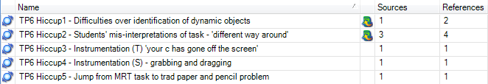

Figure 1 Tim’s coded hiccups for the activity ‘Pythagoras exploration’.

The analysis of all of the lesson data enabled all of the hiccups to be identified and there were sixty-six in total. A constant comparison method, led to the definition of seven categories of ‘trigger’. These are detailed later in the paper. What follows immediately is a detailed description on one particular hiccup and a justification of why its occurrence provided evidence for the teacher’s epistemological development.

### An example of a hiccup and its relationship to Tim’s situated learning

In the lesson activity ‘Pythagoras exploration’, Tim had designed an activity in which his students were dragging the vertices of a geometric construction and it was his intention that the students would conclude that when the triangle was dragged such that it appeared to be right-angled, the areas Tim had defined as *a* and *b* would sum to the area he had defined as *c*.

|  |  |
| --- | --- |
| The initial screen that the students encountered is shown in Figure 2. | Figure 2 The students’ opening view of the task |

What follows is the detailed analysis of one of these hiccups (coded TP6 Hiccup2 from Figure 1), and an articulation of how this event may have contributed towards Tim’s situated learning during and soon after the lesson.

This hiccup was observed during a point in the lesson when Tim was clearly reflecting deeply on the students’ contributions to the shared learning space and ‘thinking on his feet’ with respect to responding to these. It coincided with his observation of an unanticipated student response. The chosen hiccup came about when a student had found a correct situation for the task, that is the two smaller squares’ areas summed to give the area of the larger square, but the situation did not meet Tim’s activity constraint of ***a* + *b* = *c*.**

Tim commented about this in his personal written reflection after the lesson,

One student had created a triangle for which a+b did not equal c, but (I think) a+c=b. This was also right angled. This was an interesting case because it demonstrated that the ‘order’ did not matter... when the sum of the smaller squares equalled that of the larger square, then the triangle became right angled.

|  |  |
| --- | --- |
| Tim revised the TI-Nspire file after the lesson, providing some convincing evidence of his learning as a result of the use of the MRT. Tim gives an insight into his learning through his suggestions as to how he thought that some of these perceived difficulties might be overcome by some amendments to the original file (see Figure 3). | BJT6(tns-T-Task2v2).jpg  Figure 3 Tim’s revised MRT file for the task |

The squares whose areas were previously represented by ‘a’ and ‘b’ have been lightly shaded and the square represented by the area measurement ‘c’ has been darkly shaded. Tim also added an angle measurement for the angle that is opposite the side that was intended to represent the hypotenuse.

Both of these amendments to the original file suggest that Tim wanted to direct the students’ attentions more explicitly to the important representational features. He wanted to enable the students to connect the relevant squares to their area measurements and ‘notice’ more explicitly the condition that when the condition for the areas was met, the angle opposite the hypotenuse would be (close to) a right angle. This seemed to suggest that Tim was still trying to overcome the inherent difficulty when using mathematical software concerning the display of measured and calculated values in the hope that students would achieve an example where the areas were equal and the measured angle showed ninety degrees. This seemed to suggest a conflict with his earlier willingness to try to encourage his students to accept an element of mathematical tolerance when working with technology with respect to the concept of equality.

## Categories of hiccups

The research concluded that the teachers were engaged in substantial situated learning, prompted by their experiences of lesson hiccups. In this sense the hiccups are an epistemological phenomenon as they are the manifestation of a rupture in the fabric of the teacher’s knowledge. The seven categories of hiccups are detailed below alongside a brief exemplification from the research data.

### 1. Aspects of the initial activity design:

Hiccups in this category were attributed to aspects of the teacher’s choice of initial examples, the sequencing of the examples, the methods for identifying and discussing objects displayed on the MRT or unfamiliar pedagogical approaches. The hiccup described previously within Tim’s lesson is an example of this type as the lack of any on-screen labelling made it difficult for the students to interpret the initial instructions for the task.

### 2. Interpreting the mathematical generality under scrutiny:

This category concerned the acts of relating specific cases to the wider generality under observation, the appreciation of the permissible range of responses that satisfy the generality or failing to notice the generality at all. For example, in a lesson designed and taught by Eleanor, the large set in functions that the students were asked to plot within the MRT led to diverse set of screens on which it was difficult for the students to notice the generality that was common to the functions that had all been transformed by a ‘sideways shift’ of ±a.

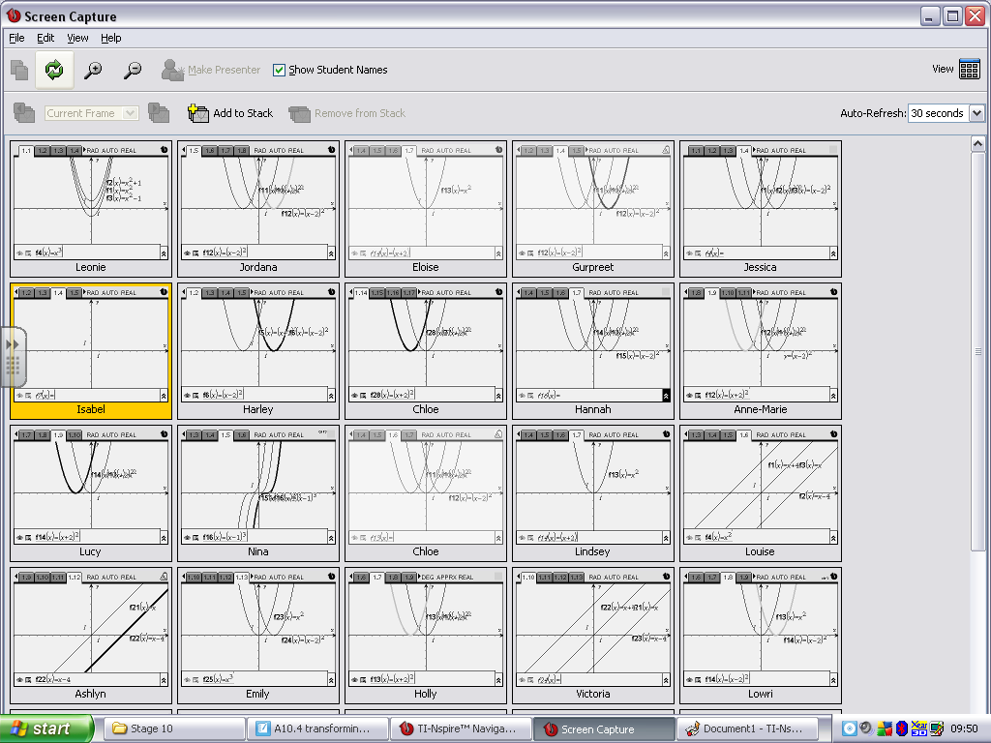

Figure 4 The students’ handheld screens displayed publicly during the plenary.

### 3. Unanticipated student responses as a result of using the MRT:

There were several instances where the response from the student differed from that which the teacher had anticipated in his or her original design, leading to occurrences of hiccups. For example, the students’ prior understanding was below the teacher’s expectation, the students’ interpretations of the activity objectives differed from that of the teachers or the students developed their own instrument utilisation schemes for the activity.

|  |  |
| --- | --- |
| For example, in a lesson created by Eleanor, in which she has asked her students to construct linear functions through the given co-ordinate point (3, 6), one of the students produced the screen in Figure 5. | Figure 5 Emily’s response to the task |

### 4. Perturbations experienced by students as a result of the representational outputs of the MRT:

A number of observed hiccups resulted from the students responses to a particular syntactic or geometric output or their doubt of the ‘authority’ of the syntactic output from the MRT.

|  |  |
| --- | --- |
| An example of this is shown in Figure 6 where Tim was required to make sense of a student’s response to a task in which the student had questioned the output of the MRT. | Figure 6 A student’s screen in which he repeats his entry to the MRT. |

### 5. Instrumentation issues experienced by students when making inputs to the MRT and whilst actively engaging with the MRT:

The hiccups within this category resonate with much of the research concerning students’ uses of complex technologies and they were related to: entering numeric and syntactic data; plotting free coordinate points; grabbing and dragging dynamic objects; organising on-screen objects; navigating between application windows; enquiries about new instrumentation and the accidental deletion of objects.

### 6. Instrumentation issue experienced by one teacher whilst actively engaging with the MRT:

The high level of experience and confidence of the two teachers with the MRT most probably accounts for the low incidence of hiccups relating to their own instrumentation issues. In this case, the teacher ‘forgot’ how to reveal the function table at a key point in one activity.

### 7. Unavoidable technical issues:

The teachers were using prototype classroom network technology which did result in some equipment failures during some lessons. Although these occurrences were definitely classed as hiccups, they were considered to be outside of the domain of the research study.

## CONCLUSIONS

The evidence from the study strongly supports the thesis that teachers were engaged in substantial situated learning, which was prompted by their experiences of lesson hiccups, as they designed and evaluated activities using the MRT. These activity designs privileged explorations of variance and invariance in some way and most also involved multiple mathematical representations. In this sense the hiccup is considered to be an epistemological phenomenon, that is, a rupture in the fabric of the teacher’s knowledge. All of these hiccups provided opportunities for the teachers to at least interrogate, if not develop their knowledge. It is not suggested that all hiccups would lead to a clear learning outcome for the teachers. However, the research evidence from my study is rich with examples of how individual hiccups (and combinations of hiccups) have prompted the teachers to rethink the subtle aspects of their activity designs evidencing them to be learning sites for the teachers. The discussions within the CERME conference working group raised a number of interesting questions such as: how the concept of the hiccup might be incorporated into the design of professional development for teachers? and, if so, whether the theory should be introduced first or whether teachers should need to be allowed to experience them first? Other questions related to how the notion of the hiccup might be incorporated into existing theories about teacher knowledge development and whether the teacher’s experience might be an important factor.

## REFERENCES

Clark-Wilson, A. (2008b). *Teachers researching their own practice: Evidencing student learning using TI-Nspire*. Paper presented at the Day conference of the British Society for the Learning of Mathematics, 28 (2).

Clark-Wilson, A. (in press). A methodological approach to researching teachers’ epistemological development concerning mathematical variance and invariance in a multi-representational technological setting. In A. Clark-Wilson, O. Robutti & N. Sinclair (Eds.), *The Mathematics Teacher in the Digital Era*. Berlin: Springer.

Guin, D., & Trouche, L. (1999). The complex process of converting tools into mathematical instruments: The case of calculators. *International Journal of Computers for Mathematical Learning, 3*(3).

Kaput, J. (1986). Information technology and mathematics: Opening new representational windows. *Journal of Mathematical Behavior, 5*(2).

Kaput, J. (1989). Linking representations in the symbol systems of algebra. In C. Kieran & S. Wagner (Eds.), *Research Issues in the Learning and Teaching of Algebra* (pp. 167-194). Reston, VA: Lawrence Erlbaum/NCTM.

Mason, J. (1996). Expressing generality and roots of algebra. In N. Bednarz, C. Kieran & L. Lee (Eds.), *Approaches to algebra: Perspectives for research and teaching* (pp. 65 - 86). Dordrecht: Kluwer.

Pierce, R., & Stacey, K. (2009). Researching principles of lesson design to realize the pedagogical opportunities of mathematics analysis software. *Teaching Mathematics and its Applications, 28*(4).

Polanyi, M. (1966). *The tacit dimension*. Chicago: The University of Chicago Press.

Rowland, T., Huckstep, P., & Thwaites, A. (2005). Elementary teachers' mathematics subject knowledge: The knowledge quartet and the case of Naomi. *Journal of Mathematics Teacher Education, 8*.

Ruthven, K., & Hennessy, S. (2002). A practitioner model for the use of computer-based tools and resources to support mathematics teaching and learning. *Educational Studies in Mathematics, 49*.

Shulman, L. (1986). Those who understand: Knowledge growth in teaching. *Educational Researcher, 15*(2).

Stacey, K. (2008). *Pedagogical maps for describing teaching with technology*. Paper presented at the Paper presented at Sharing Inspiration Conference.

Verillon, P., & Rabardel, P. (1995). Cognition and artefacts: A contribution to the study of thought in relation to instrumented activity. *European Journal of Psychology of Education, 10*(1).