A methodological approach to researching the development of teachers’ knowledge in a multi-representational technological setting

Alison Clark-Wilson

a.clarkwilson@chi.ac.uk

Institute of Education, University of London, UK

Abstract

This chapter details the methodological approach adopted within a doctoral study that sought to apply and expand Verillon and Rabardel’s (1995) triad of instrumented activity as a means to understand the longitudinal epistemological development of a group of secondary mathematics teachers as they began to integrate a complex new multi-representational technology (Clark-Wilson, 2010a). The research was carried out in two phases. The initial phase involved fifteen teachers who contributed a total of sixty-six technology-mediated classroom activities to the study. The second phase adopted a case study methodology during which the two selected teachers contributed a further fourteen activities. The chapter provides insight into the methodological tools and processes that were developed to support an objective, systematic and robust analysis of a complex set of qualitative classroom data. The subsequent analysis of this data, supported by questionnaires and interviews, led to a number of conclusions relating to the nature of the teachers’ individual technology-mediated learning.

Acknowledgements

The data collection carried out during Phase One of the study (and part of the data collection in Phase Two) was funded by Texas Instruments within two evaluation research projects, which have been published in Clark-Wilson (2008a) and (2009).

Introduction

The research that is reported in this chapter had the broad aim to articulate the nature of secondary mathematics teachers’ epistemological development as they began to use a complex new multi-representational technological tool with students in their classrooms. The chosen technology was new in the sense that it offered linked multiple representations between numeric, syntactic and geometric domains (See Arzarello and Robutti (2010) for a more in-depth description). I defined a teacher’s epistemological development as the trajectory of their growth in mathematical, pedagogic and technological knowledge within the context of the design and teaching of activities that privileged their students’ explorations of variance and invariance. The research was carried out in two phases, July 2007 - Nov 2008 and April 2009 – December 2009, when groups of teachers were selected, and a series of methodological tools developed, to capture rich evidence of the teachers’ uses of the technology in their classrooms to enable the aims of the study to be realised. The first phase of the project was located within a professional development setting, which blended opportunities for the teachers to learn about the affordances of the technology alongside time for the teachers to design activities and give subsequent feedback about the outcomes of their lessons. The second phase of the study was situated within the participating teachers’ mathematics classrooms.

Theoretical background

The theoretical foundations for the study concerned three domains: coming to know new technologies and the role of technology in developing subject and pedagogic knowledge; the concept of variance and invariance in a multi-representational technological setting; and making sense of the process of teacher learning.

The theoretical framework that was developed for the study was rooted in Verillon and Rabardel’s (1995) theory of instrumented activity systems as a model to describe the processes involved in human-instrument interactions. In this framework a distinction between artefact and instrument is introduced in order to distinguish between the object itself (as an independent artefact), and the same object as used by a subject. The object is referred to as an artefact when it is used by a person during an activity. The same object is referred to as an instrument when it has been endowed with specific utilisation schemes that have been introduced by the subject. Consequently, as these schemes of use are introduced by the subject, the relation between the artefact and its uses evolve, giving rise to the process of instrumental genesis. While the artefact is an object that can be considered statically, in the sense that it does not change its features over time, the instrument can be conceived dynamically, in the sense that it can change its features, according to the schemes of use that are activated by the user. Therefore, the same artefact can become different instruments, related to the purpose of the subject’s actions. In their original model, the Subject-Instrument-Object triad assumed that the subject’s primary consideration was to evolve uses of the instrument for some clear purpose, which is to carry out a particular, specified task. This model has been applied to a number of situations within mathematics education research where the lens has been trained on *students* of mathematics who were beginning to use chosen technologies for the purpose of solving mathematical problems (Guin and Trouche, 1999, Artigue, 2001, Ruthven, 2002). However, the context for my own study brought another consideration to the fore. As the subjects within my study were *teachers*, there were two facets to the object for their subsequent use for the technology. It was obviously necessary for them to become familiar with the affordances of the technology but also, a simultaneous consideration for them was whether and how these affordances could be integrated into educationally legitimate classroom activities for mathematics.

Within my study, subjects were ‘teachers as learners’ and the objective for their technology-related activity concerned the processes of designing, teaching and evaluating explorations of mathematical variance and invariance. My research was interested in the teachers’ epistemological development over several years as they were engaged in these processes. By epistemological development, I mean the development of their personal knowledge, which would incorporate mathematical, technological and pedagogic aspects. For my context, the instrument incorporated the mediating artefact, that is, the TI-Nspire handheld and software alongside the emergent utilisation schemes developed individually by each teacher or socially, where collaboration was involved. Hence the study sought to gain deeper insight into the mediating role of the technology. This sense of ‘double instrumentation’ resonates with the findings of Haspekian’s (2005 and chapter XX in this volume) research within the context of a spreadsheet environment in which she concludes that the spreadsheet is one instrument for teacher’s personal mathematical work and *another* instrument for the teacher’s professional didactical work (Haspekian, 2006). This led to the notion of *double instrumental genesis* from the teacher’s perspective.

The mathematical focus for the study concerned activities that privileged the students’ *explorations of variance and invariance*. This is the approach whereby the technology is being used in an exploratory way, with the intention that the students will ‘discover’ some mathematical generalisation(s) by varying some sort of input and observing the output provided by the technology. Essentially, this meant that the teachers were privileging explorations of variant and invariant properties within a chosen mathematical context. This focus was a constraint of the project’s methodology as the teachers favoured the design of tasks that encouraged student autonomy by requiring them to make inputs to the technology and draw conclusions in relation to the resulting outputs.

The multi-representational features of TI-Nspire (Arzarello and Robutti, 2010) prompted a review of key texts and research that had considered both the mediating role of technology in supporting such explorations alongside a review of literature on the nature of a mathematical variable (Bednarz et al., 1996, Moreno-Armella et al., 2008, Sutherland and Mason, 1995, Kaput, 1986, Kaput, 1998, Kieran and Wagner, 1989). This review led me to define mathematical learning as being predominantly concerned with the privileging of students’ opportunities to generalise and specialise as a means to constructing their own mathematical meanings.

Within the context of this study, the teacher’s role was to design and orchestrate classroom activities and approaches, using the various functionality of the multi-representational technology to achieve this. However, as teachers’ individual belief systems (in the usual sense) about mathematical learning (and the role of technology within this) would undoubtedly influence their decisions and actions, the trajectory of teacher development to which I refer also revealed evidence of these preconceptions.

Finally, as the study was concerned with the nature and processes of mathematics teachers’ epistemological development, two areas of related literature were reviewed. The first area concerned definitions and interpretations of mathematics teachers’ personal knowledge, subject knowledge for teaching and pedagogic knowledge (Shulman, 1986, Rowland et al., 2005, Zodik and Zaslavsky, 2008, Polanyi, 1962, 1966). The second area examined constructs concerning the process of teacher learning (Schön, 1984, Thompson, 1992, Mason, 2002, Jaworski, 1994, Ahmed and Williams, 1997). The review of literature referring to the content, nature and process of teacher learning led me to adopt a broad interpretation of knowledge as proposed by Shulman’s *knowledge for teaching*. It also highlighted the complexities of the process of teacher learning and supported the development of methodological tools that would capture the evidence of this learning in line with my desire to describe teachers’ trajectories of epistemological development. I use the word epistemology in a deliberate sense to indicate that I was most concerned with how their knowledge developed over time. This had implications for the methodological approach that was adopted as, although some of these theoretical ideas gave a framework for describing teachers’ knowledge, they did not necessarily lend themselves to the development of a useful set of methodological tools and techniques.

Methodology

An extensive data collection period between July 2007 and November 2009 resulted in the participating teachers contributing eighty *lesson bundles* to the study. During the first phase of the study, a lesson bundle comprised all or some of the following:

* a compulsory lesson evaluation questionnaire - (see Clark-Wilson, 2008b);
* an activity plan in the form of a school lesson planning proforma or a hand-written set of personal notes;
* a lesson structure for use in the classroom (for example a Smart NoteBook or PowerPoint file);
* a software file developed by the teacher for use by the teacher (to introduce the activity or demonstrate an aspect of the activity);
* a software file developed by the teacher for use by the students, which would normally need to be transferred to the students’ handhelds in advance or at the beginning of the lesson;
* an activity or instruction sheet developed by the teacher for students’ use;
* students’ written work resulting from the activity;
* students’ software files captured during and/or at the end of the activity;
* audio or video clips of the activity;
* notes or slides from presentations made by the teachers about the activity.

These lesson bundles resonate with the idea of the teachers’ *documentation system* (See Aldon Page XX this volume) that capture the complete set of resources developed (or made use of) such that teachers can make use of technologies for mathematics within classroom settings (Gueudet and Trouche, 2009).

Summarising lessons

The sets of raw data were imported to the qualitative data analysis software package, Nvivo8 (QSR International, 2008), where they were subsequently scrutinised and coded to elicit three elements: a broad description of the lesson; an inference concerning the teacher’s interpretation of variance and invariance within the designed activity; and the suggested instrument utilisation scheme that the students were expected to use.

An example of this for a lesson ‘Prime factorisation’, submitted by one of the teachers early at the beginning of the first phase of the study is shown in Table 1.

| Lesson code, title, activity description and age of students. | Relevant screenshots and implied evidence of teacher learning | Interpretation of variance and invariance | Implied Instrument Utilisation Scheme (with respect to the students) |
| --- | --- | --- | --- |
| Lesson code: SJK1  12-13 years  Prime factorisation  Students created a new file and used the *factor()* command within the Calculator application to explore different inputs and outputs to encourage generalisation. Students recorded their work on a worksheet prepared by the teacher. | *Definitely the worksheet idea as this enables pupils to work at their own pace. I needed the worksheet for me as well as for them. I was able to refer to the sheet and that helped my confidence. The sheet also allowed pupils to continue with the work whilst I went round to help students with a problem. BUT - the sheet could have been more structured i.e. not jump around haphazardly but be more systematic. Factor (1), Factor (2), Factor (3), etc...*  *I was nervous to use the device even though I am a very experienced teacher of maths. I needed the worksheet as support. Having done one lesson I would now be confident to try again. The worksheet could have been more interesting. Pupils seemed to enjoy the lesson.* [SJK1(Quest2)] | The teacher had constructed a worksheet (with support from her mentor) that did lead students through a set of suggested input numbers that progressed in their level of complexity.  Variance = changing the input number (a manual text input to calculator application using factor() syntax)  Invariance = all prime numbers had only two factors (by definition). | IUS1: *Vary a numeric or syntactic input and use the instrument’s functionality to observe the resulting output in numeric, syntactic, tabular or graphical form.*  Private utilisation scheme:  Students worked with a numerical input and output within one application responding to the same set of numbers, as provided by the teacher.  No use of multiple representations using the technology.  Social utilisation scheme (with respect to the students):  Whilst JK developed this lesson in close collaboration with TP, who taught a similar lesson [STP1]. The lessons had very different utilisation schemes. JK provided a structured worksheet for the students that contained a variety of questions that did not appear to follow any conceptual progression, although the factorised forms became increasingly complex. |

Table 1 The summary data for the lesson ‘Prime factorisation’

The subsequent cross-case analysis of these individual lesson data led to the development of nine ‘instrument utilisation schemes’, which sought to generalise the flow of an activity in relation to the intended interactions by the student as they used the technology, using a constant comparison method. The resulting instrument utilisation schemes considered the broad representational input or output as being either numeric, syntactic or graphic. For example, the lesson ‘Prime factorisation’ described in Table 1, would lead to the instrument utilisation scheme in Figure 1 below.

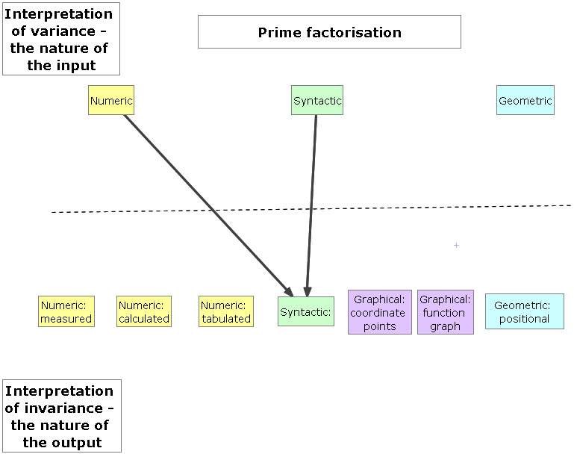

Figure 1 The Instrument Utilisation Scheme (IUS1) for the lesson 'Prime Factorisation’

In this activity the input was a combination of a syntactic entry (i.e. factor(n)) and a numeric entry (i.e. n) and the output was syntactic in that the representation 22•5 implies a mathematical syntax that is adopted by the technology.

A numeric input might involve entering numeric values into a spreadsheet or changing an input for a numeric variable. A syntactic input is considered to encompass both the syntactic forms of conventional mathematical notation in addition to the syntax required when using specific functionalities of the technology such as the need to use the specific syntax of the built-in ‘Factor’ command. In this respect, the word syntactic is not being interpreted in a wholly linguistic sense but it does embrace Shulman’s sense of ‘syntactic structures’ (Shulman, 1986). As I began to classify the nature of the ‘outputs’ representational system I initially used the same three categories. However, it quickly became apparent that the analysis became more informative if some sub-divisions of the initial three categories were made. Hence the ‘numeric’ category was subdivided into ‘measured’, ‘calculated’ and ‘tabulated’; the ‘geometric’ category was subdivided into ‘graphical (data points)’, graphical (function graphs) and geometric (positional).

Instrument utilisation scheme type one (IUS1) was the simplest of all of the schemes, and it was also the most frequently used scheme by the teachers in the first phase of the study, with over half of the reported lessons being classified as IUS1.

By contrast, as the project progressed, there were three teachers who developed a diverse set of IUS. As the nature of the activities that the teachers created were all exploratory, they all had an initial input and output phase. However, a more diverse set of IUSs developed as teachers began to design tasks that elaborated on this initial phase by requiring different forms of interaction with the technology such as dragging or the inclusion of an additional representational form. One such example was the lesson activity developed by Eleanor, ‘Perpendicular functions’ which is described in detail in Table 2.

| Lesson code, title and activity description | Relevant screenshots and implied evidence of teacher learning | Interpretation of variance and invariance | Implied IUS |
| --- | --- | --- | --- |
| CEL5  Perpendicular functions  Students created a new file and used the Graphs and Geometry application to define a linear function and draw a freehand ‘perpendicular line’. They used the angle measure facility to check their accuracy, dragged the geometric line until it was perpendicular and then generated parallel functions to this geometric line. They used a Notes page to record their findings. Students saved their work. | *If the perpendicular value did not appear to fit the rule we checked angles were 90o.* [CEL5(Quest2)]  Q. What changes would you make?  *To reinforce looking for connections between perpendicular gradients as written for the value of m. To encourage more formal methods of recording results. To introduce a spreadsheet page to establish that the product of perpendicular gradients is -1. Slope can be measured. Ensuring all hand-held are in degree mode and all with a float of 3.*  *Students were very intuitive with using the new technology. Would need to reinforce girls to do more mathematical thinking and reflection and to view the technology as a means to do this.* [CEL5(Quest2)] | Variance = initial definition (positioning?) of linear function, ‘by eye’ positioning of geometric line, value of measured angle, the gradients of the two lines (by measurement or by definition).  Invariance = the condition that, when the lines were perpendicular, the products of their gradients would equal -1. | IUS7: *Construct a graphical and geometric scenario and then vary the position of geometric objects by dragging to satisfy a specified mathematical condition. Input functions syntactically to observe invariant properties.*  New possibilities for the action: This was a very innovative use of the technology – it combined defining functions with dragging and measuring angle. EL also suggested develops that would integrate the Spreadsheet page as a means for collating results and checking conjectures.  Private utilisation scheme:  *To draw a simple linear function on a graphs page. To construct a line that crosses this at 90°o. To measure this angle and draw a selection of parallel lines to this drawn line. To record findings.* [CEL5(Quest2)]  *Results were recorded on a notes page and we brought together the many concepts related to gradients, parallelness, perpendicular and y=mx+c.* [CEL5(Quest2)]  Social utilisation scheme:  This idea was ‘mis-remembered’ by the teacher from a lesson developed by another teacher and reported at the third project meeting [PSH3]. |

Table 2 The summary data for the lesson ‘Perpendicular functions’ (Students aged 14-15 years)

The instrument utilisation scheme for this lesson (IUS7) is shown in Figure 3.

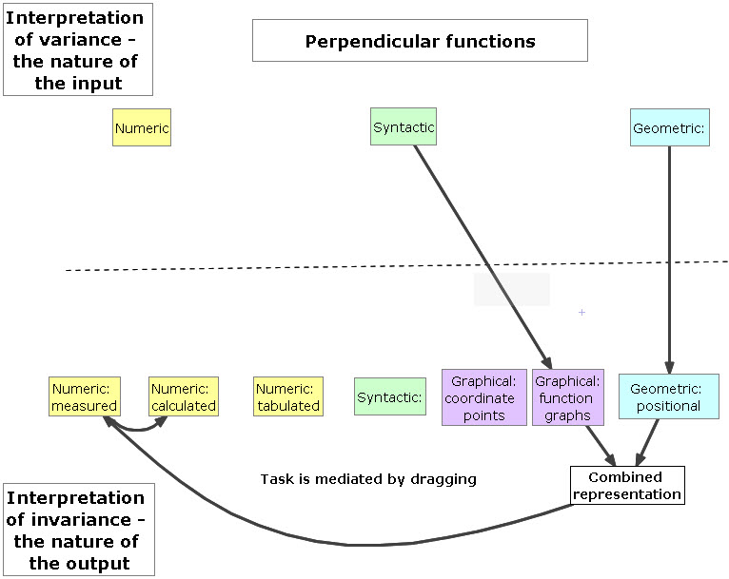

Figure 2 The instrument utilisation scheme (IUS7) for the lesson 'Perpendicular functions’.

The second phase of the study still required the teachers to design, teach and evaluate lesson activities using the technology and, additionally, it involved lesson observations, which were all audio-recorded (with key sequences also video-recorded). The two case study teachers (Eleanor and Tim) were also interviewed before and after the classroom observations. This more substantive data was initially used to write a detailed description of the lesson (8 -10 pages), interspersed with mediating screen shots from the teacher’s and students’ files. This process was greatly supported through the use of the handheld classroom network system TI-Navigator, which facilitated the real-time data collection process without interrupting the flow of the lessons. Following this, I used elements of Pierce and Stacey’s (2008) pedagogical map as a tool to support the writing of a summary of each lesson from the three perspectives they describe as ‘layers of pedagogical opportunities’, namely the task layer, the classroom layer and the subject layer. This led to a detailed set of interpretations of the teachers’ actions within the individual lessons alongside a map of their enacted instrument utilisation schemes as observed during the second phase of the study.

Hence, over time, evidence of the individual teacher’s development began to emerge. The development of each teacher’s instrument utilisation schemes was made visible by overlaying the individual lesson analyses from the Phase One and the Phase Two of the study (Figures 3 and 4).

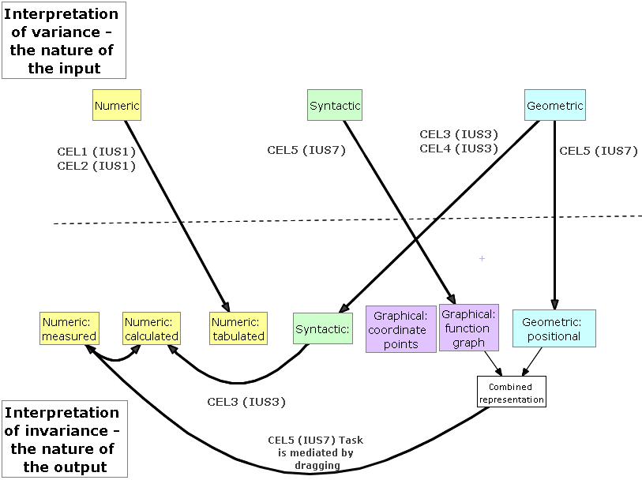

Figure 3 The summary of Eleanor’s Instrument Utilisation Schemes produced from the analysis of her Phase One lesson data (5 lessons, coded CEL1 to CEL5)[1].

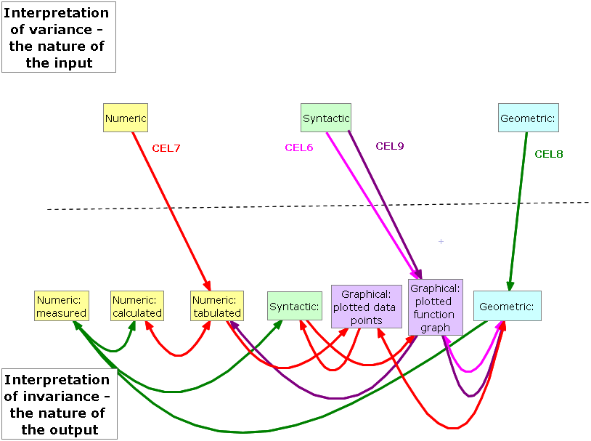

Figure 4 The summary of Eleanor’s Instrument Utilisation Schemes produced from the analysis of her Phase Two lesson data. (4 further lessons, coded CEL6 to CEL9)

It was immediately apparent that Eleanor’s activities incorporated a greater diversity of representations and each activity had its own sequential flow. This was sufficient evidence to conclude *that* Eleanor’s practice had developed but it gave little indication of *how* this development had evolved.

Whilst I was writing the detailed narratives of the observed lessons, I became aware of the incidents within the lessons where the teachers experienced perturbations, triggered by the use of the technology, which seemed to illuminate discontinuities in their knowledge. I defined these as the lesson ‘hiccups’ and I viewed these hiccups as opportunities for the teachers’ epistemological development within the domain of the study. They were highly observable events as they often caused the teacher to hesitate or pause, before responding in some way. Occasionally the teachers looked across to me in the classroom in surprise and, particularly in the case of hiccups relating to what they considered to be unhelpful technological outputs, they sometimes expressed their dissatisfaction verbally. Consequently, I also started to code each activity for hiccups within NVivo.

Identifying, coding and categorising hiccups

In order to make sense of what follows, it is necessary to include a detailed description of a lesson activity. For this purpose I have selected an early activity that was designed and taught by Eleanor during the second phase of the study, which I called *Transformations of functions*. This activity took place during a single one hour lesson with a group of 29 higher achieving girls aged 14-15 years working from the English and Welsh General Certificate of Secondary Education (GCSE) higher tier examination syllabus. Eleanor’s lesson objective was for students to develop ‘An understanding of standard transformations of graphs’ and she expanded on this by saying ‘I wanted the students to explore the effects of different transformations of linear and quadratic functions to enable them to make generalisations for themselves’. In the lesson the students were given a worksheet devised by Eleanor that included six sets of linear, quadratic and cubic functions laid out as three pairs. Each pair was intended to encourage students to compare particular transformations, for example the first set compared the effects of y =f(x)±a with y=f(x±a). There were thirty-nine different functions in total and the activity sheet did not label the sets of functions in any way (Figure 5).

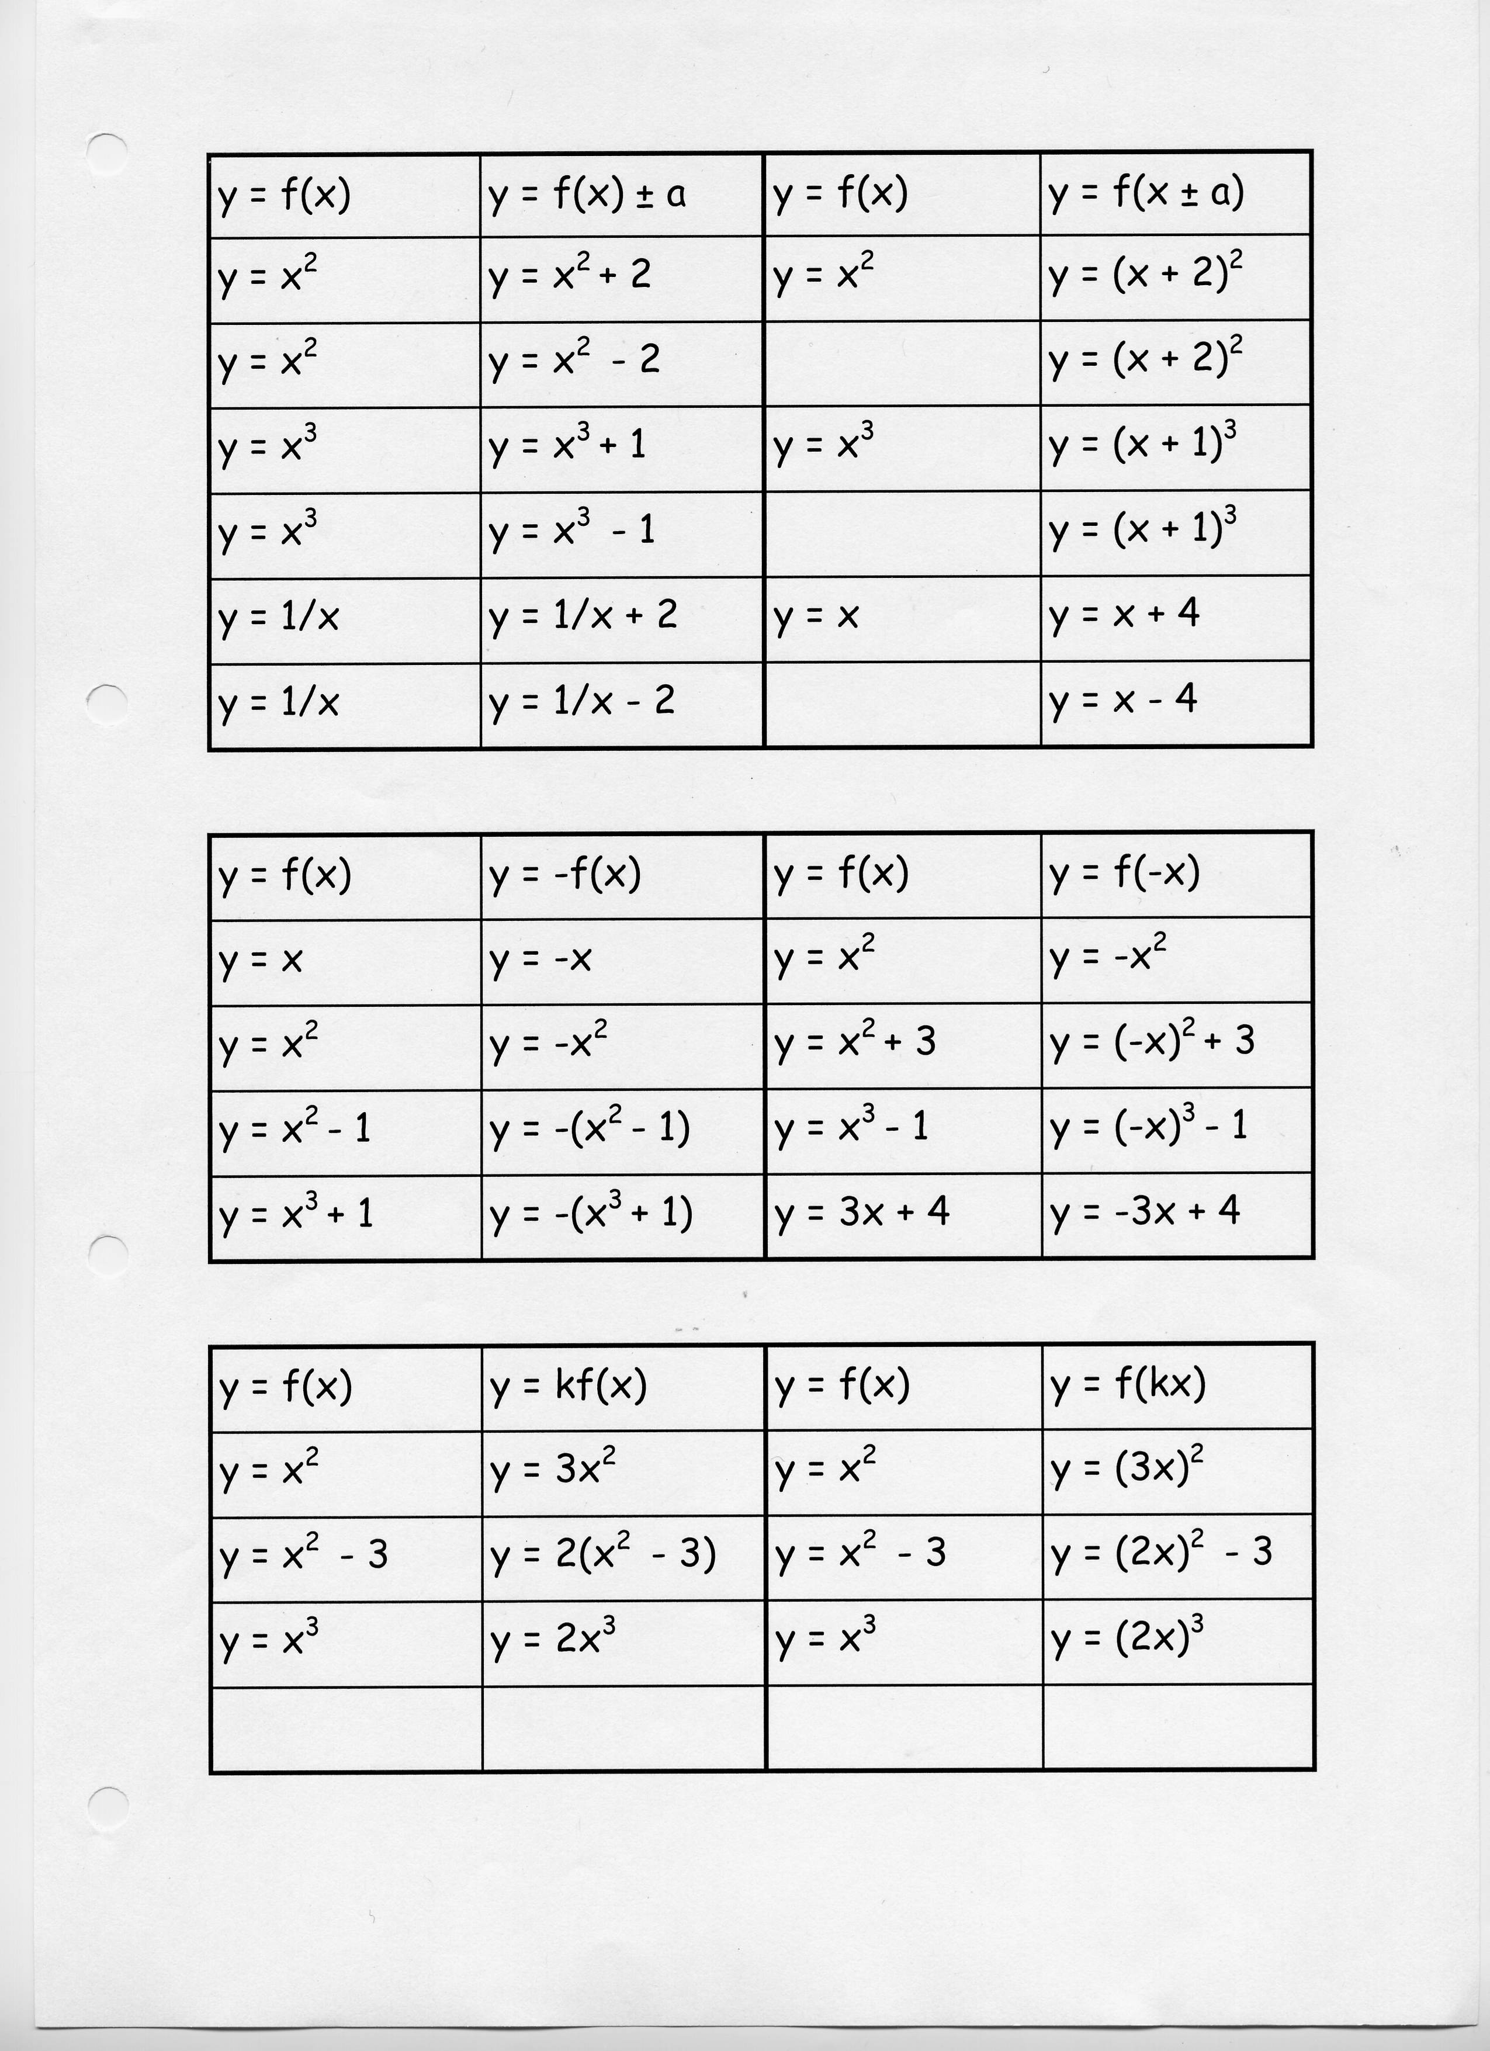

Figure 5 The student task sheet for the activity ‘Transforming functions’

The students were asked to enter the functions syntactically into a Graphing application on their handhelds and to describe the transformations they observed within each set of functions. Eleanor questioned the students about different types of transformations (reflection, translation, rotation and enlargement) and encouraged them to use these words when describing their observations. They were not instructed as to how they should communicate their observations, however, it seemed to be an established classroom practice that they would discuss their outcomes with their neighbours. The Smart Notebook file that Eleanor developed to present the activity to the students included the suggestion that the students should ‘use 2 graphs per page’. A typical student’s response to the first stage of the activity is shown in Figure 6.



Figure 6 A student’s TI-Nspire screen in response to the task ‘Transformations of functions’

During the lesson Eleanor moved around the classroom and responded to questions initiated by the students. These were mainly related to instrumentation issues concerning graphing the functions such as, ‘where is the squared key?’ and ‘how do I insert a new page?’. Ten minutes prior to the end of the lesson, Eleanor instigated one episode of whole class discourse in which she asked the students to open ‘your page where you’ve explored this set’ whilst gesturing to the set of functions shown in Figure 7.

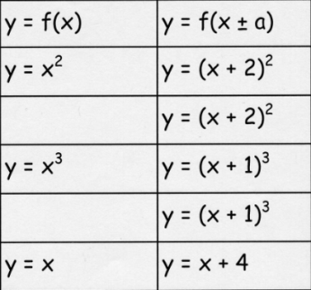

Figure 7 Function set selected for whole class display

The resulting screen capture view (see Figure 8) was on public display in the classroom. Eleanor attempted to use Mason’s idea of ‘funnelling’ (Mason, 2010) in order to elicit from the students the key generalisation for this transformation, i.e. that it resulted in a ‘sideways shift’ of ±a. No other mathematical representations were used during this discussion to justify or explore why this was true.

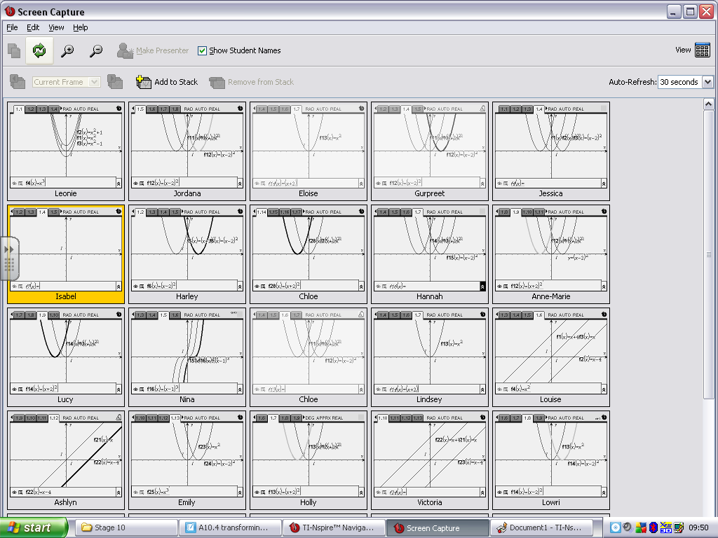

Figure 8 The students’ handheld screens on public display during the class plenary.

Hiccups identified from the lesson data:

During this lesson a total of nine hiccups were observed and they were grouped into the six broad categories as shown in Figure 9.

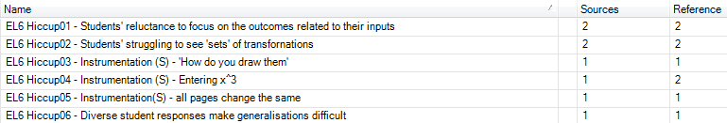

Figure 9 The observed hiccups and their raw codes for the activity ‘Transformations of functions’ as captured within Nvivo8.

The omission of any labelling of the sets of functions as they were laid out on the worksheet (or related teacher explanation) seemed to trigger the following hiccups during the lesson:

* Difficulties experienced by the students in making global sense of the activity and noticing the invariant properties as Eleanor had intended through her activity design.
* Whilst the students were competent with entering the functions into the technology, they did this in different combinations on different pages.
* The large number of different functions that the students were being asked to plot focused the students’ activity on entering as many of them as they could, rather than looking closely at any individual set and discussing or making written notes in relation to the outcomes. Some students had worked very diligently to input all thirty-nine functions into the technology, but had failed to appreciate the ‘sets’ as Eleanor had envisaged.

As a consequence, Eleanor experienced difficulties in identifying any specific generalities on which to focus the whole-class discourse in the plenary session that she convened as the lesson came to a close.

There were of course many other types of hiccups that occurred during lessons other than those prompted by the technology. These concerned general classroom management issues, for example, resulting from students’ off-task behaviour. However, these were outside of the domain of the study.

Evidence of situated learning

In response to the identified hiccups, there was evidence for the teachers’ *situated learning* (as defined by Lave and Wenger, 1991) in the form of the list of seven actions taken by Eleanor during the lesson, which are summarised in Figure 10.

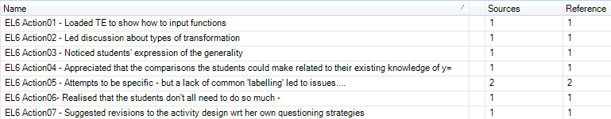

Figure 10 Evidence of the teacher’s actions in response to the hiccups[2].

Although the actions described above were observed during or shortly after the lessons, it was only through our discussions in the subsequent interview that the evidence for the situated learning was clarified.

Eleanor was confident in her responses to the students’ instrumentation difficulties, giving quick tips such as ‘control escape to undo’ and ‘press escape’ and loading the teacher edition software to demonstrate how to input functions. However, the hiccups experienced by Eleanor in this lesson led her to reflect on aspects that she felt she would change, which she articulated during our post-lesson discussion. Reflecting on her activity design, Eleanor commented,

I did not need all of the students to work through many similar problems - it was actually much more memorable to look at screens that appeared different, but, because of an underlying mathematical concept had something similar about them. This meant that I could have let the students choose their own functions to transform in particular ways - something that I will try next time. [Interview transcript]

Eleanor and I agreed that the underlying approach for the lesson was sound. However we discussed a redesigned format for the lesson, which responded to Eleanor’s comment that she could allow the students to explore their own functions. We also incorporated an element of the lesson that I had felt was a constituent part in developing the students’ understanding of the outcomes of each of the transformations. To exemplify this, when the function y=f(x) is compared with y=f(x±a), the visible horizontal shift in the graph is linked with the apparent shift in the corresponding values of x within the table of values for the functions when viewed side-by-side. This is shown for the function y=x2 and y=(x+2)2 in Figure 11.

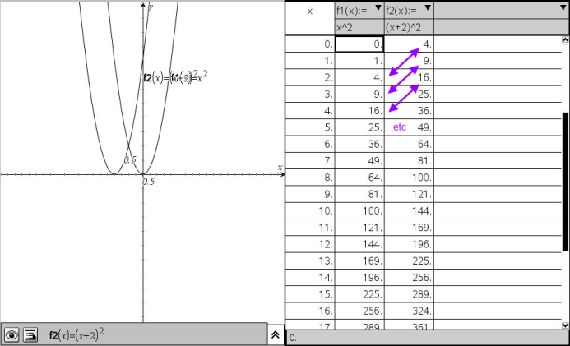

Figure 11 Using the multi-representational technology to explore the function table

In our discussion, when I showed this to Eleanor, she commented that she had never thought about this connection before, partly because she had learned the various transformations herself by rote. As she considered how she would approach this topic next time, Eleanor suggested that she might ask pairs of students to focus on particular transformation types with a view to them being able to summarise and justify the outcomes of their explorations to other members of the class. Eleanor’s epistemological development concerned: her reconceptualization of the nature of the variant and invariant properties within her chosen example space; the use of the technology to represent an appropriate set of functions; and the way in which she could coordinate the whole-class discourse to support the students to notice the chosen generality.

Global categories of hiccups

By repeating the process described previously for each of the lessons observed during the second phase, the cross-case analysis, supported by the functionality within Nvivo8, led to a conclusion that all of the hiccups could be attributed to one of the following seven considerations:

|  |  |
| --- | --- |
| **Hiccup type** | **Exemplification** |
| 1. Aspects of the initial activity design: | Choice of initial examples.  Sequencing of examples.  Identifying and discussing objects displayed by the technology.  Unfamiliar pedagogical approach for the students. |
| 2. Interpreting the mathematical generality under scrutiny: | Relating specific cases to the wider generality.  Appreciating the permissible range of responses that satisfy the generality.  The students fail to notice the generality. |
| 3. Unanticipated student responses as a result of using the technology: | The students’ prior understanding is above or below the teacher’s expectation.  The students’ interpretations of the activity’s objectives differ from the teachers.  The students develop their own instrument utilisation schemes for the activity that differ from the teacher’s planned scheme . |
| 4. Perturbations experienced by students as a result of the representational outputs of the technology: | Resulting from a syntactic output.  Resulting from a geometric output.  Doubting the ‘authority’ of the syntactic output. |
| 5. Instrumentation issues experienced by students when making inputs to the technology and whilst actively engaging with it: | Entering numeric and syntactic data.  Plotting free coordinate points.  Grabbing and dragging dynamic objects.  Organising on-screen objects.  Navigating between application windows.  Enquiring about a new instrumentation.  Deleting objects accidentally. |
| 6. Instrumentation issue experienced by one teacher whilst actively engaging with the technology: | Displaying the function table. |
| 7. Unavoidable technical issues:  *The teachers were using prototype classroom network technology that did result in some equipment failures during some lessons.* | Transferring files to students’ handhelds.  Displaying teacher’s software or handheld screen to the class. |

Table 2 The emergent types of hiccups experienced by secondary mathematics teachers learning to use a multi-representational technology.

This set of classifications has implications for the ways in which we consider both the formal and informal support for teachers as they begin to use multi-representational technology in the classroom. For example, the emphasis within most professional development support and training, when introducing new mathematical technologies to teachers, concern the technical steps to achieve the desired functionality or ‘key pressing’ with a view to avoiding the occurrence of students’ instrumentation issues (Hiccup type 7). However, often far less time is spent considering the mathematical and pedagogical implications of the activities that teachers design and the implications of their design decisions on the possible student outcomes.

The implications for these findings concern the nature of in-class support for teachers in addition to the global design of professional development initiatives concerning new technologies.

Conclusion

In conclusion, the study provided deep insight into teachers’ technology-mediated epistemological development over a twenty-four month period as they began to integrate a complex new technology within their classroom practices. Their mathematical, pedagogical and technical knowledge developed through a multifaceted journey, which was centralised on their classroom-based experiences and the professional exchanges that we had before and after their lessons. The longitudinal nature of the research enabled the fragments of this epistemological development to be pieced together to show how their actions changed over time as they re-encountered *known hiccups* but had developed appropriate *response repertoires*.

Moreover, the adaptation of Verillon and Rabardel’s framework provided a useful construct for the research as it focused the research lens onto teachers’ classroom practices and demanded a robust set of methodological tools to evidence the different interactions. However, the key purpose of this chapter was to provide insight into one researcher’s approach to the study of teachers’ epistemological development through a detailed description of the methodology that led to the conclusion that it was the *contingent moments* or *hiccups* that the teachers experienced when integrating the multi-representational technology into their classroom practices that provided both rich contexts for their situated learning and fruitful foci for professional discourse.

References:

AHMED, A. & WILLIAMS, H. 1997. Numeracy project: a catalyst for teacher development and teachers researching. *Teacher Development*, 1, pp. 357-84.

ARZARELLO, F. & ROBUTTI, O. 2010. Multimodality in multi-representational environments. *ZDM – The International Journal on Mathematics Education,* 42**,** pp. 715-731.

ARTIGUE, M. 2001. *Learning mathematics in a CAS environment: The genesis of a reflection about instrumentation and the dialectics between technical and conceptual work*. Computer Algebra in Mathematics Education Symposium. Utrecht University, Netherlands.

BEDNARZ, N., KIERAN, C. & LEE, L. (eds.) 1996. *Approaches to algebra: Perspectives for research and teaching*, Dordrecht: Kluwer.

CLARK-WILSON, A. 2008a. *Research Report*. *Evaluating TI-Nspire in secondary mathematics classrooms.* Chichester, UK: University of Chichester.

CLARK-WILSON, A. 2008b. *Teachers researching their own practice: Evidencing student learning using TI-Nspire*. Day conference of the British Society for the Learning of Mathematics, 28 (2). University of Southampton.

CLARK-WILSON, Alison. 2009. *Research Report*. *Connecting mathematics in the connected classroom*: TI-Nspire Navigator. Chichester, UK: University of Chichester.

CLARK-WILSON, A. 2010a. *How does a multi-representational mathematical ICT tool mediate teachers’ mathematical and pedagogical knowledge concerning variance and invariance?* PhD thesis, Institute of Education, University of London.

CLARK-WILSON, A. 2010b. *Connecting mathematics in a connected classroom: Teachers emergent practices within a collaborative learning environment*. British Congress on Mathematics Education, BSRLM Proceedings 30 (1). University of Manchester.

CLARK-WILSON, A. submitted. Integrating multi-representational software into mathematics teaching – trajectories of teachers’ practices. *International Journal of Science and Mathematics Education*.

GUEUDET, G., & TROUCHE. (2009). Towards new documentation systems for mathematics teachers? *Educational Studies in Mathematics*, 71(3), pp. 199-218.

GUIN, D. & TROUCHE, L. 1999. The complex process of converting tools into mathematical instruments: The case of calculators. *International Journal of Computers for Mathematical Learning*, 3, pp. 195-227.

HASPEKIAN, M. 2005. *Intégration d’outils informatiques dans l’enseignement des mathématiques, étude du cas des tableurs*. PhD, Doctoral thesis, University Paris 7.

HASPEKIAN, M. 2006. *Evolution des usages du tableur*. Rapport intermédiaire de l'ACI-EF Genèses d'usages professionnels des technologies chez les enseignants [Online]. Available: <http://gupten.free.fr/ftp/GUPTEn-RapportIntermediaire.pdf>.

JAWORSKI, B. 1994. *Investigating mathematics teaching*. London: Falmer.

KAPUT, J. 1986. Information technology and mathematics: Opening new representational windows. *Journal of Mathematical Behavior*, 5, pp. 187 - 207.

KAPUT, J. 1998. Transforming algebra from an engine of inequity to an engine of mathematical power by 'algebrafying' the K-12 curriculum. In: NATIONAL COUNCIL OF TEACHERS OF MATHEMATICS & MATHEMATICAL SCIENCES EDUCATION BOARD (eds.) *Proceedings of a national symposium*. Washington, DC: National Research Council, National Academy Press.

KIERAN, C. & WAGNER, S. (eds.) 1989. *Research Issues in the Learning and Teaching of Algebra*, Reston, VA: Lawrence Erlbaum/NCTM.

LAVE, J. & WENGER, E. 1991. *Situated learning: Legitimate peripheral participation*, New York, Cambridge University Press.

MASON, J. 2002. *Researching your own practice: The discipline of noticing*, London, Routledge-Falmer.

MASON, J., GRAHAM, A. & JOHNSON-WILDER, S. (eds.) 2005. *Developing thinking in algebra*, London: Open University Press.

MASON, J. & JOHNSTON-WILDER, S. (eds.) 2005. *Developing thinking in geometry*, London: Open University Press.

MASON, J. 2010. Asking mathematical questions mathematically. *International Journal of Mathematical Education in Science & Technology,* 31**,** 97-111.

MORENO-ARMELLA, L., HEGEDUS, S. J. & KAPUT, J. J. 2008. From static to dynamic mathematics: historical and representational perspectives. *Educational Studies in Mathematics*, 68, p. 99-111.

PIERCE, R., and SATCEY, K. (2008). Using pedagogical maps to show the opportunities afforded by CAS for improving the teaching of mathematics. *Australian Senior Mathematics Journal*, 22(1), pp. 6-12.

PIERCE, R. & STACEY, K. 2009. Researching principles of lesson design to realize the pedagogical opportunities of mathematics analysis software. *Teaching Mathematics and its Applications*, 28, pp. 228-233.

POLANYI, M. 1962. *Personal knowledge: Towards a post-critical philosophy*, Chicago, The University of Chicago Press.

POLANYI, M. 1966. *The tacit dimension*, Chicago, The Universty of Chicago Press.

QSR INTERNATIONAL 2008. Nvivo8. Melbourne: QSR International.

ROWLAND, T., HUCKSTEP, P. & THWAITES, A. 2005. Elementary teachers' mathematics subject knowledge: The knowledge quartet and the case of Naomi. *Journal of Mathematics Teacher Education*, 8, pp. 255-281.

RUTHVEN, K. 1999. Reconstructing professional judgement in mathematics education: From good practice to warranted practice. In: HOYLES, C. (ed.) *Rethinking the mathematics curriculum*. London: Falmer Press.

RUTHVEN, K. 2002. Instrumenting mathematical activity: Reflections on key studies of the educational use of computer algebra systems. *International Journal of Computers for Mathematical Learning*, 7.

SCHÖN, D. 1984. *The Reflective Practitioner: How professionals think in action*, New York, Basic Books.

SCHÖN, D. 1987. *Educating the reflective practitioner*, London, Jossey-Bass.

SHULMAN, L. 1986. Those Who Understand: Knowledge Growth in Teaching. *Educational Researcher*, 15, pp. 4-14.

STACEY, K. 2008. *Pedagogical Maps for Describing Teaching with Technology*. Paper presented at Sharing Inspiration Conference. Berlin 16-18 May 2008.

SUTHERLAND, R. & MASON, J. 1995. *Exploiting Mental Imagery with Computers in Mathematics Education*, Berlin, Springer-Verlag.

THOMPSON, A. 1992. Teachers’ beliefs and conceptions; a synthesis of the research. In: GROUWS, D. (ed.) *Handbook of research on mathematics teaching and learning*. New York: Macmillan.

VERILLON, P. & RABARDEL, P. 1995. Cognition and Artefacts: A contribution to the study of thought in relation to instrumented activity. *European Journal of Psychology of Education*, 10, 77-102.

WATSON, A. & MASON, J. 1998. *Questions and Prompts for Mathematical Thinking*, Derby, Association of Teachers of Mathematics.

ZODIK, I. & ZASLAVSKY, O. 2008. Characteristics of teachers’ choice of examples in and for the mathematics classroom. *Educational Studies in Mathematics*, 69, 165-182.

1. The codes that begin with IUS refer to the different categories of instrument utilisation scheme that emerged during the whole study. These are described more extensively in Clark-Wilson (2010a) and Clark-Wilson (in press).
2. ‘wrt’ is an abbreviation of ‘with respect to’ and ‘TE’ is an acronym for ‘Teacher Edition’, the TI-Nspire software that the teachers used for whole class display.